**MINISTRY OF EDUCATION AND TRAINING**

**FPT UNIVERSITY**

Capstone Project Document

Website of Law Firm Management System

Final Report

|  |  |
| --- | --- |
| Group 14 | |
| Group Members | Lê Duy Hoàng – Team Leader – SE60744  Đặng Nguyễn Khiêm – Team Member – SE60595  Trần Anh Tuấn – Team Member – SE60631  Phạm Văn Duy – Team Member – SE60634 |
| Supervisor | Nguyễn Văn Sang |
| Capstone Project code | LFMS |

- Ha Noi, 09/2014 -

Contents

Report No.1: Introduction 4

1.1. Introduction 4

1.2. Initial idea of the LFMS 4

1.3. Limitations of the existing system 4

1.4. Benefits of expected system 4

1.5. Conclusion 4

Report No.2: Software Management Plan 6

2.1 Problem Definition 6

2.1.1 Name of this Capstone Project 6

2.1.2 Problem Abstract 6

2.1.3 Project Overview 6

2.2 Project organization 7

2.2.1 System Process Model 7

2.2.2 Roles and Responsibilities 9

2.2.3 Tools and Techniques 12

2.3 Schedule 12

2.4 Convention Rules 15

Report No.3: Software Requirement Specification 17

3.1. User Requirement Specification 17

3.2. System Requirement Specification (Specific Requirements) 17

3.2.1. External Interface Requirements 17

3.2.2. Functional Requirements 17

3.2.3. Non-Functional Requirements 221

3.3. Entity Relationship Diagram 222

Report No.4: Software Design Specification 224

4.1. Design Overview 224

4.2. System Architectural Design 224

4.2.1. Choice of System Architecture 224

4.2.2. Discussion of Alternative Designs 226

4.2.3. Description of System Interface 226

4.2.4. Architectural Presentation 226

4.2.5. Package Diagram 227

4.3. Detailed Design 228

4.3.1. Data Model 228

4.3.2. Controller 229

4.3.3. Business 250

Class 265

4.3.4. Data Access 268

4.3.5. Login 290

4.3.6. Change password 292

4.3.7. View Home 294

4.3.8. Notify 297

4.3.9. Manage Calendar Event 299

4.3.10. Manage Case 306

4.3.11. Manage Customer Group 323

4.3.12. Manage Customer 323

4.3.13. Manage Staff Group 332

4.3.14. Manage Staff 333

4.3.15. Manage Service Type 347

4.3.16. Manage Service 348

4.3.17. Manage Office 355

4.3.18. Statistic 366

4.4. Database Design 374

4.4.1. Relational Database Diagram 375

4.4.2. Table Dictionary 375

Report No.5: Software Testing 386

5.1. Introduction 386

5.1.1. System Overview 386

5.1.2. Test Approach 386

5.2. Test plan 386

5.2.1. Scope of testing 386

5.2.2. Requirement for testing 387

5.2.3. Test strategy 390

5.3. Test Cases 393

5.3.1. Login 393

5.3.2. Logout 396

5.3.3. Change Password 397

5.3.4. View Home 403

5.3.5. Manage Calendar Event 403

5.3.6. Manage Case 409

5.3.7. Manage Customer Group 487

5.3.8. Manage Customer 487

5.3.9. Manage Staff Group 492

5.3.10. Manage Staff 492

5.3.11. Manage Service Type 503

5.3.12. Manage Service 503

5.3.13. Manage Office 506

Report No.6: Software User’s Manuals 512

6.1. Installation Guide 512

6.1.1. Introduction 512

6.1.2. Environment 512

6.1.3. Application Installation 512

6.2. User’s Guide 522

6.2.1. How to create a Calendar Event 522

6.2.2. How to view calendar event of other lawyer 523

6.2.3. How to create an Operation Event 524

6.2.4. How to upload photos to Documents Related 526

6.2.5. How to create a case 526

6.2.6. How to create a customer 527

6.2.7. How to create a Staff 529

6.2.8. How to create a service 530

6.2.9. How to create an office 531

6.2.10. How to view statistic 533

# Introduction

## Introduction

Law Firm Management System is a web site for law office management. The project also has an abbreviation called LFMS.

## Initial idea of the LFMS

This project get requirements from "Thuan Nguyen Lawyer Office" in Vinh Long City. The majority of this project is to use internal systems used to manage Office, Service, Staff, Customer, Case Management, Consulting, Contract and Reports…

Existing solution is to go for the actual project, met the manager of law office, Mr. Thuan. And then get actual requirements for project.

## Limitations of the existing system

Thuan Nguyen Lawyer Office currently has a management software that runs on Windows, but is limited as many errors occur during the use, difficult to maintain, limit the number of computers can use…

## Benefits of expected system

Our idea to develop a system to manage the law office. The future systems will provide the ingredients as mentioned above. It will have many benefits such as steady running, easy upgrade and maintenance, multiple computers can use at the same time, and many other customer support function.

## Conclusion

Goal of Software Engineering is to create software products in fact, helpful people. LFMS is no exception to that goal. But the main purpose of this project is to summarize the knowledge that we have learned 4 years at FPT University.

# Software Management Plan

## Problem Definition

### Name of this Capstone Project

English: Website of Law Firm Management System

Vietnamese: Trang web hệ thống quản lý hồ sơ án tại văn phòng luật sư

Abbreviation: LFMS

### Problem Abstract

Today, the emergence of the law office is very popular. Every industry, every job when disputes occur are needed to the law office to advice and resolve. However, current law office management system, mostly using traditional methods. No digitization and no online. Cause difficulties and time-consuming to manage. So, to help law offices can easily manage and store Cases, LFMS born.

### Project Overview

#### The Current System

Below are current system of Thuan Nguyen Law Office:

* Advantages:
  + Online data storage and centralized
  + Easy to manage than traditional methods
* Disadvantages:
  + Many errors occur during the use
  + Difficult to maintain
  + Limit the number of computers can use

#### The Proposed System

The new system will have seven components:

* Case Management: Manage all information of Case by customers, general information, operation event, lawyer viewpoint, people related, document related and Used Service. Assign one or many lawyer into Case, payments of each case.
* Manage Calendar: Manage all calendar work of staff.
* Customer Management: Add new, edit customer information and delete customer. Stored for use in later Cases.
* Staff Management: Add new, edit staff information and deactivate staff. Division of roles in the system used.
* Service Management: Add new, edit service information and delete service. Use for Used Service.
* Office Management: Add new, edit office information and deactivate office. Can only be used by “super admin” – the admin user role have StaffId is 1.
* Statistics Management: View all Statistics of system about revenue, number of case received and compare revenue, number of case between offices, staffs.

Advantages over the old system:

* More stable
* Easy upgrade and maintenance
* Multiple computers can use at the same time by web platform
* Many other customer support function

#### Boundaries of the System

* The system is designed for Thuan Nguyen law offices and the same law office.
* System used internally.
* The language of the system is Vietnamese.
* The system does not include human resource management, budget and attendance.

#### Development Environment

N/A

## Project organization

### System Process Model

With the schedule of weekly reports and a huge of information every week, the software will be developed by using Rational Unified Process model which is very simple and easy for a new group want to make a big project. With RUP model, developing process will include four main phases:

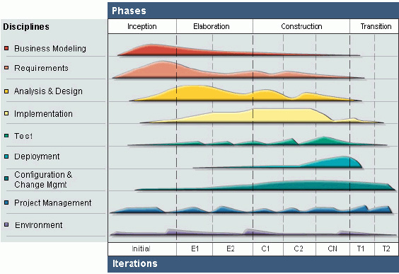

Figure 1: Rational Unified Process Process Model

* **Inception Phase**: This is the first phase of process. In this startup phase, we should provide business case of the system and determine the scope of project. Besides, we have to create the project management plan that has project schedule, effort estimation and risk management etc. At the end of this phase, we should check the objectives of project and decide whether to continue development or not. Hence, Inception phase must be properly planned and done. Based activities of this phase:
  + Study business case and feasibility study of project.
  + Complete draft ERD of system.
  + Complete draft screen prototypes.
  + Complete draft requirements.
  + Determine project scopes.
  + Complete project management plan.
* **Elaboration Phase**: The objectives of this phase are to determine appropriate architectural and construction plan for the project. The architectural decision needs to be made for the entire system, and to describe most of the requirements of system. At the end of this phase, we must examine the objectives and scopes, the choice of architecture and decide whether to proceed to the next phase. Based activities of this phases:
* Complete user requirement specification.
* Complete ERD, final prototypes.
* Complete Software Requirement Specification.
* Complete database model.
* Complete System Architecture Design.
* **Construction Phase**: Construction is the third phase of RUP lifecycle. In this phase, we must have done all the coding and testing work. After coding, developers will do unit test themselves, then test team will do functional test and regression test when finishing all. Based activities of this phase:

- Complete coding and unit test.

- Complete functional and regression test.

- Complete user manual.

* **Transition Phase**: Transition is the final phase of the RUP lifecycle. In this phase, project team has to deploy the application and give it to users. The next step is receiving feedback from users to identify the problems and then complete the system. Based activities of this phase:

- Deploy the system.

- Deliver source code.

- Complete all reports and documents.

### Roles and Responsibilities

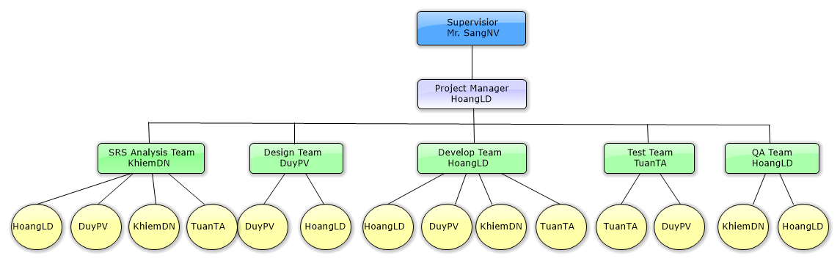

Figure 2: Roles and Responsibilities

|  |  |  |  |
| --- | --- | --- | --- |
| # | Name | Role | Responsibilities |
| 1 | Nguyễn Văn Sang | Supervisor | Support business and solution  Tracking and review project |
| 2 | Lê Duy Hoàng | Project Manager  SRS Analysis  Designer  Developer Leader  QA Leader | * - PM has responsibilities to develop the project plan and manage project stakeholders, project team, project risk, project schedule, project budget, project conflicts.   - Analyze business.  - Ensure that the Project Team completes the project.  - Provide suitable technology solutions, tools for project development process.  - Design and develop interfce.  - Create coding guidelines, coding convention and standards.  - Cooperate with Developer to create software specification requirement (SRS), architectural design (SAD) and software detailed design (SDD).  - Review document, product, and reports.  - Support other team members. |
| 3 | Đặng Nguyễn Khiêm | Member  SRS Analysis Leader  Developer  QA | - Analyze business. Understand business related to project topic.  - Present and explain business information to other members.  -Create and review SRS, SAD and SDD documents.  - Coding function.  - Writing report. |
| 4 | Trần Anh Tuấn | Member  SRS Analysis  Developer  Tester Leader | - Create software specification requirement (SRS).  - Coding function.  - Develop the test plan based on project plan and SRS, SDD documents.  - Create test data for all functions.  - Create test cases for the system, both in document and script.  - Execute test to ensure all functions fulfill requirements and make test report. |
| 5 | Phạm Văn Duy | Member  Designer Leader  Developer  SRS Analysis  Tester | - Analyze business, create software specification requirement (SRS).  - Develop a plan to draw and control architectural design.  - Create and review SRS, SAD and SDD documents.  - Design and create database.  - Coding function  - Execute test to ensure all functions fulfill requirements and make test report.  - Support other team members. |

Table 1: Roles and Responsibilities

### Tools and Techniques

#### Tools

* Microsoft Visual Studio 2012: Integrated Development Environment (IDE)
* Microsoft SQL Server 2008: Database Management System (DBMS)
* Microsoft Office: Create documents and reports
* Software Ideas Modeler: Draw diagrams
* TortoiseSVN: Subversion repository for controlling source code
* Firefox: Environment to use and testing project

#### Techniques

* ASP .NET MVC4
* Entity Framework (EF) 5
* Ajax, JQuery

## Schedule

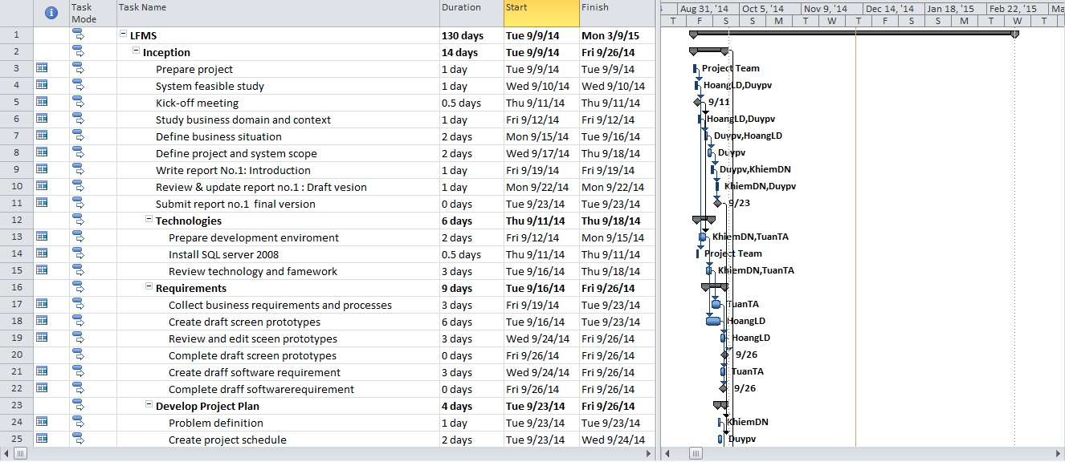

Figure 3: Project plan - 1

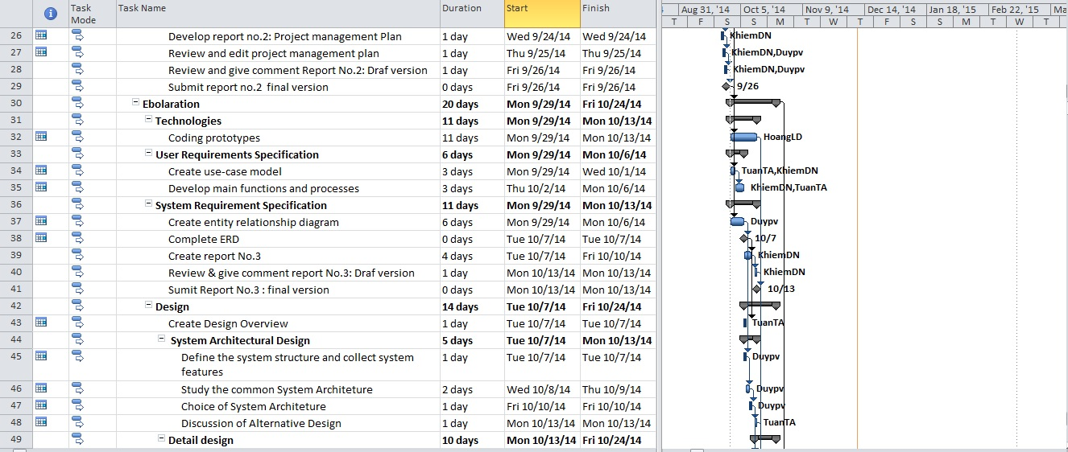

Figure 4: Project plan - 2

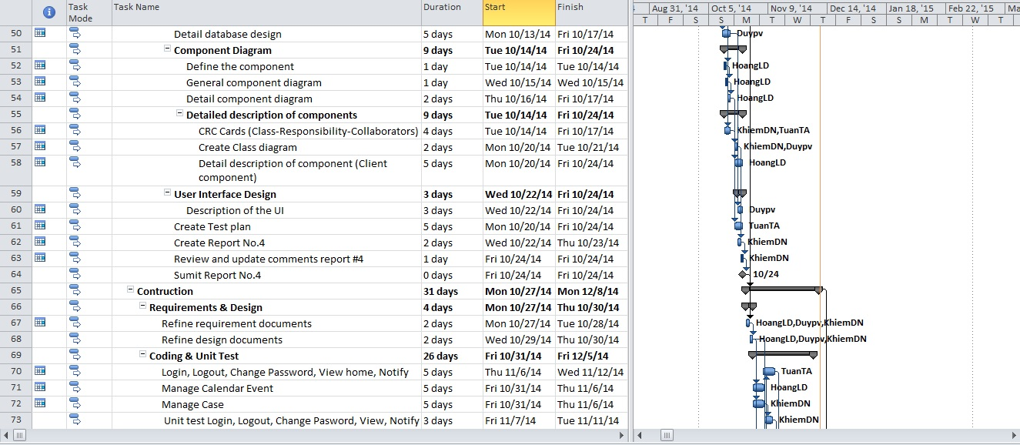

Figure 5: Project plan - 3

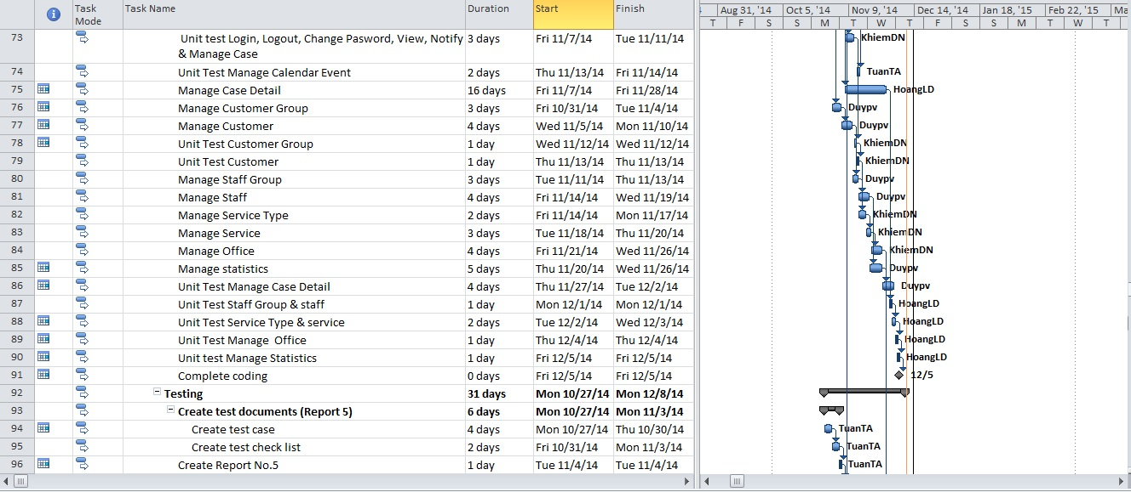

Figure 6: Project plan - 4

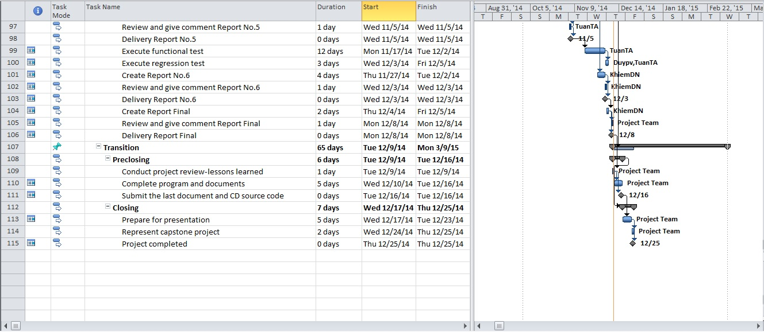

Figure 7: Project plan - 5

## Convention Rules

Summary:

* Naming Convention.
* Indentation.
* Declaration.
* Code Examples.

Follow “Code Conventions for the C# Programming Language, by Microsoft:

<http://msdn.microsoft.com/en-us/library/ff926074.aspx>

# Software Requirement Specification

## User Requirement Specification

The Law Firm Management System (LFMS) is an internal website, which allows management law office system. It must be includes five basic functions: Case management, Customer management, Staff management, Service management, Office management.

LFMS have only one back end component, system is designed for use by Administrators, Lawyers and Staff have the authority (if any).

## System Requirement Specification (Specific Requirements)

### External Interface Requirements

#### User Interfaces

System is designed so friendly and easy to use with users. Home page list all the records of reception Cases. Besides have the calendar, prompted by notification bar at the top.

All functions in menu must be grouped in a meaningful way to make it easy for users to locate and access the features.

#### Communications Protocol

The system is web base so it’s should be applied Hypertext Transfer Protocol (HTTP) is main communication protocol.

### Functional Requirements

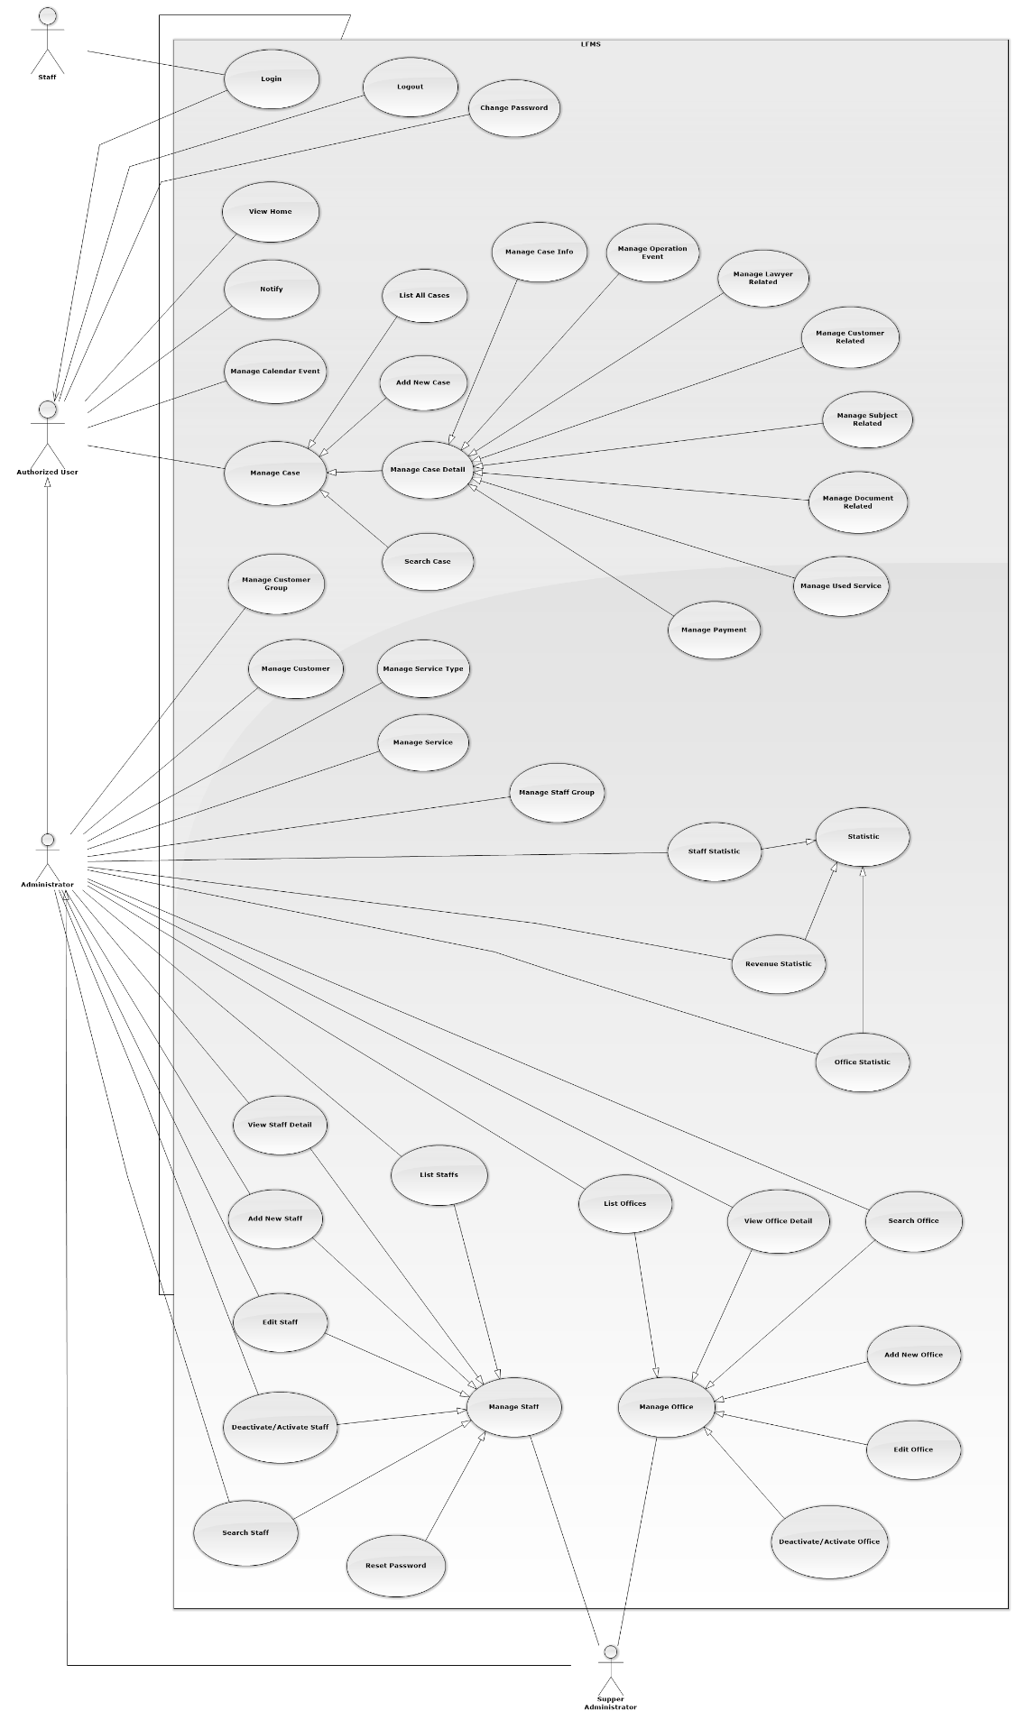

Figure 1: Overview Use-Case Diagram

#### Login

##### Login Use-Case Diagram

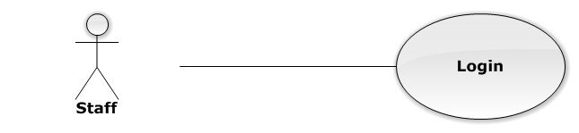

Figure 2: Login Use-Case Diagram

##### Login Use-Case Diagram Specification

|  |  |  |  |
| --- | --- | --- | --- |
| USE CASE SPECIFICATION | | | |
| Use-case No. | UC0001 | Use-case Version | 1.0 |
| Use-case Name | Login | | |
| Author | Trần Anh Tuấn | | |
| Date | 09/10/2014 | Priority | Normal |
| Actor:  Staff.  Summary:  This use case allows staff to log on into the system.  **Goal:**  Authenticate user.  Triggers:  User access website area that is intended staff.  Preconditions:  User has an account and has not logged in yet.  Post Conditions:  **Success**: User logged in. System redirects user to “Home” page.  **Failure**: System redirects to “Login” page.  Main Success Scenario:   |  |  |  | | --- | --- | --- | | *Step* | *User* | *System* | | 1 | User go to website page | Website will show [Login] page | | 2 | User input information into username field and password field |  | | 3 | Presses “Đăng nhập” button or click “Enter” key | Checks username and password.  Redirect to “Home” page.  [Exception 1]  [Exception 2] |   Alternative Scenario:  N/A  Exceptions:   |  |  |  | | --- | --- | --- | | *#* | *User* | *System* | | 1 | Presses “Login” button. If invalid username or password. | System redirect to “Login” page and display error message “Tên đăng nhập hoặc mật khẩu không đúng!” | | 2 | Presses “Login” button. If have error when connect database | System redirect to “Login” page and display error message “Lỗi kết nối đến máy chủ!” |   Relationships:  N/A  Business Rules:   * Password must be longer than 6 characters | | | |

#### Logout

##### Logout Use-Case Diagram

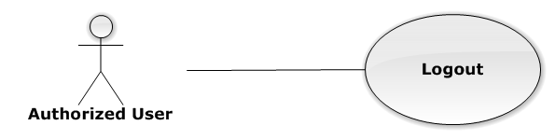

Figure 3: Logout Use-Case Diagram

##### Logout Use-Case Specification

|  |  |  |  |
| --- | --- | --- | --- |
| USE CASE SPECIFICATION | | | |
| Use-case No. | UC0002 | Use-case Version | 1.0 |
| Use-case Name | Logout | | |
| Author | Trần Anh Tuấn | | |
| Date | 09/10/2014 | Priority | Normal |
| Actor:  Authorized User.  Summary:  This use case allows staff to logout the system.  **Goal:**  The users can log out successful from their roles.  Triggers:  Staff click on “Đăng xuất” on User Control Panel.  Preconditions:  Staff has logged in to the website.  Post Conditions:  Success: Back to login screen  Failure: An error message is displayed.  Main Success Scenario:   |  |  |  | | --- | --- | --- | | *Step* | *User* | *System* | | 1 | Staff click “Đăng xuất” button on User Control Panel | The user name of user will be disappeared on webstie, Redirect to “Login” page. |   Alternative Scenario:  N/A  Exceptions:  N/A  Relationships:  N/A  Business Rules:  N/A | | | |

#### Change Password

##### Change Password Use-Case Diagram

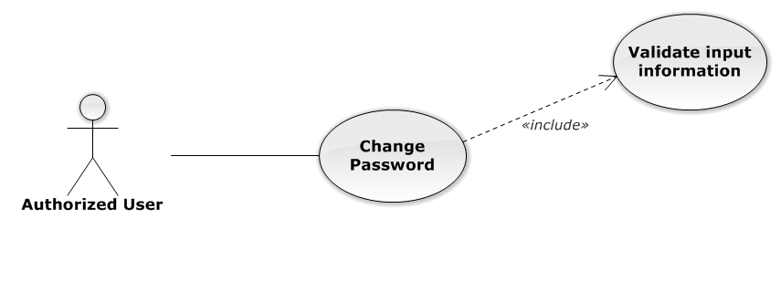

Figure 4: Change Password Use-Case Diagram

##### Change Password Use-Case Specification

|  |  |  |  |
| --- | --- | --- | --- |
| USE CASE SPECIFICATION | | | |
| Use-case No. | UC0003 | Use-case Version | 1.0 |
| Use-case Name | Change Password | | |
| Author | Trần Anh Tuấn | | |
| Date | 09/10/2014 | Priority | Normal |
| Actor:  Authorized User.  Summary:  This use case allows staff can change password of them.  **Goal:**  Change password.  Triggers:  User access website area and click on “Đổi mật khẩu”.  Preconditions:  User has logged in.  Post Conditions:  **Success**: The password is changed and display message “Cập nhật mật khẩu nhân viên thành công!”  **Failure**: Password is not changed. Display error message.  Main Success Scenario:   |  |  |  | | --- | --- | --- | | *Step* | *User* | *System* | | 1 | Staff has logged in, click on “Đổi mật khẩu” on User Control Panel. | Modal Popup “Thay đổi mật khẩu”is display with three fields:“Mật khẩu cũ, “Mật khẩu mới and “Lặp lại mật khẩu mới  Two button “Đóng” , “Đổi mật khẩu” | | 2 | User input information, Click “Đổi mật khẩu” button  [Alternative 1]  [Exception 1] | Check information validity and change password |   Alternative Scenario:   |  |  |  | | --- | --- | --- | | *#* | *User* | *System* | | 1 | Click on [X] button, “Đóng” button, or click out of modal | Modal popup is close |   Exceptions:   |  |  |  | | --- | --- | --- | | *#* | *User* | *System* | | 1 | Field “Mật khẩu cũ” are blank | Shows error message “Hãy nhập lại mật khẩu cũ” | | Field “Mật khẩu mới”, are blank | Shows error message “Hãy nhập mật khẩu mới” | | Field “Lặp lại mật khẩu mới ” are blank | Shows error message “Hãy nhập lại mật khẩu mới” | | Input to field “Mật khẩu cũ”, “Mật khẩu mới” and field “Lặp lại mật khẩu mới” regular expression. | Shows error message “Mật khẩu không được có kí tự đặc biệt” | | Input to field “Mật khẩu mới ” and field “Lặp lại mật khẩu mới ” not enough 6 character | Shows error message “Mật khẩu mới phải có ít nhất 6 kí tự” | | Input to field “Mật khẩu mới ” and field “Lặp lại mật khẩu mới ” are diffirent | Shows error message “Mật khẩu 2 không trùng khớp” | | Input to field “Mật khẩu cũ” not the same with database | Shows error message “Mật khẩu cũ không đúng!”. |   Relationships:  N/A  Business Rules:   * Password must be longer than 6 characters | | | |

#### View Home

##### View Home Use-Case Diagram

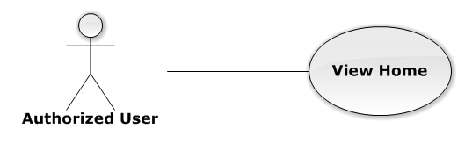

Figure 5: View Home Use-Case Diagram

##### View Home Use-Case Specification

|  |  |  |  |
| --- | --- | --- | --- |
| USE-CASE SPECIFICATION | | | |
| Use-case No. | UC0004 | Use-case Version | 1.0 |
| Use-case Name | View Home | | |
| Author | Trần Anh Tuấn | | |
| Date | 09/10/2014 | Priority | Normal |
| Actor:  Authorized User  Summary:  User must be Login before and then redirect them to “Trang Chủ” page.  Goal:  To allowing user to view some information of all Cases, which is operating and assigned by Staff related.  Triggers:   * User click on logo LFMS * Click on “Trang Chủ” link.   Preconditions:   * Must be logged-in * The page is fully loaded   Post Conditions:  Success: System redirect user to “Trang Chủ” page and list cases  Failure: Do nothing.  Main Success Scenario:   |  |  |  | | --- | --- | --- | | *Step* | *User* | *System* | | 1 | Click on logo LFMS or “Trang Chủ” link | * Redirect to “Trang Chủ” page * List Cases by Office filter |   Alternative Scenario:  N/A  Exceptions:  N/A  Relationships:  N/A  Business Rules:  N/A | | | |

#### Notify

##### Notify Use-Case Diagram

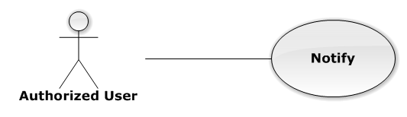

Figure 6: Notify Use-Case Diagram

##### Notify Use-Case Specification

|  |  |  |  |
| --- | --- | --- | --- |
| USE-CASE SPECIFICATION | | | |
| Use-case No. | UC0005 | Use-case Version | 1.0 |
| Use-case Name | Notify | | |
| Author | Trần Anh Tuấn | | |
| Date | 09/10/2014 | Priority | Normal |
| Actor:  Authorized User  Summary:  User must be login before and then the system will be show notification in navigation bar.  Goal:  User can see all Today's events.  Triggers:  The notification is always to show.  Preconditions:   * Must be logged-in * The page is fully loaded   Post Conditions:  Success: Show to user  Failure: Do nothing.  Main Success Scenario:   |  |  |  | | --- | --- | --- | | *Step* | *User* | *System* | | 1 | Login into the system | User can see notification about all Today's events |   Alternative Scenario:  N/A  Exceptions:  N/A  Relationships:  N/A  Business Rules:  N/A | | | |

#### Manage Calendar Event

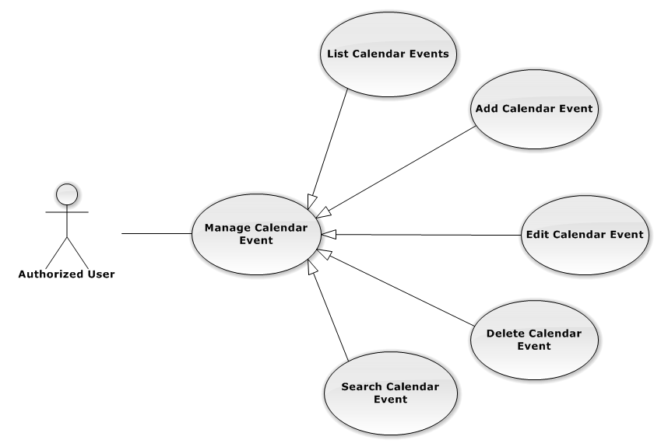

Figure 7: Manage Calendar Event Use-Case Diagram

##### List Calendar Events

###### List Calendar Events Use-Case Diagram

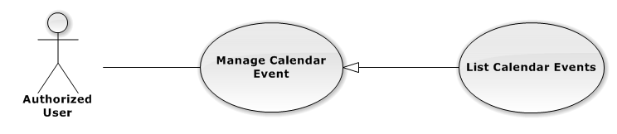

Figure 8: List Calendar Event Use-Case Diagram

###### List Calendar Events Use-Case Specification

|  |  |  |  |
| --- | --- | --- | --- |
| USE CASE SPECIFICATION | | | |
| Use-case No. | UC0006 | Use-case Version | 1.0 |
| Use-case Name | List Calendar Events | | |
| Author | Trần Anh Tuấn | | |
| Date | 09/10/2014 | Priority | Normal |
| Actor:  Authorized User.  Summary:  List All Calendar Event.  Goal:  The purpose of List Calendar Event use case is allowing User to view all Events in full-calendar.  Triggers:  User choose “Lịch làm việc” tab in Homepage.  Preconditions:  User is authenticated.  Post Conditions:  Success: All Calendar Events are listed.  Failure: N/A  Main Success Scenario:   |  |  |  | | --- | --- | --- | | *Step* | *User* | *System* | | 1 | Click “Lịch làm việc” tab in home page. | All Calendar Events are loaded. |   Alternative Scenario:  N/A  Exceptions:  N/A  Relationships:  Manage Calendar Event  Business Rules:  N/A | | | |

##### Add New Calendar Event

###### Add New Calendar Event Use-Case Diagram

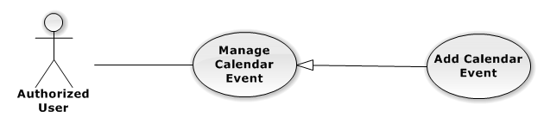

Figure 9: Add New Calendar Event

###### Add New Calendar Event Use-Case Specification

|  |  |  |  |
| --- | --- | --- | --- |
| USE CASE SPECIFICATION | | | |
| Use-case No. | UC0007 | Use-case Version | 1.0 |
| Use-case Name | Add New Calendar Event | | |
| Author | Trần Anh Tuấn | | |
| Date | 09/10/2014 | Priority | Normal |
| Actor:  Authorized User.  Summary:  Add new Calendar Event.  Goal:  The purpose of Add Calendar Event use case is allowing User to add new Calendar Event.  Triggers:  User choose “Lịch làm việc” tab in home page.  Preconditions:  User is authenticated.  Post Conditions:  Success: New Calendar Event is created.  Failure: N/A  Main Success Scenario:   |  |  |  | | --- | --- | --- | | *Step* | *User* | *System* | | 1 | Click anywhere in calendar. | Show Add new calendar event pop-up. | | 2 | Enters the Calendar Event Name |  | | 3 | Presses “Thêm Sự kiện” button.  [Alternative: 1] | Add new Calendar Event to database. |   Alternative Scenario:   |  |  |  | | --- | --- | --- | | *#* | *User* | *System* | | 1 | Presses “Đóng”, “X” button or click outside pop-up. | The Add New Calendar event pop-up is close. |   Exceptions:  N/A  Relationships:  Manage Calendar Event  Business Rules:  N/A | | | |

##### Edit Calendar Event

###### Edit Calendar Event Use-Case Diagram

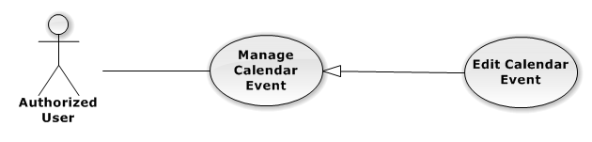

Figure 10: Edit Calendar Event Use-Case Diagram

###### Edit Calendar Event Use-Case Specification

|  |  |  |  |
| --- | --- | --- | --- |
| USE CASE SPECIFICATION | | | |
| Use-case No. | UC0008 | Use-case Version | 1.0 |
| Use-case Name | Edit Calendar Event | | |
| Author | Trần Anh Tuấn | | |
| Date | 09/10/2014 | Priority | Normal |
| Actor:  Authorized User.  Summary:  Update Calendar Event.  Goal:  The purpose of Update Calendar Event use case is allowing User to edit Calendar Event.  Triggers:  User choose “Lịch làm việc” tab in Homepage.  Preconditions:  User is authenticated.  Post Conditions:  Success: The Calendar Event is Updated.  Failure: N/A  Main Success Scenario:   |  |  |  | | --- | --- | --- | | *Step* | *User* | *System* | | 1 | Click at an exist event. | Show edit calendar event pop-up. | | 2 | Enters the new Calendar Event Name |  | | 3 | Presses “Lưu chỉnh sửa” button.  [Alternative: 1] | Update Calendar event to database. | | 1 | Drag and drop an exist event. | Update Calendar event to database. | | 1 | Reside an exist event. | Update Calendar event to database. |   Alternative Scenario:   |  |  |  | | --- | --- | --- | | *#* | *User* | *System* | | 1 | Presses “Đóng”, “X” button or click outside pop-up. | The Update Clendar event pop-up is close. |   Exceptions:  N/A  Relationships:  Manage Calendar Event  Business Rules:  N/A | | | |

##### Delete Calendar Event

###### Delete Calendar Event Use-Case Diagram

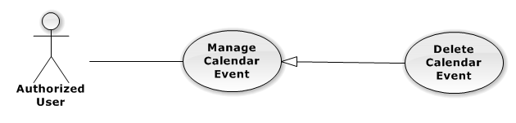

Figure 11: Delete Calendar Event Use-Case Diagram

###### Delete Calendar Event Use-Case Specification

|  |  |  |  |
| --- | --- | --- | --- |
| USE CASE SPECIFICATION | | | |
| Use-case No. | UC0009 | Use-case Version | 1.0 |
| Use-case Name | Delete Calendar Event | | |
| Author | Trần Anh Tuấn | | |
| Date | 09/10/2014 | Priority | Normal |
| Actor:  Authorized User.  Summary:  Delete Calendar Event.  Goal:  The purpose of Delete Calendar Event use case is allowing User to delete Calendar Event.  Triggers:  User choose “Lịch làm việc” tab in Homepage.  Preconditions:  User is authenticated.  Post Conditions:  Success: The Calendar Event is deleted.  Failure: N/A  Main Success Scenario:   |  |  |  | | --- | --- | --- | | *Step* | *User* | *System* | | 1 | Click at an exist event. | Show confirm pop-up | | 2 | Presses “Xóa sự kiện” button.  [Alternative: 1] | Delete Calendar Event from database. |   Alternative Scenario:   |  |  |  | | --- | --- | --- | | *#* | *User* | *System* | | 1 | Presses “Đóng”, “X” button or click outside pop-up. | The confirm pop-up is close. |   Exceptions:  N/A  Relationships:  Manage Calendar Event  Business Rules:  N/A | | | |

##### Search Calendar Event

###### Search Calendar Event Use-Case Diagram

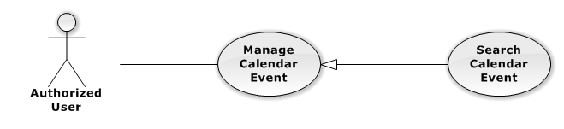

Figure 12: Search Calendar Event Use-Case Diagram

###### Search Calendar Event Use-Case Specification

|  |  |  |  |
| --- | --- | --- | --- |
| USE CASE SPECIFICATION | | | |
| Use-case No. | UC0010 | Use-case Version | 1.0 |
| Use-case Name | Search Calendar Event | | |
| Author | Trần Anh Tuấn | | |
| Date | 09/10/2014 | Priority | Normal |
| Actor:  Authorized User.  Summary:  Show all Calendar Event of a Staff.  Goal:  The purpose of Search Calendar Event use case is allowing User to view Calendar event of other staff.  Triggers:  Click at “Lịch làm việc luật sư khác” button.  Preconditions:  User is authenticated.  Post Conditions:  Success: The Calendar Event is showed.  Failure: Do nothing.  Main Success Scenario:   |  |  |  | | --- | --- | --- | | *Step* | *User* | *System* | | 1 | Click at “Lịch làm việc luật sư khác” button. | Show helper frame. | | 2 | Choose a staff in combo-box | Show al Calendar Event of these Staff. |   Alternative Scenario:  N/A  Exceptions:  N/A  Relationships:  Manage calendar event  Business Rules:  N/A | | | |

#### Manage Case

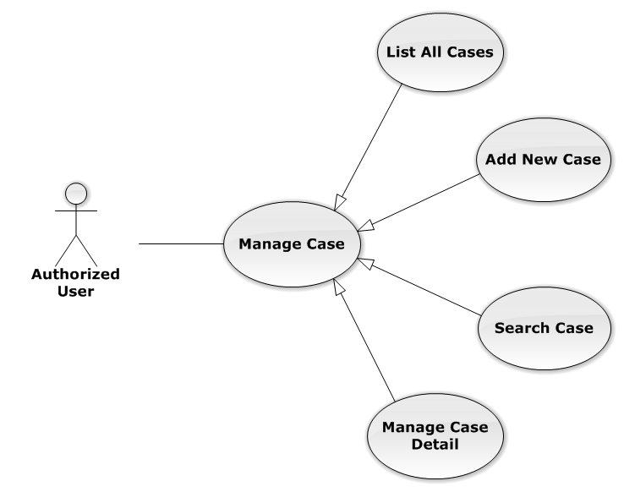

Figure 13: Manage Case Use-Case Diagram

##### List All Cases

###### List All Cases Use-Case Diagram

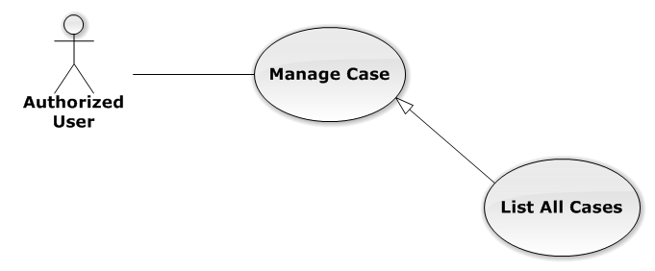

Figure 14: List All Cases Use-Case Diagram

###### List All Cases Use-Case Specification

|  |  |  |  |
| --- | --- | --- | --- |
| USE-CASE SPECIFICATION | | | |
| Use-case No. | UC0011 | Use-case Version | 1.0 |
| Use-case Name | List All Cases | | |
| Author | Trần Anh Tuấn | | |
| Date | 09/10/2014 | Priority | Normal |
| Actor:  Authorized User  Summary:  Redirect to “Danh sách hồ sơ” page and list all cases.  Goal:  To allowing customer to view any detail information of all Cases  Triggers:   * User click on User Control Panel and then click on “Danh sách hồ sơ” link * Click on “Danh sách hồ sơ” link in Case Detail of each Case   Preconditions:   * Must be logged-in * The page is fully loaded   Post Conditions:  Success: System redirects user to “Danh sách hồ sơ” page.  Failure: Do nothing.  Main Success Scenario:   |  |  |  | | --- | --- | --- | | *Step* | *User* | *System* | | 1 | Click on “Danh sách hồ sơ” link | * Redirect to “Danh sách hồ sơ” page * Show all Cases by searching condition |   Alternative Scenario:  N/A  Exceptions:  N/A  Relationships:  Manage Case  Business Rules:  N/A | | | |

##### Add New Case

###### Add New Case Use-Case Diagram

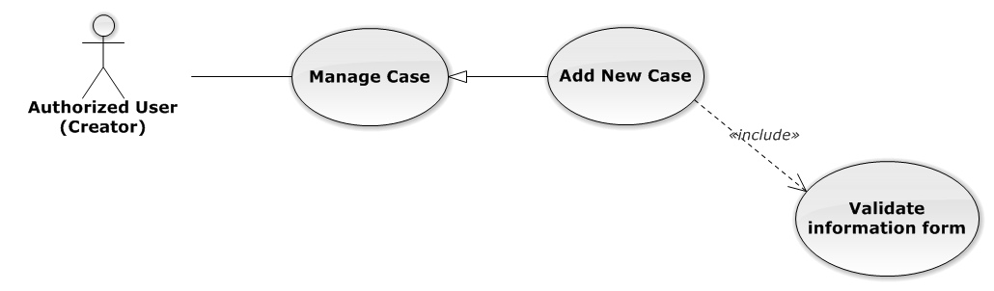

Figure 15: Add New Case Use-Case Diagram

###### Add New Case Use-Case Specification

|  |  |  |  |
| --- | --- | --- | --- |
| USE-CASE SPECIFICATION | | | |
| Use-case No. | UC0012 | Use-case Version | 1.0 |
| Use-case Name | Add New Case | | |
| Author | Trần Anh Tuấn | | |
| Date | 09/10/2014 | Priority | High |
| Actor:  Authorized User have “Creator” role  Summary:  Staff can add new case by input data on form modal  Goal:  Helps Staff input information of a case when they add new one  Triggers:  Staff click on “Thêm mới” button in modal  Preconditions:   * Must be logged-in with “Creator” role * The page is fully loaded   Post Conditions:  Success:   * Add new case successful * Add current Staff to Lawyer Related of the new Case * Redirect to view detail page of new case   Failure: System display error message “Thêm hồ sơ thất bại!”  Main Success Scenario:   |  |  |  | | --- | --- | --- | | *Step* | *User* | *System* | | 1 | * Staff click on icon-plus button in “Trang chủ” page * Click on “Thêm hồ sơ tác nghiệp” button in “Danh sách hồ sơ” page | Modal popup is displayed with fields for input information of new case | | 2 | Input corresponding information in form then click “Thêm mới” button  [Alternative 1]  [Exception 1] | * Modal popup is close * System display successful message “Thêm hồ sơ thành công!” * Update list case on page |   Alternative Scenario:   |  |  |  | | --- | --- | --- | | *#* | *User* | *System* | | 1 | Click on [X] button, “Đóng” button, or click out of modal | Modal popup is close |   Exceptions:   |  |  |  | | --- | --- | --- | | *#* | *User* | *System* | | 1 | Leave empty require fields then click on “Thêm mới” button | Modal popup display validation for needed to input field |   Relationships:  Manage Case  Business Rules:   * Authorized User must have “Creator” role to use this function * After create case successfully, system will be automatically assign Creator into that new case | | | |

##### Search Case

###### Search Case Use-Case Diagram

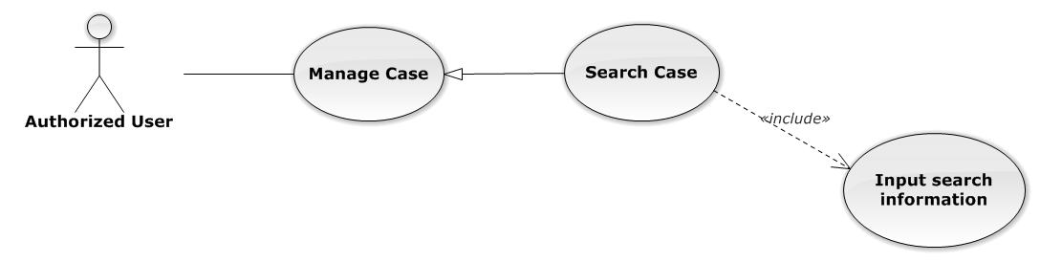

Figure 16: Search Case Use-Case Diagram

###### Search Case Use-Case Specification

|  |  |  |  |
| --- | --- | --- | --- |
| USE-CASE SPECIFICATION | | | |
| Use-case No. | UC0013 | Use-case Version | 1.0 |
| Use-case Name | Search Case | | |
| Author | Trần Anh Tuấn | | |
| Date | 09/10/2014 | Priority | Normal |
| Actor:  Authorized User  Summary:  Staff can search Cases by multi condition  Goal:  Helps Staff to search Cases of system more easy  Triggers:  Staff inputs key words on “Tìm kiếm” textbox at the top right of case list table to search follow key words inputted. When the key up, system will be automatic search.  Preconditions:   * Must be logged-in * The page is fully loaded * Inputs key words on “Tìm kiếm” textbox   Post Conditions:  Success: Cases of the system are displayed page by page  Failure: Do nothing  Main Success Scenario:   |  |  |  | | --- | --- | --- | | *Step* | *User* | *System* | | 1 | Input key words into textbox and then key up  [Alternative 1]  [Alternative 2]  [Alternative 3] | Display cases matches key words and multi condition |   Alternative Scenario:   |  |  |  | | --- | --- | --- | | *#* | *User* | *System* | | 1 | Select number result in page | Display many cases follow number result in page | | 2 | Click on another page number | Display many cases result in another page | | 3 | Click on “Mã hồ sơ” link | Redirect to view Case detail |   Exceptions:  N/A  Relationships:  Manage Case  Business Rules:  N/A | | | |

##### Manage Case Detail

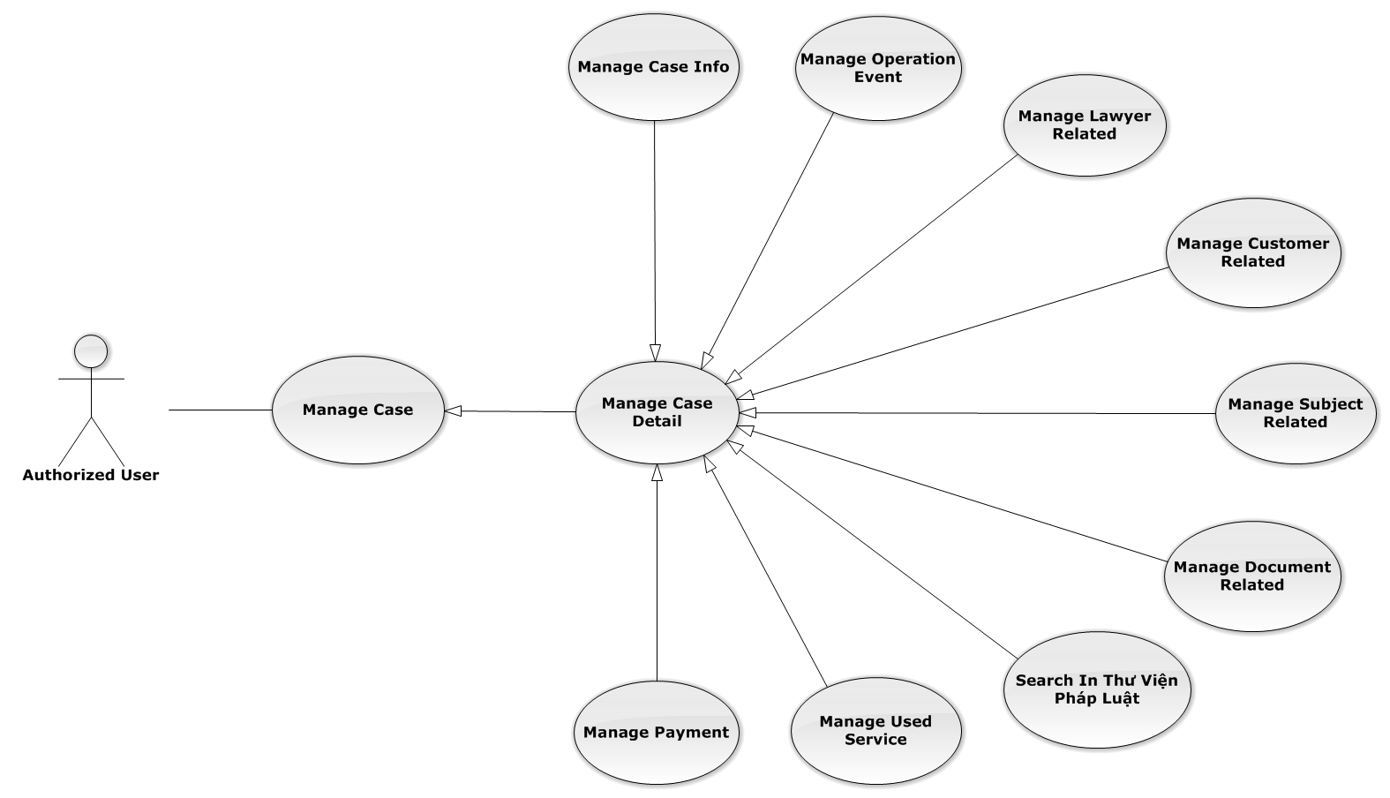

Figure 17: Manage Case Detail Use-Case Diagram

###### Manage Case Info

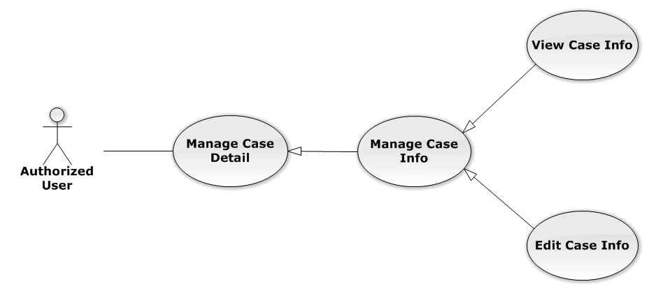

Figure 18: Manage Case Info Use-Case Diagram

View Case Info

View Case Info Use-Case Diagram

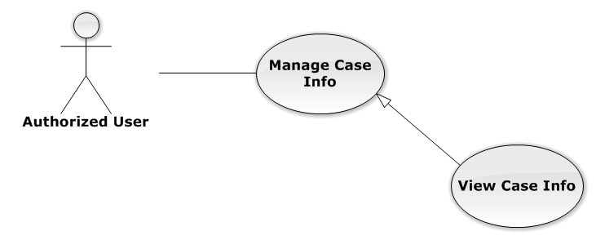

Figure 19: View Case Info Use-Case Diagram

View Case Info Use-Case Specification

|  |  |  |  |
| --- | --- | --- | --- |
| USE-CASE SPECIFICATION | | | |
| Use-case No. | UC0014 | Use-case Version | 1.0 |
| Use-case Name | View Case Info | | |
| Author | Trần Anh Tuấn | | |
| Date | 09/10/2014 | Priority | Normal |
| Actor:  Authorized User  Summary:  Staff can view current case’s information  Goal:  Helps staff to get detail and main content of the case quickly  Triggers:   * Staff click on “Mã hồ sơ” link in “Danh sách hồ sơ” * Staff click on big button corresponding with each case on “Trang chủ”   Preconditions:   * Must be logged-in * The page is fully loaded * Must be in Case Detail page   Post Conditions:  Success: The case’s detail is displayed correctly and successfully  Failure: Do nothing  Main Success Scenario:   |  |  |  | | --- | --- | --- | | *Step* | *User* | *System* | | 1 | * Staff click on “Mã hồ sơ” link in “Danh sách hồ sơ” * Staff click on big button on “Trang chủ” | * System redirect to Case Detail page * Show detail of main case content |   Alternative Scenario:  N/A  Exceptions:  N/A  Relationships:  Manage Case Info  Business Rules:  N/A | | | |

Edit Case Info

Edit Case Info Use-Case Diagram

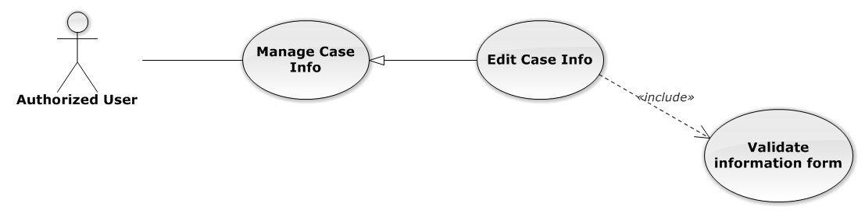

Figure 20: Edit Case Info Use-Case Diagram

Edit Case Info Use-Case Specification

|  |  |  |  |
| --- | --- | --- | --- |
| USE-CASE SPECIFICATION | | | |
| Use-case No. | UC0015 | Use-case Version | 1.0 |
| Use-case Name | Edit Case Info | | |
| Author | Trần Anh Tuấn | | |
| Date | 09/10/2014 | Priority | Normal |
| Actor:  Authorized User who is assigned in current case  Summary:  Staff can edit and update case detail  Goal:  Helps Staff easy to update case information  Triggers:  Staff click on “Lưu chỉnh sửa” button  Preconditions:   * Must be logged-in * The page is fully loaded * Must be in Case Detail page * Click on edit icon beside “Thông tin chung” label before and the case have “Đang thụ lý” status   Post Conditions:  Success: The case detail will be updated and system display message “Cập nhật chi tiết hồ sơ thành công!”  Failure: System display message “Cập nhật chi tiết hồ sơ thất bại!”  Main Success Scenario:   |  |  |  | | --- | --- | --- | | *Step* | *User* | *System* | | 1 | Click on edit icon beside “Thông tin chung” label  [Exception 1] | * All off fields will enable to input * “Hủy chỉnh sửa” and “Lưu chỉnh sửa” button is display | | 2 | Input information and then click “Lưu chỉnh sửa” button  [Alternative 1]  [Exception 2] | * The case detail will be updated * System display message “Cập nhật chi tiết hồ sơ thành công!” * All off fields will disable * “Hủy chỉnh sửa” and “Lưu chỉnh sửa” button is hidden |   Alternative Scenario:   |  |  |  | | --- | --- | --- | | *#* | *User* | *System* | | 1 | Click on “Hủy chỉnh sửa” button | * The case detail will be reloaded * All off fields will disable * “Hủy chỉnh sửa” and “Lưu chỉnh sửa” button is hidden |   Exceptions:   |  |  |  | | --- | --- | --- | | *#* | *User* | *System* | | 1 | Click on edit icon when the case have “Đã thụ lý” status | System display message “Hồ sơ đã thụ lý!” | | 2 | Leave empty require fields then click on “Lưu chỉnh sửa” button | Display validation message for needed to input field |   Relationships:  Manage Case Info  Business Rules:  Only Administrator or Authorized User is assigned in current case can be use this function when status of case is “Đang thụ lý” and Office that have current case must is active. | | | |

###### Manage Operation Event

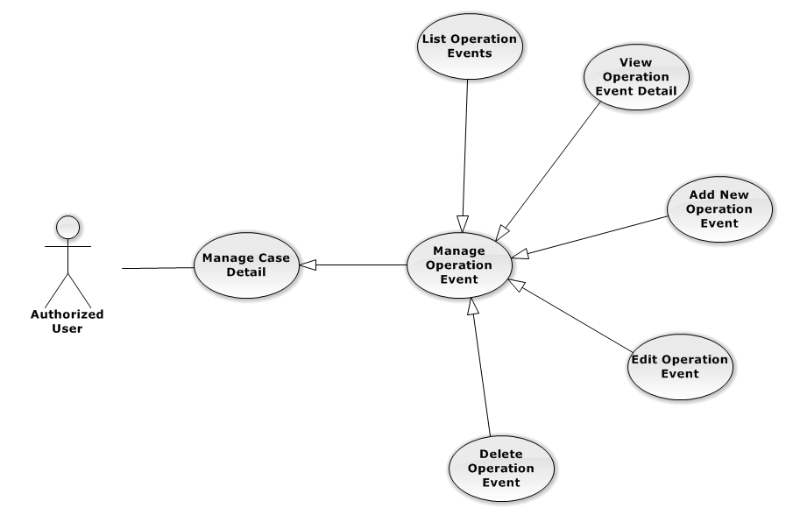

Figure 21: Manage Operation Event Use-Case Diagram

List Operation Events

List Operation Events Use-Case Diagram

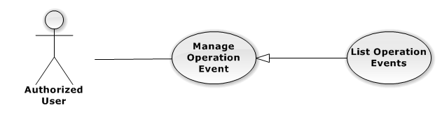

Figure 22: List Operation Events Use-Case Diagram

List Operation Events Use-Case Specification

|  |  |  |  |
| --- | --- | --- | --- |
| USE-CASE SPECIFICATION | | | |
| Use-case No. | UC0016 | Use-case Version | 1.0 |
| Use-case Name | List Operation Events | | |
| Author | Trần Anh Tuấn | | |
| Date | 09/10/2014 | Priority | Normal |
| Actor:  Authorized User  Summary:  Show all event of case.  Goal:  Help staff to view all event of case.  Triggers:  User click on “Sự kiện” link in Case Detail page  Preconditions:   * Must be logged-in * The page is fully loaded * Must be in Case Detail page   Post Conditions:  Success: List all event in current case  Failure: Do nothing  Main Success Scenario:   |  |  |  | | --- | --- | --- | | *Step* | *User* | *System* | | 1 | Click on “Sự kiện” link | Show all event in current case |   Alternative Scenario:  N/A  Exceptions:  N/A  Relationships:  Manage Operation Event  Business Rules:  N/A | | | |

View Operation Event Detail

View Operation Event Detail Use-Case Diagram

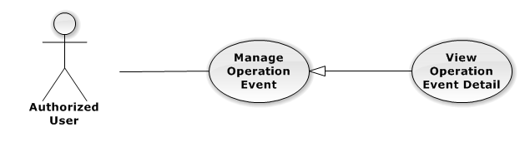

Figure 23: View Operation Event Detail Use-Case Diagram

View Operation Event Detail Use-Case Specification

|  |  |  |  |
| --- | --- | --- | --- |
| USE-CASE SPECIFICATION | | | |
| Use-case No. | UC0017 | Use-case Version | 1.0 |
| Use-case Name | View operation event detail | | |
| Author | Trần Anh Tuấn | | |
| Date | 09/10/2014 | Priority | Normal |
| Actor:  Authorized User  Summary:  Staff can view detail of event information  Goal:  Helps staff to view event information  Triggers:   * Staff click on “Sự kiện” link * Click on one event * Click on “Mở rộng” button   Preconditions:   * Must be logged-in * The page is fully loaded * Must be in Lawyer related page   Post Conditions:  Success: The detail event information is displayed  Failure: Do nothing  Main Success Scenario:   |  |  |  | | --- | --- | --- | | *Step* | *User* | *System* | | 1 | Staff click on event day’s link  [Alternative 1], [Alternative 2] | The detail event information is displayed |   Alternative Scenario:   |  |  |  | | --- | --- | --- | | *#* | *User* | *System* | | 1 | Click on “Mở rộng” button | Display detail of all event of current case | | 2 | Click on “Thu nhỏ” button | Close all detail event of current case, back to list event screen. |   Exceptions:  N/A  Relationships:  Manage Operation Event  Business Rules:  N/A | | | |

Add New Operation Event

Add New Operation Event Use-Case Diagram

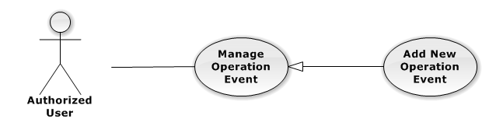

Figure 24: Add New Operation Event Use-Case Diagram

Add New Operation Event Use-Case Specification

|  |  |  |  |
| --- | --- | --- | --- |
| USE-CASE SPECIFICATION | | | |
| Use-case No. | UC0018 | Use-case Version | 1.0 |
| Use-case Name | Add New Operation Event | | |
| Author | Trần Anh Tuấn | | |
| Date | 09/10/2014 | Priority | High |
| Actor:  Authorized User, who is assigned in current case  Summary:  Staff can add new event into Case  Goal:  Helps Staff create event into Case  Triggers:   * Staff click on “Sự kiện” link in Case Detail page * Click on edit icon beside “Sư kiện tác nghiệp” button * Click on “Thêm mới” button to add new event to current case.   Preconditions:   * Must be logged-in * The page is fully loaded * Must be in event page * Click on edit icon beside “Sự kiện tác nghiệp” label before   Post Conditions:  Success:   * At new event into current Case * Show message successfully: “Thêm sự kiện thành công!”   Failure: System display error message “Thêm sự kiện thất bại!", "hãy kiểm tra lại kết nối database!”  Main Success Scenario:   |  |  |  | | --- | --- | --- | | *Step* | *User* | *System* | | 1 | Click on edit icon beside “Sự kiện tác nghiệp” label | Form, “Thêm sự kiện” and “Hoàn thành” button is display | | 2 | Click on the “Thêm sự kiện” button | Input form display , “Đóng” and “Tạo sự kiện” button is display | | 3 | Input information into fields and click button “Hoàn thành” button  [Alternative 1], [Exception 1] | System display message “Thêm sự kiện thành công!” |   Alternative Scenario:   |  |  |  | | --- | --- | --- | | *#* | *User* | *System* | | 1 | Click on “Đóng” button | Input form close back to list all event screen. |   Exceptions:   |  |  |  | | --- | --- | --- | | *#* | *User* | *System* | | 1 | System cannot insert event to data base. | Shows error message “Tạo sự kiện thất bại, hãy kiểm tra lại kết nối database”. |   Relationships:  Manage Operation Event  Business Rules:  Only Administrator or Authorized User is assigned in current case can be use this function when status of case is “Đang thụ lý” and Office that have current case must is active. | | | |

Edit Operation Event

Edit Operation Event Use-Case Diagram

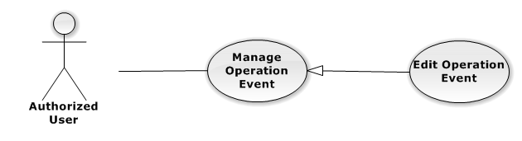

Figure 25: Edit Operation Event Use-Case Diagram

Edit Operation Event Use-Case Specification

|  |  |  |  |
| --- | --- | --- | --- |
| USE-CASE SPECIFICATION | | | |
| Use-case No. | UC0019 | Use-case Version | 1.0 |
| Use-case Name | Edit Operation Event | | |
| Author | Trần Anh Tuấn | | |
| Date | 09/10/2014 | Priority | Normal |
| Actor:  Authorized User, who is assigned in current case  Summary:  Staff can update event into Case  Goal:  Helps Staff update event into Case  Triggers:   * Staff click on “Sự kiện” link in Case Detail page * Click on edit icon beside “Sư kiện tác nghiệp” button * Click on “Edit” button to update event.   Preconditions:   * Must be logged-in * The page is fully loaded * Must be in event page * Click on edit icon beside “Sự kiện tác nghiệp” label before   Post Conditions:  Success:   * Update event into current Case * Show message successfully: “Sửa sự kiện thành công!”   Failure: System display error message “Sửa sự kiện thất bại!", "hãy kiểm tra lại kết nối database!”  Main Success Scenario:   |  |  |  | | --- | --- | --- | | *Step* | *User* | *System* | | 1 | Click on edit icon beside “Sự kiện tác nghiệp” label | List all event in current case, “Edit” and “Delete” icon is display, “Thêm sự kiện” and “Hoàn thành” button is display | | 2 | Click on the “Edit” button | Input form display , “Đóng” and “Lưu chỉnh sửa” button is display | | 3 | Edit information into fields and click button “Lưu chỉnh sửa” button  [Alternative 1] , [Exception 1] | System display message “Sửa sự kiện thành công!” |   Alternative Scenario:   |  |  |  | | --- | --- | --- | | *#* | *User* | *System* | | 1 | Click on “Đóng” button | Input form close back to list all event screen. |   Exceptions:   |  |  |  | | --- | --- | --- | | *#* | *User* | *System* | | 1 | While edit information of event click edit icon beside “Sư kiện tác nghiệp” button | Shows error message “Chỉnh sửa chưa hoàn thành! Hãy lưu hoặc đóng chỉnh sửa”. | | System cannot insert event to data base. | Shows error message “Chỉnh sửa sự kiện thất bại, hãy kiểm tra lại kết nối database”. |   Relationships:  Manage Operation Event  Business Rules:  Only Administrator or Authorized User is assigned in current case can be use this function when status of case is “Đang thụ lý” and Office that have current case must is active. | | | |

Delete Operation Event

Delete Operation Event Use-Case Diagram

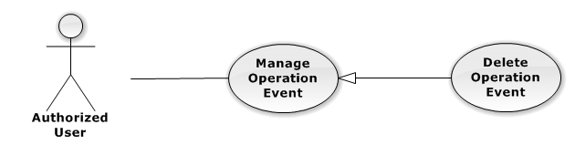

Figure 26: Delete Operation Event Use-Case Diagram

Delete Operation Event Use-Case Specification

|  |  |  |  |
| --- | --- | --- | --- |
| USE-CASE SPECIFICATION | | | |
| Use-case No. | UC0020 | Use-case Version | 1.0 |
| Use-case Name | Delete Operation Event | | |
| Author | Trần Anh Tuấn | | |
| Date | 09/10/2014 | Priority | Normal |
| Actor:  Authorized User, who is assigned in current case  Summary:  Staff can remove Event in Case  Goal:  Helps Staff remove Event in Case  Triggers:  Staff click on delete icon in the end table list  Preconditions:   * Must be logged-in * The page is fully loaded * Must be in Lawyer related page * Click on edit icon beside “Sự kiện tác nghiệp” label before   Post Conditions:  Success:   * Remove the Event out of current Case * Show message remove successfully: “Xóa sự kiện thành công!”   Failure: System display error message “Xóa sự kiện thất bại!”  Main Success Scenario:   |  |  |  | | --- | --- | --- | | *Step* | *User* | *System* | | 1 | Click on edit icon beside “Sự kiện tác nghiệp” label | Icon delete is display | | 2 | Click on icon delete corresponding with Event want to remove | Show a modal popup to confirm | | 3 | Click on “Xác nhận” button  [Alternative 1] | System display message “Xóa sự kiện thành công!” |   Alternative Scenario:   |  |  |  | | --- | --- | --- | | *#* | *User* | *System* | | 1 | Click on “Bỏ qua” button | Modal popup is close and system do not remove the Event |   Exceptions:  N/A  Relationships:  Manage Operation Event  Business Rules:  Only Administrator or Authorized User is assigned in current case can be use this function when status of case is “Đang thụ lý” and Office that have current case must is active. | | | |

###### Manage Lawyer Related

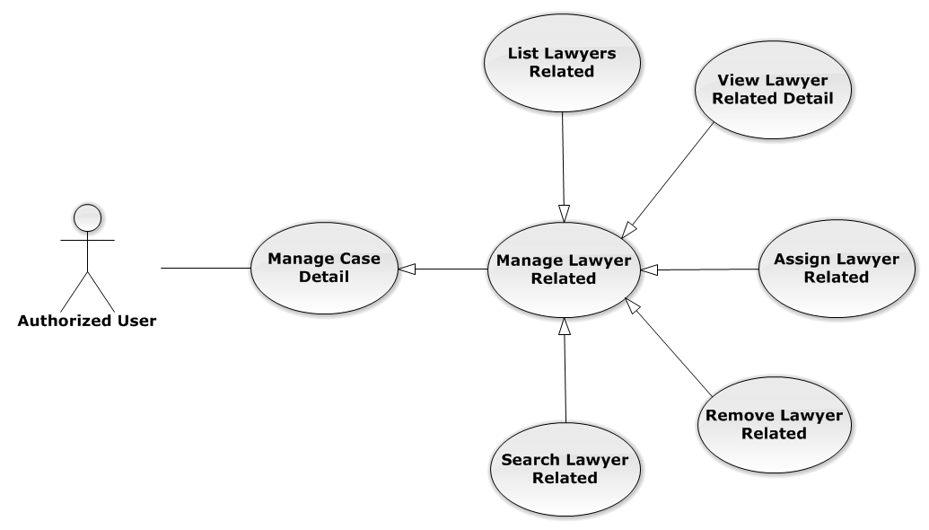

Figure 27: Manage Lawyer Related Use-Case Diagram

List Lawyers Related

List Lawyers Related Use-Case Diagram

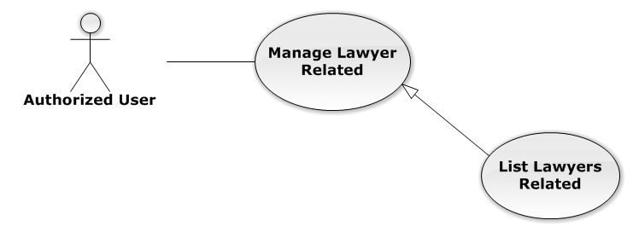

Figure 28: List Lawyers Related Use-Case Diagram

List Lawyers Related Use-Case Specification

|  |  |  |  |
| --- | --- | --- | --- |
| USE-CASE SPECIFICATION | | | |
| Use-case No. | UC0021 | Use-case Version | 1.0 |
| Use-case Name | List Lawyers Related | | |
| Author | Đặng Nguyễn Khiêm | | |
| Date | 09/10/2014 | Priority | Normal |
| Actor:  Authorized User  Summary:  Show all Lawyers, who is assigned in current case  Goal:  Help to view all Lawyers, who is assigned in current case  Triggers:   * User click on “Người liên quan” link in Case Detail page * Click on “Luật sư” link at right top page   Preconditions:   * Must be logged-in * The page is fully loaded * Must be in Case Detail page   Post Conditions:  Success: List all Staffs is assigned in current case  Failure: Do nothing  Main Success Scenario:   |  |  |  | | --- | --- | --- | | *Step* | *User* | *System* | | 1 | Click on “Người liên quan” link or “Luật sư” link | Show all Lawyers is assigned in current case |   Alternative Scenario:  N/A  Exceptions:  N/A  Relationships:  Manage Lawyer Related  Business Rules:  N/A | | | |

View Lawyer Related Detail

View Lawyer Related Detail Use-Case Diagram

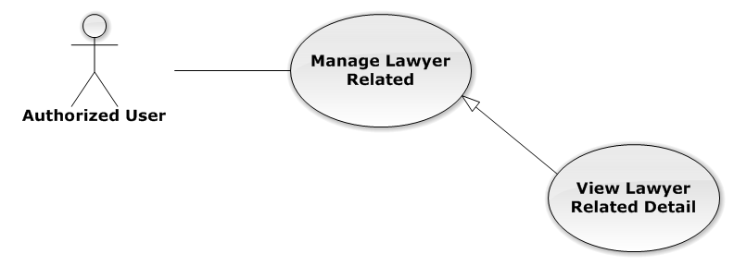

Figure 29: View Lawyer Related Detail Use-Case Diagram

View Lawyer Related Detail Use-Case Specification

|  |  |  |  |
| --- | --- | --- | --- |
| USE-CASE SPECIFICATION | | | |
| Use-case No. | UC0022 | Use-case Version | 1.0 |
| Use-case Name | View Lawyer Related Detail | | |
| Author | Đặng Nguyễn Khiêm | | |
| Date | 09/10/2014 | Priority | Normal |
| Actor:  Authorized User  Summary:  Staff can view Lawyer related information  Goal:  Helps staff to view Lawyer related information  Triggers:   * Staff click on “Họ và tên” link * Click on avatar image   Preconditions:   * Must be logged-in * The page is fully loaded * Must be in “Người liên quan” page   Post Conditions:  Success: The popup modal have lawyer information is displayed  Failure: Do nothing  Main Success Scenario:   |  |  |  | | --- | --- | --- | | *Step* | *User* | *System* | | 1 | Staff click on “Họ và tên” link or avatar image | The popup modal have lawyer information is displayed  [Alternative 1] |   Alternative Scenario:   |  |  |  | | --- | --- | --- | | *#* | *User* | *System* | | 1 | Click on [X] button, “Đóng” button, or click out of modal | Modal popup is close |   Exceptions:  N/A  Relationships:  Manage Lawyer Related  Business Rules:  N/A | | | |

Assign Lawyer Related

Assign Lawyer Related Use-Case Diagram

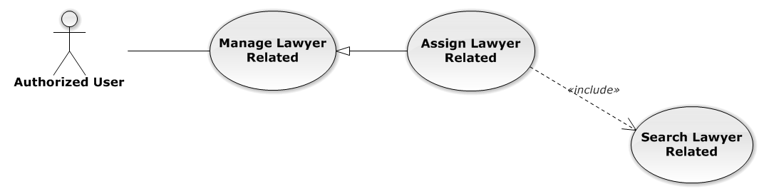

Figure 30: Assign Lawyer Related Use-Case Diagram

Assign Lawyer Related Use-Case Specification

|  |  |  |  |
| --- | --- | --- | --- |
| USE-CASE SPECIFICATION | | | |
| Use-case No. | UC0023 | Use-case Version | 1.0 |
| Use-case Name | Assign Lawyer Related | | |
| Author | Đặng Nguyễn Khiêm | | |
| Date | 09/10/2014 | Priority | High |
| Actor:  Authorized User, who create the current Case  Summary:  Staff can assign Lawyer into Case  Goal:  Helps Staff assign any Lawyers into Case  Triggers:  Staff click on “Thêm vào danh sách” button after choose Lawyer in search form beside  Preconditions:   * Must be logged-in * The page is fully loaded * Must be in “Người liên quan” page * Click on edit icon beside “Luật sư phụ trách” label and used Search Lawyer Related function before   Post Conditions:  Success:   * Assign the Lawyer in search form to current Case * Show message assign successfully: “Đã phân công luật sư!”   Failure: System display error message “Phân công luật sư thất bại!”  Main Success Scenario:   |  |  |  | | --- | --- | --- | | *Step* | *User* | *System* | | 1 | Click on edit icon beside “Luật sư phụ trách” label | Search form, “Thêm vào danh sách” and “Hoàn thành” button is display | | 2 | After search and choose a Lawyer, Staff click on “Thêm vào danh sách” button  [Alternative 1]  [Exception 1]  [Exception 2] | System display message “Đã phân công luật sư!” |   Alternative Scenario:   |  |  |  | | --- | --- | --- | | *#* | *User* | *System* | | 1 | Click on “Hoàn thành” button | Search form, “Thêm vào danh sách” and “Hoàn thành” button is hidden |   Exceptions:   |  |  |  | | --- | --- | --- | | *#* | *User* | *System* | | 1 | Not search lawyer then click on “Thêm vào danh sách” button | Display validation message for needed to search lawyer before: “Hãy chọn 1 luật sư!” | | 2 | Lawyer is exist in list lawyer related | Display message “Đã tồn tại luật sư!” |   Relationships:  Manage Lawyer Related  Business Rules:  Only Administrator or Authorized User, who create the current Case can be use this function when status of case is “Đang thụ lý” and Office that have current case must is active. | | | |

Remove Lawyer Related

Remove Lawyer Related Use-Case Diagram

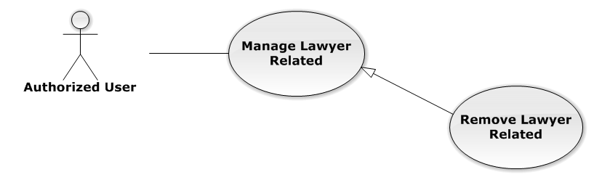

Figure 31: Remove Lawyer Related Use-Case Diagram

Remove Lawyer Related Use-Case Specification

|  |  |  |  |
| --- | --- | --- | --- |
| USE-CASE SPECIFICATION | | | |
| Use-case No. | UC0024 | Use-case Version | 1.0 |
| Use-case Name | Remove Lawyer Related | | |
| Author | Đặng Nguyễn Khiêm | | |
| Date | 09/10/2014 | Priority | Normal |
| Actor:  Authorized User, who create the current Case  Summary:  Staff can remove Lawyer related in Case  Goal:  Helps Staff remove Lawyer related in Case  Triggers:  Staff click on delete icon in the end table list  Preconditions:   * Must be logged-in * The page is fully loaded * Must be in “Người liên quan” page * Click on edit icon beside “Luật sư phụ trách” label before   Post Conditions:  Success:   * Remove the Lawyer out of current Case * Show message remove successfully: “Loại bỏ luật sư thành công!”   Failure: System display error message “Loại bỏ luật sư thất bại!”  Main Success Scenario:   |  |  |  | | --- | --- | --- | | *Step* | *User* | *System* | | 1 | Click on edit icon beside “Luật sư phụ trách” label | Icon delete is display | | 2 | Click on icon delete corresponding with Lawyer want to remove | Show a modal popup to confirm | | 3 | Click on “Xác nhận” button  [Alternative 1] | System display message “Loại bỏ luật sư thành công!” |   Alternative Scenario:   |  |  |  | | --- | --- | --- | | *#* | *User* | *System* | | 1 | Click on “Bỏ qua” button | Modal popup is close and system do not remove the Lawyer |   Exceptions:  N/A  Relationships:  Manage Lawyer Related  Business Rules:  Only Administrator or Authorized User, who create the current Case can be use this function when status of case is “Đang thụ lý” and Office that have current case must is active. | | | |

Search Lawyer Related

Search Lawyer Related Use-Case Diagram

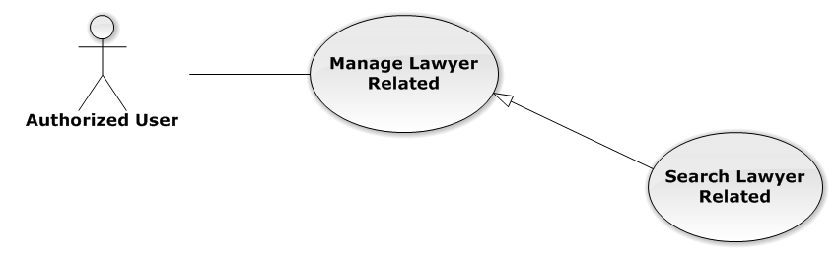

Figure 32: Search Lawyer Related Use-Case Diagram

Search Lawyer Related Use-Case Specification

|  |  |  |  |
| --- | --- | --- | --- |
| USE-CASE SPECIFICATION | | | |
| Use-case No. | UC0025 | Use-case Version | 1.0 |
| Use-case Name | Search Lawyer Related | | |
| Author | Đặng Nguyễn Khiêm | | |
| Date | 09/10/2014 | Priority | Normal |
| Actor:  Authorized User, who create the current Case  Summary:  Staff can search Lawyer for assign into Case  Goal:  Helps Staff can assign Lawyer easily  Triggers:  Staff input key word is StaffName or Username of Lawyer. When the key up, system will be automatic search.  Preconditions:   * Must be logged-in * The page is fully loaded * Must be in “Người liên quan” page * Click on edit icon beside “Luật sư phụ trách” label before   Post Conditions:  Success: The lawyer has been choose in search form by StaffName or Username  Failure: Do nothing  Main Success Scenario:   |  |  |  | | --- | --- | --- | | *Step* | *User* | *System* | | 1 | Click on edit icon beside “Luật sư phụ trách” label | Search form is display | | 2 | Input key words into search form and then key up | Display lawyers matches key words by StaffName and Username | | 3 | Click on result have lawyer want to assign  [Alternative 1] | The lawyer has been choose, wait for assign |   Alternative Scenario:   |  |  |  | | --- | --- | --- | | *#* | *User* | *System* | | 1 | Click out of result list | Result list is clear |   Exceptions:  N/A  Relationships:  Manage Lawyer Related  Business Rules:  Only Administrator or Authorized User, who create the current Case can be use this function when status of case is “Đang thụ lý” and Office that have current case must is active. | | | |

###### Manage Customer Related

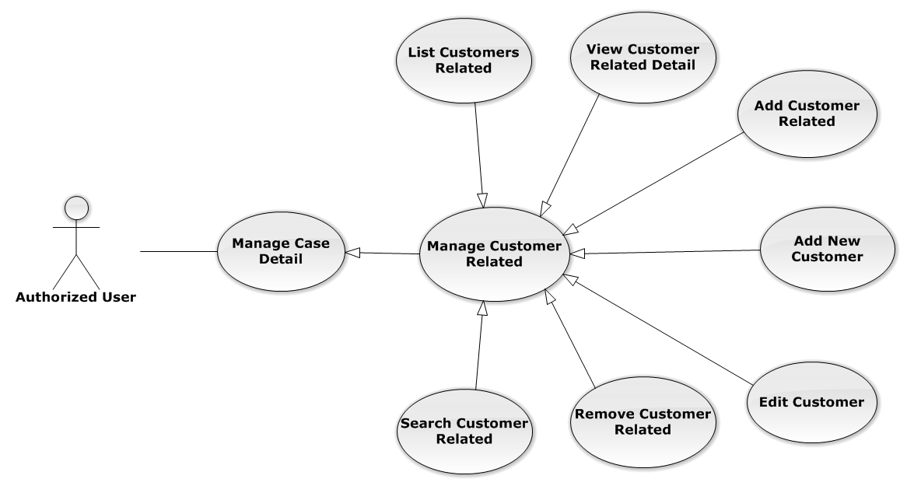

Figure 33: Manage Customer Related Use-Case Diagram

List Customers Related

List Customers Related Use-Case Diagram

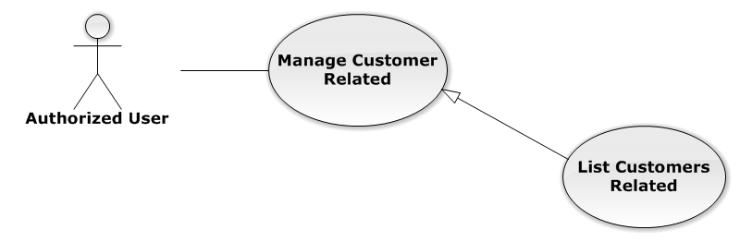

Figure 34: List Customers Related Use-Case Diagram

List Customers Related Use-Case Specification

|  |  |  |  |
| --- | --- | --- | --- |
| USE-CASE SPECIFICATION | | | |
| Use-case No. | UC0026 | Use-case Version | 1.0 |
| Use-case Name | List Customers Related | | |
| Author | Đặng Nguyễn Khiêm | | |
| Date | 09/10/2014 | Priority | Normal |
| Actor:  Authorized User  Summary:  List all Customers of current case, each case can have one or more customers  Goal:  Help to view all Customers related  Triggers:  User click on “Khách hàng” link at right top page  Preconditions:   * Must be logged-in * The page is fully loaded * Must be in “Người liên quan” page   Post Conditions:  Success: Show all Customers of current case in table  Failure: Do nothing  Main Success Scenario:   |  |  |  | | --- | --- | --- | | *Step* | *User* | *System* | | 1 | Click on “Khách hàng” link | Show all Customers of current case in table line by line |   Alternative Scenario:  N/A  Exceptions:  N/A  Relationships:  Manage Customer Related  Business Rules:  N/A | | | |

View Customer Related Detail

View Customer Related Detail Use-Case Diagram

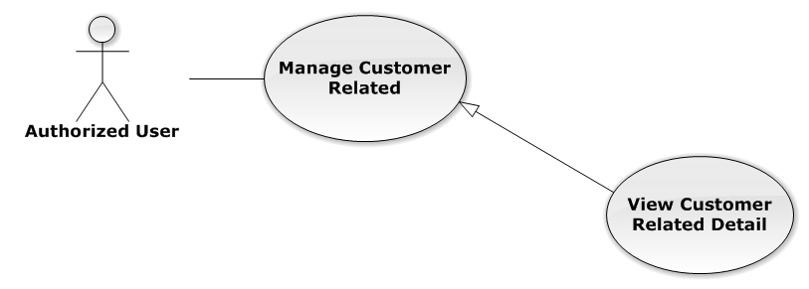

Figure 35: View Customer Related Detail Use-Case Diagram

View Customer Related Detail Use-Case Specification

|  |  |  |  |
| --- | --- | --- | --- |
| USE-CASE SPECIFICATION | | | |
| Use-case No. | UC0027 | Use-case Version | 1.0 |
| Use-case Name | View Customer Related Detail | | |
| Author | Đặng Nguyễn Khiêm | | |
| Date | 09/10/2014 | Priority | Normal |
| Actor:  Authorized User  Summary:  Staff can view Customer related information  Goal:  Helps staff to view Customer related information  Triggers:  Staff click on “Họ và tên” link  Preconditions:   * Must be logged-in * The page is fully loaded * Must be in “Khách hàng” page   Post Conditions:  Success: The popup modal have customer information is displayed  Failure: Do nothing  Main Success Scenario:   |  |  |  | | --- | --- | --- | | *Step* | *User* | *System* | | 1 | Staff click on “Họ và tên” link | The popup modal have customer information is displayed  [Alternative 1] |   Alternative Scenario:   |  |  |  | | --- | --- | --- | | *#* | *User* | *System* | | 1 | Click on [X] button, “Đóng” button, or click out of modal | Modal popup is close |   Exceptions:  N/A  Relationships:  Manage Customer Related  Business Rules:  N/A | | | |

Add Customer Related

Add Customer Related Use-Case Diagram

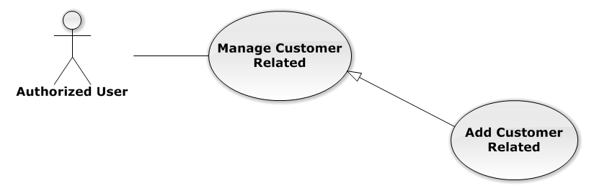

Figure 36: Add Customer Related Use-Case Diagram

Add Customer Related Use-Case Specification

|  |  |  |  |
| --- | --- | --- | --- |
| USE-CASE SPECIFICATION | | | |
| Use-case No. | UC0028 | Use-case Version | 1.0 |
| Use-case Name | Add Customer Related | | |
| Author | Đặng Nguyễn Khiêm | | |
| Date | 09/10/2014 | Priority | Normal |
| Actor:  Authorized User, who is assigned in current case  Summary:  Staff can add a available customer on Database into Case  Goal:  Helps Staff add a available customer into Case  Triggers:  Staff click on “Thêm vào danh sách” button after choose Customer in search form beside  Preconditions:   * Must be logged-in * The page is fully loaded * Must be in “Khách hàng” page * Click on edit icon beside “Khách hàng” label and used Search Customer Related function before   Post Conditions:  Success:   * Add a customer into Case * Show message assign successfully: “Thêm khách hàng thành công!”   Failure: System display error message “Thêm khách hàng thất bại!”  Main Success Scenario:   |  |  |  | | --- | --- | --- | | *Step* | *User* | *System* | | 1 | Click on edit icon beside “Khách hàng” label | Search form, “Thêm vào danh sách” and “Hoàn thành” button is display | | 2 | After search and choose a Customer, Staff click on “Thêm vào danh sách” button  [Alternative 1]  [Exception 1]  [Exception 2] | System display message “Thêm khách hàng thành công!” |   Alternative Scenario:   |  |  |  | | --- | --- | --- | | *#* | *User* | *System* | | 1 | Click on “Hoàn thành” button | Search form, “Thêm vào danh sách” and “Hoàn thành” button is hidden |   Exceptions:   |  |  |  | | --- | --- | --- | | *#* | *User* | *System* | | 1 | Not search customer then click on “Thêm vào danh sách” button | Display validation message for needed to search lawyer before: “Hãy chọn 1 khách hàng!” | | 2 | Customer is exist in list customer related | Display message “Đã tồn tại khách hàng!” |   Relationships:  Manage Customer Related  Business Rules:  Only Administrator or Authorized User is assigned in current case can be use this function when status of case is “Đang thụ lý” and Office that have current case must is active. | | | |

Add New Customer

Reference to Add New Customer function in Manage Customer

Edit Customer

Reference to Edit Customer function in Manage Customer

Remove Customer Related

Remove Customer Related Use-Case Diagram

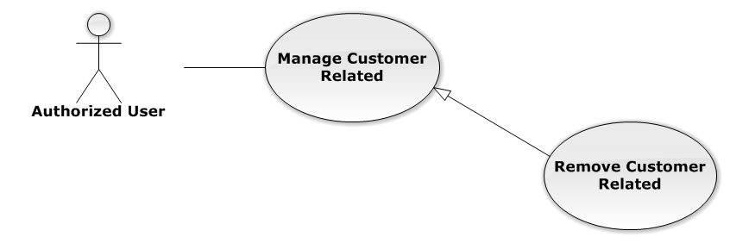

Figure 37: Remove Customer Related Use-Case Diagram

Remove Customer Related Use-Case Specification

|  |  |  |  |
| --- | --- | --- | --- |
| USE-CASE SPECIFICATION | | | |
| Use-case No. | UC0029 | Use-case Version | 1.0 |
| Use-case Name | Remove Customer Related | | |
| Author | Đặng Nguyễn Khiêm | | |
| Date | 09/10/2014 | Priority | Normal |
| Actor:  Authorized User, who is assigned in current case  Summary:  Staff can remove Customer related in Case  Goal:  Helps Staff remove Customer related in Case  Triggers:  Staff click on delete icon in the end table list  Preconditions:   * Must be logged-in * The page is fully loaded * Must be in “Khách hàng” page * Click on edit icon beside “Khách hàng” label before   Post Conditions:  Success:   * Remove the Customer out of current Case * Show message remove successfully: “Loại bỏ khách hàng thành công!”   Failure: System display error message “Loại bỏ khách hàng thất bại!”  Main Success Scenario:   |  |  |  | | --- | --- | --- | | *Step* | *User* | *System* | | 1 | Click on edit icon beside “Khách hàng” label | Icon delete is display | | 2 | Click on icon delete corresponding with Customer want to remove | Show a modal popup to confirm | | 3 | Click on “Xác nhận” button  [Alternative 1] | System display message “Loại bỏ khách hàng thành công!” |   Alternative Scenario:   |  |  |  | | --- | --- | --- | | *#* | *User* | *System* | | 1 | Click on “Bỏ qua” button | Modal popup is close and system do not remove the Customer |   Exceptions:  N/A  Relationships:  Manage Customer Related  Business Rules:  Only Administrator or Authorized User is assigned in current case can be use this function when status of case is “Đang thụ lý” and Office that have current case must is active. | | | |

Search Customer Related

Search Customer Related Use-Case Diagram

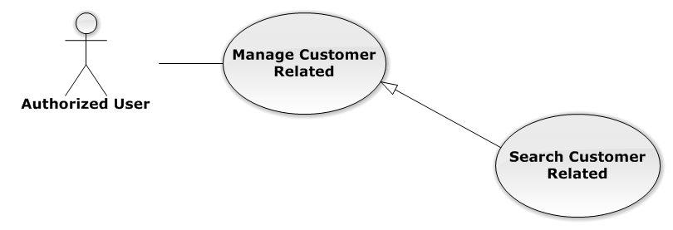

Figure 38: Search Customer Related Use-Case Diagram

Search Customer Related Use-Case Specification

|  |  |  |  |
| --- | --- | --- | --- |
| USE-CASE SPECIFICATION | | | |
| Use-case No. | UC0030 | Use-case Version | 1.0 |
| Use-case Name | Search Customer Related | | |
| Author | Đặng Nguyễn Khiêm | | |
| Date | 09/10/2014 | Priority | Normal |
| Actor:  Authorized User, who is assigned in current case  Summary:  Staff can search Customer for add customer related  Goal:  Helps Staff can search Customer easily  Triggers:  Staff input key word is CustomerName or Address of Customer. When the key up, system will be automatic search after 500ms delay time.  Preconditions:   * Must be logged-in * The page is fully loaded * Must be in “Khách hàng” page * Click on edit icon beside “Khách hàng” label before   Post Conditions:  Success: The customer has been choose in search form by CustomerName or Address  Failure: Do nothing  Main Success Scenario:   |  |  |  | | --- | --- | --- | | *Step* | *User* | *System* | | 1 | Click on edit icon beside “Khách hàng” label | Search form is display | | 2 | Input key words into search form and then key up | Display customers matches key words by CustomerName or Address | | 3 | Click on result have customer want to add  [Alternative 1] | The customer has been choose, wait for add |   Alternative Scenario:   |  |  |  | | --- | --- | --- | | *Step* | *User* | *System* | | 1 | Click out of result list | Result list is clear |   Exceptions:  N/A  Relationships:  Manage Customer Related  Business Rules:  Only Administrator or Authorized User is assigned in current case can be use this function when status of case is “Đang thụ lý” and Office that have current case must is active. | | | |

###### Manage Subject Related

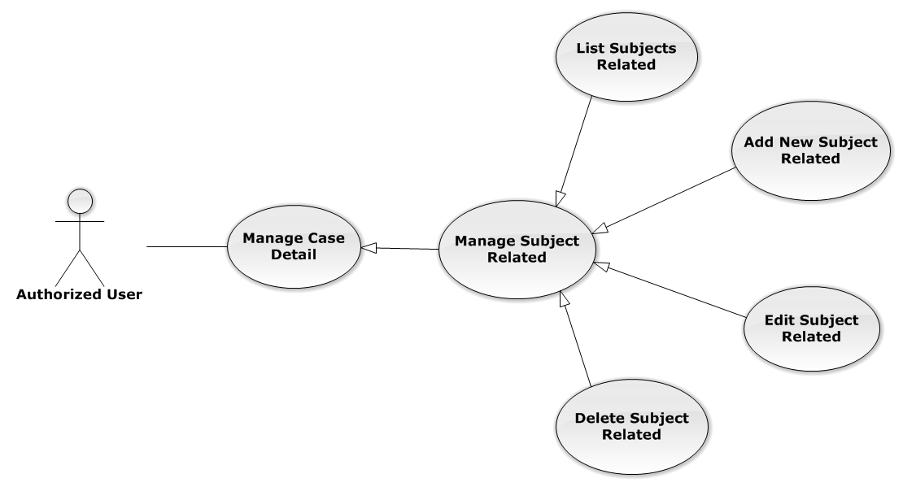

Figure 39: Manage Subject Related Use-Case Diagram

List Subjects Related

List Subjects Related Use-Case Diagram

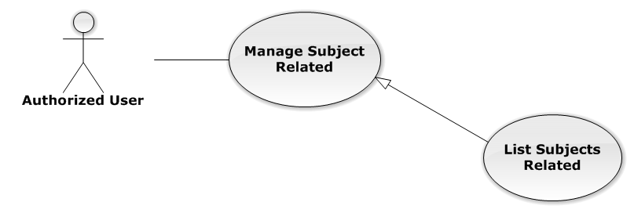

Figure 40: List Subjects Related Use-Case Diagram

List Subjects Related Use-Case Specification

|  |  |  |  |
| --- | --- | --- | --- |
| USE-CASE SPECIFICATION | | | |
| Use-case No. | UC0031 | Use-case Version | 1.0 |
| Use-case Name | List Subjects Related | | |
| Author | Đặng Nguyễn Khiêm | | |
| Date | 09/10/2014 | Priority | Normal |
| Actor:  Authorized User  Summary:  List all Subjects of current case, each case can have one or more subjects  Goal:  Help to view all Subject related  Triggers:  User click on “Chủ thể” link at right top page  Preconditions:   * Must be logged-in * The page is fully loaded * Must be in “Người liên quan” page   Post Conditions:  Success: Show all Subjects of current case in table  Failure: Do nothing  Main Success Scenario:   |  |  |  | | --- | --- | --- | | *Step* | *User* | *System* | | 1 | Click on “Chủ thể” link | Show all Subjects of current case in table line by line |   Alternative Scenario:  N/A  Exceptions:  N/A  Relationships:  Manage Subject Related  Business Rules:  N/A | | | |

Add New Subject Related

Add New Subject Related Use-Case Diagram

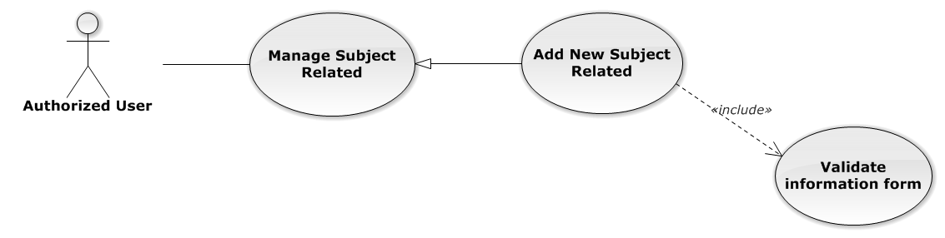

Figure 41: Add New Subject Related Use-Case Diagram

Add New Subject Related Use-Case Specification

|  |  |  |  |
| --- | --- | --- | --- |
| USE-CASE SPECIFICATION | | | |
| Use-case No. | UC0032 | Use-case Version | 1.0 |
| Use-case Name | Add New Subject Related | | |
| Author | Đặng Nguyễn Khiêm | | |
| Date | 09/10/2014 | Priority | Normal |
| Actor:  Authorized User, who is assigned in current case  Summary:  Staff can create new a subject related into case  Goal:  Helps Staff create new a subject easily  Triggers:  Staff click on “Tạo chủ thể” button at the bottom of table  Preconditions:   * Must be logged-in * The page is fully loaded * Must be in “Chủ thể” page * Click on edit icon beside “Chủ thể liên quan” label before   Post Conditions:  Success:   * Add new a subject into Case * Show message assign successfully: “Thêm chủ thể thành công!”   Failure: System display error message “Thêm chủ thể thất bại!”  Main Success Scenario:   |  |  |  | | --- | --- | --- | | *Step* | *User* | *System* | | 1 | Click on edit icon beside “Chủ thể liên quan” label | “Thêm chủ thể mới” button is display | | 2 | Staff click on “Tạo chủ thể” button | Modal popup is displayed with fields for input information of new subject  [Alternative 1] | | 3 | Input corresponding information in form then click “Thêm mới” button  [Exception 1] | * Modal popup is close * System display successful message “Thêm chủ thể thành công!” * Update list subject on page |   Alternative Scenario:   |  |  |  | | --- | --- | --- | | *#* | *User* | *System* | | 1 | Click on [X] button, “Đóng” button, or click out of modal | Modal popup is close |   Exceptions:   |  |  |  | | --- | --- | --- | | *#* | *User* | *System* | | 1 | Leave empty require fields then click on “Thêm mới” button | Modal popup display validation for needed to input field |   Relationships:  Manage Subject Related  Business Rules:   * Only Administrator or Authorized User is assigned in current case can be use this function when status of case is “Đang thụ lý” and Office that have current case must is active. * After create subject successfully, system will be automatically add new subject into that case | | | |

Edit Subject Related

Edit Subject Related Use-Case Diagram

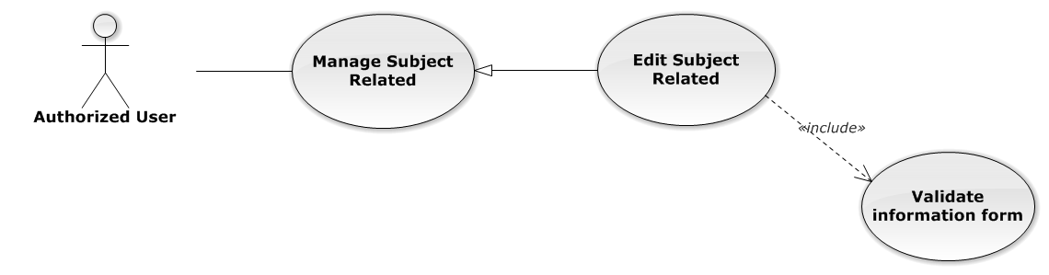

Figure 42: Edit Subject Related Use-Case Diagram

Edit Subject Related Use-Case Specification

|  |  |  |  |
| --- | --- | --- | --- |
| USE-CASE SPECIFICATION | | | |
| Use-case No. | UC0033 | Use-case Version | 1.0 |
| Use-case Name | Edit Subject Related | | |
| Author | Đặng Nguyễn Khiêm | | |
| Date | 09/10/2014 | Priority | Normal |
| Actor:  Authorized User, who is assigned in current case  Summary:  Staff can edit a available subject related  Goal:  Helps Staff edit a available subject information  Triggers:  Staff click on edit icon at the right table  Preconditions:   * Must be logged-in * The page is fully loaded * Must be in “Chủ thể” page * Click on edit icon beside “Chủ thể liên quan” label before   Post Conditions:  Success:   * Edit a subject information * Show message assign successfully: “Cập nhật chủ thể thành công!”   Failure: System display error message “Cập nhật chủ thể thất bại!”  Main Success Scenario:   |  |  |  | | --- | --- | --- | | *Step* | *User* | *System* | | 1 | Click on edit icon beside “Chủ thể liên quan” label | The icon to edit subject is display | | 2 | Staff click on edit icon | Modal popup is displayed with fields for input new information of subject  [Alternative 1] | | 3 | Input corresponding information in form then click “Lưu chỉnh sửa” button  [Exception 1] | * Modal popup is close * System display successful message “Cập nhật chủ thể thành công!” * Update list subject on page |   Alternative Scenario:   |  |  |  | | --- | --- | --- | | *#* | *User* | *System* | | 1 | Click on [X] button, “Đóng” button, or click out of modal | Modal popup is close |   Exceptions:   |  |  |  | | --- | --- | --- | | *#* | *User* | *System* | | 1 | Leave empty require fields then click on “Lưu chỉnh sửa” button | Modal popup display validation for needed to input field |   Relationships:  Manage Subject Related  Business Rules:  Only Administrator or Authorized User is assigned in current case can be use this function when status of case is “Đang thụ lý” and Office that have current case must is active. | | | |

Delete Subject Related

Delete Subject Related Use-Case Diagram

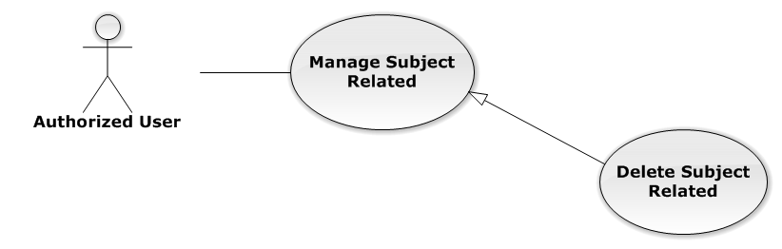

Figure 43: Delete Subject Related Use-Case Diagram

Delete Subject Related Use-Case Specification

|  |  |  |  |
| --- | --- | --- | --- |
| USE-CASE SPECIFICATION | | | |
| Use-case No. | UC0034 | Use-case Version | 1.0 |
| Use-case Name | Delete Subject Related | | |
| Author | Đặng Nguyễn Khiêm | | |
| Date | 09/10/2014 | Priority | Normal |
| Actor:  Authorized User, who is assigned in current case  Summary:  Staff can delete Subject related in Case  Goal:  Helps Staff delete Subject related  Triggers:  Staff click on delete icon in the end table list  Preconditions:   * Must be logged-in * The page is fully loaded * Must be in “Chủ thể” page * Click on edit icon beside “Chủ thể liên quan” label before   Post Conditions:  Success:   * Delete the subject out of current Case * Show message remove successfully: “Xóa chủ thể thành công!”   Failure: System display error message “Xóa chủ thể hàng thất bại!”  Main Success Scenario:   |  |  |  | | --- | --- | --- | | *Step* | *User* | *System* | | 1 | Click on edit icon beside “Chủ thể liên quan” label | Icon delete is display | | 2 | Click on icon delete corresponding with Subject want to delete | Show a modal popup to confirm | | 3 | Click on “Xác nhận” button  [Alternative 1] | System display message “Xóa chủ thể thành công!” |   Alternative Scenario:   |  |  |  | | --- | --- | --- | | *#* | *User* | *System* | | 1 | Click on “Bỏ qua” button | Modal popup is close and system do not remove the Subject |   Exceptions:  N/A  Relationships:  Manage Subject Related  Business Rules:  Only Administrator or Authorized User is assigned in current case can be use this function when status of case is “Đang thụ lý” and Office that have current case must is active. | | | |

###### Manage Document Related

Reference to DVD: <root>/Documents/LFMS Project Document - Full Report.docx

###### Manage Used Service

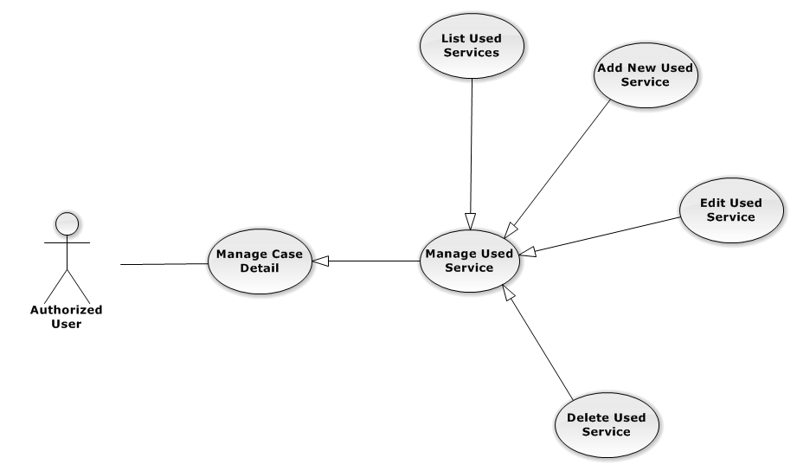

Figure 44: Manage Used Service Use-Case Diagram

List Used Services

List Used Services Use-Case Diagram

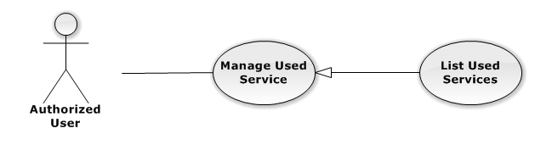

Figure 45: List Used Services Use-Case Diagram

List Used Services Use-Case Specification

|  |  |  |  |
| --- | --- | --- | --- |
| USE-CASE SPECIFICATION | | | |
| Use-case No. | UC0035 | Use-case Version | 1.0 |
| Use-case Name | List Used Services | | |
| Author | Đặng Nguyễn Khiêm | | |
| Date | 09/10/2014 | Priority | Normal |
| Actor:  Authorized User  Summary:  Show all Used Service of case.  Goal:  Help staff to view all Used Service of case.  Triggers:  User click on “Hóa đơn” link in Case Detail page  Preconditions:   * Must be logged-in * The page is fully loaded * Must be in Case Detail page   Post Conditions:  Success:   * List all Used Service in current case include company name and customer name. * Display total money of list Used Service   Failure: Do nothing  Main Success Scenario:   |  |  |  | | --- | --- | --- | | *Step* | *User* | *System* | | 1 | Click on “Hóa đơn” link | Show all Used Service in current case |   Alternative Scenario:  N/A  Exceptions:  N/A  Relationships:  Manage Used Service  Business Rules:  In the end of Used Service table have fill name “Tổng chi phí” display total money of all Used Service.  In the end of table have fill name “Chưa Thanh Toán” display total money of all Used Service. | | | |

Add New Used Service

Add New Used Service Use-Case Diagram

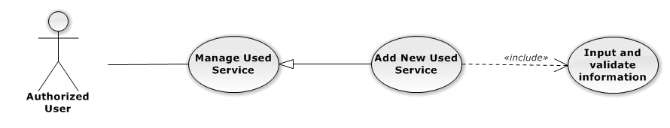

Figure 46: Add New Used Service Use-Case Diagram

Add New Used Service Use-Case Specification

|  |  |  |  |
| --- | --- | --- | --- |
| USE-CASE SPECIFICATION | | | |
| Use-case No. | UC0036 | Use-case Version | 1.0 |
| Use-case Name | Add New Used Service | | |
| Author | Đặng Nguyễn Khiêm | | |
| Date | 09/10/2014 | Priority | Normal |
| Actor:  Authorized User, who is assigned in current case  Summary:  Staff can add new Used Service into Case  Goal:  Helps Staff create event into Case  Triggers:   * Staff click on “Hóa đơn” link in Case Detail page * Click on edit icon beside “Chi phí dịch vụ” button * Click on “Thêm dịch vụ” button to add new Used Service to current case.   Preconditions:   * Must be logged-in * The page is fully loaded * Must be in Used Service page * Click on edit icon beside “Chi phí dịch vụ” label before   Post Conditions:  Success:   * At new Used Service into current Case * Calculation and display the total money of Used Service to “Tổng Chi Phí” field and “Chưa Thanh Toán” fileld. * Show message successfully: “Thêm dịch vụ thành công!”   Failure: System display error message “Thêm dịch vụ thất bại!", "hãy kiểm tra lại kết nối database!”  Main Success Scenario:   |  |  |  | | --- | --- | --- | | *Step* | *User* | *System* | | 1 | Click on edit icon beside “Chi phí dịch vụ” label, click “Thêm dịch vụ” button | Pop-up input is display.  With two button “Đóng” and “Tạo dịch vụ” is display | | 2 | Input information into fields and click button “Tạo mới”  button  [Alternative 1], [Exception 1], [Exception 2] | System display message “Thêm dịch vụ thành công!” |   Alternative Scenario:   |  |  |  | | --- | --- | --- | | *#* | *User* | *System* | | 1 | Click on “Đóng” button | Input form close back to list all Used Service screen. |   Exceptions:   |  |  |  | | --- | --- | --- | | *#* | *User* | *System* | | 1 | Field “Loại Dịch Vụ”, are blank | Shows error message “Nhập vào tên dịch vụ!”. | | Field “Tên Dịch Vụ”, are blank | Shows error message “Chọn dịch vụ!”. | | Field “Chi Phí”, are blank | Shows error message “Nhập chi phí!”. | | Field “Nội dung”, are blank | Shows error message “Nhập nội dung!”. | | 2 | System cannot insert Used Service to data base. | Shows error message “Thêm thanh toán thất bại!", "Hãy kiểm tra lại kết nối database” |   Relationships:  Manage Used Service  Business Rules:  Only Administrator or Authorized User is assigned in current case can be use this function when status of case is “Đang thụ lý” and Office that have current case must is active. | | | |

Edit Used Service

Edit Used Service Use-Case Diagram

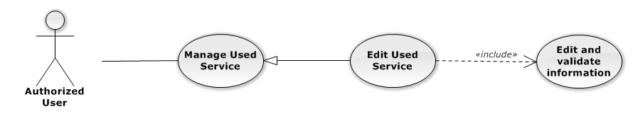

Figure 47: Edit Used Service Use-Case Diagram

Edit Used Service Use-Case Specification

|  |  |  |  |
| --- | --- | --- | --- |
| USE-CASE SPECIFICATION | | | |
| Use-case No. | UC0037 | Use-case Version | 1.0 |
| Use-case Name | Edit Used Service | | |
| Author | Đặng Nguyễn Khiêm | | |
| Date | 09/10/2014 | Priority | Normal |
| Actor:  Authorized User, who is assigned in current case  Summary:  Staff can update Used Service into Case  Goal:  Helps Staff update Used Service into Case  Triggers:   * Staff click on “Hóa đơn” link in Case Detail page * Click on edit icon beside “Chi phí dịch vụ” button * Click on “Edit” button to update event.   Preconditions:   * Must be logged-in * The page is fully loaded * Must be in Used Service page * Click on edit icon beside “Chi phí dịch vụ” label before   Post Conditions:  Success:   * Update Used Service into current Case * Show message successfully: “Sửa dịch vụ thành công!” * Calculation and display the total money of Used Service to “Tổng Chi Phí” field and “Chưa Thanh Toán” fileld   Failure: System display error message “Sửa dịch vụ thất bại!", "hãy kiểm tra lại kết nối database!”  Main Success Scenario:   |  |  |  | | --- | --- | --- | | *Step* | *User* | *System* | | 1 | Click on edit icon beside “Chi phí dịch vụ” label | List all Used Service in current case, “Edit” and “Delete” icon is display, “Thêm dịch vụ” and “Hoàn thành” button is display | | 2 | Click on the “Edit” button | Pop-up “Sửa chi phí” is display load detail of 1 Used Service, “Đóng” and “Sửa chi phí” button is display | | 3 | Edit information into fields and click button “Sửa chi phí” button  [Alternative 1], [Exception 1], [Exception 2] | System display message “Sửa dịch vụ thành công!” |   Alternative Scenario:   |  |  |  | | --- | --- | --- | | *#* | *User* | *System* | | 1 | Click on “Đóng” button | Input form close back to list all event screen. |   Exceptions:   |  |  |  | | --- | --- | --- | | *#* | *User* | *System* | | 1 | Field “Chi Phí”, are blank | Shows error message “Nhập chi phí!”. | | Field “Nội dung”, are blank | Shows error message “Nhập nội dung!”. | | 2 | System cannot insert event to data base. | Shows error message “Sửa dịch vụ thất bại!", "Hãy kiểm tra lại kết nối database”. |   Relationships:  Manage Used Service  Business Rules:  Only Administrator or Authorized User is assigned in current case can be use this function when status of case is “Đang thụ lý” and Office that have current case must is active. | | | |

Delete Used Service

Delete Used Service Use-Case Diagram

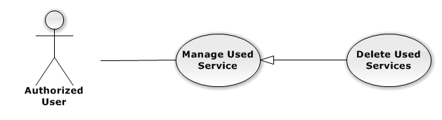

Figure 48: Delete Used Service Use-Case Diagram

Delete Used Service Use-Case Specification

|  |  |  |  |
| --- | --- | --- | --- |
| USE-CASE SPECIFICATION | | | |
| Use-case No. | UC0038 | Use-case Version | 1.0 |
| Use-case Name | Delete Used Service | | |
| Author | Đặng Nguyễn Khiêm | | |
| Date | 09/10/2014 | Priority | Normal |
| Actor:  Authorized User, who is assigned in current case  Summary:  Staff can remove Used Service in Case  Goal:  Helps Staff remove Used Service in Case  Triggers:  Staff click on delete icon in the end table list  Preconditions:   * Must be logged-in * The page is fully loaded * Must be in Lawyer related page * Click on edit icon beside “Chi phí dịch vụ” label before   Post Conditions:  Success:   * Remove the Event out of current Case * Show message remove successfully: “Xóa dịch vụ thành công!” * Calculation and display the total money of Used Service to “Tổng Chi Phí” field and “Chưa Thanh Toán” fileld   Failure: System display error message “Xóa dịch vụ thất bại!", "Hãy kiểm tra lại kết nối database”  Main Success Scenario:   |  |  |  | | --- | --- | --- | | *Step* | *User* | *System* | | 1 | Click on edit icon beside “Chi phí dịch vụ” label | Icon delete is display | | 2 | Click on icon delete corresponding with Used Service want to remove | Show a modal popup to confirm | | 3 | Click on “Xác nhận” button  [Alternative 1] | System display message “Xóa dịch vụ thành công!” |   Alternative Scenario:   |  |  |  | | --- | --- | --- | | *#* | *User* | *System* | | 1 | Click on “Bỏ qua” button | Modal popup is close and system do not remove the Event |   Exceptions:  N/A  Relationships:  Manage Used Service  Business Rules:  Only Administrator or Authorized User is assigned in current case can be use this function when status of case is “Đang thụ lý” and Office that have current case must is active. | | | |

###### Manage Payment

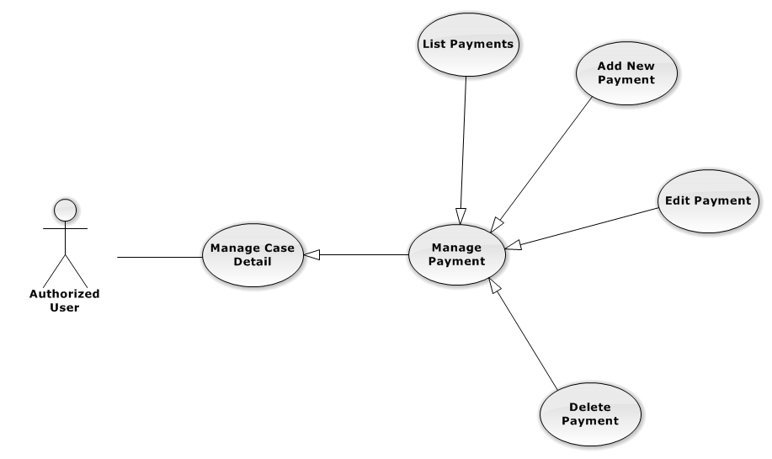

Figure 49: Manage Payment Use-Case Diagram

List Payments

List Payments Use-Case Diagram

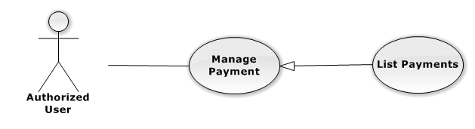

Figure 50: List Payments Use-Case Diagram

List Payments Use-Case Specification

|  |  |  |  |
| --- | --- | --- | --- |
| USE-CASE SPECIFICATION | | | |
| Use-case No. | UC0039 | Use-case Version | 1.0 |
| Use-case Name | List Payments | | |
| Author | Đặng Nguyễn Khiêm | | |
| Date | 09/10/2014 | Priority | Normal |
| Actor:  Authorized User  Summary:  Show all payment of case.  Goal:  Help staff to view all payment of case.  Triggers:  User click on “Hóa đơn” link in Case Detail page  Preconditions:   * Must be logged-in * The page is fully loaded * Must be in Case Detail page   Post Conditions:  Success:   * List all payment in current case include * Display total money of list payment.   Failure: Do nothing  Main Success Scenario:   |  |  |  | | --- | --- | --- | | *Step* | *User* | *System* | | 1 | Click on “Hóa đơn” link [Alternative 1], [Alternative 2] | Show all payment in current case |   Alternative Scenario:   |  |  |  | | --- | --- | --- | | *#* | *User* | *System* | | 1 | If total Payment > total Used Services | Display total money Unpaid in field “Số dư” | | 2 | If total Payment < total Used Services | Display total money balance in field “Chưa thanh toán” |   Exceptions:  N/A  Relationships:  Manage Payment  Business Rules:  In the end of Used Service table have fill name “Tổng chi phí” display total money of all Used Service. | | | |

Add New Payment

Add New Payment Use-Case Diagram

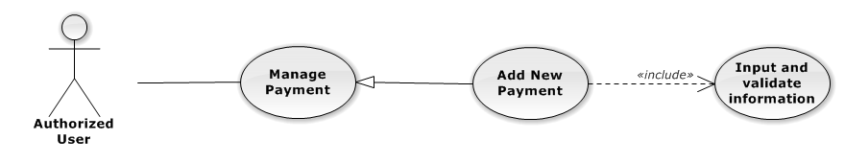

Figure 51: Add New Payment Use-Case Diagram

Add New Payment Use-Case Specification

|  |  |  |  |
| --- | --- | --- | --- |
| USE-CASE SPECIFICATION | | | |
| Use-case No. | UC0040 | Use-case Version | 1.0 |
| Use-case Name | Add New Payment | | |
| Author | Đặng Nguyễn Khiêm | | |
| Date | 09/10/2014 | Priority | High |
| Actor:  Authorized User, who is assigned in current case  Summary:  Staff can add new payment into Case  Goal:  Helps Staff create payment into Case  Triggers:   * Staff click on “Hóa đơn” link in Case Detail page * Click on edit icon beside “Hóa đơn thanh toán” button * Click on “Thêm thanh toán button to add new payment to current case.   Preconditions:   * Must be logged-in * The page is fully loaded * Must be in payment page * Click on edit icon beside “Hóa đơn thanh toán” label before   Post Conditions:  Success:   * At new Used Service into current Case * Calculation and display the total money of Payment and display total of money unpaid or balancein field “Chưa thanh toán” , “Số dư”. * Show message successfully: “Thêm thanh toán thành công!”   Failure: System display error message “Thêm thanh toán thất bại!", "hãy kiểm tra lại kết nối database!”  Main Success Scenario:   |  |  |  | | --- | --- | --- | | *Step* | *User* | *System* | | 1 | Click on edit icon beside “Hóa đơn thanh toán” label, click “Thêm thanh toán” button | Pop-up input is display. | | 2 | Input information into fields and click button “Tạo thanh toán” button  [Alternative 1], [Exception 1], [Exception 2] | System display message “Thêm thanh toán thành công!” |   Alternative Scenario:   |  |  |  | | --- | --- | --- | | *#* | *User* | *System* | | 1 | Click on “Đóng” button | Input form close back to list all Used Service screen. |   Exceptions:   |  |  |  | | --- | --- | --- | | *#* | *User* | *System* | | 1 | Field “Thanh Toán”, are blank | Shows error message “Nhập số tiền thanh toán!”. | | Field “Nội dung”, are blank | Shows error message “Nhập nội dung!”. | | 2 | System cannot insert payment to data base. | Shows error message “Thêm thanh toán thất bại!", "Hãy kiểm tra lại kết nối database” |   Relationships:  Manage Payment  Business Rules:  Only Administrator or Authorized User is assigned in current case can be use this function when status of case is “Đang thụ lý” and Office that have current case must is active. | | | |

Edit Payment

Edit Payment Use-Case Diagram

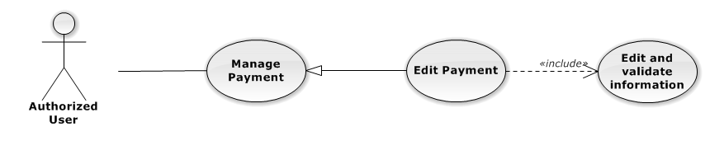

Figure 52: Edit Payment Use-Case Diagram

Edit Payment Use-Case Specification

|  |  |  |  |
| --- | --- | --- | --- |
| USE-CASE SPECIFICATION | | | |
| Use-case No. | UC0041 | Use-case Version | 1.0 |
| Use-case Name | Edit Payment | | |
| Author | Đặng Nguyễn Khiêm | | |
| Date | 09/10/2014 | Priority | Normal |
| Actor:  Authorized User, who is assigned in current case  Summary:  Staff can update payment service into Case  Goal:  Helps Staff update payment service into Case  Triggers:   * Staff click on “Hóa đơn” link in Case Detail page * Click on edit icon beside “Hóa đơn thanh toán” button * Click on “Edit” button to update event.   Preconditions:   * Must be logged-in * The page is fully loaded * Must be in Used Service page * Click on edit icon beside “Hóa đơn thanh toán” label before   Post Conditions:  Success:   * Update Used Service into current Case * Show message successfully: “Sửa thanh toán thành công!” * Calculation and display the total money of Payment and display total of money unpaid or balancein field “Chưa thanh toán” , “Số dư”.   Failure: System display error message “Sửa thanh toán thất bại!", "hãy kiểm tra lại kết nối database!”  Main Success Scenario:   |  |  |  | | --- | --- | --- | | *Step* | *User* | *System* | | 1 | Click on edit icon beside “Hóa đơn thanh toán” label | List all payment in current case, “Edit” and “Delete” icon is display, “Thêm dịch vụ” and “Hoàn thành” button is display | | 2 | Click on the “Edit” button | Pop-up “Sửa thanh toán” is display load detail of 1 Used Service, “Đóng” and “Sửa chi phí” button is display | | 3 | Edit information into fields and click button “Sửa thanh toán” button  [Alternative 1], [Exception 1] ,[Exception 2] | System display message “Sửa thanh toán thành công!” |   Alternative Scenario:   |  |  |  | | --- | --- | --- | | *#* | *User* | *System* | | 1 | Click on “Đóng” button | Input form close back to list all event screen. |   Exceptions:   |  |  |  | | --- | --- | --- | | *#* | *User* | *System* | | 1 | Field “Thanh Toán”, are blank | Shows error message “Nhập số tiền thanh toán!”. | | Field “Nội dung”, are blank | Shows error message “Nhập nội dung!”. | | 2 | System cannot insert event to data base. | Shows error message “Sửa thanh toán thất bại!", "Hãy kiểm tra lại kết nối database”. |   Relationships:  Manage Payment  Business Rules:  Only Administrator or Authorized User is assigned in current case can be use this function when status of case is “Đang thụ lý” and Office that have current case must is active. | | | |

Delete Payment

Delete Payment Use-Case Diagram

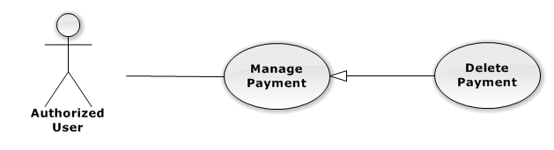

Figure 53: Delete Payment Use-Case Diagram

Delete Payment Use-Case Specification

|  |  |  |  |
| --- | --- | --- | --- |
| USE-CASE SPECIFICATION | | | |
| Use-case No. | UC0042 | Use-case Version | 1.0 |
| Use-case Name | Delete Payment | | |
| Author | Đặng Nguyễn Khiêm | | |
| Date | 09/10/2014 | Priority | Normal |
| Actor:  Authorized User, who is assigned in current case  Summary:  Staff can remove payment in Case  Goal:  Helps Staff remove payment in Case  Triggers:  Staff click on delete icon in the end table list  Preconditions:   * Must be logged-in * The page is fully loaded * Must be in Lawyer related page * Click on edit icon beside “Hóa đơn thanh toán” label before   Post Conditions:  Success:   * Remove the Event out of current Case * Show message remove successfully: “Xóa thanh toán thành công!” * Calculation and display the total money of payment   Failure: System display error message “Xóa thanh toán thất bại!", "Hãy kiểm tra lại kết nối database”  Main Success Scenario:   |  |  |  | | --- | --- | --- | | *Step* | *User* | *System* | | 1 | Click on edit icon beside “Chi phí dịch vụ” label | Icon delete is display | | 2 | Click on icon delete corresponding with Used Service want to remove | Show a modal popup to confirm | | 3 | Click on “Xác nhận” button  [Alternative 1] | System display message “Xóa thanh toán thành công!” |   Alternative Scenario:   |  |  |  | | --- | --- | --- | | *#* | *User* | *System* | | 1 | Click on “Bỏ qua” button | Modal popup is close and system do not remove the Event |   Exceptions:  N/A  Relationships:  Manage Payment  Business Rules:  Only Administrator or Authorized User is assigned in current case can be use this function when status of case is “Đang thụ lý” and Office that have current case must is active. | | | |

#### Manage Customer Group

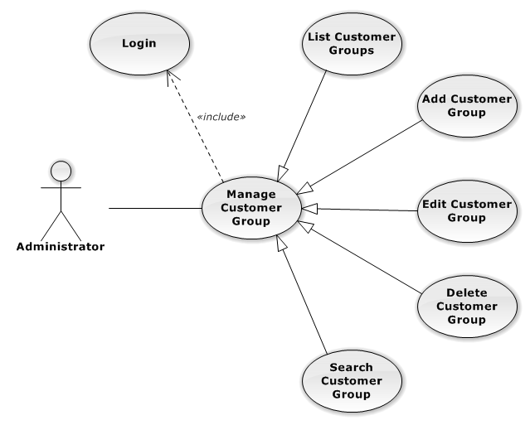

Figure 54: Manage Customer Group Use-Case Diagram

##### List Customer Groups

###### List Customer Groups Use-Case Diagram

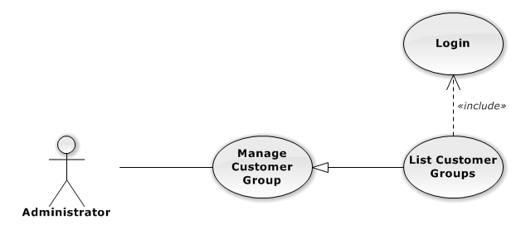

Figure 55: List Customer Groups Use-Case Diagram

###### List Customer Groups Use-Case Specification

|  |  |  |  |
| --- | --- | --- | --- |
| USE CASE SPECIFICATION | | | |
| Use-case No. | UC0046 | Use-case Version | 1.0 |
| Use-case Name | List Customer Groups | | |
| Author | Đặng Nguyễn Khiêm | | |
| Date | 09/10/2014 | Priority | Normal |
| Actor:  Administrator  Summary:  List All Customer Group.  Goal:  The purpose of List Customer Group use case is allowing Admin to view all Customer Groups.  Triggers:  User choose “Quản lý Nhóm Khách Hàng” in menu.  Preconditions:  User is authenticated and has role “admin”.  The page is fully loaded.  Post Conditions:  Success: All Customer Groups are listed.  Failure: N/A  Main Success Scenario:   |  |  |  | | --- | --- | --- | | *Step* | *User* | *System* | | 1 | Click “Quản lý Nhóm Khách Hàng” in menu. | All Customer Groups are loaded. |   Alternative Scenario:  N/A  Exceptions:  N/A  Relationships:  Manage Customer Group  Business Rules:  N/A | | | |

##### Add New Customer Group

###### Add New Customer Group Use-Case Diagram

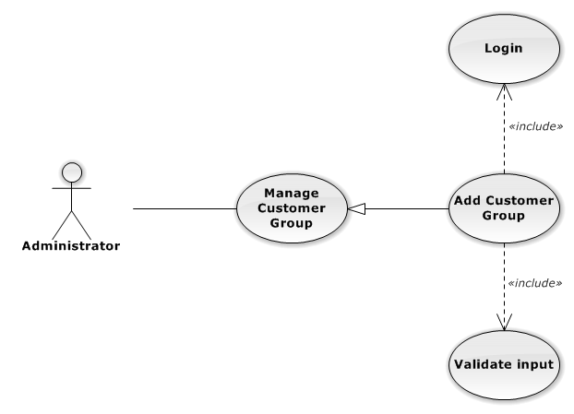

Figure 56: Add New Customer Group Use-Case Diagram

###### Add New Customer Group Use-Case Specification

|  |  |  |  |
| --- | --- | --- | --- |
| USE CASE SPECIFICATION | | | |
| Use-case No. | UC0047 | Use-case Version | 1.0 |
| Use-case Name | Add Customer Group | | |
| Author | Đặng Nguyễn Khiêm | | |
| Date | 09/10/2014 | Priority | Normal |
| Actor:  Administrator  Summary:  Add new Customer Group.  Goal:  The purpose of Add Customer Group use case is allowing Admin to add new Customer Group.  Triggers:  User choose “Quản lý Nhóm Khách Hàng” in menu.  Preconditions:  User is authenticated and has role “admin”.  Post Conditions:  Success: New Customer Group is created.  Failure: No Customer Group is created and Error message will be showed.  Main Success Scenario:   |  |  |  | | --- | --- | --- | | *Step* | *User* | *System* | | 1 | Click “Thêm Nhóm Khách Hàng” button. | Show add new customer group pop-up. | | 2 | Enters the Customer Group Name and Description |  | | 3 | Presses “Thêm Nhóm Khách Hàng” button.  [Alternative: 1] | Checks validate, add new Customer Group to database.  Show success message.  [Exception: 1]  [Exception: 2]  [Exception: 3] |   Alternative Scenario:   |  |  |  | | --- | --- | --- | | *#* | *User* | *System* | | 1 | Presses “Đóng”, “X” button or click outside pop-up. | The Add New Customer Group pop-up is close. |   Exceptions:   |  |  |  | | --- | --- | --- | | *#* | *User* | *System* | | 1 | Customer Group Name is missing. | Show error “Nhập tên nhóm khách hang” to user. | | 2 | Add Customer group fail. | The Add New Customer Group is closed and display error message “Tạo nhóm khách hàng thất bại!", "Hãy kiểm tra lại kết nối database." | | 3 | Add Customer group error. | The Add New Customer Group is closed and display error message "Tạo nhóm khách hàng thất bại!", "Có lỗi xảy ra trong quá trình tạo nhóm khách hàng." |   Relationships:  Manage Customer Group  Business Rules:  N/A | | | |

##### Edit Customer Group

###### Edit Customer Group Use-Case Diagram

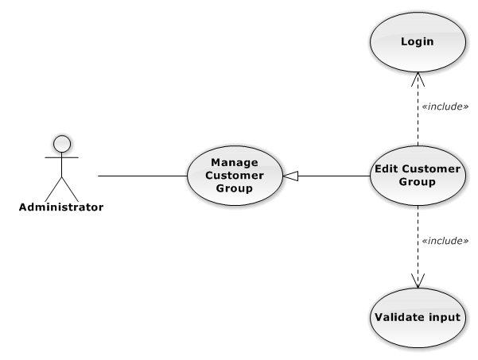

Figure 57: Edit Customer Group Use-Case Diagram

###### Edit Customer Group Use-Case Specification

|  |  |  |  |
| --- | --- | --- | --- |
| USE CASE SPECIFICATION | | | |
| Use-case No. | UC0048 | Use-case Version | 1.0 |
| Use-case Name | Delete Customer Group | | |
| Author | Đặng Nguyễn Khiêm | | |
| Date | 09/10/2014 | Priority | Normal |
| Actor:  Administrator  Summary:  Update Customer Group.  Goal:  The purpose of Update Customer Group use case is allowing Admin to update Customer Group.  Triggers:  User choose “Quản lý Nhóm Dịch Vụ” in menu.  Preconditions:  User is authenticated and has role “admin”.  Post Conditions:  Success: The Customer Group id Updated.  Failure: The Customer Group is not updated and Error message will be showed.  Main Success Scenario:   |  |  |  | | --- | --- | --- | | *Step* | *User* | *System* | | 1 | Click Update icon. |  | | 2 | Enters the new Customer Group Name and Description |  | | 3 | Presses “Lưu chỉnh sửa” button.  [Alternative: 1] | Checks validate, update Customer Group to database.  Show success message.  [Exception: 1]  [Exception: 2]  [Exception: 3] |   Alternative Scenario:   |  |  |  | | --- | --- | --- | | *#* | *User* | *System* | | 1 | Presses “Đóng”, “X” button or click outside pop-up. | The Update Customer Group pop-up is close. |   Exceptions:   |  |  |  | | --- | --- | --- | | *#* | *User* | *System* | | 1 | Customer Group Name is missing. | Show error “Nhập tên nhóm khách hàng” to user. | | 2 | Update Customer group fail. | The Update Customer Group is closed and display error message “Chỉnh sửa nhóm khách hàng thất bại!", "Hãy kiểm tra lại kết nối database." | | 3 | Update Customer group error. | The Update Customer Group is closed and display error message "Chỉnh sửa nhóm khách hàng thất bại!", "Có lỗi xảy ra trong quá trình tạo nhóm khách hàng." |   Relationships:  Manage Customer Group  Business Rules:  N/A | | | |

##### Delete Customer Group

###### Delete Customer Group Use-Case Diagram

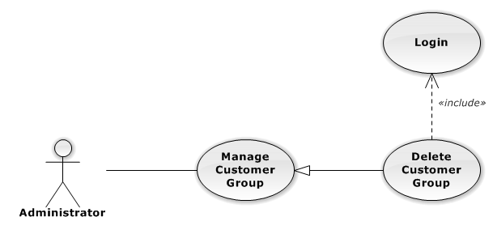

Figure 58: Delete Customer Group Use-Case Diagram

###### Delete Customer Group Use-Case Specification

|  |  |  |  |
| --- | --- | --- | --- |
| USE CASE SPECIFICATION | | | |
| Use-case No. | UC0049 | Use-case Version | 1.0 |
| Use-case Name | Delete Customer Group | | |
| Author | Đặng Nguyễn Khiêm | | |
| Date | 09/10/2014 | Priority | Normal |
| Actor:  Administrator  Summary:  Delete Customer Group.  Goal:  The purpose of Delete Customer Group use case is allowing Admin to delete Customer Group.  Triggers:  User choose “Quản lý Nhóm Khách Hàng” in menu.  Preconditions:  User is authenticated and has role “admin”.  Post Conditions:  Success: The Customer Group is deleted.  Failure: The Customer Group is not delete and Error message will be showed.  Main Success Scenario:   |  |  |  | | --- | --- | --- | | *Step* | *User* | *System* | | 1 | Click Delete icon. | Show confirm pop-up | | 2 | Presses “Đồng ý” button.  [Alternative: 1] | Delete Customer Group from database.  Show success message.  [Exception: 1]  [Exception: 2] |   Alternative Scenario:   |  |  |  | | --- | --- | --- | | *#* | *User* | *System* | | 1 | Presses “Đóng”, “X” button or click outside pop-up. | The confirm pop-up is close. |   Exceptions:   |  |  |  | | --- | --- | --- | | *#* | *User* | *System* | | 1 | Delete Customer group fail. | The Add New Customer Group is closed and display error message “Xóa nhóm khách hàng thất bại!", "Hãy kiểm tra lại kết nối database." | | 2 | Delete Customer group error. | The Add New Customer Group is closed and display error message "Xóa nhóm khách hàng thất bại!", "Có lỗi xảy ra trong quá xóa nhóm khách hàng." |   Relationships:  Manage Customer Group  Business Rules:  N/A | | | |

##### Search Customer Group

###### Search Customer Group Use-Case Diagram

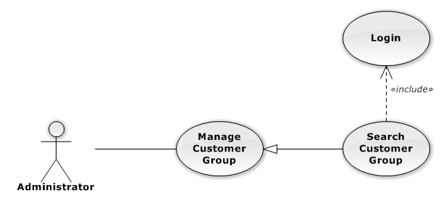

Figure 59: Search Customer Group Use-Case Diagram

###### Search Customer Group Use-Case Specification

|  |  |  |  |
| --- | --- | --- | --- |
| USE CASE SPECIFICATION | | | |
| Use-case No. | UC0050 | Use-case Version | 1.0 |
| Use-case Name | Search Customer Group | | |
| Author | Đặng Nguyễn Khiêm | | |
| Date | 09/10/2014 | Priority | Normal |
| Actor:  Administrator  Summary:  Search Customer Group.  Goal:  The purpose of Search Customer Group use case is allowing Admin to search Customer.  Triggers:  User choose “Quản lý Nhóm khách hàng” in menu.  Preconditions:  User is authenticated and has role “admin”.  Post Conditions:  Success: List of Customer Group with search key words is displayed.  Failure: No record is displayed.  Main Success Scenario:   |  |  |  | | --- | --- | --- | | *Step* | *User* | *System* | | 1 | In “Quản lý Nhóm khách hàng” screen, input key word at “Tìm kiếm” textbox. | List of Customer Group with search key words is displayed. |   Alternative Scenario:  N/A  Exceptions:  N/A  Relationships:  Manage Customer Group  Business Rules:  N/A | | | |

#### Manage Customer

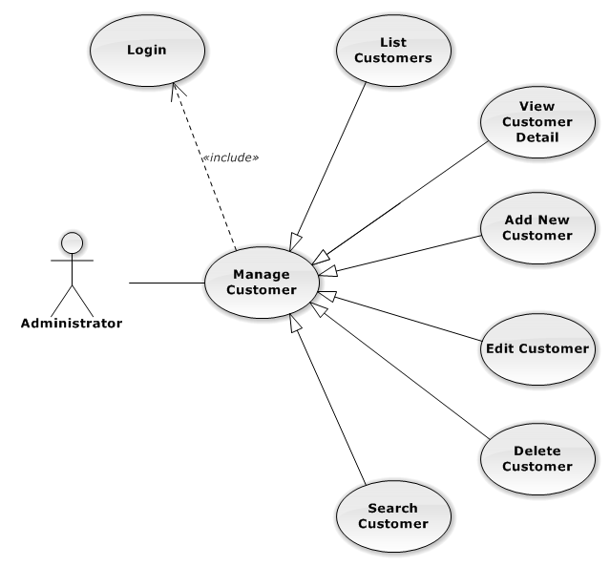

Figure 60: Manage Customer Use-Case Diagram

##### List Customers

###### List Customers Use-Case Diagram

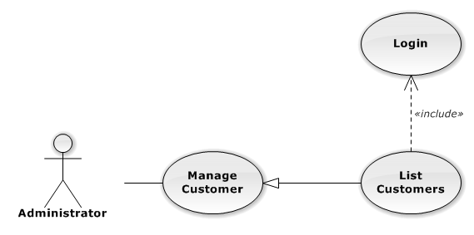

Figure 61: List Customers Use-Case Diagram

###### List Customers Use-Case Specification

|  |  |  |  |
| --- | --- | --- | --- |
| USE CASE SPECIFICATION | | | |
| Use-case No. | UC0051 | Use-case Version | 1.0 |
| Use-case Name | List Customers | | |
| Author | Đặng Nguyễn Khiêm | | |
| Date | 09/10/2014 | Priority | Normal |
| Actor:  Administrator  Summary:  List All Customer.  Goal:  The purpose of List Customers use case is allowing Admin to view all Customers.  Triggers:  User choose “Quản lý Khách Hàng” in menu.  Preconditions:  User is authenticated and has role “admin”.  The page is fully loaded.  Post Conditions:  Success: All Customer is listed.  Failure: N/A  Main Success Scenario:   |  |  |  | | --- | --- | --- | | *Step* | *User* | *System* | | 1 | Click “Quản lý Khách Hàng” in menu. | All Customers are loaded. |   Alternative Scenario:  N/A  Exceptions:  N/A  Relationships:  Manage Customer  Business Rules:  N/A | | | |

##### View Customer Detail

###### View Customer Detail Use-Case Diagram

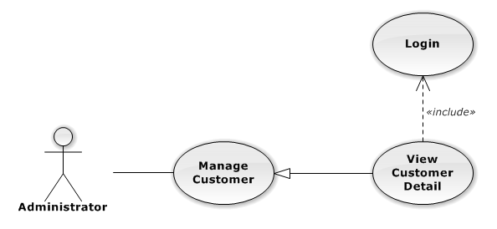

Figure 62: View Customer Detail Use-Case Diagram

###### View Customer Detail Use-Case Specification

|  |  |  |  |
| --- | --- | --- | --- |
| USE CASE SPECIFICATION | | | |
| Use-case No. | UC0052 | Use-case Version | 1.0 |
| Use-case Name | View Customer Detail | | |
| Author | Đặng Nguyễn Khiêm | | |
| Date | 09/10/2014 | Priority | Normal |
| Actor:  Administrator  Summary:  View Customer Detail.  Goal:  The purpose of View Customer Detail use case is allowing Admin to view a Customer detail.  Triggers:  User choose “Quản lý Khách Hàng” in menu. Then click “View detail” icon.  Preconditions:  User is authenticated and has role “admin”.  Post Conditions:  Success: Customer Detail is showed.  Failure: Do nothing.  Main Success Scenario:   |  |  |  | | --- | --- | --- | | *Step* | *User* | *System* | | 1 | In Manage Customer page, click “View detail” icon | The Customer Detail is showed. |   Alternative Scenario:  N/A  Exceptions:  N/A  Relationships:  Manage Customer  Business Rules:  N/A | | | |

##### Add New Customer

###### Add New Customer Use-Case Diagram

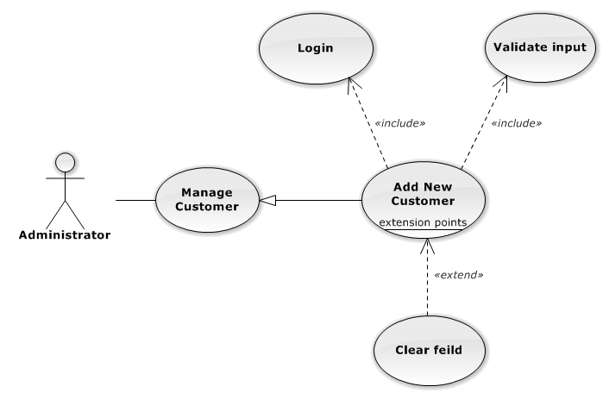

Figure 63: Add New Customer Use-Case Diagram

###### Add New Customer Use-Case Specification

|  |  |  |  |
| --- | --- | --- | --- |
| USE CASE SPECIFICATION | | | |
| Use-case No. | UC0053 | Use-case Version | 1.0 |
| Use-case Name | Add New Customer | | |
| Author | Đặng Nguyễn Khiêm | | |
| Date | 09/10/2014 | Priority | Normal |
| Actor:  Administrator  Summary:  Add Customer.  Goal:  The purpose of Add Customer use case is allowing Admin to add new Customer.  Triggers:  User choose “Quản lý Khách Hàng” in menu.  Preconditions:  User is authenticated and has role “admin”.  Post Conditions:  Success: New Customer is created.  Failure: No Customer is created and Error message will be showed.  Main Success Scenario:   |  |  |  | | --- | --- | --- | | *Step* | *User* | *System* | | 1 | Click “Thêm Khách Hàng” button. | Show add Customer pop-up. | | 2 | Enters the Customer detail. |  | | 3 | Presses “Thêm Khách Hàng” button.  [Alternative: 1] | Checks validate, add new Customer to database.  Show success message.  [Exception: 1]  [Exception: 2]  [Exception: 3] |   Alternative Scenario:   |  |  |  | | --- | --- | --- | | *#* | *User* | *System* | | 1 | Presses “Đóng”, “X” button or click outside pop-up. | The Add New Customer pop-up is close. |   Exceptions:   |  |  |  | | --- | --- | --- | | *#* | *User* | *System* | | 1 | Customer Name is missing. | Show error “"Nhập tên khách hàng!" to user. | | Represent-Person is missing. | Show error “"Nhập tên người đại diện!” to user. | | Customer Group is not chosen. | Show error “"Chọn nhóm khách hàng!” to user. | | Address is missing. | Show error “"Nhập địa chỉ!" to user. | | Email format is wrong. | Show error “Email chưa đúng định dạng!" to user. | | Mobile is missing. | Show error “Nhập số điện thoại di động!” to user. | | 2 | Add Customer fail. | The Add New Customer is closed and display error message “Tạo khách hàng thất bại!", "Hãy kiểm tra lại kết nối database." | | 3 | Add Customer error. | The Add New Customer is closed and display error message "Tạo khách hàng thất bại!", "Có lỗi xảy ra trong quá trình tạo khách hàng." |   Relationships:  Manage Customer  Business Rules:  N/A | | | |

##### Edit Customer

###### Edit Customer Use-Case Diagram

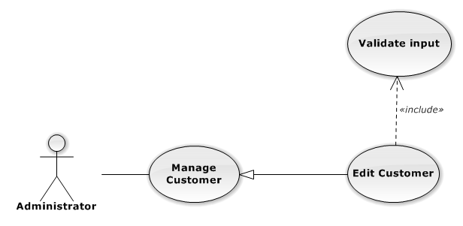

Figure 64: Edit Customer Use-Case Diagram

###### Edit Customer Use-Case Specification

|  |  |  |  |
| --- | --- | --- | --- |
| USE CASE SPECIFICATION | | | |
| Use-case No. | UC0054 | Use-case Version | 1.0 |
| Use-case Name | Edit Customer | | |
| Author | Đặng Nguyễn Khiêm | | |
| Date | 09/10/2014 | Priority | Normal |
| Actor:  Administrator  Summary:  Update Customer.  Goal:  The purpose of Update Customer use case is allowing Admin to update Customer.  Triggers:  User choose “Quản lý Khách Hàng” in menu.  Preconditions:  User is authenticated and has role “admin”.  Post Conditions:  Success: The Customer is Updated.  Failure: The Customer is not updated and Error message will be showed.  Main Success Scenario:   |  |  |  | | --- | --- | --- | | *Step* | *User* | *System* | | 1 | Click Update icon. | Show update Customer pop-up. | | 2 | Enters the new Customer’s detail. |  | | 3 | Presses “Lưu chỉnh sửa” button.  [Alternative: 1] | Checks validate, update Customer to database.  Show success message.  [Exception: 1]  [Exception: 2]  [Exception: 3] |   Alternative Scenario:   |  |  |  | | --- | --- | --- | | *#* | *User* | *System* | | 1 | Presses “Đóng”, “X” button or click outside pop-up. | The Update Customer pop-up is close. |   Exceptions:   |  |  |  | | --- | --- | --- | | *#* | *User* | *System* | | 1 | Customer Name is missing. | Show error “"Nhập tên khách hàng!" to user. | | Represent-Person is missing. | Show error “"Nhập tên người đại diện!” to user. | | Customer Group is not chosen. | Show error “"Chọn nhóm khách hàng!” to user. | | Address is missing. | Show error “"Nhập địa chỉ!" to user. | | Email format is wrong. | Show error “Email chưa đúng định dạng!" to user. | | Mobile is missing. | Show error “Nhập số điện thoại di động!” to user. | | 2 | Update Customer fail. | The Update Customer pop-up is closed and display error message “Chỉnh sửa khách hàng thất bại!", "Hãy kiểm tra lại kết nối database." | | 3 | Update Customer error. | The Update Customer pop-up is closed and display error message "Chỉnh sửa khách hàng thất bại!", "Có lỗi xảy ra trong quá trình chỉnh sửa khách hàng." |   Relationships:  Manage Customer  Business Rules:  N/A | | | |

##### Delete Customer

###### Delete Customer Use-Case Diagram

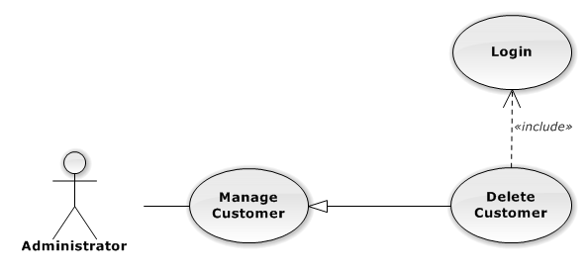

Figure 65: Delete Customer Use-Case Diagram

###### Delete Customer Use-Case Specification

|  |  |  |  |
| --- | --- | --- | --- |
| USE CASE SPECIFICATION | | | |
| Use-case No. | UC0055 | Use-case Version | 1.0 |
| Use-case Name | Delete Customer | | |
| Author | Đặng Nguyễn Khiêm | | |
| Date | 09/10/2014 | Priority | Normal |
| Actor:  Administrator  Summary:  Delete Customer.  Goal:  The purpose of Delete Customer use case is allowing Admin to delete Customer.  Triggers:  User choose “Quản lý Khách Hàng” in menu.  Preconditions:  User is authenticated ans has role “admin”.  Post Conditions:  Success: The Customer is deleted.  Failure: The Customer is not delete and Error message will be showed.  Main Success Scenario:   |  |  |  | | --- | --- | --- | | *Step* | *User* | *System* | | 1 | Click Delete icon. | Show confirm pop-up | | 2 | Presses “Đồng ý” button.  [Alternative: 1] | Delete Customer from database.  Show success message.  [Exception: 1]  [Exception: 2] |   Alternative Scenario:   |  |  |  | | --- | --- | --- | | *#* | *User* | *System* | | 1 | Presses “Đóng”, “X” button or click outside pop-up. | The confirm pop-up is close. |   Exceptions:   |  |  |  | | --- | --- | --- | | *#* | *User* | *System* | | 1 | Delete Customer fail. | The confirm pop-up is closed and display error message “Xóa nhóm dịch vụ thất bại!", "Hãy kiểm tra lại kết nối database." | | 2 | Delete Customer error. | The confirm pop-up is closed and display error message “Xóa nhóm dịch vụ thất bại!", "Có lỗi xảy ra trong quá trình xóa khách hàng." |   Relationships:  Manage Customer  Business Rules:  N/A | | | |

##### Search Customer

###### Search Customer Use-Case Diagram

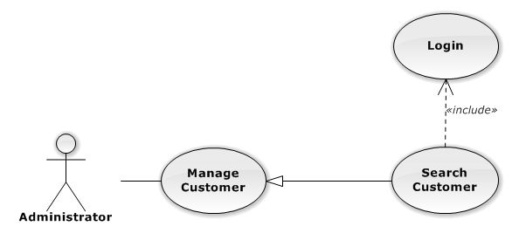

Figure 66: Search Customer Use-Case Diagram

###### Search Customer Use-Case Specification

|  |  |  |  |
| --- | --- | --- | --- |
| USE CASE SPECIFICATION | | | |
| Use-case No. | UC0056 | Use-case Version | 1.0 |
| Use-case Name | Search Customer | | |
| Author | Đặng Nguyễn Khiêm | | |
| Date | 09/10/2014 | Priority | Normal |
| Actor:  Administrator  Summary:  Search Customer.  Goal:  The purpose of Search Customer use case is allowing Admin to search Customer.  Triggers:  User choose “Quản lý Khách hàng” in menu.  Preconditions:  User is authenticated and has role “admin”.  Post Conditions:  Success: List of Customer with search key words is displayed.  Failure: No record is displayed.  Main Success Scenario:   |  |  |  | | --- | --- | --- | | *Step* | *User* | *System* | | 1 | In “Quản lý Khách hàng” screen, input key word at “Tìm kiếm” textbox. | List of Customer with search key words is displayed. |   Alternative Scenario:  N/A  Exceptions:  N/A  Relationships:  N/A  Business Rules:  N/A | | | |

#### Manage Staff Group

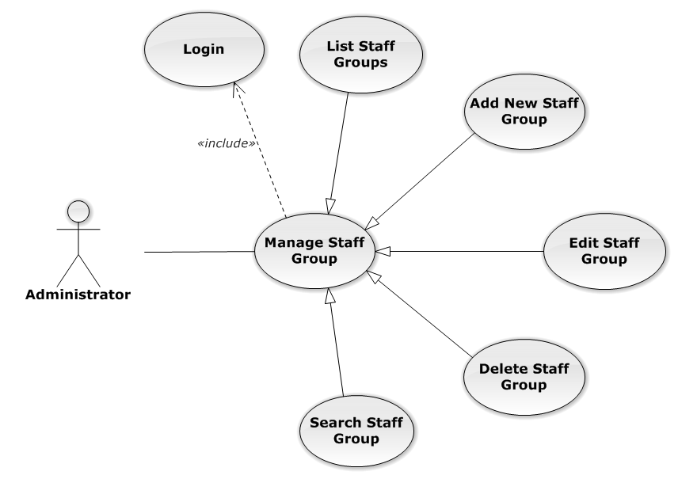

Figure 67: Manage Staff Group Use-Case Diagram

##### List Staff Groups

###### List Staff Groups Use-Case Diagram

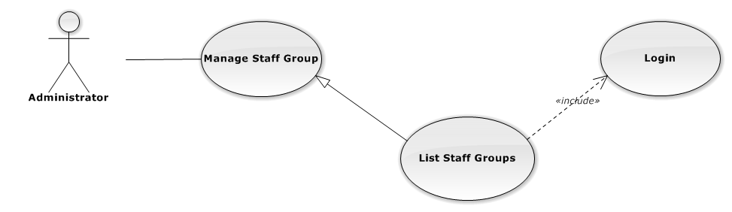

Figure 68: List Staff Groups Use-Case Diagram

###### List Staff Groups Use-Case Specification

|  |  |  |  |
| --- | --- | --- | --- |
| USE-CASE SPECIFICATION | | | |
| Use-case No. | UC0057 | Use-case Version | 1.0 |
| Use-case Name | List Staff Groups | | |
| Author | Đặng Nguyễn Khiêm | | |
| Date | 09/10/2014 | Priority | Normal |
| Actor:  Administrator  Summary:  Redirect user to “Quản lí nhóm nhân viên” page and list all staff group.  Goal:  To allowing Administrator view any detail information of all staff group.  Triggers:   * User click on User Control Panel and then click on “Quản lí nhân viên” link * On sub menu click on “nhóm nhân viên”.   Preconditions:   * Must be logged-in with “Admin” role. * The page is fully loaded   Post Conditions:  Success: System redirects user to “Quản lí nhóm nhân viên” page.  Failure: Do nothing.  Main Success Scenario:   |  |  |  | | --- | --- | --- | | *Step* | *User* | *System* | | 1 | Click on “Quản lí nhóm nhân viên” link | Redirect to “Quản lí nhóm nhân viên” page  Show all staff group. |   Alternative Scenario:  N/A  Exceptions:  N/A  Relationships:  Manage Staff Group  Business Rules:  Only Staff with role =”Admin” can be use this function. | | | |

##### Add New Staff Group

###### Add New Staff Group Use-Case Diagram

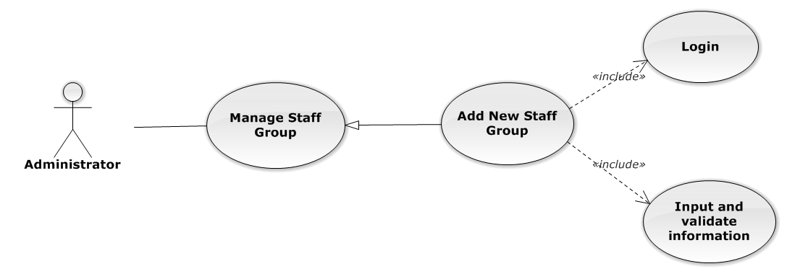

Figure 69: Add New Staff Group Use-Case Diagram

###### Add New Staff Group Use-Case Specification

|  |  |  |  |
| --- | --- | --- | --- |
| USE CASE SPECIFICATION | | | |
| Use-case No. | UC0058 | Use-case Version | 1.0 |
| Use-case Name | Add New Staff Group | | |
| Author | Đặng Nguyễn Khiêm | | |
| Date | 09/10/2014 | Priority | Normal |
| Actor:  Administrator.  Summary:  Administrator can insert new staff group in the system.  **Goal:**  Add new staff group.  Triggers:  At “Quản lí nhóm nhân viên” page click “Thêm nhóm nhân viên” button, fill information and click button “Thêm mới”.  Preconditions:   * Logged-in as “Admin” role. * The page is fully loaded   Post Conditions:  Success: New staff group is inserted into database, message show “Tạo nhóm nhân viên mới thành công!” and display on “Quản lí nhân viên” screen.  Failure: Show message “Tạo nhóm nhân viên mới thất bại!”  Main Success Scenario:   |  |  |  | | --- | --- | --- | | *Step* | *User* | *System* | | 1 | Administrator click on “Thêm nhóm nhân viên” button at “Quản lí Nhóm nhân viên” page. | Modal popup is displayed with fields for input information of new staff group. | |  | Fill information into fields and click button “Thêm mới”  [Alternative 1]  [Exception 1], [Exception 2], [Exception 3] | Modal popup is close  System display successful message “Tạo nhóm nhân viên mới thành công!”  Update list staff group on page |   Alternative Scenario:   |  |  |  | | --- | --- | --- | | *#* | *User* | *System* | | 1 | Click on [X] button, “Đóng” button, or click out of modal | Modal popup is close |   Exceptions:   |  |  |  | | --- | --- | --- | | *#* | *User* | *System* | | 1 | Field “Tên nhóm nhân viên” are blank | Shows error message “Nhập tên nhóm nhân viên!”. | | Field “Chi tiết nhóm nhân viên”, are blank | Shows error message “Nhập chi tiết chi tiết nhân viên!” | | 2 | System cannot insert staff group to data base. | Shows error message “Tạo nhóm nhân viên thất bại!” | | 3 | System fail insert staff group to data base. | Shows error message “Tạo nhóm nhân viên thất bại!", "Hãy kiểm tra lại kết nối database!”. |   Relationships:  Manage Staff Group  Business Rules:  Only Staff with role=”Admin” can be use this function. | | | |

##### Edit Staff Group

###### Edit Staff Group Use-Case Diagram

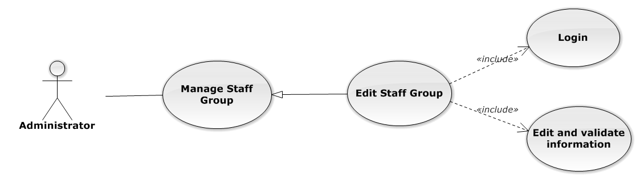

Figure 70: Edit Staff Group Use-Case Diagram

###### Edit Staff Group Use-Case Specification

|  |  |  |  |
| --- | --- | --- | --- |
| USE CASE SPECIFICATION | | | |
| Use-case No. | UC0059 | Use-case Version | 1.0 |
| Use-case Name | Edit Staff Group | | |
| Author | Đặng Nguyễn Khiêm | | |
| Date | 09/10/2014 | Priority | Normal |
| Actor:  Administrator.  Summary:  Administrator can update information of staff group.  **Goal:**  Administrator can update information of staff group and save to database system.  Triggers:   * Administrator goes to “Chi tiết nhóm nhân viên” Popup and click “Chỉnh Sửa” button and modify information, after that click button “Lưu Chỉnh Sửa”. * Administrator goes to “Nhóm nhân viên” screen, click “Chỉnh Sửa” button and modify information, after that click button “Lưu Chỉnh Sửa”.   Preconditions:   * User has logged-in as “Admin” role. * The page is fully loaded   Post Conditions:  Success:  Information of staff group is updated and saves to database, message show “Cập nhật chi tiết nhóm nhân viên thành công!” and display information after update on “Quản lý nhóm nhân viên” screen.  Failure:  Show message “Cập nhật chi tiết nhóm nhân viên thất bại!”  Main Success Scenario:   |  |  |  | | --- | --- | --- | | *Step* | *User* | *System* | | 1 | Manager click on “Chỉnh sửa” button at “Quản lí nhóm nhân viên” screen. | Modal popup is displayed with fields for detil information of staff group. | | 2 | Edit information into fields and click button “Lưu chỉnh sửa”  [Alternative 1]  [Exception 1], [Exception 1], [Exception 3] | Modal popup is close  System display successful message “Cập nhật chi tiết nhóm nhân viên thành công!”  Update list staff group on page |   Alternative Scenario:   |  |  |  | | --- | --- | --- | | *#* | *User* | *System* | | 1 | Click on [X] button, “Đóng” button, or click out of modal | Modal popup is close |   Exceptions:   |  |  |  | | --- | --- | --- | | *#* | *User* | *System* | | 1 | Field “Tên nhóm nhân viên” are blank | Shows error message “Nhập tên nhóm nhân viên!”. | | Field “Chi tiết nhóm nhân viên”, are blank | Shows error message “Nhập chi tiết chi tiết nhân viên!”. | | 2 | System cannot update staff to data base. | Shows error message “Cập nhật chi tiết nhóm nhân viên thất bại!”. | | 3 | System fail insert staff to data base. | Shows error message “Cập nhật chi tiết nhóm nhân viên thất bại!", "Hãy kiểm tra lại kết nối database!”. |   Relationships:  Manage Staff Group  Business Rules:  Only Staff with role=”Admin” can be use this function. | | | |

##### Delete Staff Group

###### Delete Staff Group Use-Case Diagram

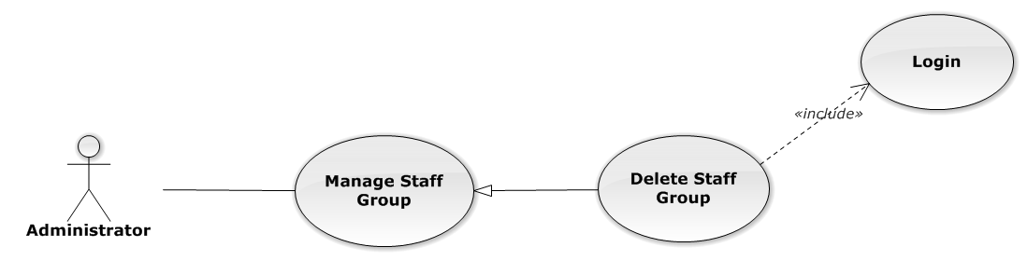

Figure 71: Delete Staff Group Use-Case Diagram

###### Delete Staff Group Use-Case Specification

|  |  |  |  |
| --- | --- | --- | --- |
| USE CASE SPECIFICATION | | | |
| Use-case No. | UC0060 | Use-case Version | 1.0 |
| Use-case Name | Delete Staff Group | | |
| Author | Đặng Nguyễn Khiêm | | |
| Date | 09/10/2014 | Priority | Normal |
| Actor:  Administrator.  Summary:  Administrator can delete staff group.  **Goal:**  Helps Administrator delete staff group if it didn’t use in Staff manager and save to database system.  Triggers:  Administrator goes to “Quản lí nhóm nhân viên ”page click button “Xóa”. After that click on “Bỏ qua” or“Xác nhận” button to confirm delete staff group.  Preconditions:   * User has logged-in as Admin role. * The page is fully loaded   Post Conditions:  Success:  Delete staff group and save to database system, display message “Xóa nhóm nhân viên thành công!”  Failure:  Show message “Xóa nhóm nhân viên thất bại!","Nhóm nhân viên này hiện đang được sử dụng!”.  Main Success Scenario:   |  |  |  | | --- | --- | --- | | *Step* | *User* | *System* | | 1 | Supper admin click on “Xóa” button at “Quản lí nhóm nhân viên” screen. | Show Pop-up confirm “Bạn có muốn thực hiện thao tác này” with two button “Xác nhận” and “Bỏ qua” | | 2 | User click “Bỏ qua” button | Staff group not delete, comeback to “Chi tiết nhóm nhân viên” screen. | | 3 | User click “ Xác nhận” button  [Exception 1], [Exception 2] | Show message “Xóa nhóm nhân viên thành công!” |   Alternative Scenario:  N/A  Exceptions:   |  |  |  | | --- | --- | --- | | *#* | *User* | *System* | | 1 | Delete staff group fail because staff group is use. | Shows error message “Xóa nhóm nhân viên thất bại!","Nhóm nhân viên này hiện đang được sử dụng!” | | 2 | Delete staff group error because staff group is use. | Shows error message “Xóa nhóm nhân viên thất bại!", "Có lỗi xảy ra trong quá trình xóa nhóm nhân viên”. |   Relationships:  Manage Staff Group  Business Rules:  Only Staff with role=”Admin” can be use this function. | | | |

##### Search Staff Group

###### Search Staff Group Use-Case Diagram

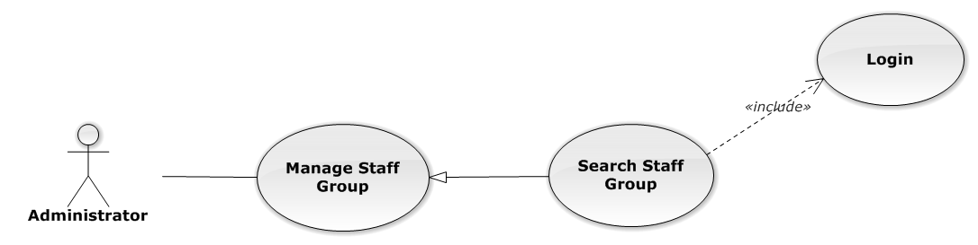

Figure 72: Search Staff Group Use-Case Diagram

###### Search Staff Group Use-Case Specification

|  |  |  |  |
| --- | --- | --- | --- |
| USE CASE SPECIFICATION | | | |
| Use-case No. | UC0061 | Use-case Version | 1.0 |
| Use-case Name | Search Staff Group | | |
| Author | Đặng Nguyễn Khiêm | | |
| Date | 09/10/2014 | Priority | Normal |
| Actor:  Administrator.  Summary:  Administrator search staff in list of staff group.  **Goal:**  Helps Administrator search staff group.  Triggers:   * Administrator wants to search staff group. * Administrator goes to “Quản lý nhóm nhân viên” screen, input word into “Tìm Kiếm” textbox.   Preconditions:   * User has logged-in as Admin role. * The page is fully loaded   Post Conditions:  Success:  List of staff group map with word search is displayed.  Failure:  Do nothing  Main Success Scenario:   |  |  |  | | --- | --- | --- | | *Step* | *User* | *System* | | 1 | In “Quản lý nhóm nhân viên” screen, input key word at “Tìm kiếm” textbox. | List of staff group mapping with word search is display. |   Alternative Scenario:  N/A  Exceptions:  N/A  Relationships:  Manage Staff Group  Business Rules:  Only Staff with role=”Admin” can be use this function. | | | |

#### Manage Staff

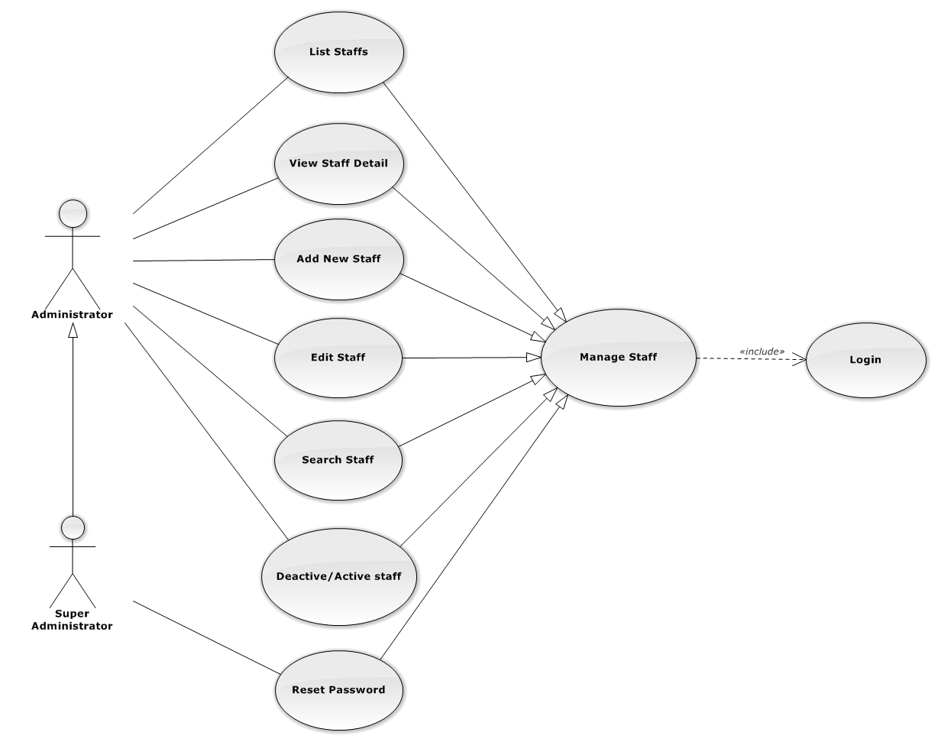

Figure 73: Manage Staff Use-Case Diagram

##### List Staffs

###### List Staffs Use-Case Diagram

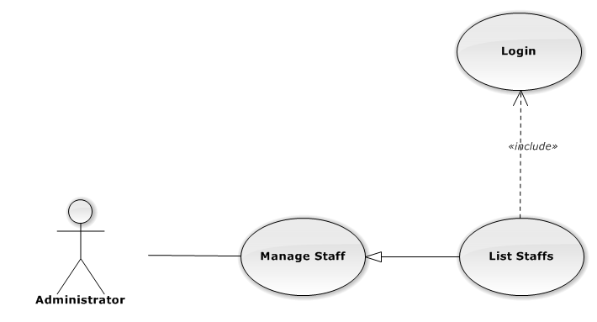

Figure 74: List Staffs Use-Case Diagram

###### List Staffs Use-Case Specification

|  |  |  |  |
| --- | --- | --- | --- |
| USE-CASE SPECIFICATION | | | |
| Use-case No. | UC0062 | Use-case Version | 1.0 |
| Use-case Name | List Staffs | | |
| Author | Đặng Nguyễn Khiêm | | |
| Date | 09/10/2014 | Priority | Normal |
| Actor:  Administrator  Summary:  Redirect user to “Quản lí nhân viên” page and list all staff.  Goal:  To allowing Administrator view any detail information of all staff.  Triggers:  User click on User Control Panel and then click on “Quản lí nhân viên” link  Preconditions:   * Must be logged-in with “Admin” role. * The page is fully loaded   Post Conditions:  Success: System redirects user to “Quản lí nhân viên” page.  Failure: Do nothing.  Main Success Scenario:   |  |  |  | | --- | --- | --- | | *Step* | *User* | *System* | | 1 | Click on “Quản lí nhân viên” link | Redirect to “Quản lí nhân viên” page. Show all staff. |   Alternative Scenario:  N/A  Exceptions:  N/A  Relationships:  Manage Staff  Business Rules:  Only Staff login with role “Admin” can be use this function. | | | |

##### View Staff Detail

###### View Staff Detail Use-Case Diagram

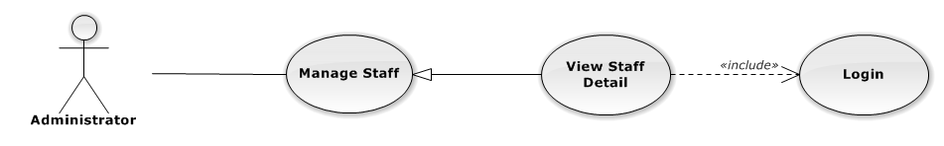

Figure 75: View Staff Detail Use-Case Diagram

###### View Staff Detail Use-Case Specification

|  |  |  |  |
| --- | --- | --- | --- |
| USE-CASE SPECIFICATION | | | |
| Use-case No. | UC0063 | Use-case Version | 1.0 |
| Use-case Name | View Staff Detail | | |
| Author | Đặng Nguyễn Khiêm | | |
| Date | 09/10/2014 | Priority | Normal |
| Actor:  Administrator  Summary:  Administrator can view detail of staff information  Goal:  Helps Administrator view staff information  Triggers:   * On User Control Panel click on “Quản lí nhân viên**”,** * Click click on “Chi tiết” button * Click on image staff.   Preconditions:   * Must be logged-in with “Admin” role * The page is fully loaded   Post Conditions:  Success: The detail staff information is displayed  Failure: Do nothing  Main Success Scenario:   |  |  |  | | --- | --- | --- | | *Step* | *User* | *System* | | 1 | Staff click on “chi tiết” button or click on image link  [Alternative 1] ,[Alternative 2]  [Alternative 3] ,[Alternative 4] | The detail staff information is displayed. |   Alternative Scenario:   |  |  |  | | --- | --- | --- | | *#* | *User* | *System* | | 1 | Click on [X] button, “Đóng” button, or click out of modal | Modal popup is close | | 2 | If staff login with Id=”1”, Click on “Chỉnh sửa” button | Administrator can update information of office (ref 3.2.2.2.4. Update staff) | | 3 | If staff login with Id=”1”, Click on “Hoạt động lại” or “Ngừng hoạt động” link | Administrator can Deactivate/Activate staff (ref 3.2.2.2.5. Deactivate/Activate staff) | | 4 | If staff login with Id=”1”, Click on “Đặt lại mật khẩu” link | Administrator can reset password staff (ref 3.2.2.2.7. Reset Password staff) |   Exceptions:  N/A  Relationships:  Manage Staff  Business Rules:  Only Staff login with role “Admin” can be use this function. | | | |

##### Add New Staff

###### Add New Staff Use-Case Diagram

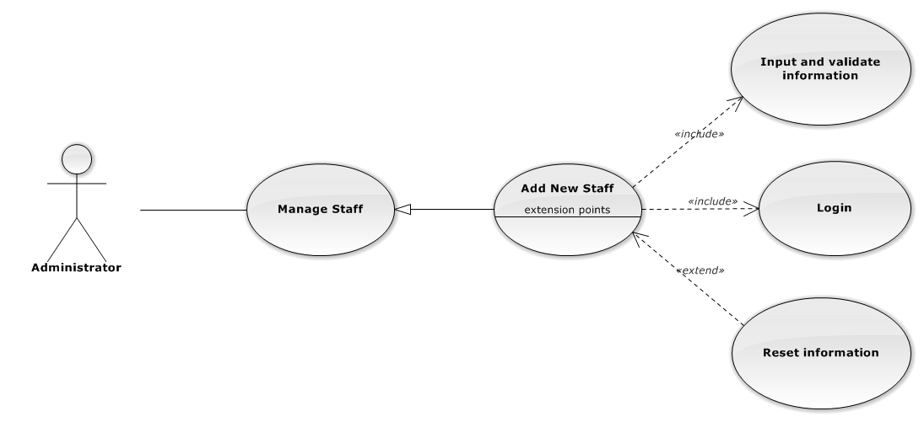

Figure 76: Add New Staff Use-Case Diagram

###### Add New Staff Use-Case Specification

|  |  |  |  |
| --- | --- | --- | --- |
| USE CASE SPECIFICATION | | | |
| Use-case No. | UC0064 | Use-case Version | 1.0 |
| Use-case Name | Add New Staff | | |
| Author | Đặng Nguyễn Khiêm | | |
| Date | 09/10/2014 | Priority | High |
| Actor:  Administrator.  Summary:  Administrator can insert new staff into the system.  **Goal:**  Add new staff.  Triggers:  At “Quản lí nhân viên” page, Administrator click on “Thêm nhân viên” button and fill information after that click button “Thêm mới” button.  Preconditions:   * User has logged-in as “Admin” role. * The page is fully loaded   Post Conditions:  Success:   * Add new case successful and message show “Thêm nhân viên thành công”. * Add current staff’s office to data system. * New staff’s status is “Đang hoạt động”. * Add current with username and default password is “123456” to data system.   Failure:  Show message “Thêm nhân viên thất bại, hãy kiểm tra lại kết nối database”.  Main Success Scenario:   |  |  |  | | --- | --- | --- | | *Step* | *User* | *System* | | 1 | Administrator click on “Thêm nhân viên” button at “Quản lí nhân viên” page. | Modal popup is displayed with fields for input information of new staff. | | 2 | Fill information into fields and click button “Thêm mới”  [Alternative 1]  [Exception 1], [Exception 2], [Exception 3], [Exception 4] | Modal popup is closed.  System display successful message “Thêm nhân viên thành công!”  Update list staff on page |   Alternative Scenario:   |  |  |  | | --- | --- | --- | | *#* | *User* | *System* | | 1 | Click “Làm trống” button | All input field reset to blank. |   Exceptions:   |  |  |  | | --- | --- | --- | | *#* | *User* | *System* | | 1 | Field “Tên nhân viên” are blank | Shows error message “Nhập tên nhân viên!”. | | Field “Tên đăng nhập”, are blank | Shows error message “Nhập vào tên đăng nhập!”. | | Field “Nhóm nhân viên” are blank | Shows error message “Chọn nhóm cho nhân viên!”. | | Field “Ngày sinh” are blank | Shows error message “Chọn ngày sinh của nhân viên!”. | | Field “Điện thoại di động” are blank | Shows error message “Nhập vào số điện thoại nhân viên!”. | | Field “Email” are blank | Shows error message “Hãy nhập Email của nhân viên!”. | | Input “Email” not follow the rule | Shows error message “Hãy nhập địa chỉ email đúng!”. | | Field “Địa chỉ liên hệ” are blank | Shows error message “Nhập địa chỉ của nhân viên!”. | | Field “Thuộc văn phòng ” are blank | Shows error message “Chọn một văn phòng!”. | | Field “Vai trò nhân viên” are blank | Shows error message “Chọn vai trò cho nhân viên!”. | | Field “CMND” are blank | Shows error message “Nhập vào số chứng minh nhân dân!”. | | Field “Ngày cấp CMND” are blank | Shows error message “Chọn ngày cấp chứng minh nhân dân!“. | | Field “Nơi cấp CMND” are blank | Shows error message “Nhập vào nơi cấp chứng minh nhân dân!”. | | Input “Tên đăng nhập” not follow the rule | Shows error message “Tên đăng nhập không được chứa ký tự đặc biệt!”. | | 2 | Input “Tên đăng nhập” is existed in Database | Shows error message “Tên đăng nhập nhân viên đã tồn tại!”. | | 3 | System cannot insert staff to data base. | Shows error message “Tạo nhân viên thất bại!” | | 4 | System error insert staff to data base. | Shows error message “Tạo nhân viên thất bại!", "Hãy kiểm tra lại kết nối database!”. |   Relationships:  Manage Staff.  Manage Staff Group  Business Rules:  Only Staff login with role “Admin” can be use this function. | | | |

##### Edit Staff

###### Edit Staff Use-Case Diagram

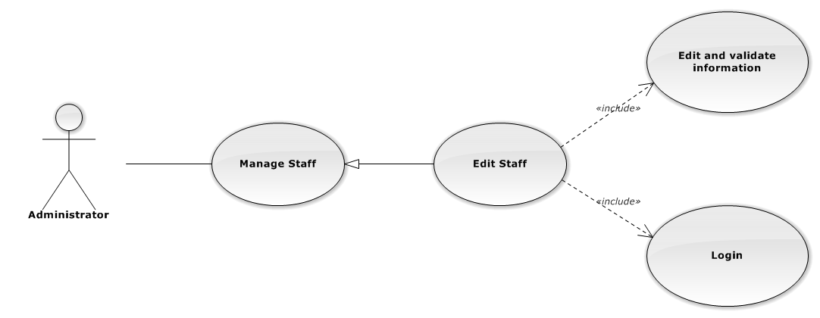

Figure 77: Edit Staff Use-Case Diagram

###### Edit Staff Use-Case Specification

|  |  |  |  |
| --- | --- | --- | --- |
| USE CASE SPECIFICATION | | | |
| Use-case No. | UC0065 | Use-case Version | 1.0 |
| Use-case Name | Edit Staff | | |
| Author | Đặng Nguyễn Khiêm | | |
| Date | 09/10/2014 | Priority | Normal |
| Actor:  Administrator.  Summary:  Administrator can update information of staff.  **Goal:**  Administrator can update information of staff and save to database system.  Triggers:   * Administrator goes to “Quản lý nhân viên” screen, click button “Chỉnh Sửa” button and modify information, after that click button “Lưu Chỉnh Sửa”. * Manager goes to “Chi tiết nhân viên” Popup screen, click on “Chỉnh Sửa” button and modify information, after that click button “Lưu Chỉnh Sửa”.   Preconditions:   * Logged-in as “Admin” role. * The page is fully loaded   Post Conditions:  Success:   * Information of Office is updated and saves to database * Message show “Cập nhật chi tiết nhân viên thành công” and display information after update on “Quản lý nhân viên” screen.   Failure:  Show message “Cập nhật chi tiết nhân viên thất bại!", "Hãy kiểm tra lại kết nối database.”  Main Success Scenario:   |  |  |  | | --- | --- | --- | | *Step* | *User* | *System* | | 1 | Manager click on “Chỉnh sửa” button at “Quản lí nhân viên” screen. | Modal popup is displayed with fields for detail information of new staff. | | 2 | Edit information into fields and click button “Lưu chỉnh sửa”  [Alternative 1]  [Exception 1], [Exception 2], [Exception 3] | Modal popup is close  System display successful message “Cập nhật chi tiết nhân viên thành công!”  Update list staff on page |   Alternative Scenario:   |  |  |  | | --- | --- | --- | | *#* | *User* | *System* | | 1 | Click on [X] button, “Đóng” button, or click out of modal | Modal popup is close |   Exceptions:   |  |  |  | | --- | --- | --- | | *#* | *User* | *System* | | 1 | Field “Tên nhân viên” are blank | Shows error message “Nhập tên nhân viên!”. | | Field “Tên đăng nhập”, are blank | Shows error message “Nhập vào tên đăng nhập!”. | | Field “Nhóm nhân viên” are blank | Shows error message “Chọn nhóm cho nhân viên!”. | | Field “Ngày sinh” are blank | Shows error message “Chọn ngày sinh của nhân viên!”. | | Field “Điện thoại di động” are blank | Shows error message “Nhập vào số điện thoại nhân viên!”. | | Field “Email” are blank | Shows error message “Hãy nhập Email của nhân viên!” | | Input “Email” not a regular expression | Shows error message “Hãy nhập địa chỉ email đúng!” | | Field “Địa chỉ liên hệ” are blank | Shows error message “Nhập địa chỉ của nhân viên!”. | | Field “Thuộc văn phòng ” are blank | Shows error message “Chọn một văn phòng!”. | | Field “Vai trò nhân viên” are blank | Shows error message “Chọn vai trò cho nhân viên!”. | | Field “CMND” are blank | Shows error message “Nhập vào số chứng minh nhân dân!” | | Field “Ngày cấp CMND” are blank | Shows error message “Chọn ngày cấp chứng minh nhân dân!” | | Field “Nơi cấp CMND” are blank | Shows error message “Nhập vào nơi cấp chứng minh nhân dân!” | | 2 | System cannot insert staff to data base. | Shows error message “Cập nhật chi tiết nhân viên thất bại!” | | 3 | System error insert staff to data base. | Shows error message “Cập nhật chi tiết nhân viên thất bại!", "Hãy kiểm tra lại kết nối database!” |   Relationships:  Manage Staff  Business Rules:  Only Staff login with role “Admin” can be use this function. | | | |

##### Deactivate/Activate staff

###### Deactivate/Activate staff Use-CaseDiagram

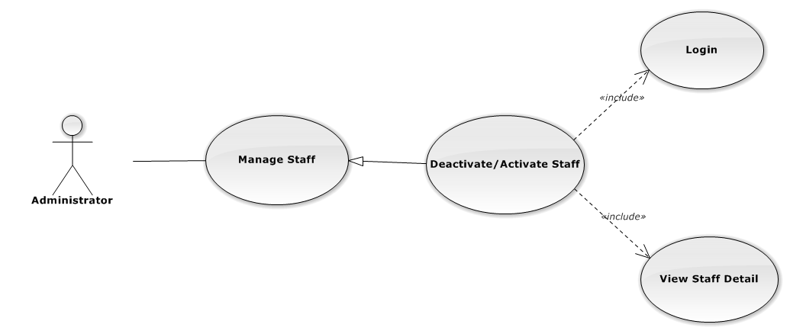

Figure 78: Deactivate/Activate Staff Use-Case Diagram

###### Deactivate/Activate staff Use-Case Specification

|  |  |  |  |
| --- | --- | --- | --- |
| USE CASE SPECIFICATION | | | |
| Use-case No. | UC0066 | Use-case Version | 1.0 |
| Use-case Name | Deactivate/Activate staff | | |
| Author | Đặng Nguyễn Khiêm | | |
| Date | 09/10/2014 | Priority | Normal |
| Actor:  Administrator.  Summary:  Administrator can change status of Staff.  **Goal:**  Helps Administrator update Status of staff and save to database system.  Triggers:  Administrator goes “Chi tiết nhân viên” Pop-Up screen , Click button “Ngừng hoạt động” or “Hoạt động lại”. After that click on “Bỏ qua” or “Xác nhận” button to confirm change status Staff.  Preconditions:   * Logged-in as “Admin” role * The page is fully loaded   Post Conditions:  Success:  Information of Staff is updated and saves to database, message show “[…] đã hoạt động lại!” or “[…] đã ngừng hoạt động!” and display information after update on “Quản lý nhân viên” screen.  Failure:  Show message “Thay đổi hoạt động nhân viên thất bại!", "Hãy kiểm tra lại kết nối database”.  Main Success Scenario:   |  |  |  | | --- | --- | --- | | *Step* | *User* | *System* | | 1 | Supper admin click on “Chỉnh sửa” button at “Quản lí nhân viên” screen. | Show “Chi tiết nhân viên” Pop-up information. | | 2 | On “Chi tiết văn phòng” Pop-up click button “Ngừng hoạt động ” if Staff have status “Đang hoạt động” or Click button “Hoạt động lại” if staff have status "Ngừng hoạt động”.  [Alternative 1] | Display message box confirm “Bạn có muốn thực hiện thao tác này” with two button “Xác nhận” and “Bỏ qua” | | 3 | User click “Bỏ qua” button | Status of staff not change comeback to “Chi tiết nhân viên” Pop-up screen. | | 4 | User click “ Xác nhận” button  [Exception 1] ,[Exception 2] | Status of staff is change and comeback to “Quản lí nhân viên”screen |   Alternative Scenario:  Alternative:   |  |  |  | | --- | --- | --- | | *#* | *User* | *System* | | 1 | Click on [X] button, “Đóng” button, or click out of modal | Modal popup is close |   Exceptions:   |  |  |  | | --- | --- | --- | | *#* | *User* | *System* | | 1 | System fail change status of staff | Shows error message “Thay đổi hoạt động nhân viên thất bại!", "Có lỗi xảy ra trong quá trình xóa nhân viên.”. | | 2 | System error change status of staff. | Shows error message “Thay đổi hoạt động nhân viên thất bại!", "Hãy kiểm tra lại kết nối database”. |   Relationships:  Manage Staff  Business Rules:  Only Staff login with role “Admin” can be use this function. | | | |

##### Search Staff

###### Search Staff Use-Case Diagram

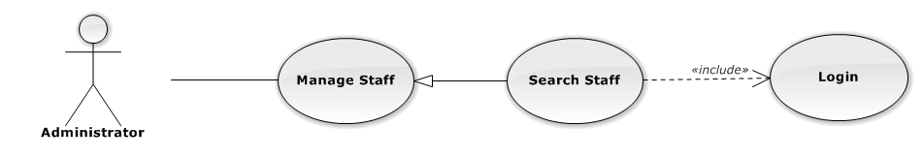

Figure 79: Search Staff Use-Case Diagram

###### Search Staff Use-Case Specification

|  |  |  |  |
| --- | --- | --- | --- |
| USE CASE SPECIFICATION | | | |
| Use-case No. | UC0067 | Use-case Version | 1.0 |
| Use-case Name | Search Staff | | |
| Author | Đặng Nguyễn Khiêm | | |
| Date | 09/10/2014 | Priority | Normal |
| Actor:  Administrator.  Summary:  Administrator search staff in list of staff  **Goal:**  Helps Administrator search staff.  Triggers:   * Administrator wants to search staff. * Administrator input key word is StaffName. When the key up, system will be automatic search.   Preconditions:   * Logged-in as “Admin” role. * The page is fully loaded   Post Conditions:  Success: List of staff map with word search is displayed.  Failure: Do nothing.  Main Success Scenario:   |  |  |  | | --- | --- | --- | | *Step* | *User* | *System* | | 1 | In “Quản lý nhân viên” screen, input key word at “Tìm kiếm” textbox. | List of staff mapping with word search is display. |   Alternative Scenario:  N/A  Exceptions:  N/A  Relationships:  Manage Staff  Business Rules:  Only Staff with role=”Admin” can be use this function. | | | |

##### Reset Password

###### Reset Password Use-Case Diagram

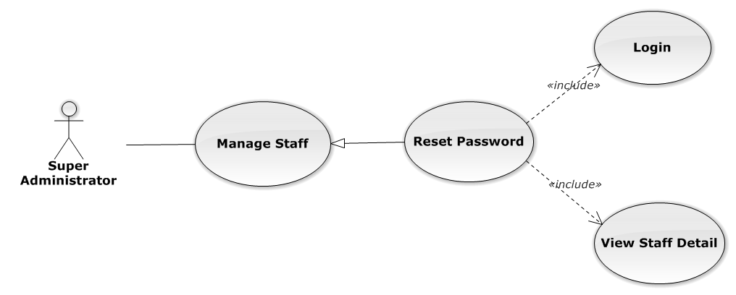

Figure 80: Reset Password Use-Case Diagram

###### Reset Password Use-Case Specification

|  |  |  |  |
| --- | --- | --- | --- |
| USE CASE SPECIFICATION | | | |
| Use-case No. | UC0068 | Use-case Version | 1.0 |
| Use-case Name | Reset Password | | |
| Author | Đặng Nguyễn Khiêm | | |
| Date | 09/10/2014 | Priority | Normal |
| Actor:  Supper Administrator.  Summary:  Supper Administrator can reset password of all staff to default.  **Goal:**  Helps Supper Administrator reset password to default is “123456”.  Triggers:  Supper Supper Administrator wants to reset password staff.  Supper Administrator goes to “Staff detail” screen, and click to button “Đặt lại mật khẩu”  Preconditions:   * Logged-in to system. * The page is fully loaded   Post Conditions:  Success: Default password “123456” is save to database, message show “Khôi phục mật khẩu thành công  Failure:   * The user is presented with an error message on screen. * Show message “Khôi phục mật mật khẩu thất bại!”.   Main Success Scenario:   |  |  |  | | --- | --- | --- | | *Step* | *User* | *System* | | 1 | Supper admin click on “Chi tiết” button at “Quản lí nhân viên” screen. | Show “Chi tiết nhân viên” Pop-up information. | | 2 | On “Chi tiết văn phòng” Pop-up click button “Đặt lại mật khẩu”  [Alternative 1] | Display message box confirm “Bạn muốn khôi phục mật khẩu nhân viên này về mặc định?” with two button “Xác nhận” and “Bỏ qua” | | 3 | User click “Bỏ qua” button | Password of staff not change comeback to “Chi tiết nhân viên” Pop-up screen. | | 4 | User click “ Xác nhận” button  [Exception 1], [Exception 2] | Password of staff is reset to default “123456” and comeback to “Quản lí nhân viên” screen |   Alternative Scenario:   |  |  |  | | --- | --- | --- | | *#* | *User* | *System* | | 1 | Click on [X] button, “Đóng” button, or click out of modal | Modal popup is close |   Exceptions:   |  |  |  | | --- | --- | --- | | *#* | *User* | *System* | | 1 | System cannot reset password staff. | Shows error message “Khôi phục mật mật khẩu thất bại!” | | 2 | System fail reset password staff. | Shows error message “"Khôi phục mật khẩu thất bại", "Hãy kiểm tra lại kết nối database.”. |   Relationships:  Manage Staff  Business Rules:  Only Staff with id=”1” (Super Administrator) can be use this function. | | | |

#### Manage Service Type

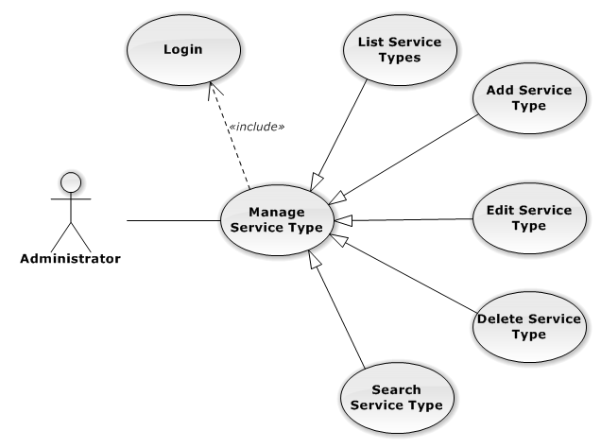

Figure 81: Manage Service Type Use-Case Diagram

##### List Service Types

###### List Service Types Use-Case Diagram

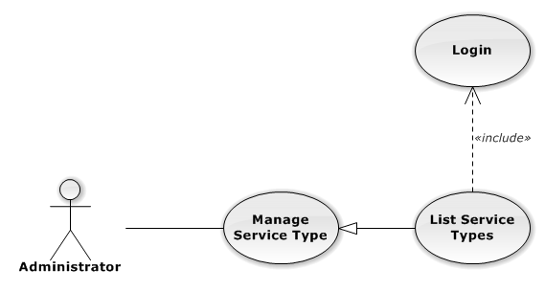

Figure 82: List Service Types Use-Case Diagram

###### List Service Types Use-Case Specification

|  |  |  |  |
| --- | --- | --- | --- |
| USE CASE SPECIFICATION | | | |
| Use-case No. | UC0069 | Use-case Version | 1.0 |
| Use-case Name | List Service Types | | |
| Author | Trần Anh Tuấn | | |
| Date | 09/10/2014 | Priority | Normal |
| Actor:  Administrator  Summary:  List All Service Type.  Goal:  The purpose of List Service Type use case is allowing Admin to view all Services Type.  Triggers:  User choose “Quản lý Loại Dịch Vụ” in menu.  Preconditions:  User is authenticated and has role “admin”.  The page is fully loaded.  Post Conditions:  Success: All Services Type is listed.  Failure: Do nothing.  Main Success Scenario:   |  |  |  | | --- | --- | --- | | *Step* | *User* | *System* | | 1 | Click “Quản lý Loại Dịch Vụ” in menu. | All Service Types are loaded. |   Alternative Scenario:  N/A  Exceptions:  N/A  Relationships:  Manage Service Type  Business Rules:  N/A | | | |

##### Add New Service Type

###### Add New Service Type Use-Case Diagram

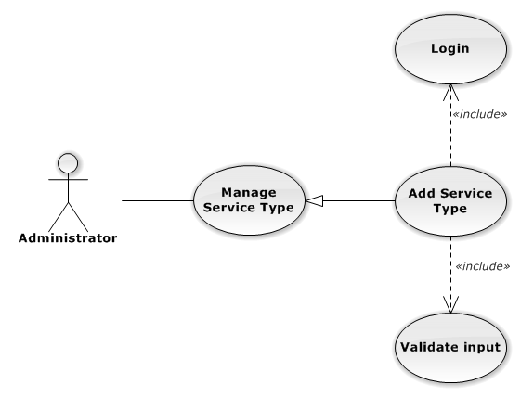

Figure 83: Add New Service Type Use-Case Diagram

###### Add New Service Type Use-Case Specification

|  |  |  |  |
| --- | --- | --- | --- |
| USE CASE SPECIFICATION | | | |
| Use-case No. | UC0070 | Use-case Version | 1.0 |
| Use-case Name | Add New Service Type | | |
| Author | Trần Anh Tuấn | | |
| Date | 09/10/2014 | Priority | Normal |
| Actor:  Administrator  Summary:  Add Service Type.  Goal:  The purpose of Add Service Type use case is allowing Admin to add Service Type.  Triggers:  User choose “Quản lý Nhóm Dịch Vụ” in menu. Then click “Thêm loại dịch vụ” button.  Preconditions:  User is authenticated and has role “admin”.  Post Conditions:  Success: New Service Type is created.  Failure: No Service Type is created and Error message will be showed.  Main Success Scenario:   |  |  |  | | --- | --- | --- | | *Step* | *User* | *System* | | 1 | Click “Thêm loại dịch vụ” button. | Show add Service type pop-up. | | 2 | Enters the Service Type Name and Description |  | | 3 | Presses “Thêm mới” button.  [Alternative: 1] | Checks validate, add new Service Type to database.  Show success message.  [Exception: 1]  [Exception: 2]  [Exception: 3] |   Alternative Scenario:   |  |  |  | | --- | --- | --- | | *#* | *User* | *System* | | 1 | Presses “Đóng”, “X” button or click outside pop-up. | The Add New Service Type pop-up is close. |   Exceptions:   |  |  |  | | --- | --- | --- | | *#* | *User* | *System* | | 1 | Service Type Name is missing. | Show error “Nhập tên loại dịch vụ” | | 2 | Add Service type fail. | The Add New Service Type is closed and display error message “Tạo loại dịch vụ thất bại!", "Hãy kiểm tra lại kết nối database." | | 1 | Add Service type error. | The Add New Service Type is closed and display error message "Tạo loại dịch vụ thất bại!", "Có lỗi xảy ra trong quá trình tạo loại dịch vụ." |   Relationships:  Manage Service Type  Business Rules:  N/A | | | |

##### Edit Service Type

###### Edit Service Type Use-Case Diagram

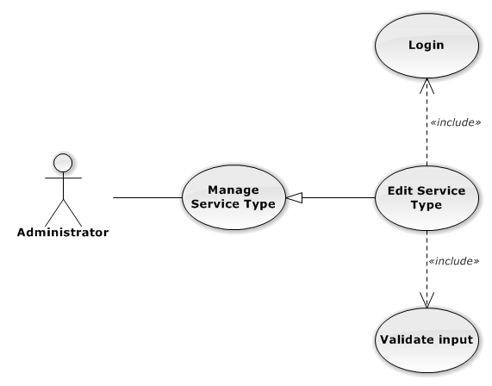

Figure 84: Edit Service Type Use-Case Diagram

###### Edit Service Type Use-Case Specification

|  |  |  |  |
| --- | --- | --- | --- |
| USE CASE SPECIFICATION | | | |
| Use-case No. | UC0071 | Use-case Version | 1.0 |
| Use-case Name | Edit Service Type | | |
| Author | Trần Anh Tuấn | | |
| Date | 09/10/2014 | Priority | Normal |
| Actor:  Administrator  Summary:  Update Service Type.  Goal:  The purpose of Update Service Type use case is allowing Admin to update Service Type.  Triggers:  User choose “Quản lý Loại Dịch Vụ” in menu. Then click update icon.  Preconditions:  User is authenticated and has role “admin”.  Post Conditions:  Success: The Service Type is Updated.  Failure: The Service Type is not updated and Error message will be showed.  Main Success Scenario:   |  |  |  | | --- | --- | --- | | *Step* | *User* | *System* | | 1 | Click Update icon. | Show update Service type pop-up. | | 2 | Enters the new Service Type Name and Description |  | | 3 | Presses “Lưu chỉnh sửa” button.  [Alternative: 1] | Checks validate, update Service Type to database.  Show success message.  [Exception: 1]  [Exception: 2]  [Exception: 3] |   Alternative Scenario:   |  |  |  | | --- | --- | --- | | *#* | *User* | *System* | | 1 | Presses “Đóng”, “X” button or click outside pop-up. | The Update Service Type pop-up is close. |   Exceptions:   |  |  |  | | --- | --- | --- | | *#* | *User* | *System* | | 1 | Service Type Name is missing. | Show error “Nhập tên loại dịch vụ!” to user. | | 2 | Update Service type fail. | The Add New Service Type is closed and display error message “Chỉnh sửa loại dịch vụ thất bại!", "Hãy kiểm tra lại kết nối database." | | 3 | Update Service type error. | The Add New Service Type is closed and display error message "Chỉnh sửa loại dịch vụ thất bại!", "Có lỗi xảy ra trong quá trình tạo loại dịch vụ." |   Relationships:  Manage Service Type  Business Rules:  N/A | | | |

##### Delete Service Type

###### Delete Service Type Use-Case Diagram

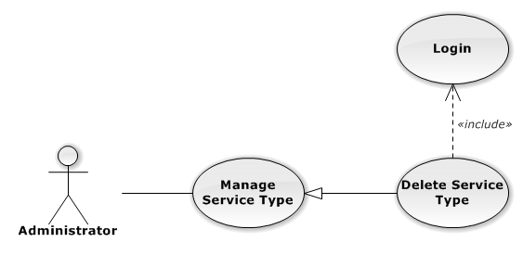

Figure 85: Delete Service Type Use-Case Diagram

###### Delete Service Type Use-Case Specification

|  |  |  |  |
| --- | --- | --- | --- |
| USE CASE SPECIFICATION | | | |
| Use-case No. | UC0072 | Use-case Version | 1.0 |
| Use-case Name | Delete Service Type | | |
| Author | Trần Anh Tuấn | | |
| Date | 09/10/2014 | Priority | Normal |
| Actor:  Administrator  Summary:  Delete Service Type.  Goal:  The purpose of Delete Service Type use case is allowing Admin to delete Service Type.  Triggers:  User choose “Quản lý Dịch Vụ” in menu.  Preconditions:  User is authenticated and has role “admin”.  Post Conditions:  Success: The Service Type is deleted.  Failure: The Service Type is not delete and Error message will be showed.  Main Success Scenario:   |  |  |  | | --- | --- | --- | | *Step* | *User* | *System* | | 1 | Click Delete icon. | Show confirm pop-up | | 2 | Presses “Đồng ý” button.  [Alternative: 1] | Delete Service Type from database.  Show success message.  [Exception: 1]  [Exception: 2] |   Alternative Scenario:   |  |  |  | | --- | --- | --- | | *#* | *User* | *System* | | 1 | Presses “Hủy bỏ”, “X” button. | The confirm pop-up is close. |   Exceptions:   |  |  |  | | --- | --- | --- | | *#* | *User* | *System* | | 1 | Delete Service type fail. | The Add New Service Type is closed and display error message “Xóa loại dịch vụ thất bại!", "Hãy kiểm tra lại kết nối database." | | 2 | Delete Service type error. | The Add New Service is closed and display error message "Xóa loại dịch vụ thất bại!", "Có lỗi xảy ra trong quá xóa loại dịch vụ." |   Relationships:  Manage Service Type  Business Rules:  N/A | | | |

##### Search Service Type

###### Search Service Type Use-Case Diagram

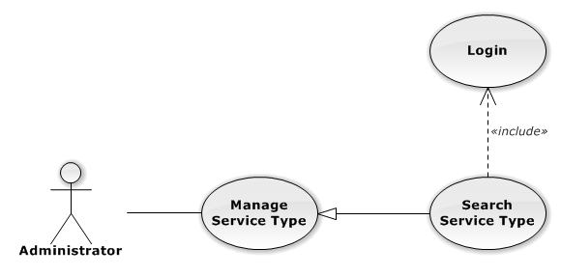

Figure 86: Search Service Type Use-Case Diagram

###### Search Service Type Use-Case Specification

|  |  |  |  |
| --- | --- | --- | --- |
| USE CASE SPECIFICATION | | | |
| Use-case No. | UC0073 | Use-case Version | 1.0 |
| Use-case Name | Search Service Type | | |
| Author | Trần Anh Tuấn | | |
| Date | 09/10/2014 | Priority | Normal |
| Actor:  Administrator  Summary:  Search Service Type.  Goal:  The purpose of Search Service Type use case is allowing Admin to search Service Type.  Triggers:  User choose “Quản lý Dịch Vụ” in menu.  Preconditions:  User is authenticated and has role “admin”.  Post Conditions:  Success: List of Service Type with search key words is displayed.  Failure: No record is displayed.  Main Success Scenario:   |  |  |  | | --- | --- | --- | | *Step* | *User* | *System* | | 1 | In “Quản lý loại dịch vụ” screen, input key word at “Tìm kiếm” textbox. | List of Service Type with search key words is displayed. |   Alternative Scenario:  N/A  Exceptions:  N/A  Relationships:  Manage Service Type  Business Rules:  N/A | | | |

#### Manage Service

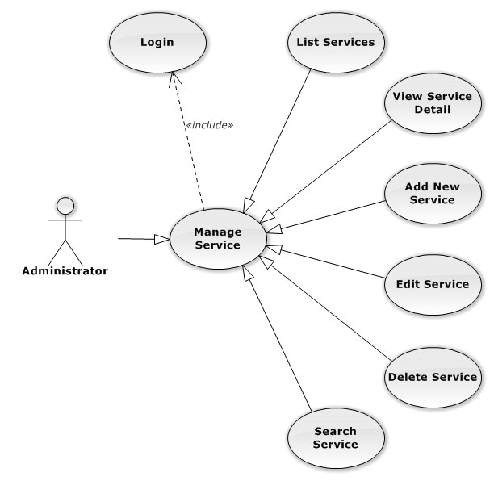

Figure 87: Manage Service Use-Case Diagram

##### List Services

###### List Services Use-Case Diagram

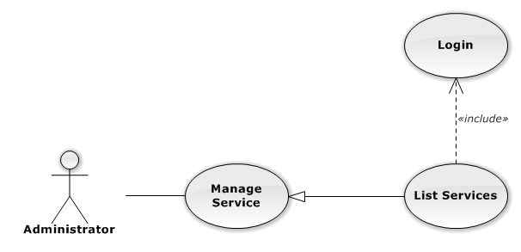

Figure 88: List Services Use-Case Diagram

###### List Services Use-Case Specification

|  |  |  |  |
| --- | --- | --- | --- |
| USE CASE SPECIFICATION | | | |
| Use-case No. | UC0074 | Use-case Version | 1.0 |
| Use-case Name | List Services | | |
| Author | Trần Anh Tuấn | | |
| Date | 09/10/2014 | Priority | Normal |
| Actor:  Administrator  Summary:  List All Service.  Goal:  The purpose of List Service use case is allowing Admin to view all Services.  Triggers:  User choose “Quản lý Dịch Vụ” in menu.  Preconditions:  User is authenticated and has role “admin”.  The page is fully loaded.  Post Conditions:  Success: All Services is listed.  Failure: Do nothing.  Main Success Scenario:   |  |  |  | | --- | --- | --- | | *Step* | *User* | *System* | | 1 | Click “Quản lý Dịch Vụ” in menu. | All Services are loaded. |   Alternative Scenario:  N/A  Exceptions:  N/A  Relationships:  Manage Service  Business Rules:  N/A | | | |

##### View Service Detail

###### View Service Detail Use-Case Diagram

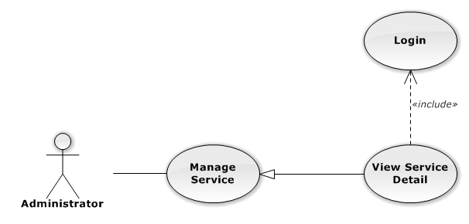

Figure 89: View Service Detail Use-Case Diagram

###### View Service Detail Use-Case Specification

|  |  |  |  |
| --- | --- | --- | --- |
| USE CASE SPECIFICATION | | | |
| Use-case No. | UC0075 | Use-case Version | 1.0 |
| Use-case Name | View Service Detail | | |
| Author | Trần Anh Tuấn | | |
| Date | 09/10/2014 | Priority | Normal |
| Actor:  Administrator  Summary:  View Service Detail.  Goal:  The purpose of View Service Detail use case is allowing Admin to view a Service detail.  Triggers:  User choose “Quản lý Dịch Vụ” in menu. Then click “View detail” icon.  Preconditions:  User is authenticated and has role “admin”.  Post Conditions:  Success: Service Detail is showed.  Failure: Do nothing.  Main Success Scenario:   |  |  |  | | --- | --- | --- | | *Step* | *User* | *System* | | 1 | In Manage Service page, click “View detail” icon | The Service Detail is showed. |   Alternative Scenario:  N/A  Exceptions:  N/A  Relationships:  Manage Service  Business Rules:  N/A | | | |

##### Add New Service

###### Add New Service Use-Case Diagram

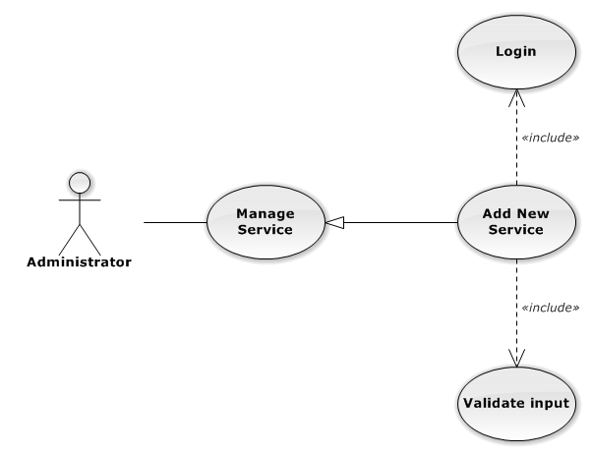

Figure 90: Add New Service Use-Case Diagram

###### Add New Service Use-Case Specification

|  |  |  |  |
| --- | --- | --- | --- |
| USE CASE-n SPECIFICATION | | | |
| Use-case No. | UC0076 | Use-case Version | 1.0 |
| Use-case Name | Add New Service | | |
| Author | Trần Anh Tuấn | | |
| Date | 09/10/2014 | Priority | Normal |
| Actor:  Administrator  Summary:  Add new Service.  Goal:  The purpose of Add Service use case is allowing Admin to add new Service.  Triggers:  User choose “Quản lý Dịch Vụ” in menu. Then click “Thêm dịch vụ mới” button.  Preconditions:  User is authenticated and has role “admin”.  Post Conditions:  Success: New Service is created.  Failure: No Service is created and Error message will be showed.  Main Success Scenario:   |  |  |  | | --- | --- | --- | | *Step* | *User* | *System* | | 1 | Click “Thêm dịch vụ mới” button. | Show add Service pop-up. | | 2 | Enters the Service Name and Description |  | | 3 | Presses “Thêm mới” button.  [Alternative: 1] | Checks validate, add new Service to database.  Show success message.  [Exception: 1]  [Exception: 2]  [Exception: 3] |   Alternative Scenario:   |  |  |  | | --- | --- | --- | | *#* | *User* | *System* | | 1 | Presses “Đóng”, “X” button or click outside pop-up. | The Add New Service pop-up is close. |   Exceptions:   |  |  |  | | --- | --- | --- | | *#* | *User* | *System* | | 1 | Service Name is missing. | Show error “Nhập tên dịch vụ!” to user. | | Service Group is not chosen. | Show error “Chọn loại dịch vụ!” to user. | | 2 | Add Service fail. | The Add New Service is closed and display error message “Tạo dịch vụ thất bại!", "Hãy kiểm tra lại kết nối database." | | 3 | Add Service error. | The Add New Service is closed and display error message "Tạo dịch vụ thất bại!", "Có lỗi xảy ra trong quá trình tạo dịch vụ." |   Relationships:  Manage Service  Business Rules:  N/A | | | |

##### Edit Service

###### Edit Service Use-Case Diagram

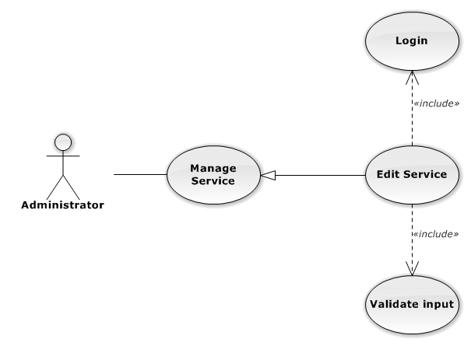

Figure 91: Edit Service Use-Case Diagram

###### Edit Service Use-Case Specification

|  |  |  |  |
| --- | --- | --- | --- |
| USE CASE SPECIFICATION | | | |
| Use-case No. | UC0077 | Use-case Version | 1.0 |
| Use-case Name | Edit Service | | |
| Author | Trần Anh Tuấn | | |
| Date | 09/10/2014 | Priority | Normal |
| Actor:  Administrator  Summary:  Update Service.  Goal:  The purpose of Update Service use case is allowing Admin to update Service.  Triggers:  User choose “Quản lý Dịch Vụ” in menu. Then click update icon.  Preconditions:  User is authenticated and has role “admin”.  Post Conditions:  Success: The Service is Updated.  Failure: The Service is not updated and Error message will be showed.  Main Success Scenario:   |  |  |  | | --- | --- | --- | | *Step* | *User* | *System* | | 1 | Click Update icon. | Show update Service pop-up. | | 2 | Enters the new Service Name and Description |  | | 3 | Presses “Lưu chỉnh sửa” button.  [Alternative: 1] | Checks validate, update Service to database.  Show success message.  [Exception: 1]  [Exception: 2]  [Exception: 3] |   Alternative Scenario:   |  |  |  | | --- | --- | --- | | *#* | *User* | *System* | | 1 | Presses “Đóng”, “X” button or click outside pop-up. | The Update Service pop-up is close. |   Exceptions:   |  |  |  | | --- | --- | --- | | *#* | *User* | *System* | | 1 | Service Name is missing. | Show error “Nhập tên dịch vụ!” to user. | | 2 | Update Service fail. | The Add New Service is closed and display error message “Chỉnh sửa dịch vụ thất bại!", "Hãy kiểm tra lại kết nối database." | | 1 | Update Service error. | The Add New Service is closed and display error message "Chỉnh sửa dịch vụ thất bại!", "Có lỗi xảy ra trong quá trình chỉnh sửa dịch vụ." |   Relationships:  Manage Service  Business Rules:  N/A | | | |

##### Delete Service

###### Delete Service Use-Case Diagram

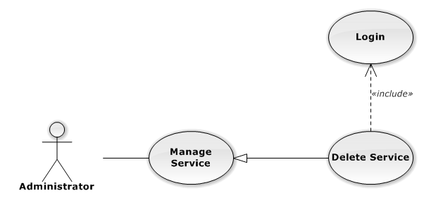

Figure 92: Delete Service Use-Case Diagram

###### Delete Service Use-Case Specification

|  |  |  |  |
| --- | --- | --- | --- |
| USE CASE SPECIFICATION | | | |
| Use-case No. | UC0078 | Use-case Version | 1.0 |
| Use-case Name | Delete Service | | |
| Author | Trần Anh Tuấn | | |
| Date | 09/10/2014 | Priority | Normal |
| Actor:  Administrator  Summary:  Delete Service.  Goal:  The purpose of Delete Service use case is allowing Admin to delete Service.  Triggers:  User choose “Quản lý Dịch Vụ” in menu. Then click delete icon.  Preconditions:  User is authenticated and has role “admin”.  Post Conditions:  Success: The Service is deleted.  Failure: The Service is not delete and Error message will be showed.  Main Success Scenario:   |  |  |  | | --- | --- | --- | | *Step* | *User* | *System* | | 1 | Click Delete icon. | Show confirm pop-up | | 2 | Presses “Xác nhận” button.  [Alternative: 1] | Delete Service from database.  Show success message.  [Exception: 1]  [Exception: 2] |   Alternative Scenario:   |  |  |  | | --- | --- | --- | | *#* | *User* | *System* | | 1 | Presses “Bỏ qua” or “X” button. | The confirm pop-up is close. |   Exceptions:   |  |  |  | | --- | --- | --- | | *#* | *User* | *System* | | 1 | Delete Service fail. | The Add New Service is closed and display error message “Xóa dịch vụ thất bại!", "Hãy kiểm tra lại kết nối database." | | 2 | Delete Service error. | The Add New Service is closed and display error message "Xóa dịch vụ thất bại!", "Có lỗi xảy ra trong quá xóa dịch vụ." |   Relationships:  Manage Service  Business Rules:  N/A | | | |

##### Search Service

###### Search Service Use-Case Diagram

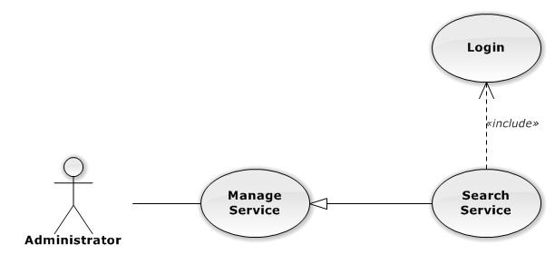

Figure 93: Search Service Use-Case Diagram

###### Search Service Use-Case Specification

|  |  |  |  |
| --- | --- | --- | --- |
| USE CASE SPECIFICATION | | | |
| Use-case No. | UC0079 | Use-case Version | 1.0 |
| Use-case Name | Search Service | | |
| Author | Trần Anh Tuấn | | |
| Date | 09/10/2014 | Priority | Normal |
| Actor:  Administrator  Summary:  Search Service.  Goal:  The purpose of Search Service use case is allowing Admin to search Service.  Triggers:  User choose “Quản lý Dịch Vụ” in menu.  Preconditions:  User is authenticated and has role “admin”.  Post Conditions:  Success: List of Service with search key words is displayed.  Failure: No record is displayed.  Main Success Scenario:   |  |  |  | | --- | --- | --- | | *Step* | *User* | *System* | | 1 | In “Quản lý dịch vụ” screen, input key word at “Tìm kiếm” textbox. | List of Service with search key words is displayed. |   Alternative Scenario:  N/A  Exceptions:  N/A  Relationships:  Manage Service  Business Rules:  N/A | | | |

#### Manage Office

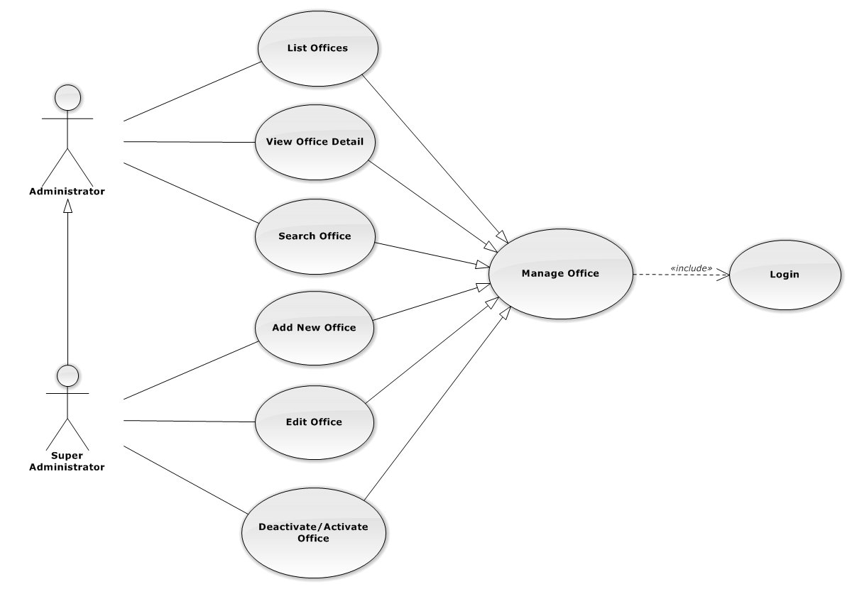

Figure 94: Manage Office Use-Case Diagram

##### List Offices

###### List Offices Use-Case Diagram

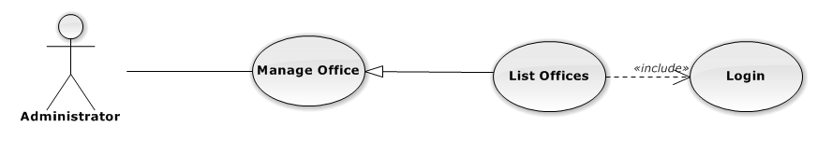

Figure 95: List Offices Use-Case Diagram

###### List Offices Use-Case Specification

|  |  |  |  |
| --- | --- | --- | --- |
| USE-CASE SPECIFICATION | | | |
| Use-case No. | UC0080 | Use-case Version | 1.0 |
| Use-case Name | List Offices | | |
| Author | Trần Anh Tuấn | | |
| Date | 09/10/2014 | Priority | Normal |
| Actor:  Administrator  Summary:  Redirect user to “Quản lí văn phòng” page and list all offfice.  Goal:  To allowing Administrator view any detail information of all Office.  Triggers:   * User click on User Control Panel and then click on “Quản lí văn phòng” link   Preconditions:   * Must be logged-in with “Admin” role. * The page is fully loaded   Post Conditions:  Success: System redirects user to “Quản lí văn phòng” page.  Failure: Do nothing.  Main Success Scenario:   |  |  |  | | --- | --- | --- | | *Step* | *User* | *System* | | 1 | Click on “Quản lí văn phòng” link | Redirect to “Quản lí văn phòng” page.Show all Office |   Alternative Scenario:  N/A  Exceptions:  N/A  Relationships:  Management Office  Business Rules:  Only Staff with role =”Admin” can be use this function. | | | |

##### View Office Detail

###### View Office Detail Use-Case Diagram

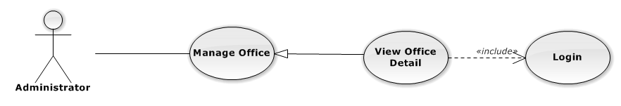

Figure 96: View Office Detail Use-Case Diagram

###### View Office Detail Use-Case Specification

|  |  |  |  |
| --- | --- | --- | --- |
| USE-CASE SPECIFICATION | | | |
| Use-case No. | UC0081 | Use-case Version | 1.0 |
| Use-case Name | View Office Detail | | |
| Author | Trần Anh Tuấn | | |
| Date | 09/10/2014 | Priority | Normal |
| Actor:  Administrator  Summary:  Staff can view detail of office information  Goal:  Helps staff to view offfice information  Triggers:   * On User Control Panel click on “Quản lí văn phòng**”,** * Click click on “Chi tiết” button * Click on name’s office link.   Preconditions:   * Must be logged-in * The page is fully loaded   Post Conditions:  Success: The detail offfice information is displayed  Failure: Do nothing  Main Success Scenario:   |  |  |  | | --- | --- | --- | | *Step* | *User* | *System* | | 1 | Staff click on “chi tiết” button or click on name’s offfce link  [Alternative 1], [Alternative 2], [Alternative 3] | The detail offfice information is displayed |   Alternative Scenario:   |  |  |  | | --- | --- | --- | | *#* | *User* | *System* | | 1 | Click on [X] button, “Đóng” button, or click out of modal | Modal popup is close | | 2 | If staff login with Id=”1”, Click on “Chỉnh sửa” button | Staff can update information of office (ref 3.2.2.2.4. Update office) | | 3 | If staff login with Id=”1”, Click on “Hoạt động lại” or “Ngừng hoạt động” link | Staff can Deactivate/Activate office (ref 3.2.2.2.5. Deactivate/Activate office) |   Exceptions:  N/A  Relationships:  Management office.  Business Rules:  Only Staff login with role “Admin” can be use this function. | | | |

##### Add New Office

###### Add New Office Use-Case Diagram

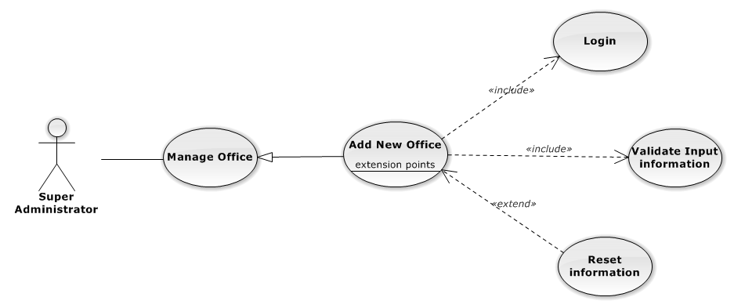

Figure 97: Add New Office Use-Case Diagram

###### Add New Office Use-Case Specification

|  |  |  |  |
| --- | --- | --- | --- |
| USE CASE SPECIFICATION | | | |
| Use-case No. | UC0082 | Use-case Version | 1.0 |
| Use-case Name | Add New Office | | |
| Author | Trần Anh Tuấn | | |
| Date | 09/10/2014 | Priority | Normal |
| Actor:  Supper Administrator.  Summary:  Insert new office in the system.  **Goal:**  Add new office.  Triggers:  On User Control Panel click on “Quản lí nhân viên” link, at “Quản lí nhân viên” page click on “Thêm văn phòng” button.  Preconditions:   * Logged-in to system. * The page is fully loaded   Post Conditions:  Success:   * New office is inserted into database, message show “Thêm văn phòng thành công” and display on “Quản lí văn phòng” screen. * New office’s status is “Đang hoạt động”.   Failure:  Show error message “Thêm văn phòng thất bại, hãy kiểm tra lại kết nối database”.  Main Success Scenario:   |  |  |  | | --- | --- | --- | | *Step* | *User* | *System* | | 1 | Administrator click on “Thêm văn phòng” button at “Quản lí văn phòng”page. | Modal popup is displayed with fields for input information of new office. | | 2 | Fill information into fields and click button “Thêm mới”  [Alternative 1]  [Exception 2], [Exception 3] | Modal popup is close  System display successful message “Thêm văn phòng thành công!”  Update list office on page |   Alternative Scenario:   |  |  |  | | --- | --- | --- | | *#* | *User* | *System* | | 1 | Click “Làm trống” button | All input field reset to blank. |   Exceptions:   |  |  |  | | --- | --- | --- | | *Step* | *User* | *System* | | 1 | Field “Tên văn phòng” are blank | Shows error message “Nhập tên văn phòng!” | | Field “Địa chỉ văn phòng”, are blank | Shows error message “Nhập địa chỉ văn phòng!” | | Field “Người quản lí” are blank | Shows error message “Nhập tên người quản lí văn phòng!” | | Field “Ðiện thoại” are blank | Shows error message “Nhập số điện thoại văn phòng!” | | Field “Email” are blank | Shows error message “Hãy nhập Email của văn phòng!” | | Input “Email” not follow the rule | Shows error message “Hãy nhập địa chỉ email đúng!” | | 2 | System cannot insert office to data base. | Shows error message “Thêm văn phòng thất bại!” | | 3 | System error insert office to data base. | Shows error message “Thêm văn phòng thất bại!", "Hãy kiểm tra lại kết nối data base”. |   Relationships:  Manage Office  Business Rules:  Only Staff with id=”1” (Supper Administrator)can be use this function. | | | |

##### Edit Office

###### Edit Office Use-Case Diagram

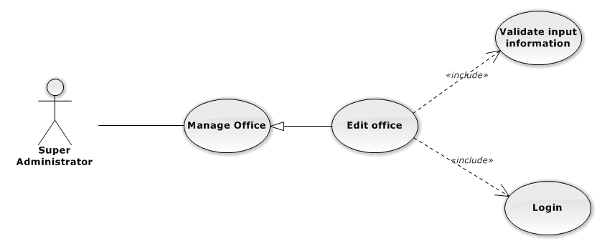

Figure 98: Edit Office Use-Case Diagram

###### Edit Office Use-Case Specification

|  |  |  |  |
| --- | --- | --- | --- |
| USE CASE SPECIFICATION | | | |
| Use-case No. | UC0083 | Use-case Version | 1.0 |
| Use-case Name | Edit Office | | |
| Author | Trần Anh Tuấn | | |
| Date | 09/10/2014 | Priority | Normal |
| Actor:  Supper Administrator.  Summary:  Supper Administrator can update information of office.  **Goal:**  Helps Supper Administrator update information of office and save to database system.  Triggers:   * Supper Administrator goes to “Quản lý văn phòng” screen, click button “Chỉnh Sửa” and modify information, after that click button “Lưu Chỉnh Sửa”. * Supper Administrator goes to “Chi tiết nhân viên” Popup screen, click on “Chỉnh Sửa” button and modify information, after that click button “Lưu Chỉnh Sửa”.   Preconditions:   * Logged-in to system. * The page is fully loaded   Post Conditions:  Success:  Information of office is updated and saves to database, message show “Cập nhật chi tiết văn phòng thành công” and display information after update on “Quản lý văn phòng” screen.  Failure:  Show error message “Cập nhật chi tiết văn phòng thất bại!”  Main Success Scenario:   |  |  |  | | --- | --- | --- | | *Step* | *User* | *System* | | 1 | Administrator click on “Chỉnh sửa” button at “Quản lí văn phòng” screen. | Modal popup is displayed with fields for input information of new office. | | 2 | Edit information into fields and click button “Lưu chỉnh sửa”  [Alternative 1]  [Exception 1], [Exception 2], [Exception 3] | Modal popup is close  System display successful message “Cập nhật chi tiết văn phòng thành công!”  Update list office on page |   Alternative Scenario:   |  |  |  | | --- | --- | --- | | *#* | *User* | *System* | | 1 | Click on [X] button, “Đóng” button, or click out of modal | Modal popup is close. |   Exceptions:   |  |  |  | | --- | --- | --- | | *Step* | *User* | *System* | | 1 | Field “Tên văn phòng” are blank | Shows error message “Nhập tên văn phòng!” | | Field “Địa chỉ văn phòng”, are blank | Shows error message “Nhập địa chỉ văn phòng!” | | Field “Người quản lí” are blank | Shows error message “Nhập tên người quản lí văn phòng!” | | Field “Ðiện thoại” are blank | Shows error message “Nhập số điện thoại văn phòng!” | | Field “Email” are blank | Shows error message “Hãy nhập Email của văn phòng!” | | Input “Email” not follow the rule | Shows error message “Hãy nhập địa chỉ email đúng!” | | 2 | System cannot update office to data base. | Shows error message “Cập nhật chi tiết văn phòng thất bại!” | | 3 | System error update office to data base. | Shows error message “Cập nhật chi tiết văn phòng thất bại! ", "Hãy kiểm tra lại kết nối database”. |   Relationships:  Manage Office  Business Rules:  Only Staff with id=”1”( Supper Administrator) can be use this function. | | | |

##### Deactivate/Activate Office

###### Deactivate/Activate Office Use-Case Diagram

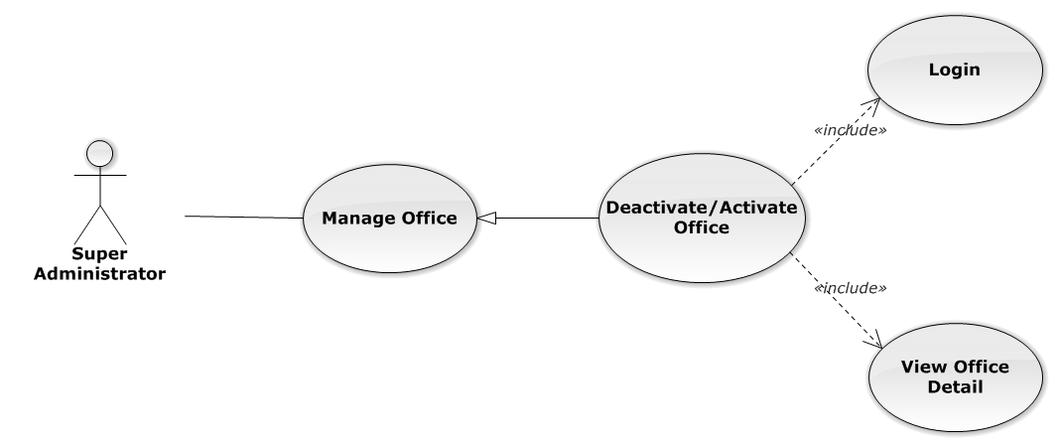

Figure 99: Deactivate/Activate Office Use-Case Diagram

###### Deactivate/Activate Office Use-Case Specification

|  |  |  |  |
| --- | --- | --- | --- |
| USE CASE SPECIFICATION | | | |
| Use-case No. | UC0084 | Use-case Version | 1.0 |
| Use-case Name | Deactivate/Activate office | | |
| Author | Trần Anh Tuấn | | |
| Date | 09/10/2014 | Priority | Normal |
| Actor:  Supper Administrator.  Summary:  Supper Administrator can change status of Office to De active or Active.  **Goal:**  Helps Supper Administrator update Status of Office and save to database system.  Triggers:   * Supper Administrator wants to update Status of office. * Supper Administrator goes “Chi tiết văn phòng” screen Pop-Up, Click button “Ngừng hoạt động văn phòng” or “Hoạt động lại”. After that click on “Bỏ qua” or “Xác nhận” button to confirm change status Office.   Preconditions:   * Logged-in to system. * The page is fully loaded   Post Conditions:  Success:  Information of Office is updated and saves to database, message show “Văn phòng đã hoạt động lại!” or “Văn phòng đã ngừng hoạt động!” and display information after update on “Quản lý văn phòng” screen.  Failure:  Show error message “Chỉnh hoạt động văn phòng thất bại!  Main Success Scenario:   |  |  |  | | --- | --- | --- | | *Step* | *User* | *System* | | 1 | Administrator click on “Chỉnh sửa” button at “Quản lí văn phòng” screen. | Show “Chi tiết văn phòng” Pop-up information. | | 2 | On “Chi tiết văn phòng” Pop-up click button “Ngừng hoạt động văn phòng” if Office have status “Đang hoạt động” or Click button “Hoạt động lại” if Office have status "Ngừng hoạt động”.  [Alternative 1] | Display message box confirm “Bạn có muốn thực hiện thao tác này” with two button “Xác nhận” and “Bỏ qua” | | 3 | User click “Bỏ qua” button | Status of Office not change comeback to “Chi tiết văn phòng” Pop-up screen. | | 4 | User click “ Xác nhận” button  [Exception 1], [Exception 2] | Status of Office is change and comeback to “Quản lí văn phòng” screen |   Alternative Scenario:   |  |  |  | | --- | --- | --- | | *#* | *User* | *System* | | 1 | Click on [X] button, “Đóng” button, or click out of modal | Modal popup is close |   Exceptions:   |  |  |  | | --- | --- | --- | | *#* | *User* | *System* | | 1 | System error update status office to data base. | Shows error message “Chỉnh hoạt động văn phòng thất bại!", "Hãy kiểm tra lại kết nối database!”. | | 2 | System error update status office to data base. | Shows error message “Chỉnh hoạt động văn phòng thất bại!", "Có lỗi xảy ra trong quá trình xóa văn phòng!”. |   Relationships:  Manage Office  Business Rules:  Only Staff with id=”1”( Supper Administrator) can be use this function. | | | |

##### Search Office

###### Search Office Use-Case Diagram

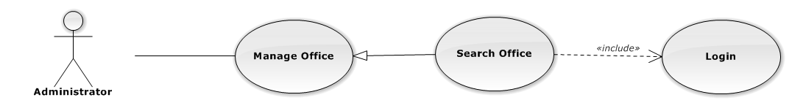

Figure 100: Search Office Use-Case Diagram

###### Search Office Use-Case Specification

|  |  |  |  |
| --- | --- | --- | --- |
| USE CASE SPECIFICATION | | | |
| Use-case No. | UC0085 | Use-case Version | 1.0 |
| Use-case Name | Search Office | | |
| Author | Trần Anh Tuấn | | |
| Date | 09/10/2014 | Priority | Normal |
| Actor:  Administrator.  Summary:  Administrator search Office in list of office  **Goal:**  Helps Administrator search Office.  Triggers:   * Manager wants to search office. * Manager goes to “Quản lý văn phòng” screen, input word into “Tìm Kiếm” textbox.   Preconditions:   * Logged-in as “Admin” role. * The page is fully loaded   Post Conditions:  Success: List of Office map with word search is displayed.  Failure: Do nothing  Main Success Scenario:   |  |  |  | | --- | --- | --- | | *Step* | *User* | *System* | | 1 | In “Quản lý văn phòng” screen, input key word at “Tìm kiếm” textbox. | List of office mapping with word search is display. |   Alternative Scenario:  N/A  Exceptions:  N/A  Relationships:  Manage Office  Business Rules:  N/A | | | |

#### Statistic

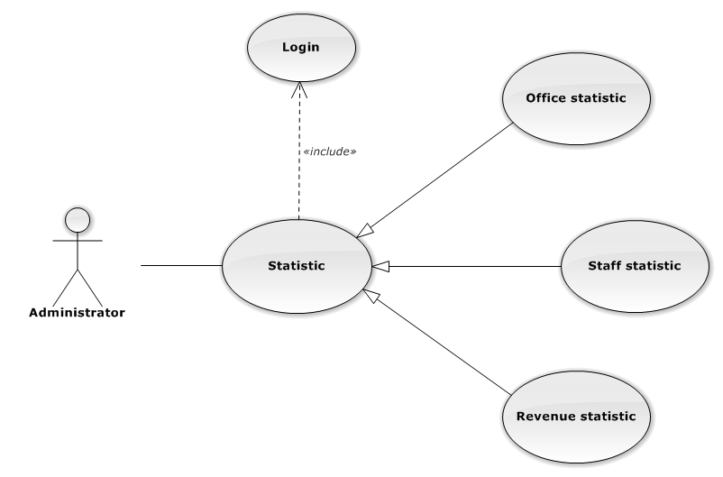

Figure 101: Statistic Use-Case Diagram

##### Office Statistic

###### Office Statistic Use-Case Diagram

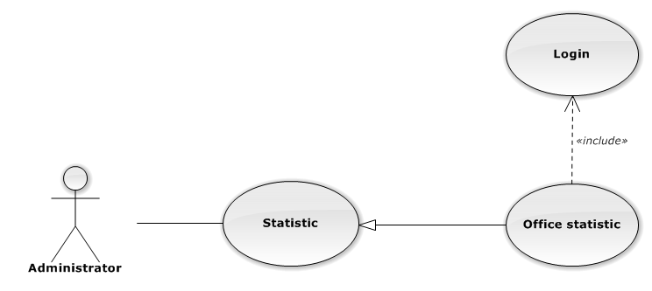

Figure 102: Office Statistic Use-Case Diagram

###### Office Statistic Use-Case Specification

|  |  |  |  |
| --- | --- | --- | --- |
| USE CASE SPECIFICATION | | | |
| Use-case No. | UC0115 | Use-case Version | 1.0 |
| Use-case Name | Office Statistic | | |
| Author | Đặng Nguyễn Khiêm | | |
| Date | 09/10/2014 | Priority | Normal |
| Actor:  Administrator.  Summary:  The statistic about office.  Goal:  The purpose of Office Statistic use case is allowing User to view Office index in graphs.  Triggers:  User choose “Thống kê” link in menu.  Preconditions:  User is authenticated.  Post Conditions:  Success: The graphs are showed.  Failure: N/A  Main Success Scenario:   |  |  |  | | --- | --- | --- | | *Step* | *User* | *System* | | 1 | Click “Văn phòng” tab in statistic page. | The graphs are loaded. |   Alternative Scenario:  N/A  Exceptions:  N/A  Relationships:  Statistic  Business Rules:  N/A | | | |

##### Staff Statistic

###### Staff Statistic Use-Case Diagram

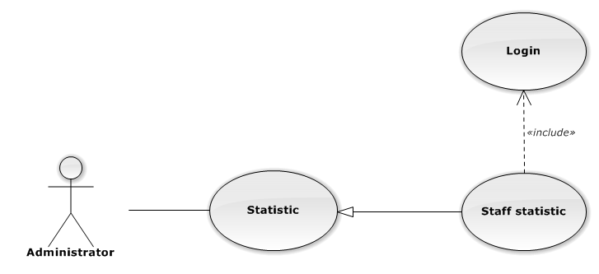

Figure 103: Staff Statistic Use-Case Diagram

###### Staff Statistic Use-Case Specification

|  |  |  |  |
| --- | --- | --- | --- |
| USE CASE SPECIFICATION | | | |
| Use-case No. | UC0116 | Use-case Version | 1.0 |
| Use-case Name | Staff Statistic | | |
| Author | Đặng Nguyễn Khiêm | | |
| Date | 09/10/2014 | Priority | Normal |
| Actor:  Administrator.  Summary:  The statistic about staffs.  Goal:  The purpose of Staff Statistic use case is allowing User to view Staff index in graphs.  Triggers:  User choose “Thống kê” link in menu.  Preconditions:  User is authenticated.  Post Conditions:  Success: The graphs are showed.  Failure: N/A  Main Success Scenario:   |  |  |  | | --- | --- | --- | | *Step* | *User* | *System* | | 1 | Click “Nhân viên” tab in statistic page. | The graphs are loaded. |   Alternative Scenario:  N/A  Exceptions:  N/A  Relationships:  Statistic  Business Rules:  N/A | | | |

##### Revenue Statistic

###### Revenue Statistic Use-Case Diagram

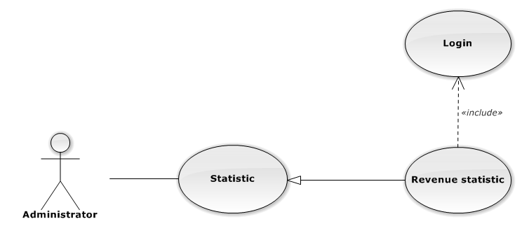

Figure 104: Revenue Statistic Use-Case Diagram

###### Revenue Statistic Use-Case Specification

|  |  |  |  |
| --- | --- | --- | --- |
| USE CASE SPECIFICATION | | | |
| Use-case No. | UC0117 | Use-case Version | 1.0 |
| Use-case Name | Revenue Statistic | | |
| Author | Đặng Nguyễn Khiêm | | |
| Date | 09/10/2014 | Priority | Normal |
| Actor:  Administrator.  Summary:  The statistic about revenue.  Goal:  The purpose of Revenue Statistic use case is allowing User to view Revenue index in graphs.  Triggers:  User choose “Thống kê” link in menu.  Preconditions:  User is authenticated.  Post Conditions:  Success: The graphs are showed.  Failure: N/A  Main Success Scenario:   |  |  |  | | --- | --- | --- | | *Step* | *User* | *System* | | 1 | Click “Doanh thu” tab in statistic page. | The graphs are loaded. |   Alternative Scenario:  N/A  Exceptions:  N/A  Relationships:  Statistic  Business Rules:  N/A | | | |

### Non-Functional Requirements

#### Reliability

The systems with high reliability, can be used like “always on” system. However, if exist accident, it's not need require immediate repair. All information and Cases can be updated later.

#### Availability

The system always responds to every user who got permission. The expected downtime for maintenance is about 5 minutes each time.

#### Security

Users must login for using the system. The user passwords are MD5 encrypted before being put into Database. Staff are restricted to view other user’s information and any function. Super Administrator has full permission to use the system.

#### Maintainability

Each component only perform specific functions so the modification of a component will not affect other components.

#### Portability

The system can be accessed anywhere with a web browser and Internet connection. It can be run on any browser, but recommend for user is Mozilla Firefox with highest version.

#### Performance

N/A

## Entity Relationship Diagram

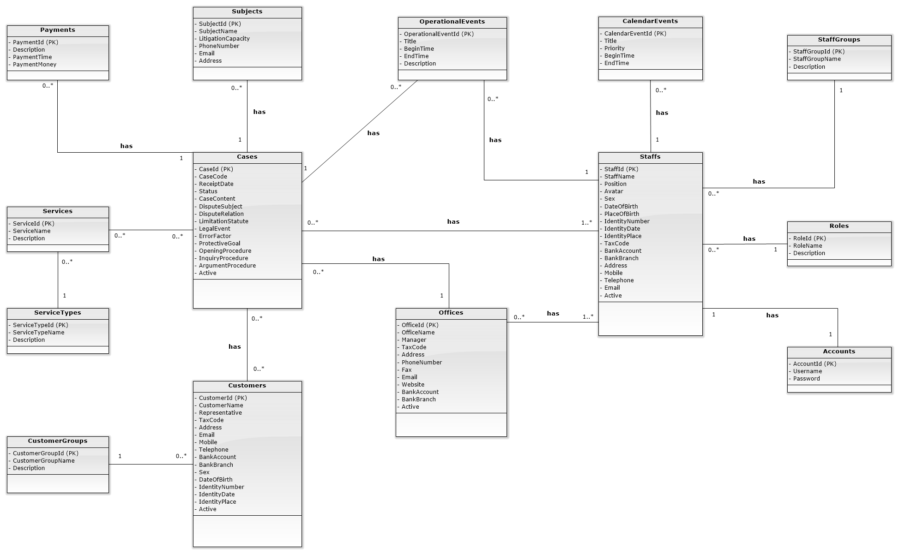

Figure 105: Entity Relationship Diagram

# Software Design Specification

## Design Overview

* This document describes the detailed design for both architectural and user interface design of the Law Firm Management System. It includes the architectural design and the detailed design of common functions and business functions. It also includes the design of database model. Each section in this report will describe a perspective of the system specifically.
* The architectural design describes the overall architecture of the system, and the architecture of each main component and subsystem. It will describe the patterns being used, the role of each component and the role of the system in the working environment, gives you an overview how the system is about to work.
* The detailed design describes static and dynamic structure for each component and function. It includes class diagrams, class explanations, and sequence diagrams of the main use cases.
* The database design describes the relationship between entities, and details of each entity.
* The user interface design describes the layout of the system, and some design for the screens.

## System Architectural Design

### Choice of System Architecture

#### System Architecture



Figure 4-1: System Architecture

* Database: This is the central data storage for the system.
* Management site: This is the website to manage Case, Customer, Staff, Service, Office.

#### MVC Architecture

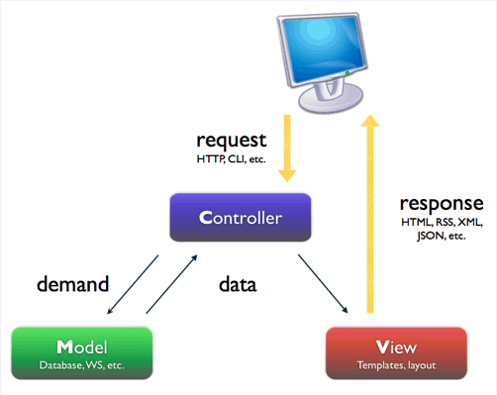

Figure 4-2: MVC Architecture

* Model: Functions that interact with the database or perform complex operations. In this architecture, model includes business logic and data access in one layer.
* View: The view displays the data and also takes input form user. It renders the model data into a form, such as graphics, buttons, and tables, and so on to display to the user.
* Controller: The controller handles all requests coming from the view or user interface. The data flows to whole application are controlled by controller.

### Discussion of Alternative Designs

### Description of System Interface

#### User Interfaces

UI should be simple, model and easy to use.

Support drag & drop easy for using Calendar Event.

#### Hardware Interfaces

The site should be deployed and available to a many devices can be use online.

* Server hardware: Support Windows hosting
* Client hardware: Can be desktop, laptop, smart phone, tablet,.. have internet connection

#### Software Interfaces

Run best on FireFox browser.

#### Communication Interfaces

The system using HTTP protocol to communicate between server and clients.

### Architectural Presentation

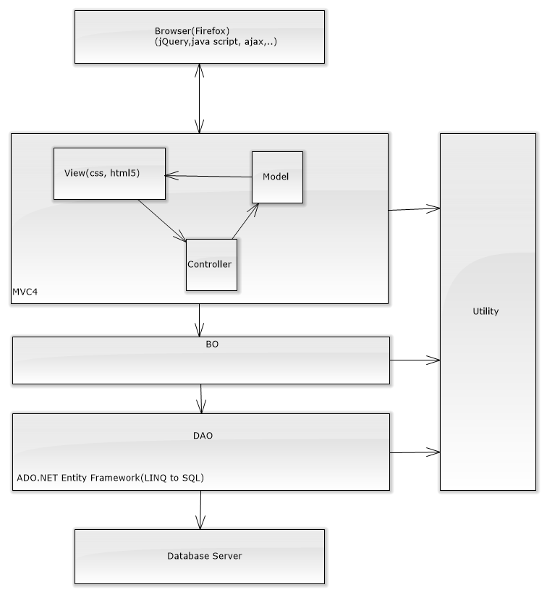

Figure 4-3: System overview

### Package Diagram

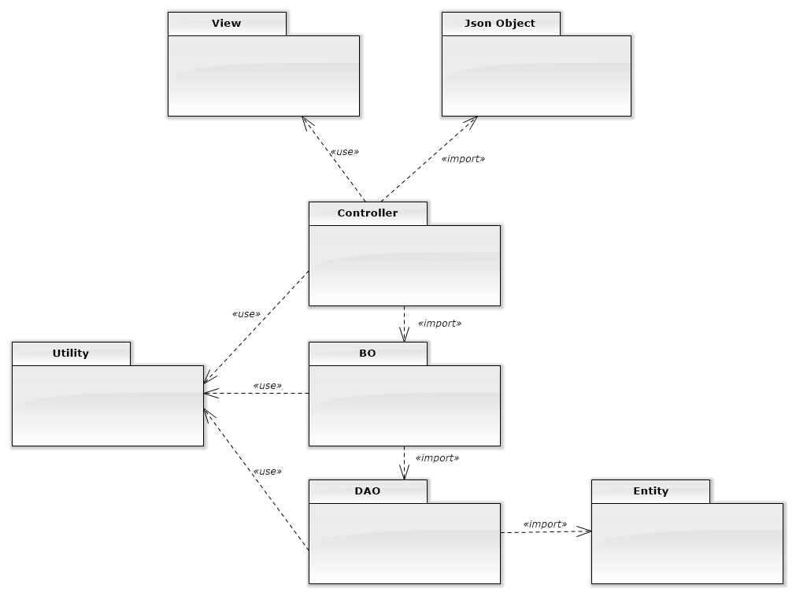

Figure 4-4: Package Diagram

## Detailed Design

### Data Model

#### Data Model Class Diagram

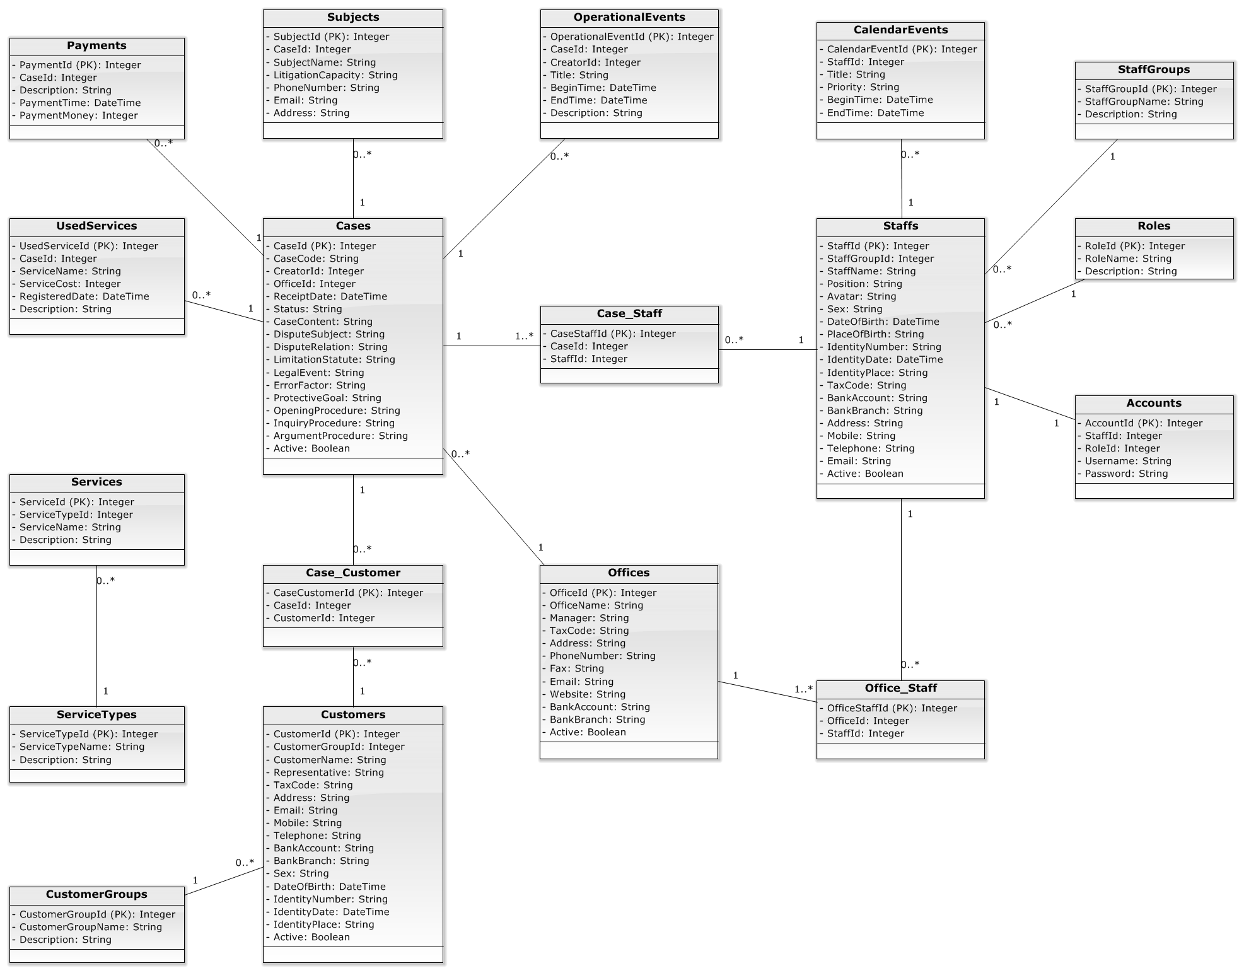

Figure 4-6: Data Model Class Diagram

### Controller

#### Controller Class Diagram

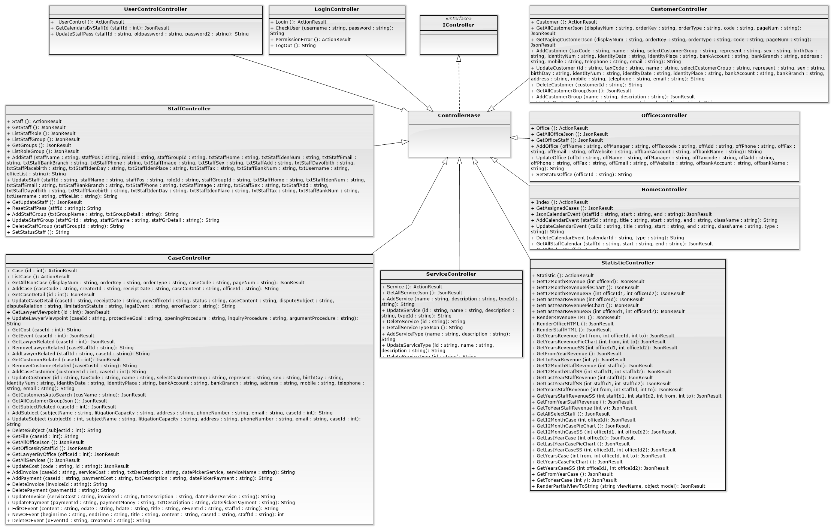

Figure 4-7: Controller Class Diagram

#### Controller Class Diagram Explanation

##### UserControlController

|  |  |  |  |  |
| --- | --- | --- | --- | --- |
| **Class** | **UserControlController** | | | |
| **Description** | This class excute all action of user controll. | | | |
| **Base Class** | ControllerBase | | | |
| **Constructor** | N/A | | | |
| **Prototype** | N/A | | | |
| **Source File** | UserControlController.cs | | | |
| **Namespace** | LFMS.Controllers | | | |
| **Attributes** | N/A | | | |
| **Methods** | **Name** | **Input** | **Output** | **Description** |
| _UserControl | N/A | ActionResult | This method excute to return partialview of user control. |
| GetCalendarsByStaffId | int staffId | JsonResult | This method excute to call method of userControlBLO to get calendar of staff |
| UpdateStaffPass | int staffId  string oldpassword string password2 | String | This method excute to call method of userControlBLO to update new password of staff. |

##### CustomerController

|  |  |  |  |  |
| --- | --- | --- | --- | --- |
| **Class** | **CustomerController** | | | |
| **Description** | This class excute all action of customer | | | |
| **Base Class** | ControllerBase | | | |
| **Constructor** | N/A | | | |
| **Prototype** | N/A | | | |
| **Source File** | CustomerController.cs | | | |
| **Namespace** | LFMS.Controllers | | | |
| **Attributes** | N/A | | | |
| **Methods** | **Name** | **Input** | **Output** | **Description** |
| _Customer | N/A | ActionResult | This method excute to return view of customer. |
| GetAllCustomerJson | int displayNum int orderKey string orderType  int pageNum | JsonResult | This method excute to call method of CustomerBLO to get all customer after paging and return a view of customer. |
| GetPagingCustomerJson | int displayNum int orderKey string orderType  int pageNum | JsonResult | This method excute to call method of CustomerBLO to get all customer after paging and return a json object. |
|  | AddCustomer | string taxCode  string name  int selectCustomerGroup  string represent string sex  string birthDay  string identityNum string identityDate string identityPlace  string bankAccount string bankBranch  string address string mobile string telephone  string email | String | This method excute to call method of CustomerBLO to add new a customer. |
|  | UpdateCustomer | Int id  string taxCode  string name  int selectCustomerGroup  string represent string sex  string birthDay  string identityNum string identityDate string identityPlace  string bankAccount string bankBranch  string address string mobile string telephone  string email | String | This method excute to call method of CustomerBLO to update information of a customer. |
|  | DeleteCustomer | int customerId | String | This method excute to call method of CustomerBLO to delete a customer. |
|  | GetAllCustomerGroupJson | N/A | JsonResult | This method excute to call method of CustomerBLO to get all group of customer and return partialview. |
|  | AddCustomerGroup | string name  string description | String | This method excute to call method of CustomerBLO to add new a group of customer. |
|  | UpdateCustomerGroup | int id  string name  string description | String | This method excute to call method of CustomerBLO to update a group of customer. |
|  | DeleteCustomerGroup | int groupId | String | This method excute to call method of CustomerBLO to delete a group of customer. |

##### StaffController

|  |  |  |  |  |
| --- | --- | --- | --- | --- |
| **Class** | **StaffController** | | | |
| **Description** | This class excute all action of staff | | | |
| **Base Class** | ControllerBase | | | |
| **Constructor** | N/A | | | |
| **Prototype** | N/A | | | |
| **Source File** | StaffController.cs | | | |
| **Namespace** | LFMS.Controllers | | | |
| **Attributes** | N/A | | | |
| **Methods** | **Name** | **Input** | **Output** | **Description** |
| Staff | N/A | ActionResult | This method excute to return view of staff. |
| GetStaff | N/A | JsonResult | This method excute to call method of StaffBLO to get all staff and return a view of all staff. |
| ListStaffRole | N/A | JsonResult | This method excute to call method of StaffBLO to get all role of staff. |
|  | ListStaffGroup | N/A | JsonResult | This method excute to call method of StaffBLO to get all group of staff. |
|  | GetGroups | N/A | JsonResult | This method excute to call method of StaffBLO to get all group of staff and return partialview. |
|  | ListRoleGroup | N/A | JsonResult | This method excute to call method of StaffBLO to get all role of each group of staff. |
|  | AddStaff | string staffName  string staffPos  int roleId  int staffGroupId  string txtStaffHome  string txtStaffIdenNum  string txtStaffEmail  string txtStaffBankBranch  string txtStaffPhone  string txtStaffImage  string txtStaffSex  string txtStaffAdd  string txtStaffDayofbith  string txtStaffPlacebirth  string txtStaffIdenDay string txtStaffIdenPlace  string txtStaffTax  string txtStaffBankNum  string txtUsername  int txtAppendantPeople string cboOffice | string | This method excute to call method of StaffBLO to add new a staff. |
|  | UpdateStaff | string staffName  string staffPos  int roleId  int staffGroupId  string txtStaffHome  string txtStaffIdenNum  string txtStaffEmail  string txtStaffBankBranch  string txtStaffPhone  string txtStaffImage  string txtStaffSex  string txtStaffAdd  string txtStaffDayofbith  string txtStaffPlacebirth  string txtStaffIdenDay string txtStaffIdenPlace  string txtStaffTax  string txtStaffBankNum  string txtUsername  int txtAppendantPeople string cboOffice | String | This method excute to call method of StaffBLO to add update information of staff. |
|  | GetUpdateStaff | N/A | JsonResult | This method excute to call method of StaffBLO to get all staff after update. |
|  | ResetStaffPass | int staffId | String | This method excute to call method of StaffBLO to reset new password for staff. |
|  | AddStaffGroup | string txtGroupName  string txtGroupDetail | string | This method excute to call method of StaffBLO to add new a group of staff. |
|  | UpdateStaffGroup | int staffGrId  string staffGrName  string staffGrDetail | String | This method excute to call method of StaffBLO to add update information of a group of staff. |
|  | DeleteStaffGroup | int staffGroupId; | String | This method excute to call method of StaffBLO to delete a group of staff. |
|  | SetStatusStaff | int staffId; | String | This method excute to call method of StaffBLO to set status of staff. |

##### CaseController

|  |  |  |  |  |
| --- | --- | --- | --- | --- |
| **Class** | **CaseController** | | | |
| **Description** | This class excute all action of case. | | | |
| **Base Class** | ControllerBase | | | |
| **Constructor** | N/A | | | |
| **Prototype** | N/A | | | |
| **Source File** | CaseController.cs | | | |
| **Namespace** | LFMS.Controllers | | | |
| **Attributes** | N/A | | | |
| **Methods** | **Name** | **Input** | **Output** | **Description** |
| Case | int id | ActionResult | This method excute to get authorize and return view of case. |
| ListCase | N/A | ActionResult | This method excute to return view of list of case. |
| GetAllJsonCasefRole | int displayNum  int orderKey  string  string caseCode  int pageNum | JsonResult | This method excute to call method of CaseBLO to get all case after paging. |
|  | AddCase | string caseCode  int creatorId  string receiptDate  string caseContent  int officeId | String | This method excute to call method of CaseBLO to get add new a case. |
|  | GetCaseDetail | int id | JsonResult | This method excute to call method of CaseBLO to get detail of a case. |
|  | GetLawyerViewpoint | int id | JsonResult | This method excute to call method of CaseBLO to get view point of lawyer. |
|  | UpdateLawyerViewpoint | int caseId  string protectiveGoal  string openingProcedure  string inquiryProcedure  string argumentProcedure | string | This method excute to call method of CaseBLO to update view point of lawyer. |
|  | GetCost | int caseId | JsonResult | This method excute to call method of CaseBLO to get cost of a case. |
|  | GetEvent | int caseId | JsonResult | This method excute to call method of CaseBLO to get all event of a case. |
|  | GetLawyerRelated | int caseId | JsonResult | This method excute to call method of CaseBLO to get all lawyer related with a case. |
|  | RemoveLawyerRelated | int caseStaffId | string | This method excute to call method of CaseBLO to remove lawyer from a case. |
|  | AddLawyerRelated | int staffId  int caseId | String | This method excute to call method of CaseBLO to add lawyer to a case. |
|  | GetCustomerRelated | int caseId | JsonResult | This method excute to call method of CaseBLO to get customer related with a case and return partialview. |
|  | RemoveCustomerRelated | int caseCusId | String | This method excute to call method of CaseBLO to remove customer from a case. |
|  | AddCaseCustomer | int customerId,  int caseId | String | This method excute to call method of CaseBLO to add customer to a case. |
|  | UpdateCustomer | int id  string taxCode  string name  int selectCustomerGroup  string represent  string sex  string birthDay  string identityNum  string identityDate  string identityPlace  string bankAccount  string bankBranch  string address string mobile  string telephone  string email | String | This method excute to call method of CustomerBLO to update information of customer. |
|  | GetCustomersAutoSearch | string cusName | JsonResult | This method excute to call method of CustomerBLO to get customer in auto search. |
|  | GetAllCustomerGroupJson | N/A | JsonResult | This method excute to call method of CustomerBLO to get all group of customer. |
|  | GetSubjectRelated | int caseId | JsonResult | This method excute to call method of CaseBLO to get subject which related with a case and return partialview ofSubject. |
|  | AddSubject | string subjectName,  string litigationCapacity, string address,  string phoneNumber, string email,  int caseId | String | This method excute to call method of CaseBLO to add new a Subject related to a case. |
|  | UpdateSubject | int subjectId  string subjectName,  string litigationCapacity, string address,  string phoneNumber, string email,  int caseId | String | This method excute to call method of CaseBLO to update a Subject. |
|  | DeleteSubject | int subjectId | String | This method excute to call method of CaseBLO to delete a Subject. |
|  | GetFile | int caseId | String | This method excute to call method of CaseBLO to get file which related with a case. |
|  | GetAllOfficeJson | N/A | JsonResult | This method excute to call method of officeBLO to get all office. |
|  | GetOfficesByStaffId | int StaffId | JsonResult | This method excute to call method of officeBLO to get all office by staff id. |
|  | GetLawyerByOffice | int officeId | JsonResult | This method excute to call method of staffBLO to get all lawyer by office id. |
|  | GetAllServices | N/A | JsonResult | This method excute to call method of ServiceBLO to get all service. |
|  | UpdateCost | string code  int id | JsonResult | This method excute to call method of caseBLO to update cost of case. |
|  | AddInvoice | int caseId  int serviceCost  string txtDescription string datePickerService  string serviceName | String | This method excute to call method of caseBLO to add invoice to a case. |
|  | AddPayment | int caseId  int serviceCost  string txtDescription string datePickerService | String | This method excute to call method of caseBLO to add payment to a case. |
|  | DeleteInvoice | int invoiceId  int caseId | String | This method excute to call method of caseBLO to delete invoice of case. |
|  | DeletePayment | int paymentId  int caseId | String | This method excute to call method of caseBLO to delete pament of case. |
|  | UpdateInvoice | int serviceCost  int invoiceId  string txtDescription string datePickerService | String | This method excute to call method of caseBLO to update invoice to a case. |
|  | UpdatePayment | int paymentId  int paymentMoney  string txtDescription string datePickerService | String | This method excute to call method of caseBLO to update payment to a case. |
|  | EditOEvent | string content  string edate  string bdate  string title  int oEventId  int creatorId  var staffId | String | This method excute to call method of caseBLO to update Operation event of a case. |
|  | NewOEvent | string beginTime  string endTime  string content  int caseId  var staffId | int | This method excute to call method of caseBLO to add new an Operation event to a case. |
|  | DeleteOEvent | int oEventId  int creatorId  var staffId | String | This method excute to call method of caseBLO to delete an Operation event of a case. |
|  | CreateCusAndAddToCase | int caseId  string taxCode  string name  int selectCustomerGroup  string represent  string sex  string birthDay  string identityNum  string identityDate  string identityPlace  string bankAccount  string bankBranch  string address string mobile  string telephone  string email | String | This method excute to call method of customerBLO to add new a customer and add to a case. |

##### OfficeController

|  |  |  |  |  |
| --- | --- | --- | --- | --- |
| **Class** | **OfficeController** | | | |
| **Description** | This class excute all action of office | | | |
| **Base Class** | ControllerBase | | | |
| **Constructor** | N/A | | | |
| **Prototype** | N/A | | | |
| **Source File** | OfficeController.cs | | | |
| **Namespace** | LFMS.Controllers | | | |
| **Attributes** | N/A | | | |
| **Methods** | **Name** | **Input** | **Output** | **Description** |
| Office | N/A | ActionResult | This method excute to return view of office. |
| GetAllOfficeJson | N/A | JsonResult | This method excute to call method of OfficeBLO to get all office. |
| GetOfficeStaff | N/A | JsonResult | This method excute to call method of OfficeBLO to get office and staff of office. |
|  | AddOffice | string offName  string offManager  string offTaxcode  string offAdd  string offPhone  string offFax  string offEmail  string offWebsite  string offbankAccount  string offbankName | String | This method excute to call method of OfficeBLO to add new an office. |
|  | UpdateOffice | int offId  string offName  string offManager  string offTaxcode  string offAdd  string offPhone  string offFax  string offEmail  string offWebsite  string offbankAccount  string offbankName | String | This method excute to call method of OfficeBLO to update an office. |
|  | SetStatusOffice | N/A | String | This method excute to call method of OfficeBLO to set status of an office. |

##### LoginController

|  |  |  |  |  |
| --- | --- | --- | --- | --- |
| **Class** | **LoginController** | | | |
| **Description** | This class excute all action of Login. | | | |
| **Base Class** | ControllerBase | | | |
| **Constructor** | N/A | | | |
| **Prototype** | N/A | | | |
| **Source File** | LoginController.cs | | | |
| **Namespace** | LFMS.Controllers | | | |
| **Attributes** | N/A | | | |
| **Methods** | **Name** | **Input** | **Output** | **Description** |
| Login | N/A | ActionResult | This method excute to return view of Login. |
| CheckUser | string username string password | String | This method excute to call method of UserBLO to check login. |
| PermissionError | N/A | ActionResult | This method excute to return view of Login error. |
|  | LogOut | N/A | string | This method excute to logout. |

##### HomeController

|  |  |  |  |  |
| --- | --- | --- | --- | --- |
| **Class** | **HomeController** | | | |
| **Description** | This class excute all action of Home | | | |
| **Base Class** | ControllerBase | | | |
| **Constructor** | N/A | | | |
| **Prototype** | N/A | | | |
| **Source File** | HomeController.cs | | | |
| **Namespace** | LFMS.Controllers | | | |
| **Attributes** | N/A | | | |
| **Methods** | **Name** | **Input** | **Output** | **Description** |
| Index | N/A | ActionResult | This method excute to return view of Home. |
| GetAssignedCases | N/A | JsonResult | This method excute to call method of CaseBLO and Office to get assigned case of staff and office. |
| JsonCalendarEvent | string start  string end int staffId | JsonResult | This method excute to call method of HomeBLO to get all calendar and operation event of staff. |
|  | AddCalendarEvent | int staffId  string title  string start string end string className | String | This method excute to call method of HomeBLO to get add new a calendar event. |
|  | UpdateCalendarEvent | int calId  string title  string start  string end  string className  string type  int staffId | String | This method excute to call method of HomeBLO to get update a calendar event. |
|  | DeleteCalendarEvent | int calendarId string type | String | This method excute to call method of HomeBLO to get delete a calendar event. |
|  | GetAllStaffCalendar | string staffId  string start  string end | JsonResult | This method excute to call method of HomeBLO to get all calendar event of all staff. |
|  | GetAllSelectStaff | N/A | JsonResult | This method excute to call method of HomeBLO to get account of seleted staff. |

##### ServiceController

|  |  |  |  |  |
| --- | --- | --- | --- | --- |
| **Class** | **ServiceController** | | | |
| **Description** | This class excute all action of service | | | |
| **Base Class** | ControllerBase | | | |
| **Constructor** | N/A | | | |
| **Prototype** | N/A | | | |
| **Source File** | ServiceController.cs | | | |
| **Namespace** | LFMS.Controllers | | | |
| **Attributes** | N/A | | | |
| **Methods** | **Name** | **Input** | **Output** | **Description** |
| Service | N/A | ActionResult | This method excute to return view of service. |
| GetAllServiceJson | N/A | JsonResult | This method excute to call method of ServiceBLO to get all service and return partialview. |
| AddService | string name  string description int typeId | String | This method excute to call method of ServiceBLO to add new a service. |
|  | UpdateService | int id  string name  string description int typeId | String | This method excute to call method of ServiceBLO to update a service. |
|  | DeleteService | int id | String | This method excute to call method of ServiceBLO to delete a service. |
|  | GetAllServiceTypeJson | N/A | JsonResult | This method excute to call method of ServiceBLO to get all type of service. |
|  | AddServiceType | string name  string description int typeId | String | This method excute to call method of ServiceBLO to add new a service type. |
|  | UpdateServiceType | int id  string name  string description int typeId | String | This method excute to call method of ServiceBLO to update a service type. |
|  | DeleteServiceType | int id | String | This method excute to call method of ServiceBLO to delete a service type. |

##### StatisticController

|  |  |  |  |  |
| --- | --- | --- | --- | --- |
| **Class** | **StatisticController** | | | |
| **Description** | This class excute all action of statistic. | | | |
| **Base Class** | ControllerBase | | | |
| **Constructor** | N/A | | | |
| **Prototype** | N/A | | | |
| **Source File** | StatisticController.cs | | | |
| **Namespace** | LFMS.Controllers | | | |
| **Attributes** | N/A | | | |
| **Methods** | **Name** | **Input** | **Output** | **Description** |
| Statistic | N/A | ActionResult | This method excute to return view of statistic. |
| Get12MonthRevenue | int officeId | JsonResult | This method excute to call method of StatisticBLO to get 12 month revenue by office id. |
| Get12MonthRevenuePieChart | N/A | JsonResult | This method excute to call method of StatisticBLO to get 12 month revenue to print pie chart. |
|  | Get12MonthRevenueSS | int officeId1  int officeId2 | JsonResult | This method excute to call method of StatisticBLO to get 12 month revenue of two office to compare. |
|  | GetLastYearRevenue | int officeId | JsonResult | This method excute to call method of StatisticBLO to get last year revenue of office. |
|  | GetLastYearRevenuePieChart | N/A | JsonResult | This method excute to call method of StatisticBLO to get last year revenue to print pie chart. |
|  | GetLastYearRevenueSS | int officeId1  int officeId2 | JsonResult | This method excute to call method of StatisticBLO to get last year revenue of two office to compare. |
|  | GetYearsRevenue | int from  int officeId  int to | JsonResult | This method excute to call method of StatisticBLO to year revenue to print chart. |
|  | GetYearsRevenuePieChart | int from  int to | JsonResult | This method excute to call method of StatisticBLO to year revenue to print pie chart. |
|  | GetYearsRevenueSS | int officeId1  int officeId2 | JsonResult | This method excute to call method of StatisticBLO to get year revenue of two office to compare. |
|  | GetFromYearRevenue | N/A | JsonResult | This method excute to call method of StatisticBLO to get from year revenue. |
|  | GetToYearRevenue | int y | JsonResult | This method excute to call method of StatisticBLO to get to year revenue. |
|  | Get12MonthStaffRevenue | int staffId | JsonResult | This method excute to call method of StatisticBLO to get to 12 month revenue of year of staff. |
|  | Get12MonthStaffSS | int staffId1  int staffId2 | JsonResult | This method excute to call method of StatisticBLO to get to 12 month revenue of year of two staff to compare. |
|  | GetLastYearStaffRevenue | int staffId | JsonResult | This method excute to call method of StatisticBLO to get revenue of last year of staff. |
|  | GetLastYearStaffSS | int staffId1  int staffId2 | JsonResult | This method excute to call method of StatisticBLO to get revenue of last year of two staff to compare. |
|  | GetYearsStaffRevenue | int from  int staffId  int to | JsonResult | This method excute to call method of StatisticBLO to revenue of year of staff. |
|  | GetYearsStaffRevenueSS | int staffId1  int staffId2  int from  int to | JsonResult | This method excute to call method of StatisticBLO to get revenue of year of two staff to compare. |
|  | GetFromYearStaffRevenue | N/A | JsonResult | This method excute to call method of StatisticBLO to get revenue of from year. |
|  | GetToYearStaffRevenue | int y | JsonResult | This method excute to call method of StatisticBLO to get revenue of to year. |
|  | GetAllSelectStaff | N/A | JsonResult | This method excute to call method of StatisticBLO to get account of seleted staff. |
|  | Get12MonthCase | int officeId | JsonResult | This method excute to call method of StatisticBLO to get number of case of office to print chart. |
|  | Get12MonthCasePieChart | N/A | JsonResult | This method excute to call method of StatisticBLO to get number of case of office to print pie chart. |
|  | Get12MonthCaseSS | int officeId1  int officeId2 | JsonResult | This method excute to call method of StatisticBLO to get number of case of two office to compare. |
|  | GetLastYearCase | int officeId | JsonResult | This method excute to call method of StatisticBLO to get number of case in last year of office to print chart. |
|  | GetLastYearCasePieChart | N/A | JsonResult | This method excute to call method of StatisticBLO to get number of case in last year of office to print pie chart. |
|  | GetLastYearCaseSS | int officeId1  int officeId2 | JsonResult | This method excute to call method of StatisticBLO to get number of case in last year of two office to compare. |
|  | GetYearsCase | int from  int officeId  int to | JsonResult | This method excute to call method of StatisticBLO to get number of case in year to print chart. |
|  | GetYearsCasePieChart | N/A | JsonResult | This method excute to call method of StatisticBLO to get number of case in year to print pie chart. |
|  | GetYearsCaseSS | int officeId1  int officeId2 | JsonResult | This method excute to call method of StatisticBLO to get number of case in year of two office to compare. |
|  | GetFromYearCase | N/A | JsonResult | This method excute to call method of StatisticBLO to get number of case from year. |
|  | GetToYearCase | int y | JsonResult | This method excute to call method of StatisticBLO to get number of case to year. |
|  | RenderPartialViewToString | string viewName, object model | string | This method excute to render partia lview. |

### Business

#### Business Logic Class Diagram

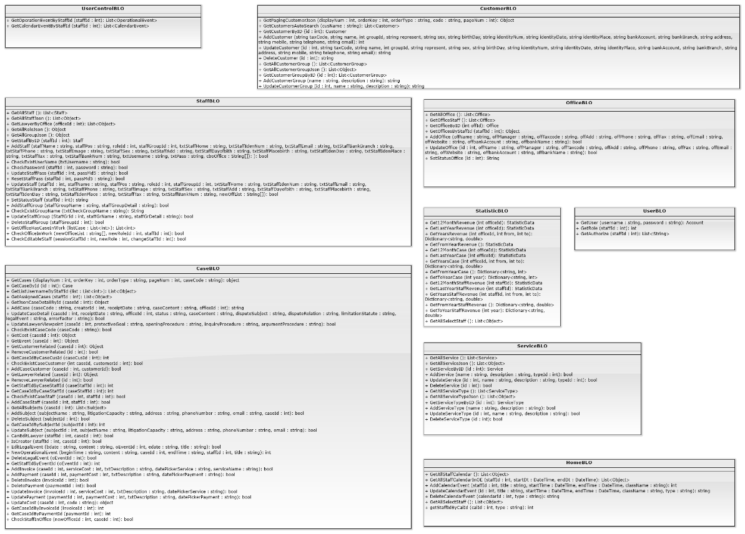

Figure 4-8: Business Class Diagram

#### Business Logic Class Diagram Explanation

##### UserBLO

|  |  |  |  |  |
| --- | --- | --- | --- | --- |
| **Class** | **UserBLO** | | | |
| **Description** | This method excute all action of uer which called from controller. | | | |
| **Base Class** | N/A | | | |
| **Constructor** | UserBLO | | | |
| **Prototype** | N/A | | | |
| **Source File** | UserBLO.cs | | | |
| **Namespace** | LFMS.Models.BLO | | | |
| **Attributes** | N/A | | | |
| **Methods** | **Name** | **Input** | **Output** | **Description** |
| GetUser | string username,  string password | Account | This method call method of userDAO to get user |
| GetRole | int staffId | List<String> | This method call method of userDAO to get role of user |
| GetAuthorize | int staffId | int | This method call method of userDAO to get authorize of user |

##### UserControlBLO

|  |  |  |  |  |
| --- | --- | --- | --- | --- |
| **Class** | **UserControlBLO** | | | |
| **Description** | This method excute all action of user control which called from controller. | | | |
| **Base Class** | N/A | | | |
| **Constructor** | UserControlBLO | | | |
| **Prototype** | N/A | | | |
| **Source File** | UserControlBLO.cs | | | |
| **Namespace** | LFMS.Models.BLO | | | |
| **Attributes** | N/A | | | |
| **Methods** | **Name** | **Input** | **Output** | **Description** |
| GetOperationEventByStaffId | int staffId | List<OperationalEvent> | This method call method of userControlDAO to get operation event by staff id |
| GetCalendarEventByStaffId | int staffId | List<CalendarEvent> | This method call method of userControlDAO to get calendar event by staff id |

##### OfficeBLO

|  |  |  |  |  |
| --- | --- | --- | --- | --- |
| **Class** | **OfficeBLO** | | | |
| **Description** | This method excute all action of office which called from controller. | | | |
| **Base Class** | N/A | | | |
| **Constructor** | OfficeBLO | | | |
| **Prototype** | N/A | | | |
| **Source File** | OfficeBLO.cs | | | |
| **Namespace** | LFMS.Models.BLO | | | |
| **Attributes** | N/A | | | |
| **Methods** | **Name** | **Input** | **Output** | **Description** |
| GetAllOffice | N/A | List<Office> | This method call method of OfficeDAO to get all office |
| GetOfficeStaff | N/A | List<Office> | This method call method of OfficeDAO to get office staff |
| GetOfficeByID | int offId | Office | This method call method of OfficeDAO to get office by id |
|  | GetOfficesByStaffId | int staffId | Object | This method call method of OfficeDAO to get office by staff id |
|  | AddOffice | string offName, string offManager,  string offTaxcode,  string offAdd,  string offPhone, string offFax, string offEmail,  string offWebsite,  string offbankAccount, string offbankName | bool | This method call method of OfficeDAO to add office |
|  | UpdateOffice | int offId,  string offName,  string offManager,  string offTaxcode,  string offAdd, string offPhone,  string offFax,  string offEmail,  string offWebsite,  string offbankAccount, string offbankName | bool | This method call method of OfficeDAO to update office |
|  | SetStatusOffice | int offId | string | This method call method of OfficeDAO to set status office |

##### ServiceBLO

|  |  |  |  |  |
| --- | --- | --- | --- | --- |
| **Class** | **ServiceBLO** | | | |
| **Description** | This method excute all action of service which called from controller. | | | |
| **Base Class** | N/A | | | |
| **Constructor** | ServiceBLO | | | |
| **Prototype** | N/A | | | |
| **Source File** | ServiceBLO.cs | | | |
| **Namespace** | LFMS.Models.BLO | | | |
| **Attributes** | N/A | | | |
| **Methods** | **Name** | **Input** | **Output** | **Description** |
| GetAllService | N/A | List<Service> | This method call method of serviceDAO to get all service |
| GetAllServiceJson | N/A | List<Object> | This method call method of serviceDAO to get all service by Json |
| GetServiceByID | int id | Service | This method call method of serviceDAO to get all service by Id |
|  | AddService | string name,  string description,  int typeId | string | This method call method of serviceDAO to add new service |
|  | UpdateService | int id,  string name,  string description,  int typeId | string | This method call method of serviceDAO to update service |
|  | DeleteService | int id | string | This method call method of serviceDAO to delete service |
|  | GetAllServiceType | N/A | List<ServiceType> | This method call method of serviceDAO to get all type of service |
|  | GetAllServiceTypeJson | N/A | List<Object> | This method call method of serviceDAO to get all type of service by Json |
|  | GetServiceTypeByID | int id | ServiceType | This method call method of serviceDAO to get all type of service by Id |
|  | AddServiceType | string name,  string description | string | This method call method of serviceDAO to add new service type |
|  | UpdateServiceType | int id,  string name,  string description | string | This method call method of serviceDAO to update service type |
|  | DeleteServiceType | int id | string | This method call method of serviceDAO to delete service type |

##### HomeBLO

|  |  |  |  |  |
| --- | --- | --- | --- | --- |
| **Class** | **HomeBLO** | | | |
| **Description** | This method excute all action of home which called from controller. | | | |
| **Base Class** | N/A | | | |
| **Constructor** | HomeBLO | | | |
| **Prototype** | N/A | | | |
| **Source File** | HomeBLO.cs | | | |
| **Namespace** | LFMS.Models.BLO | | | |
| **Attributes** | N/A | | | |
| **Methods** | **Name** | **Input** | **Output** | **Description** |
| GetAllStaffCalendar | int staffId,  string start,  string end | List<Object> | This method call method of homeDAO to get all calendar of staff |
| GetAllStaffCalendarInOE | int staffId,  string start,  string end | List<Object> | This method call method of homeDAO to get all calendar of staff by time |
| AddCalendarEvent | int staffId,  string title,  string start,  string end,  string className | int | This method call method of homeDAO to add new calendar event |
|  | UpdateCalendarEvent | int Id,  string title,  string start,  string end,  string className,  string type | string | This method call method of homeDAO to update calendar event |
|  | DeleteCalendarEvent | int calendarId,  string type | string | This method call method of homeDAO to delete calendar event |
|  | GetAllSelectStaff | int staffId | List<Object> | This method call method of homeDAO to get all selected staff |
|  | getStaffIdByCalId | int calId, string type | int | This method call method of homeDAO to get calendar of staff by calendar id |

##### CaseBLO

|  |  |  |  |  |
| --- | --- | --- | --- | --- |
| **Class** | **CaseBLO** | | | |
| **Description** | This method excute all action of case which called from controller. | | | |
| **Base Class** | N/A | | | |
| **Constructor** | CaseBLO | | | |
| **Prototype** | N/A | | | |
| **Source File** | caseBLO.cs | | | |
| **Namespace** | LFMS.Models.BLO | | | |
| **Attributes** | N/A | | | |
| **Methods** | **Name** | **Input** | **Output** | **Description** |
| GetCases | int displayNum,  int orderKey,  string orderType, int pageNum,  string caseCode, List<String> author | object | This method call method of caseDAO to get all case |
| GetCaseById | int id | Case | This method call method of caseDAO to get case by Id |
| GetListUsernameByStaffId | List<int> list | List<Object> | This method call method of caseDAO to get list uername by staff id |
|  | GetAssignedCases | int staffId | List<Object> | This method call method of caseDAO to get assigned cases |
|  | GetJsonCaseDetailById | int caseId | Object | This method call method of caseDAO to get Json case detail by Id |
|  | AddCase | string caseCode,  int creatorId,  string receiptDate,  string caseContent,  int officeId | string | This method call method of caseDAO to add new case |
|  | UpdateCaseDetail | int caseId,  string receiptDate,  int officeId,  string status,  string caseContent,  string disputeSubject,  string disputeRelation,  string limitationStatute,  string legalEvent,  string errorFactor | bool | This method call method of caseDAO to update case detail |
|  | UpdateLawyerViewpoint | int caseId,  string protectiveGoal,  string openingProcedure,  string inquiryProcedure,  string argumentProcedure | bool | This method call method of caseDAO to update lawyer view point |
|  | CheckExistCaseCode | string caseCode | bool | This method call method of caseDAO to check exist case code |
|  | GetCost | int caseId | Object | This method call method of caseDAO to get cost |
|  | GetEvent | int caseId | Object | This method call method of caseDAO to get new event |
|  | GetCustomerRelated | int caseId | Object | This method call method of caseDAO to get customer related |
|  | RemoveCustomerRelated | int id | bool | This method call method of caseDAO to remove customer related |
|  | GetCaseIdByCaseCusId | int caseCusId | int | This method call method of caseDAO to get case Id by customer Id |
|  | CheckExistCaseCustomer | int caseId,  int customerId | bool | This method call method of caseDAO to check exist case customer |
|  | AddCaseCustomer | int caseId,  int customerId | bool | This method call method of caseDAO to add a new case of customer |
|  | GetLawyerRelated | int caseId | Object | This method call method of caseDAO to get lawyer related |
|  | RemoveLawyerRelated | int id | bool | This method call method of caseDAO to remove lawyer related |
|  | GetStaffIdByCaseStaffId | int caseStaffId | int | This method call method of caseDAO to get staff id by case staff id |
|  | GetCaseIdByCaseStaffId | int caseStaffId | int | This method call method of caseDAO to get case id by case staff id |
|  | CheckExistCaseStaff | int caseId,  int staffId | bool | This method call method of caseDAO to check exist case staff |
|  | AddCaseStaff | int caseId,  int staffId | bool | This method call method of caseDAO to add a new case of staff |
|  | GetAllSubjects | int caseId | List<Subject> | This method call method of caseDAO to get all subjects |
|  | AddSubject | string subjectName,  string litigationCapacity,  string address,  string phoneNumber,  string email,  int caseId | bool | This method call method of caseDAO to add new subject |
|  | DeleteSubject | int subjectId | bool | This method call method of caseDAO to delete subject |
|  | GetCaseIdBySubjectId | int subjectId | int | This method call method of caseDAO to get case id by subject id |
|  | UpdateSubject | int subjectId,  string subjectName,  string litigationCapacity,  string address,  string phoneNumber,  string email | bool | This method call method of caseDAO to update subject |
|  | CanEditLawyer | int staffId,  int caseId | bool | This method call method of caseDAO to check can edit lawyer |
|  | IsCreator | int staffId,  int caseId | bool | This method call method of caseDAO to check who creator |
|  | EditLegalEvent | string bdate,  string content,  int oEventId,  string edate,  string title | bool | This method call method of caseDAO to edit legal event |
|  | NewOperationalEvent | string beginTime,  string content,  int caseId,  string endTime,  int staffId,  string title | int | This method call method of caseDAO to check new operational event |
|  | DeleteLegalEvent | int oEventId | bool | This method call method of caseDAO to delete legal event |
|  | GetStaffIdByEventId | int oEventId | int | This method call method of caseDAO to get staff id by event id |
|  | AddInvoice | int caseId,  int serviceCost,  string txtDescription,  string datePickerService,  string serviceName | bool | This method call method of caseDAO to add new invoice |
|  | AddPayment | int caseId,  int paymentCost,  string txtDescription,  string datePickerPayment | bool | This method call method of caseDAO to add new payment |
|  | DeleteInvoice | int invoiceId | bool | This method call method of caseDAO to delete invoice |
|  | DeletePayment | int paymentId | bool | This method call method of caseDAO to delete payment |
|  | UpdateInvoice | int invoiceId,  int serviceCost,  string txtDescription,  string datePickerService | bool | This method call method of caseDAO to update invoice |
|  | UpdatePayment | int paymentId,  int paymentCost,  string txtDescription,  string datePickerPayment | bool | This method call method of caseDAO to update payment |
|  | UpdateCost | int caseId,  string code | object | This method call method of caseDAO to update cost |
|  | GetCaseIdByInvoiceId | int invoiceId | int | This method call method of caseDAO to get case id by invoice id |
|  | GetCaseIdByPaymentId | int paymentId | int | This method call method of caseDAO to get case id by payment id |
|  | CheckStaffInOffice | int newOfficeId,  int caseId | bool | This method call method of caseDAO to check staff in office |

##### StaffBLO

|  |  |  |  |  |
| --- | --- | --- | --- | --- |
| **Class** | **StaffBLO** | | | |
| **Description** | This method excute all action of staff which called from controller. | | | |
| **Base Class** | N/A | | | |
| **Constructor** | staffBLO | | | |
| **Prototype** | N/A | | | |
| **Source File** | staffBLO.cs | | | |
| **Namespace** | LFMS.Models.BLO | | | |
| **Attributes** | N/A | | | |
| **Methods** | **Name** | **Input** | **Output** | **Description** |
| GetAllStaff | N/A | List<Staff> | This method call method of staffDAO to get all staff |
| GetAllStaffJson | N/A | List<Staff> | This method call method of staffDAO to get all staff by Json |
| GetLawyerByOffice | int officeId | List<Object> | This method call method of staffDAO to get lawyer by office |
|  | GetAllRoleJson | N/A | Object | This method call method of staffDAO to get all role by Json |
|  | GetAllGroupJson | N/A | Object | This method call method of staffDAO to get all group by Json |
|  | GetStaffByID | int staffId | Staff | This method call method of staffDAO to get staff by id |
|  | AddStaff | string staffName,  string staffPos,  int roleId, int staffGroupId,  string txtStaffHome,  string txtStaffIdenNum,  string txtStaffEmail,  string txtStaffBankBranch, string txtStaffPhone,  string txtStaffImage,  string txtStaffSex,  string txtStaffAdd,  string txtStaffDayofbith,  string txtStaffPlacebirth,  string txtStaffIdenDay,  string txtStaffIdenPlace,  string txtStaffTax,  string txtStaffBankNum,  string txtUsername,  int txtAppendantPeople,  string [] cboOffice | bool | This method call method of staffDAO to add new staff |
|  | CheckExistUserName | string txtUsername | bool | This method call method of staffDAO to check exist username |
|  | CheckPassword | int staffId, string password | bool | This method call method of staffDAO to check password |
|  | UpdateStaffPass | int staffId,  string password2 | bool | This method call method of staffDAO to update staff pass |
|  | ResetStaffPass | int staffId | bool | This method call method of staffDAO to reset staff pass |
|  | UpdateStaff | int staffId,  string staffName,  string staffPos,  int roleId, int staffGroupId,  string txtStaffHome, string txtStaffIdenNum,  string txtStaffEmail,  string txtStaffBankBranch, string txtStaffPhone,  string txtStaffImage,  string txtStaffSex,  string txtStaffAdd,  string txtStaffDayofbith,  string txtStaffPlacebirth,  string txtStaffIdenDay,  string txtStaffIdenPlace,  string txtStaffTax,  string txtStaffBankNum, int detailAppendantPeople, String [] newOffList | bool | This method call method of staffDAO to update staff |
|  | SetStatusStaff | int staffId | string | This method call method of staffDAO to set status staff |
|  | AddStaffGroup | string staffGroupName,  string staffGroupDetail,  double txtBaseSalary | bool | This method call method of staffDAO to add staff group |
|  | CheckExistGroupName | string txtCheckGroupName | bool | This method call method of staffDAO to check exist group name |
|  | UpdateStaffGroup | int StaffGrId,  string staffGrName,  string staffGrDetail, string txtEditMoney | bool | This method call method of staffDAO to update staff group |
|  | DeleteStaffGroup | int staffGroupId | bool | This method call method of staffDAO to delete staff group |
|  | GetOfficeHasCaseInWork | List<int> listCase | List<int> | This method call method of staffDAO to get office has case in work |
|  | CheckOfficeInWork | String[] newOfficeList,  int newRoleId,  int staffId | bool | This method call method of staffDAO to check office in work |
|  | CheckEditableStaff | int sessionStaffId,  int newRole, int changeStaffId | bool | This method call method of staffDAO to check editable staff |

##### CustomerBLO

|  |  |  |  |  |
| --- | --- | --- | --- | --- |
| Class | **CustomerBLO** | | | |
| **Description** | This method excute all action of customer which called from controller. | | | |
| **Base Class** | N/A | | | |
| **Constructor** | CustomerBLO | | | |
| **Prototype** | N/A | | | |
| **Source File** | CustomerBLO.cs | | | |
| **Namespace** | LFMS.Models.BLO | | | |
| **Attributes** | N/A | | | |
| **Methods** | **Name** | **Input** | **Output** | **Description** |
| GetPagingCustomerJson | int displayNum,  int orderKey,  string orderType,  string code,  int pageNum | Object | This method call method of customerDAO to get customer after paging and customer group |
| GetCustomersAutoSearch | string cusName | List<Customer> | This method call method of CustomerDAO to get customer in auto search |
| GetCustomerByID | int id | Customer | This method call method of CustomerDAO to get customer by id |
|  | AddCustomer | string taxCode,  string name,  int groupId,  string represent,  string sex,  string birthDay, string identityNum, string identityDate, string identityPlace, string bankAccount, string bankBranch, string address,  string mobile,  string telephone, string email | int | This method call method of CustomerDAO to add new customer |
|  | UpdateCustomer | int id,  string taxCode,  string name,  int groupId,  string represent,  string sex, string birthDay,  string identityNum, string identityDate, string identityPlace, string bankAccount, string bankBranch, string address,  string mobile,  string telephone,  string email | string | This method call method of CustomerDAO to update customer |
|  | DeleteCustomer | int id | string | This method call method of CustomerDAO to delete customer |
|  | GetAllCustomerGroup | N/A | List<CustomerGroup> | This method call method of CustomerDAO to get all customer group |
|  | GetAllCustomerGroupJson | N/A | List<Object> | This method call method of CustomerDAO to get all customer group by Json |
|  | GetCustomerGroupByID | int id | CustomerGroup | This method call method of CustomerDAO to get customer group by id |
|  | AddCustomerGroup | string name,  string description | string | This method call method of CustomerDAO to add new customer group |
|  | UpdateCustomerGroup | int Id,  string name,  string description | string | This method call CustomerDAO to UpdateCustomerGroup |
|  | DeleteCustomerGroup | int id | string | This method call method of CustomerDAO to delete customer group |

##### StatisticBLO

|  |  |  |  |  |
| --- | --- | --- | --- | --- |
| **Class** | **StatisticBLO** | | | |
| **Description** | This method excute all action of statistic which called from controller. | | | |
| **Base Class** | N/A | | | |
| **Constructor** | StatisticBLO | | | |
| **Prototype** | N/A | | | |
| **Source File** | StatisticBLO.cs | | | |
| **Namespace** | LFMS.Models.BLO | | | |
| **Attributes** | N/A | | | |
| **Methods** | **Name** | **Input** | **Output** | **Description** |
| Get12MonthRevenue | int officeId | StatisticData | This method call method of statisticDAO to get 12 month of revenue |
| GetLastYearRevenue | int officeId | StatisticData | This method call method of statisticDAO to get last year revenue |
| GetYearsRevenue | int officeId,  int from,  int to | Dictionary<string, double> | This method call method of statisticDAO to get years revenue |
|  | GetFromYearRevenue | N/A | Dictionary<string, int> | This method call method of statisticDAO to get from year revenue |
|  | Get12MonthCase | int officeId | StatisticData | This method call method of statisticDAO to get 12 month of case |
|  | GetLastYearCase | int officeId | StatisticData | This method call method of statisticDAO to get last year case |
|  | GetYearsCase | int officeId,  int from,  int to | Dictionary<string, double> | This method call method of statisticDAO to get year case |
|  | GetFromYearCase | N/A | Dictionary<string, int> | This method call method of statisticDAO to from year case |
|  | GetToYearCase | int year | Dictionary<string, int> | This method call method of statisticDAO to get to year case |
|  | Get12MonthStaffRevenue | int staffId | StatisticData | This method call method of statisticDAO to get 12 month staff revenue |
|  | GetLastYearStaffRevenue | int staffId | StatisticData | This method call method of statisticDAO to get last year staff revenue |
|  | GetYearsStaffRevenue | int staffId,  int from,  int to | Dictionary<string, double> | This method call method of statisticDAO to get year staff revenue |
|  | GetFromYearStaffRevenue | N/A | Dictionary<string, int> | This method call method of statisticDAO to get from year staff revenue |
|  | GetToYearStaffRevenue | int year | Dictionary<string, int> | This method call method of statisticDAO to get to year staff revenue |
|  | GetAllSelectStaff | N/A | List<Object> | This method call method of statisticDAO to get all selected staff |

### Data Access

#### Data Access Class Diagram

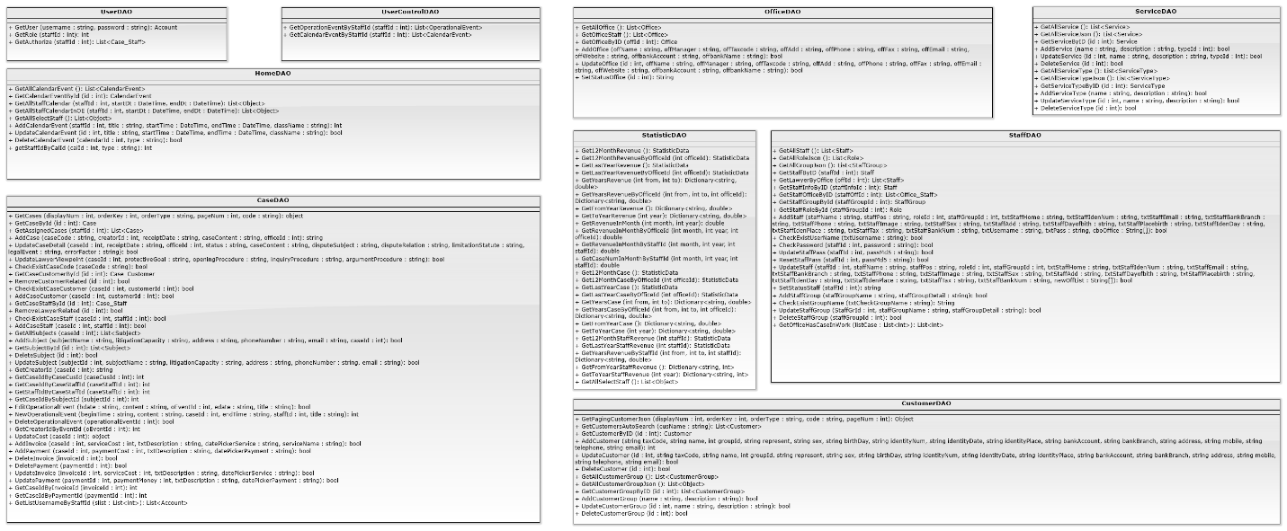

Figure 4-9: Data Access Class Diagram

#### Data Access Class Diagram Explanation

##### UserDAO

|  |  |  |  |  |
| --- | --- | --- | --- | --- |
| **Class** | **UserDAO** | | | |
| **Description** | This class excute all authorization to database. | | | |
| **Base Class** | N/A | | | |
| **Constructor** | UserDAO | | | |
| **Prototype** | N/A | | | |
| **Source File** | UserDAO.cs | | | |
| **Namespace** | LFMS.Models.DAO | | | |
| **Attributes** | N/A | | | |
| **Methods** | **Name** | **Input** | **Output** | **Description** |
| GetUser | string username, string password | Account | Get account from database to check in login. |
| GetRole | int staffId | int | Get role of staff from database |
| GetAuthorize | int staffId | List<Case_Staff> | Get all id of case of staff to check Authorize from database |

##### .UserControlDAO

|  |  |  |  |  |
| --- | --- | --- | --- | --- |
| **Class** | UserControlDAO | | | |
| **Description** | This class excute to get notification of staff about event and calendar from database. | | | |
| **Base Class** | N/A | | | |
| **Constructor** | UserControlDAO | | | |
| **Prototype** | N/A | | | |
| **Source File** | UserControlDAO.cs | | | |
| **Namespace** | LFMS.Models.DAO | | | |
| **Attributes** | N/A | | | |
| **Methods** | **Name** | **Input** | **Output** | **Description** |
| GetOperationEventByStaffId | int staffId | List<OperationalEvent> | System excute to get operation event by staff id from database. |
| GetCalendarEventByStaffId | int staffId | int | System excute to get calendar event by staff id from database |

##### OfficeDAO

|  |  |  |  |  |
| --- | --- | --- | --- | --- |
| **Class** | **OfficeDAO** | | | |
| **Description** | This class excute all action of office to database. | | | |
| **Base Class** | N/A | | | |
| **Constructor** | OfficeDAO | | | |
| **Prototype** | N/A | | | |
| **Source File** | OfficeDAO.cs | | | |
| **Namespace** | LFMS.Models.DAO | | | |
| **Attributes** | N/A | | | |
| **Methods** | **Name** | **Input** | **Output** | **Description** |
| GetActiveOffice | N/A | List<Office> | System excute to get all active office from database |
| GetRole | N/A | List<Office> | System excute to get all office from database. |
| GetOfficeStaff | N/A | List<Office> | System excute to get all active office from database. |
|  | GetOfficeByID | int offId | Office | System excute to get office by office id from database. |
|  | AddOffice | string offName,  string offManager, string offTaxcode, string offAdd, string offPhone,  string offFax,  string offEmail,  string offWebsite, string offbankAccount, string offbankName | bool | System excute to add new office to database. |
|  | UpdateOffice | int offId,  string offName,  string offManager, string offTaxcode, string offAdd, string offPhone,  string offFax,  string offEmail,  string offWebsite,  string offbankAccount, string offbankName | bool | System excute to update an office to database. |
|  | SetStatusOffice | int id | String | System excute to set the active of office to database. |
|  | CheckExistOfficeName | string txtOfficename | bool | System excute to check the name of office of office from database. |

##### ServiceDAO

|  |  |  |  |  |
| --- | --- | --- | --- | --- |
| **Class** | **ServiceDAO** | | | |
| **Description** | This class excute all action of service to database. | | | |
| **Base Class** | N/A | | | |
| **Constructor** | ServiceDAO | | | |
| **Prototype** | N/A | | | |
| **Source File** | ServiceDAO.cs | | | |
| **Namespace** | LFMS.Models.DAO | | | |
| **Attributes** | N/A | | | |
| **Methods** | **Name** | **Input** | **Output** | **Description** |
| GetAllService | N/A | List<Service> | System excute to get all service from database. |
| GetAllServiceJson | N/A | List<Object> | System excute to get all service type from database. |
| GetServiceByID | int id | Service | System excute to get service by id from database. |
|  | AddService | string name,  string description, int typeId | bool | System excute to add new service to database. |
|  | UpdateService | int id,  string name,  string description, int typeId | bool | System excute to update an service to database. |
|  | DeleteService | int id | bool | System excute to delete a service to database. |
|  | GetAllServiceType | N/A | List<ServiceType> | System excute to get all service type from database. |
|  | GetAllServiceTypeJson | N/A | List<Object> | System excute to get all service from database. |
|  | GetServiceTypeByID | int id | ServiceType | System excute to get service type by id from database. |
|  | AddServiceType | string name,  string description | bool | System excute to add new service type to database. |
|  | UpdateServiceType | int id,  string name, string description | bool | System excute to update a service type to database. |
|  | DeleteServiceType | int id | bool | System excute to delete a service type to database. |

##### HomeDAO

|  |  |  |  |  |
| --- | --- | --- | --- | --- |
| **Class** | **HomeDAO** | | | |
| **Description** | This class excute all action in Home view to database. | | | |
| **Base Class** | N/A | | | |
| **Constructor** | HomeDAO | | | |
| **Prototype** | N/A | | | |
| **Source File** | HomeDAO.cs | | | |
| **Namespace** | LFMS.Models.DAO | | | |
| **Attributes** | N/A | | | |
| **Methods** | **Name** | **Input** | **Output** | **Description** |
| GetAllCalendarEvent | N/A | List<CalendarEvent> | System excute to get all calendar event from database |
| GetCalendarEventById | int id | CalendarEvent | System excute to get calendar event by id from database. |
| GetAllStaffCalendar | int staffId, DateTime startDt, DateTime endDt | List<Object> | System excute to get calendar event of staff by staff id from database. |
|  | GetAllStaffCalendarInOE | int staffId, DateTime startDt, DateTime endDt | List<Object> | System excute to get operation event of staff by staff id from database. |
|  | GetAllSelectStaff | int staffId | List<Object> | System excute to get account and password from database. |
|  | AddCalendarEvent | int staffId,  string title, DateTime startTime, DateTime endTime, string className | int | System excute to add new a calendar event to database. |
|  | UpdateCalendarEvent | int id,  string title, DateTime startTime, DateTime endTime, string className, string type | bool | System excute to update a calendar or operation event to database. |
|  | DeleteCalendarEvent | int calendarId,  string type | bool | System excute to delete a calendar or anoperation event to database. |
|  | getStaffIdByCalId | int calId,  string type | int | System excute to get calendar or operation event by calendar id from database. |

##### CaseDAO

|  |  |  |  |  |
| --- | --- | --- | --- | --- |
| **Class** | **CaseDAO** | | | |
| **Description** | This class excute all action of Case to database. | | | |
| **Base Class** | N/A | | | |
| **Constructor** | CaseDAO | | | |
| **Prototype** | N/A | | | |
| **Source File** | CaseDAO.cs | | | |
| **Namespace** | LFMS.Models.DAO | | | |
| **Attributes** | N/A | | | |
| **Methods** | **Name** | **Input** | **Output** | **Description** |
| GetCases | int displayNum, int orderKey,  string orderType,  int pageNum,  string code, List<String> author | object | System excute to get all case after sort from database. |
| GetCaseById | int id | Case | System excute to get case by case id from database. |
| GetAssignedCases | int staffId | List<Case> | System excute to get all case of staff y staff id from database. |
|  | AddCase | string caseCode,  int creatorId,  string receiptDate, string caseContent, int officeId | string | System excute to add new a case to database. |
|  | UpdateCaseDetail | int caseId,  string receiptDate,  int officeId,  string status,  string caseContent, string disputeSubject, string disputeRelation, string limitationStatute, string legalEvent, string errorFactor | bool | System excute to update a case to database. |
|  | DeleteService | int id | bool | System excute to delete a service to database. |
|  | UpdateLawyerViewpoint | int caseId,  string protectiveGoal, string openingProcedure, string inquiryProcedure, string argumentProcedure | bool | System excute to update view point of lawyer to database. |
|  | CheckExistCaseCode | string caseCode | bool | System excute to check exist casecode from database. |
|  | GetCaseByCaseCode | string caseCode | Case | System excute to get case by casecode from database. |
|  | GetCaseCustomerById | int id | Case_Customer | System excute to get case of customer from database. |
|  | RemoveCustomerRelated | int id | bool | System excute to remove customer from a case to database. |
|  | CheckExistCaseCustomer | int caseId, int customerId | bool | System excute to check exist customer of case from database. |
|  | AddCaseCustomer | int caseId, int customerId | bool | System excute to add new casecustomer to database. |
|  | GetCaseStaffById | int id | Case_Staff | System excute to get casestaff from database. |
|  | RemoveLawyerRelated | int id | bool | System excute to remove lawyer from case to database |
|  | CheckExistCaseStaff | int caseId,  int staffId | bool | System excute to check exist case staff from database |
|  | AddCaseStaff | int caseId,  int staffId | bool | System excute to add new a case staff to database |
|  | GetAllSubjects | int caseId | List<Subject> | System excute to get all subjects of case from database. |
|  | AddSubject | string subjectName,  string litigationCapacity, string address,  string phoneNumber,  string email,  int caseId | bool | System excute to add new a subjects of case to database. |
|  | GetSubjectById | int id | Subject | System excute to get subjects by subject id from database |
|  | DeleteSubject | int id | bool | System excute to remove a subject to database. |
|  | UpdateSubject | int subjectId,  string subjectName,  string litigationCapacity, string address,  string phoneNumber,  string email | bool | System excute to update a subject to database. |
|  | GetCreatorId | int caseId | string | System excute to get creator id of case from database |
|  | GetCaseIdByCaseCusId | int caseCusId | int | System excute to get case id of case by case customer id from database |
|  | GetCaseIdByCaseStaffId | int caseStaffId | int | System excute to get case id of case by case staff id from database |
|  | GetStaffIdByCaseStaffId | int caseStaffId | Int | System excute to get staff id of case by case staff id from database |
|  | GetCaseIdBySubjectId | int subjectId | int | System excute to get case id of case by subject id from database |
|  | EditOperationalEvent | string bdate,  string content,  int oEventId,  string edate,  string title | bool | System excute to edit operation event of case to database |
|  | NewOperationalEvent | string beginTime,  string content,  int caseId,  string endTime,  int staffId,  string title | int | System excute to add new operation event of case to database |
|  | DeleteOperationalEvent | int operationalEventId | bool | System excute to delete operation event of case to database |
|  | GetCreatorIdByEventId | int oEventId | int | System excute to get creator id by operation id from database |
|  | UpdateCost | int caseId | object | System excute to update cost of case to database. |
|  | AddInvoice | int caseId,  int serviceCost,  string txtDescription,  string datePickerService, string serviceName | bool | System excute to new invoice of case to database. |
|  | AddPayment | int caseId,  int paymentCost,  string txtDescription,  string datePickerPayment | bool | System excute to add new payment of case to database. |
|  | DeleteInvoice | int invoiceId | bool | System excute to delete invoice of case to database. |
|  | DeletePayment | int paymentId | bool | System excute to delete payment of case to database. |
|  | UpdateInvoice | int invoiceId,  int serviceCost,  string txtDescription,  string datePickerService | bool | System excute to update invoice of case to database. |
|  | UpdatePayment | int paymentId,  int paymentMoney,  string txtDescription,  string datePickerPayment | bool | System excute to update payment of case to database. |
|  | GetCaseIdByInvoiceId | int invoiceId | int | System excute to get case id by invoice id from database. |
|  | GetCaseIdByPaymentId | int paymentId | int | System excute to get case id by payment id from database. |
|  | GetListUsernameByStaffId | List<int> slist | List<Account> | System excute to get list username of staff by list of staff id from database. |

##### StaffDAO

|  |  |  |  |  |
| --- | --- | --- | --- | --- |
| **Class** | **StaffDAO** | | | |
| **Description** | This class excute all action of Staff to database. | | | |
| **Base Class** | N/A | | | |
| **Constructor** | StaffDAO | | | |
| **Prototype** | N/A | | | |
| **Source File** | StaffDAO.cs | | | |
| **Namespace** | LFMS.Models.DAO | | | |
| **Attributes** | N/A | | | |
| **Methods** | **Name** | **Input** | **Output** | **Description** |
| GetAllStaff | N/A | List<Staff> | System excute to get all staff from database. |
| GetAllRoleJson | N/A | List<Role> | System excute to get all role from database. |
| GetAllGroupJson | N/A | List<StaffGroup> | System excute to get all group of staff from database. |
|  | GetStaffByID | int staffId | Staff | System excute to get staff by staff id from database. |
|  | GetLawyerByOffice | int offId | List<Staff> | System excute to get lawyer by office id from database. |
|  | GetStaffInfoByID | int staffInfoId | int | System excute to get staff infomation by id from database. |
|  | GetStaffOfficeByID | int staffOffId | List<Office_Staff> | System excute to get staff office by id from database. |
|  | GetStaffGroupById | int staffGroupId | StaffGroup | System excute to get staff group by id from database. |
|  | GetStaffRoleById | int staffGroupId | Role | System excute to get staff role by id from database. |
|  | AddStaff | string staffName,  string staffPos,  int roleId,  int staffGroupId,  string txtStaffHome,  string txtStaffIdenNum, string txtStaffEmail,  string txtStaffBankBranch, string txtStaffPhone,  string txtStaffImage,  string txtStaffSex,  string txtStaffAdd,  string txtStaffDayofbith,  string txtStaffPlacebirth, string txtStaffIdenDay,  string txtStaffIdenPlace, string txtStaffTax,  string txtStaffBankNum, string txtUsername,  int txtAppendantPeople, string txtPass,  String[] cboOffice | bool | System excute to add new staff to database. |
|  | CheckPassword | int staffId,  string password | bool | System excute to check password of staff from database. |
|  | UpdateStaffPass | int staffId,  string passMd5 | bool | System excute to update password of staff to database. |
|  | ResetStaffPass | int staffId,  string passMd5 | bool | System excute to reset password of staff to database. |
|  | UpdateStaff | int staffId,  string staffName, string staffPos,  int roleId,  int staffGroupId,  string txtStaffHome,  string txtStaffIdenNum, string txtStaffEmail,  string txtStaffBankBranch, string txtStaffPhone,  string txtStaffImage,  string txtStaffSex,  string txtStaffAdd,  string txtStaffDayofbith, string txtStaffPlacebirth, string txtStaffIdenDay,  string txtStaffIdenPlace, string txtStaffTax,  string txtStaffBankNum, int detailAppendantPeople, String[] newOffList | bool | System excute to update informtion of staff to database. |
|  | CheckExistUserName | string txtUsername | bool | System excute to check username of staff from database. |
|  | CheckExistGroupName | string txtCheckGroupName | bool | System excute to check group name of staff from database. |
|  | SetStatusStaff | int staffId | String | System excute to set status of staff to database. |
|  | AddStaffGroup | string staffGroupName,  string staffGroupDetail, double txtBaseSalary | bool | System excute to add new group of staff to database. |
|  | UpdateStaffGroup | int StaffGrId,  string staffGrName,  string staffGrDetail,  double txtEditMoney | bool | System excute to update group of staff to database. |
|  | DeleteStaffGroup | int staffGroupId | bool | System excute to delete group of staff to database. |
|  | GetOfficeHasCaseInWork | List<int> listCase | List<int> | System excute to get office in work from database. |

##### CustomerDAO

|  |  |  |  |  |
| --- | --- | --- | --- | --- |
| **Class** | **CustomerDAO** | | | |
| **Description** | This class excute all action of customer to database | | | |
| **Base Class** | N/A | | | |
| **Constructor** | CustomerDAO | | | |
| **Prototype** | N/A | | | |
| **Source File** | CustomerDAO.cs | | | |
| **Namespace** | LFMS.Models.DAO | | | |
| **Attributes** | N/A | | | |
| **Methods** | **Name** | **Input** | **Output** | **Description** |
| GetPagingCustomerJson | int displayNum,  int orderKey,  string orderType, string code,  int pageNum | Object | This method excute to get all custmer after paging from database. |
| GetCustomersAutoSearch | string cusName | List<Customer> | This method excute to get customer in auto search from database. |
| GetCustomerByID | int id | Customer | This method excute to get customer by customer id from database. |
|  | AddCustomer | string taxCode,  string name,  int groupId,  string represent,  string sex, string birthDay,  string identityNum, string identityDate, string identityPlace, string bankAccount, string bankBranch, string address,  string mobile,  string telephone, string email | int | This method excute to add new a customer to database. |
|  | UpdateCustomer | int id,  string taxCode,  string name,  int groupId,  string represent,  string sex,  string birthDay,  string identityNum, string identityDate, string identityPlace, string bankAccount, string bankBranch, string address,  string mobile,  string telephone, string email | bool | This method excute to update a customer to database. |
|  | DeleteCustomer | int id | bool | This method excute to delete a customer to database. |
|  | GetAllCustomerGroup | N/A | List<CustomerGroup> | This method excute to get all group of customer from database. |
|  | GetAllCustomerGroupJson | N/A | List<Object> | This method excute to get all group and customer of each group from database. |
|  | GetCustomerGroupByID | int id | CustomerGroup | This method excute to get group of customer by id from database. |
|  | AddCustomerGroup | string name,  string description | bool | This method excute to add new a group of customer to database. |
|  | UpdateCustomerGroup | int id,  string name,  string description | bool | This method excute to update a group of customer to database. |
|  | DeleteCustomerGroup | int id | bool | This method excute to delete a group of customer to database. |

##### StatisticDAO

|  |  |  |  |  |
| --- | --- | --- | --- | --- |
| **Class** | **StatisticDAO** | | | |
| **Description** | This class excute all statistics from database | | | |
| **Base Class** | N/A | | | |
| **Constructor** | StatisticDAO | | | |
| **Prototype** | N/A | | | |
| **Source File** | StatisticDAO.cs | | | |
| **Namespace** | LFMS.Models.DAO | | | |
| **Attributes** | N/A | | | |
| **Methods** | **Name** | **Input** | **Output** | **Description** |
| Get12MonthRevenue | N/A | StatisticData | This method excute to get revenue 12 month inyear from database. |
| Get12MonthRevenueByOfficeId | int officeId | StatisticData | This method excute to get revenue 12 month in year by office from database. |
| GetLastYearRevenue | N/A | StatisticData | This method excute to get revenue last year from database. |
|  | GetLastYearRevenueByOfficeId | int officeId | StatisticData | This method excute to get revenue last year by office from database. |
|  | GetYearsRevenue | int from,  int to | Dictionary<string, double> | This method excute to get revenue in year from database. |
|  | GetYearsRevenueByOfficeId | int from,  int to,  int officeId | Dictionary<string, double> | This method excute to get revenue in year by office from database. |
|  | GetFromYearRevenue | N/A | Dictionary<string, int> | This method excute to get revenue from year by office from database. |
|  | GetToYearRevenue | int year | Dictionary<string, int> | This method excute to get revenue to year by office from database. |
|  | GetRevenueInMonth | int month,  int year | double | This method excute to get revenue in month from database. |
|  | GetRevenueInMonthByOfficeId | int month,  int year,  int officeId | double | This method excute to get revenue in month by office from database. |
|  | GetRevenueInMonthByStaffId | int month,  int year,  int staffId | double | This method excute to get revenue in month by staff from database. |
|  | GetCaseNumInMonthByStaffId | int month,  int year,  int staffId | int | This method excute to get number of case in month by staff from database. |
|  | Get12MonthCase | N/A | StatisticData | This method excute to get number of case in 12 month from database. |
|  | Get12MonthCaseByOfficeId | int officeId | StatisticData | This method excute to get number of case in 12 month by office from database. |
|  | GetLastYearCase | N/A | StatisticData | This method excute to get number of case last year from database. |
|  | GetLastYearCaseByOfficeId | int officeId | StatisticData | This method excute to get number of case last year by office from database. |
|  | GetYearsCase | int from,  int to | Dictionary<string, double> | This method excute to get number of case in year from database. |
|  | GetYearsCaseByOfficeId | int from,  int to,  int officeId | Dictionary<string, double> | This method excute to get number of case in year by office from database. |
|  | GetFromYearCase | N/A | Dictionary<string, int> | This method excute to get number of case from year from database. |
|  | GetToYearCase | int year | Dictionary<string, int> | This method excute to get number of case to year from database. |
|  | Get12MonthStaffRevenue | int staffId | StatisticData | This method excute to get revenue in 12 month of staff from database. |
|  | GetLastYearStaffRevenue | int staffId | StatisticData | This method excute to get revenue in last year of staff from database. |
|  | GetYearsRevenueByStaffId | int from,  int to,  int staffId | Dictionary<string, double> | This method excute to get revenue in year of staff from database. |
|  | GetFromYearStaffRevenue | N/A | Dictionary<string, int> | This method excute to get revenue from year of staff from database. |
|  | GetToYearStaffRevenue | N/A | Dictionary<string, int> | This method excute to get revenue to year of staff from database. |
|  | GetAllSelectStaff | N/A | List<Object> | This method excute to get all staff from database. |

### Login

#### Class diagram

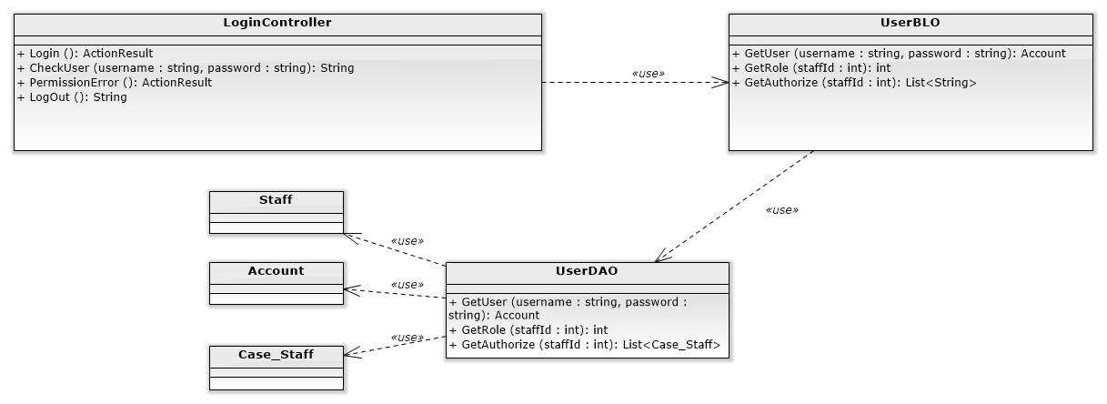

#### Screen design

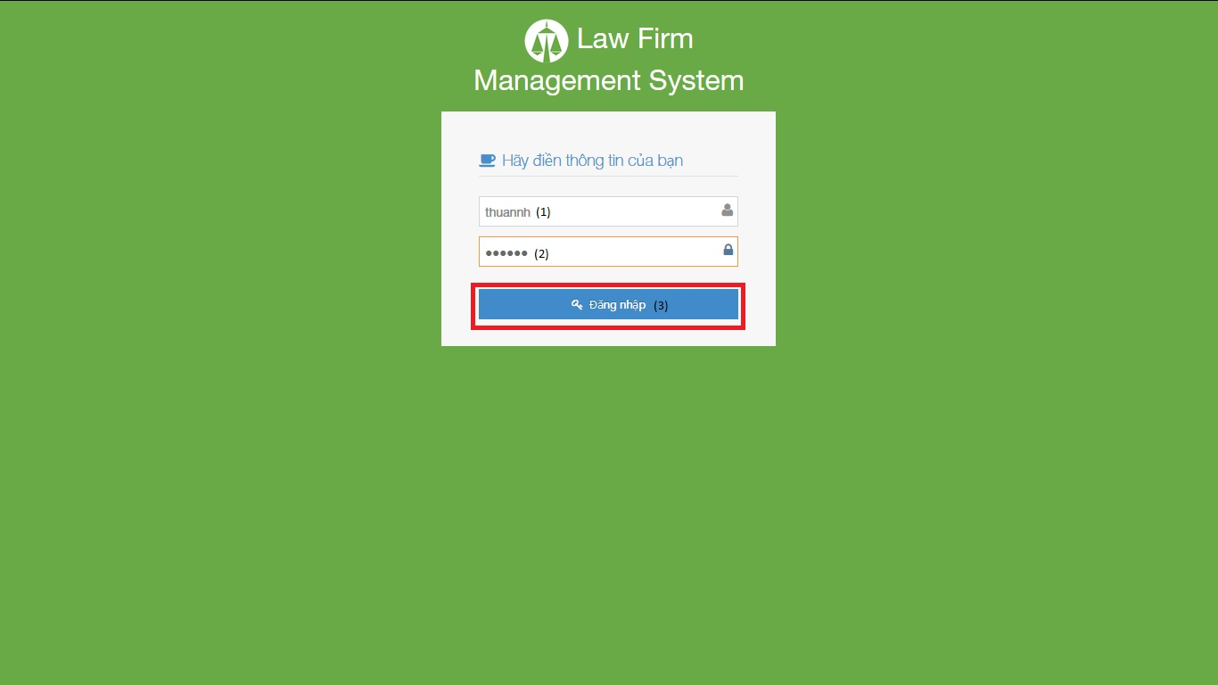

|  |  |  |  |  |
| --- | --- | --- | --- | --- |
| No | Object/ControlName | Type | Required | Description |
| 1 | Tên đăng nhập | Textbox | Yes | Username for login |
| 2 | Mật khẩu | Textbox | Yes | Password for login |
| 3 | Đăng nhập | Button | Yes | Click for login to website |

#### Sequence diagram

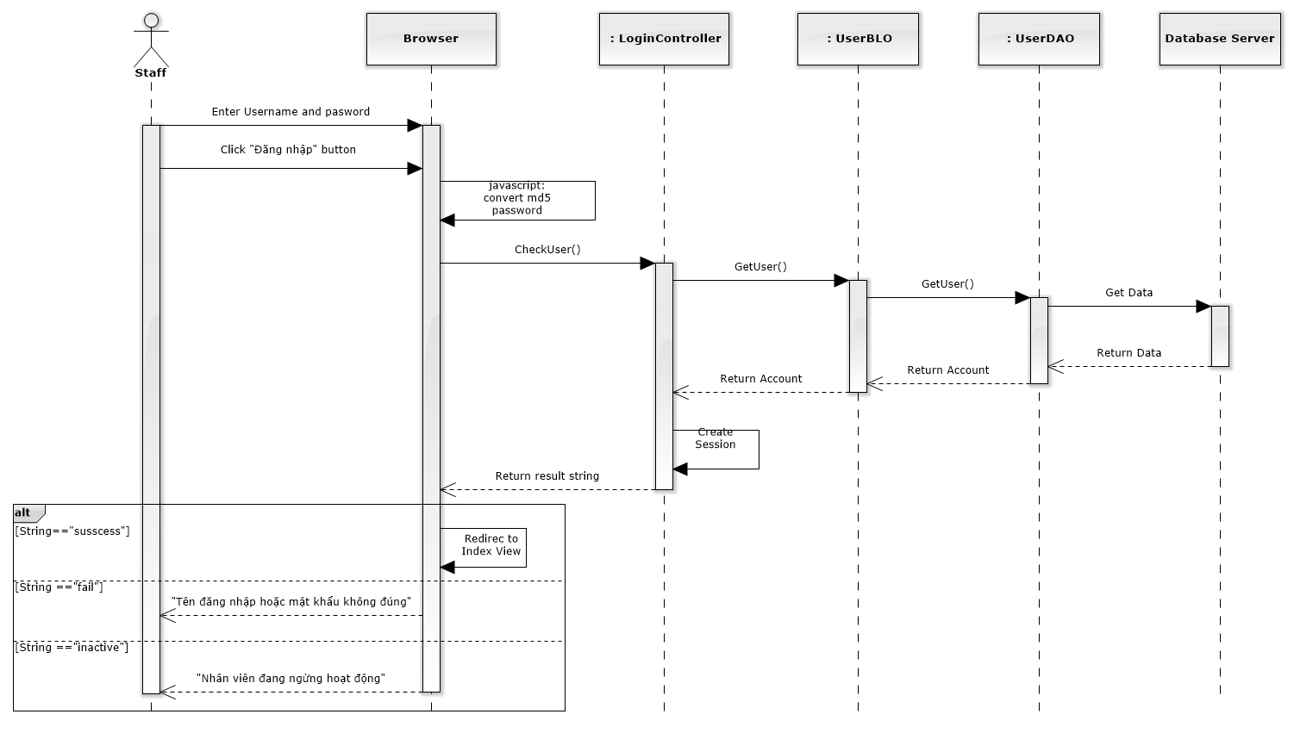

Figure 4-10: Login Sequence Diagram

### Change password

#### Class diagram

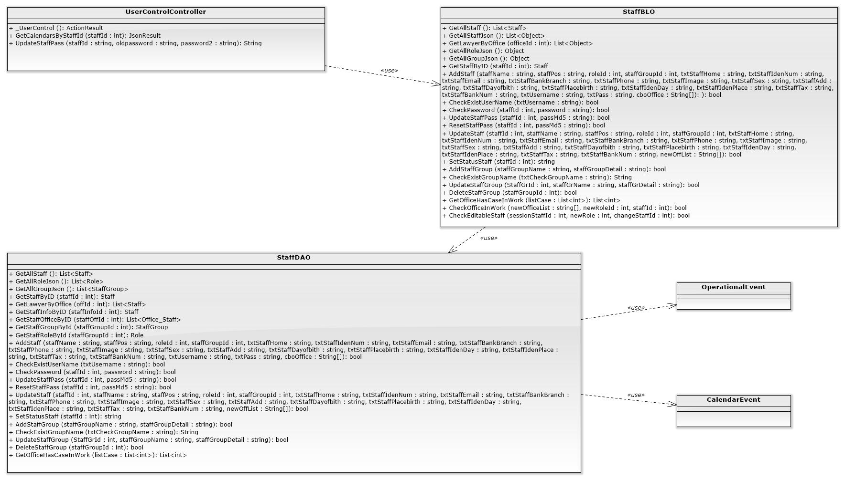

#### Screen design

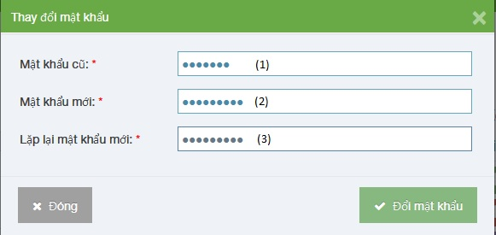

|  |  |  |  |  |
| --- | --- | --- | --- | --- |
| No | Object/ControlName | Type | Required | Description |
| 1 | Mật khẩu cũ | Textbox | Yes | Your old password |
| 2 | Mật khẩu mới | Textbox | Yes | Your new password |
| 3 | Lặp lại mật khẩu mới | Textbox | Yes | Re-input your new password |

#### Sequence diagram

Figure 4-11: Change Password Sequence Diagram

### View Home

#### Class diagram

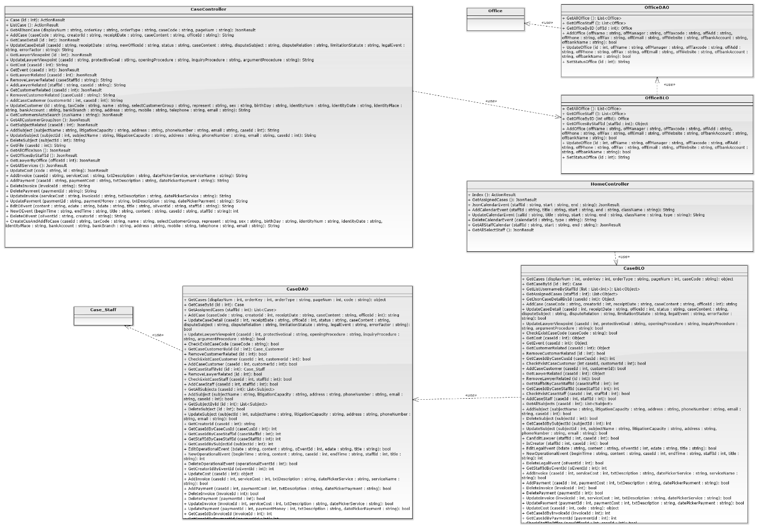

#### Screen design

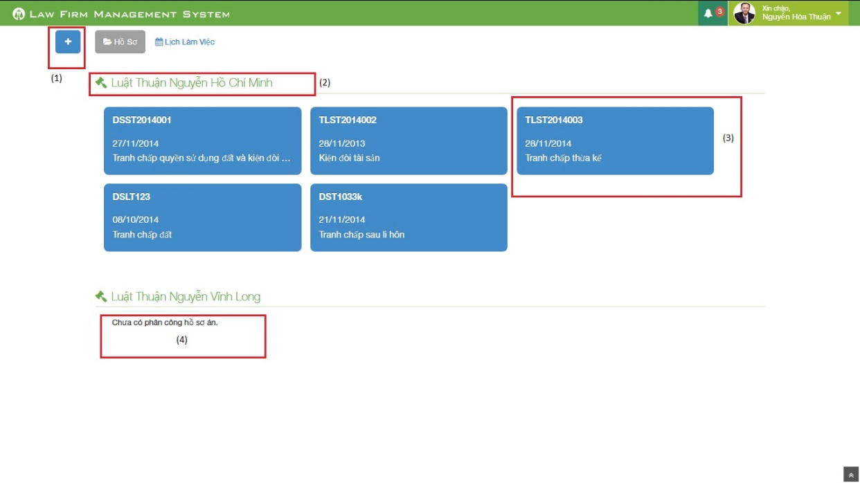

Figure 212: Home Screen Image

|  |  |  |  |  |
| --- | --- | --- | --- | --- |
| No | Object/ControlName | Type | Required | Description |
| 1 | Plus | Button | Yes | Click to show popup for add new case |
| 2 | Office name | Label | Yes | Show name of office the staff work in |
| 3 | Case information | Button | Yes | Show important information of the case, click and redirect to view case detail page |
| 4 | “Chưa có phân công hồ sơ án” | Label | Yes | If the office have no “Đang thụ lý” case, message will be show |

#### Sequence diagram

Figure 4-12: View Home Sequence Diagram

### Notify

#### Class diagram

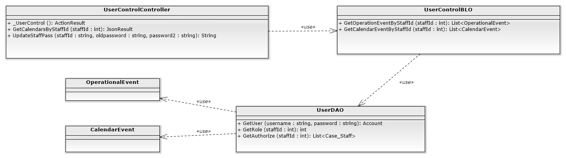

#### Screen design

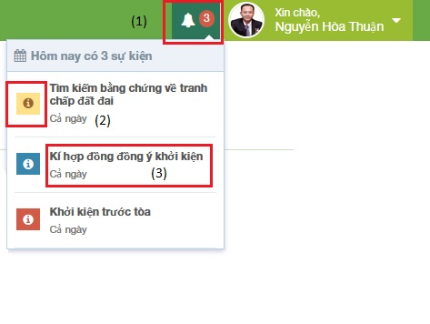

Figure 213: Notify Event Screen Image

|  |  |  |  |  |
| --- | --- | --- | --- | --- |
| No | Object/ControlName | Type | Required | Description |
| 1 | Event count | Label | Yes | Event quantity in “today” need to do. If there is at least 1 event, ring the bell |
| 2 | Priority | Icon | Yes | Show priority of event |
| 3 | Title | Label | Yes | Show title and time range of event |

#### Sequence diagram

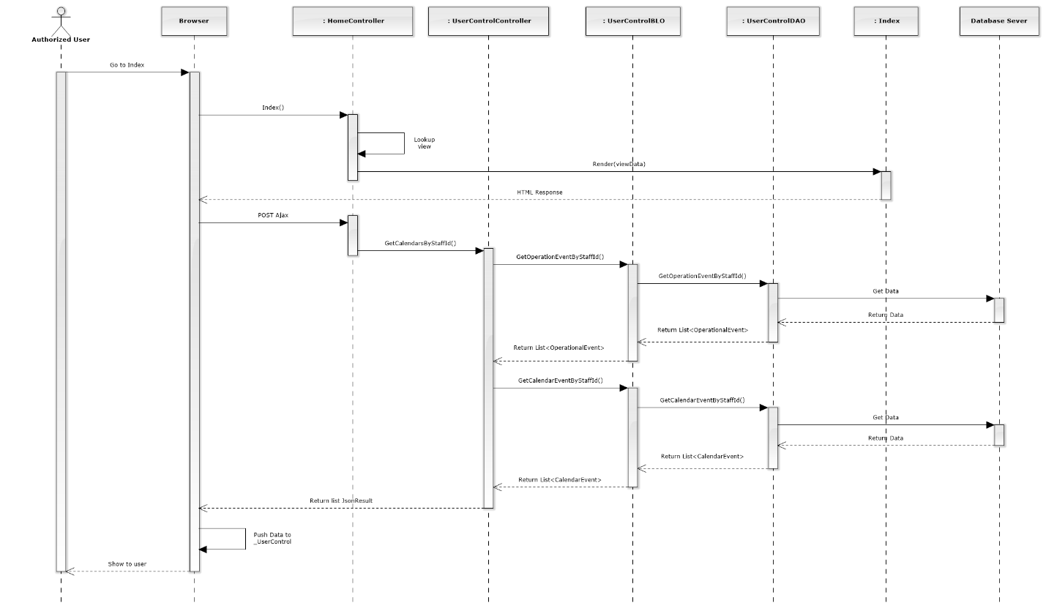

Figure 4-13: Notify Sequence Diagram

### Manage Calendar Event

#### List Calendar Events

##### Class diagram

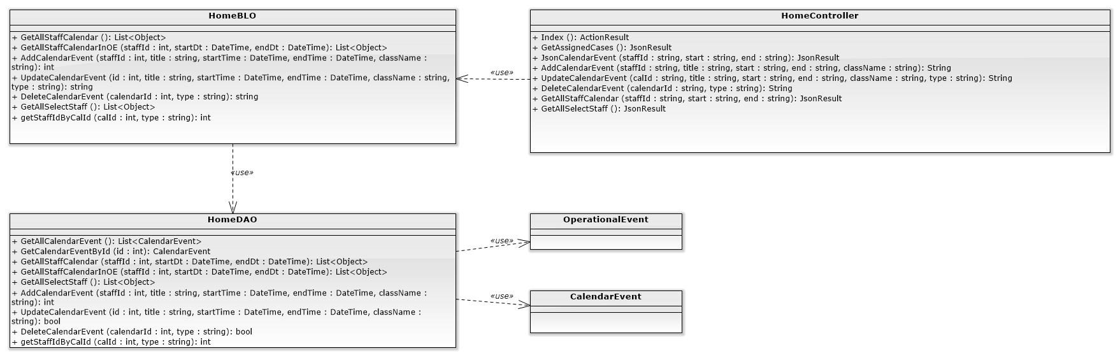

##### Screen design

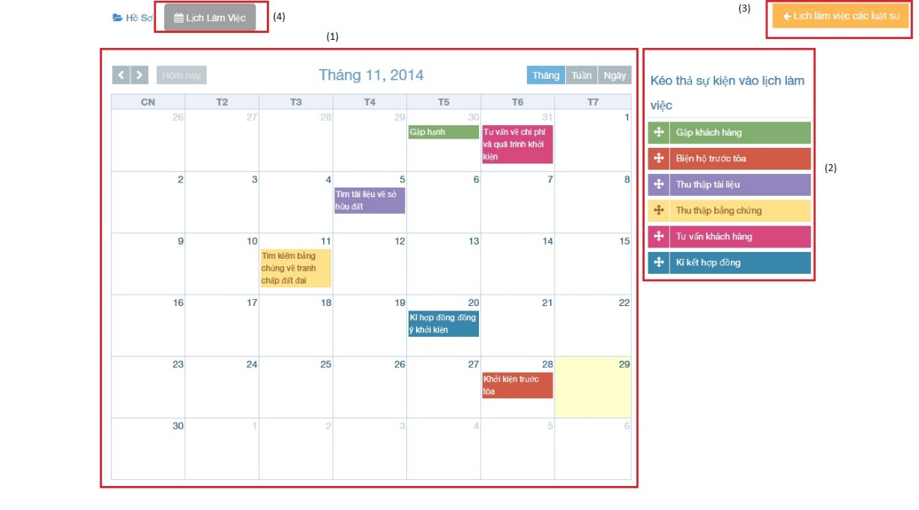

Figure 215: :List calendar events

|  |  |  |  |  |
| --- | --- | --- | --- | --- |
| No | Object/ControlName | Type | Required | Description |
| 1 | Calendar | Full Calendar | Yes | Show all event of Staff on calendar |
| 2 | Dropable event | Object | Yes | Drag and drop into calendar to create new event |
| 3 | Lịch làm việc của các luật sư | Button | Yes | Show other staff calendar pop-up |
| 4 | “Lịch làm việc” | Label | Yes | Tab for view calendar events |

##### Sequence diagram

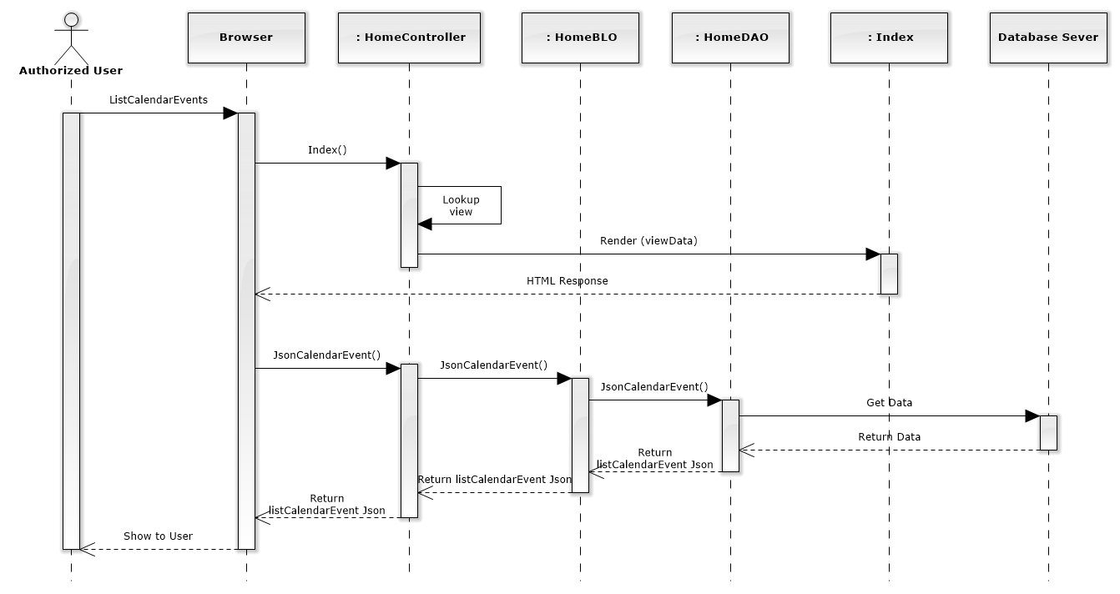

Figure 152: List Calendar Events Sequence Diagram

#### Add new calendar event

##### Screen design

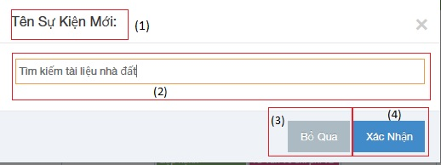

|  |  |  |  |  |
| --- | --- | --- | --- | --- |
| No | Object/ControlName | Type | Required | Description |
| 1 | “Tên Sự Kiện Mới:” | Label | Yes | View name event |
| 2 | “Tên sự kiện” | Textbox | Yes | Name event |
| 3 | “Bỏ Qua” | Button | Yes | Click to close Add new calendar event pop-up |
| 4 | “Xác Nhận” | Button | Yes | Click to create a new calendar event |

##### Sequence diagram

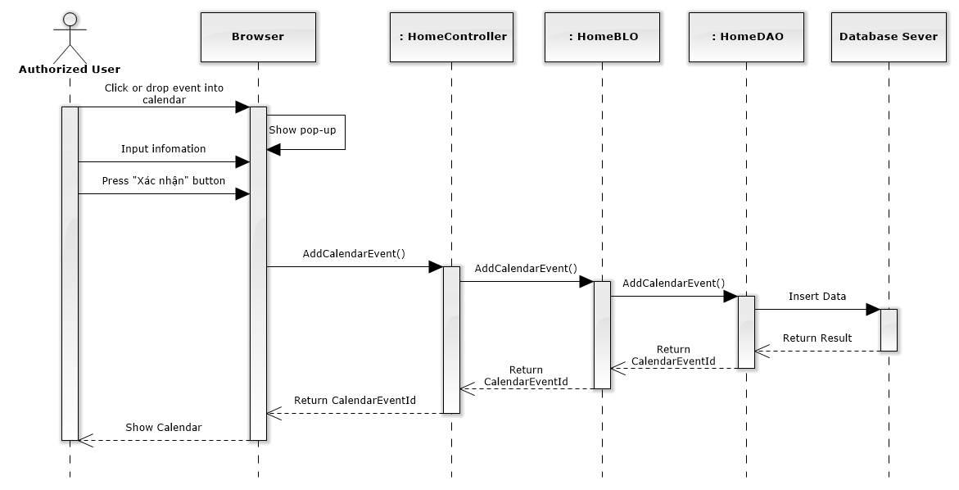

Figure 153: Add New Calendar Event Sequence Diagram

#### Edit calendar event

##### Screen design

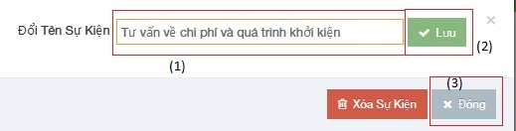

|  |  |  |  |  |
| --- | --- | --- | --- | --- |
| No | Object/ControlName | Type | Required | Description |
| 1 | “Tên sự kiện” | Textbox | Yes | Name event |
| 2 | “Lưu” | Button | Yes | Click to save edit new calendar event |
| 3 | “Đóng” | Button | Yes | Click to close Edit new calendar event pop-up |

##### Sequence diagram

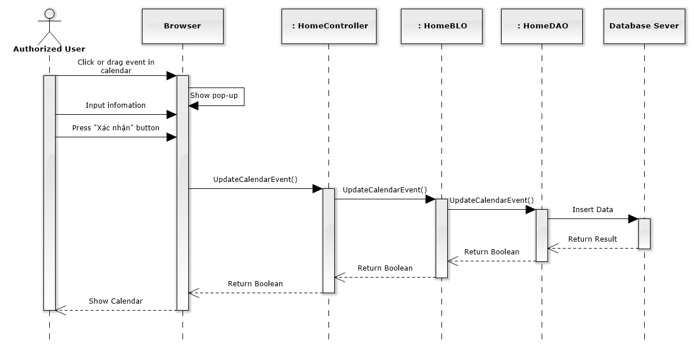

Figure 154: Edit Calendar Event Sequence Diagram

#### Delete calendar event

##### Screen design

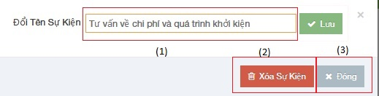

|  |  |  |  |  |
| --- | --- | --- | --- | --- |
| No | Object/ControlName | Type | Required | Description |
| 1 | “Tên sự kiện” | Textbox | Yes | Name event |
| 2 | “Xóa sự kiện” | Button | Yes | Click to delete calendar event |
| 3 | “Đóng” | Button | Yes | Click to close Delete calendar event pop-up |

##### Sequence diagram

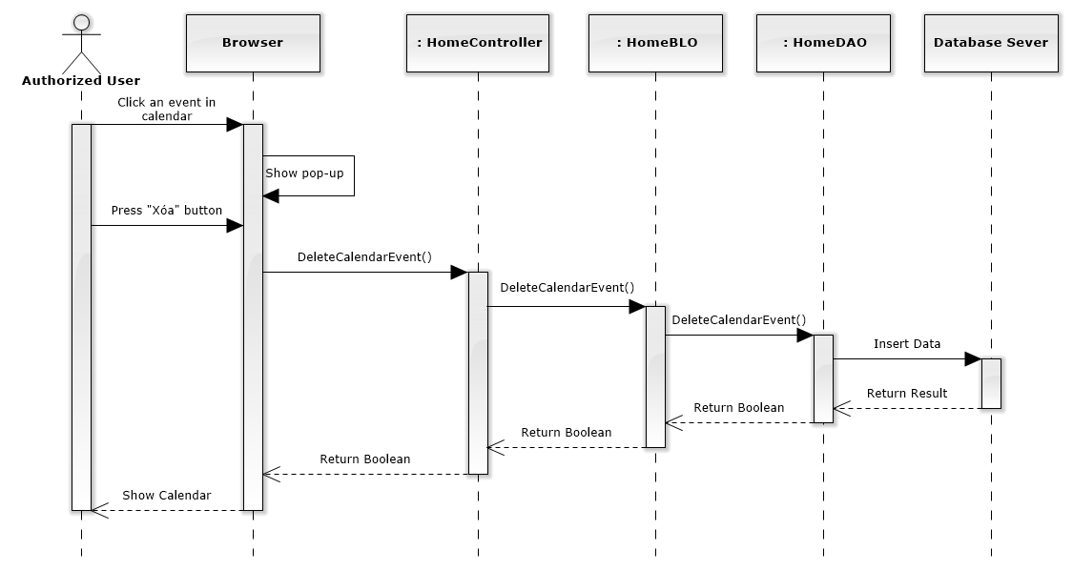

Figure 155: Delete Calendar Event Sequence Diagram

### Manage Case

#### List all cases

##### Class diagram

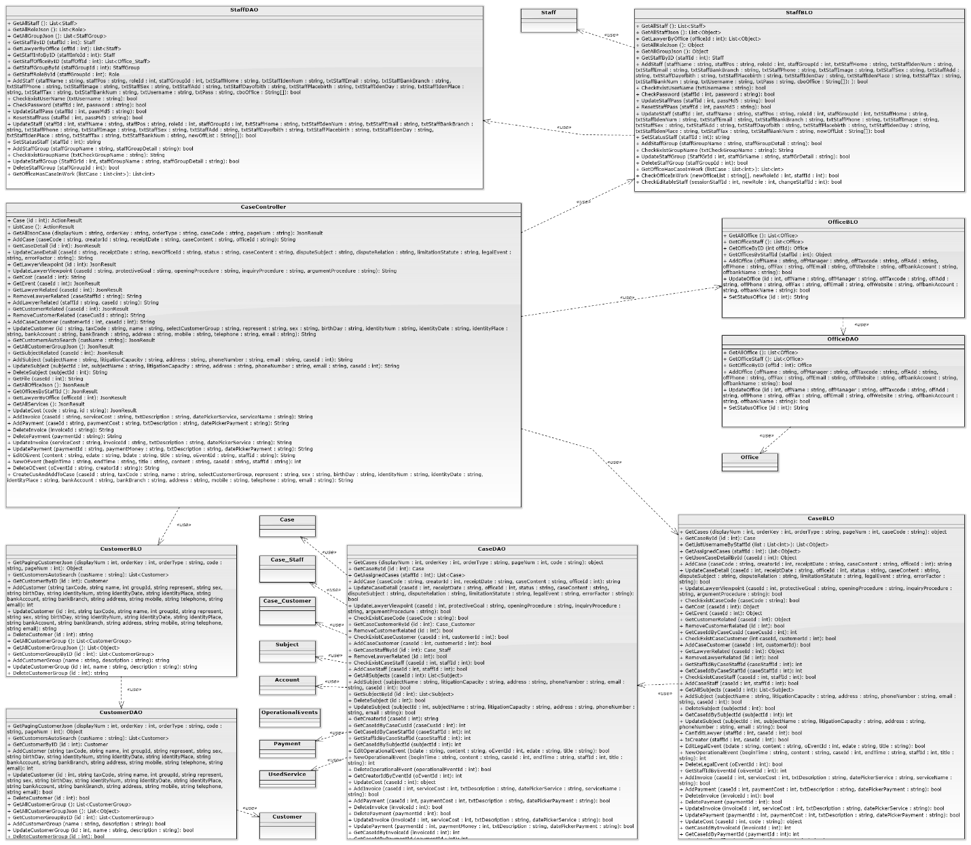

##### Screen design

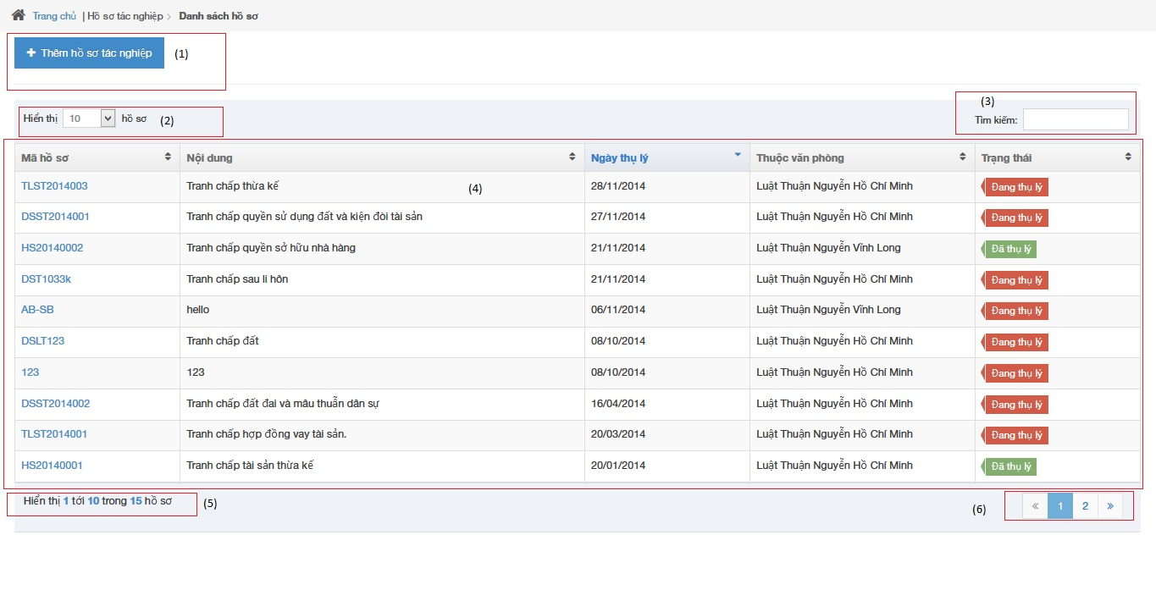

|  |  |  |  |  |
| --- | --- | --- | --- | --- |
| No | Object/ControlName | Type | Required | Description |
| 1 | “Thêm hồ sơ tác nghiệp” | Button | Yes | Click to show popup for add new case |
| 2 | Line count | Dropdown list | Yes | Select line quantity in table |
| 3 | “Tìm kiếm” | Textbox | Yes | Search case automatically |
| 4 | View all cases | Table | Yes | Show all of case |
| 5 | Case count | Label | Yes | Show case quantity of page in table |
| 6 | Paging | Button | Yes | List case page by page |

##### Sequence diagram

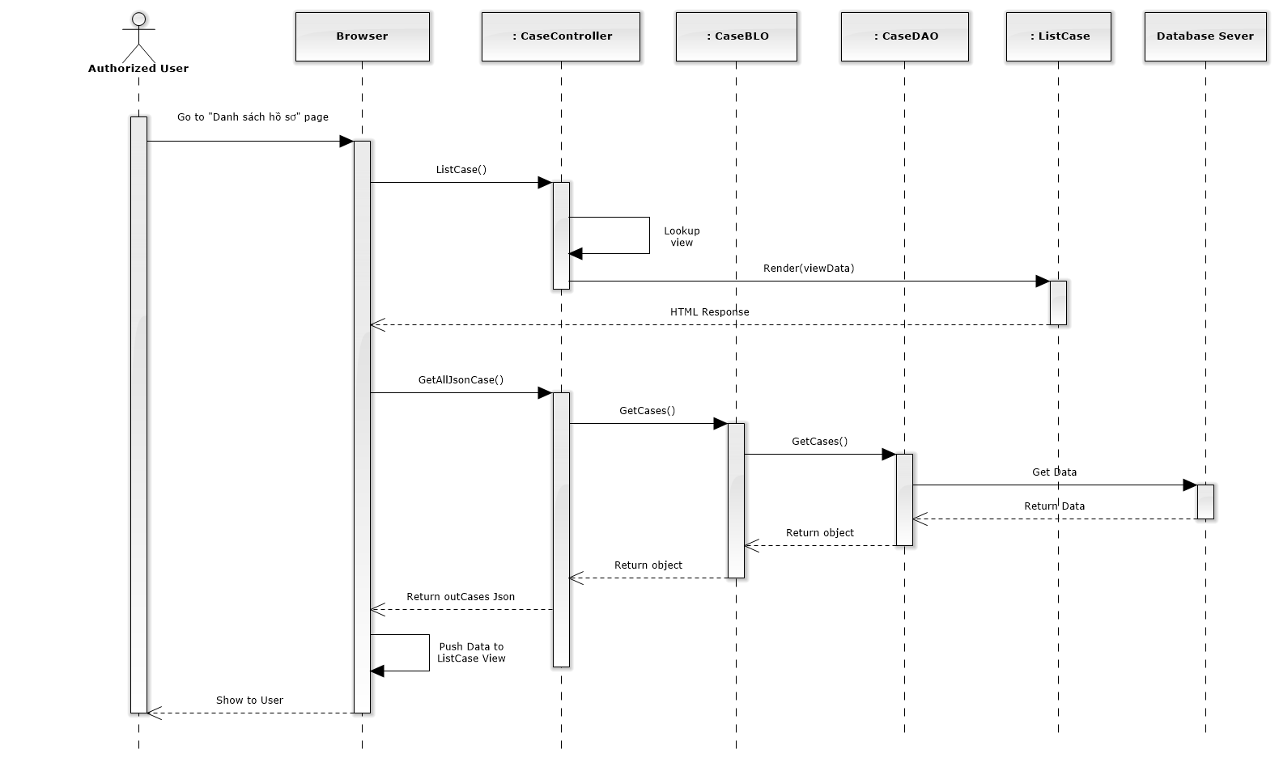

Figure 156: List All Cases Sequence Diagram

#### Add new case

##### Screen design

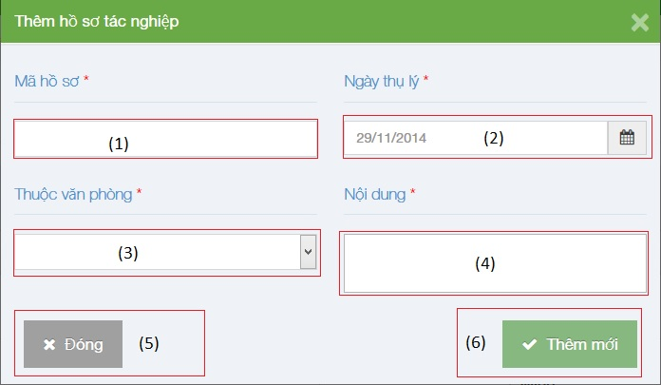

|  |  |  |  |  |
| --- | --- | --- | --- | --- |
| No | Object/ControlName | Type | Required | Description |
| 1 | “Mã hồ sơ” | Textbox | Yes | Case code |
| 2 | “Ngày thụ lý” | Textbox list | Yes | Receipt date |
| 3 | “Thuộc văn phòng” | Textbox | Yes | Choose one office |
| 4 | “Nội dung” | Textbox | Yes | Case content |
| 5 | “Đóng” | Button | Yes | Click to close modal popup |
| 6 | “Thêm mới” | Button | Yes | Click to create a new case |

##### Sequence diagram

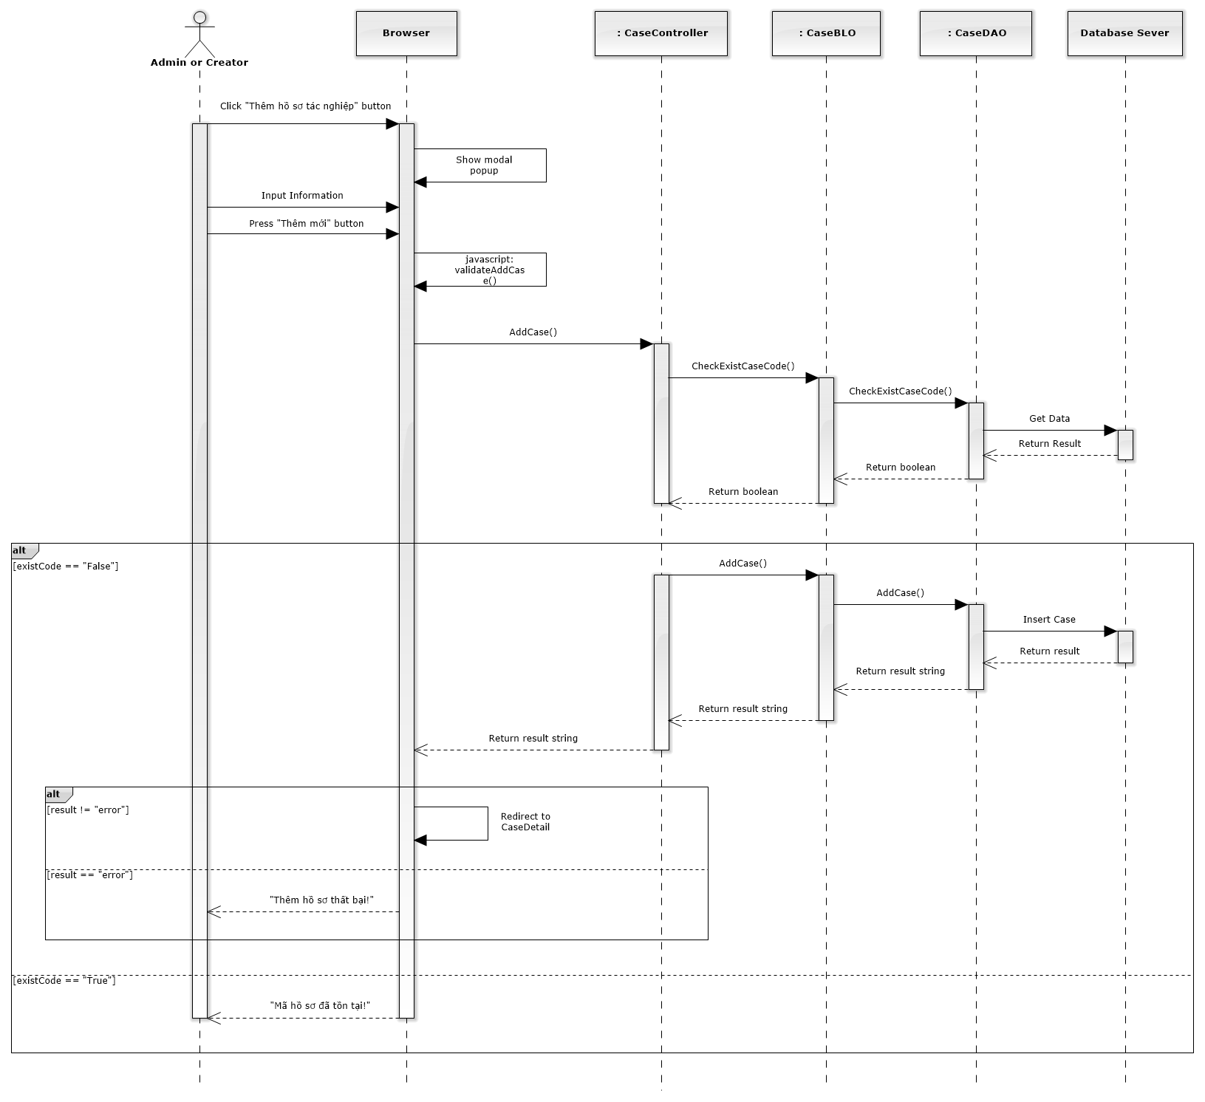

Figure 157: Add New Case Sequence Diagram

#### Search case

##### Screen design

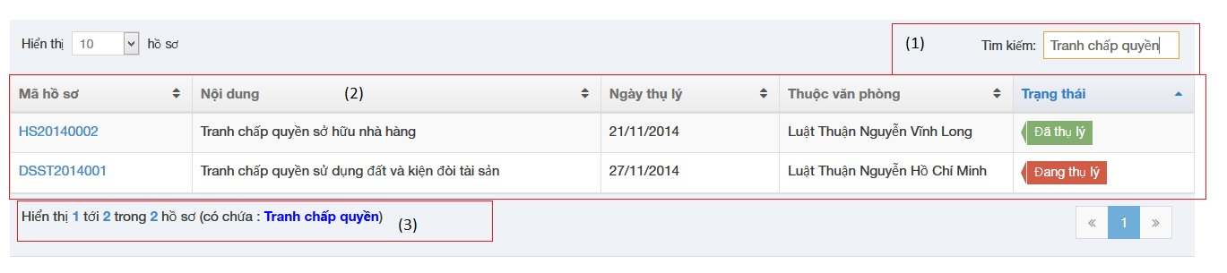

|  |  |  |  |  |
| --- | --- | --- | --- | --- |
| No | Object/ControlName | Type | Required | Description |
| 1 | “Tìm kiếm” | Textbox | Yes | Search case automatically |
| 2 | View all cases | Table | Yes | Show all result of case after searching |
| 3 | Case contain “Tranh chấp quyền” | Label | Yes | Show a word that contain in search textbox |

##### Sequence diagram

#### Manage Case Detail

##### View case detail

###### Screen design

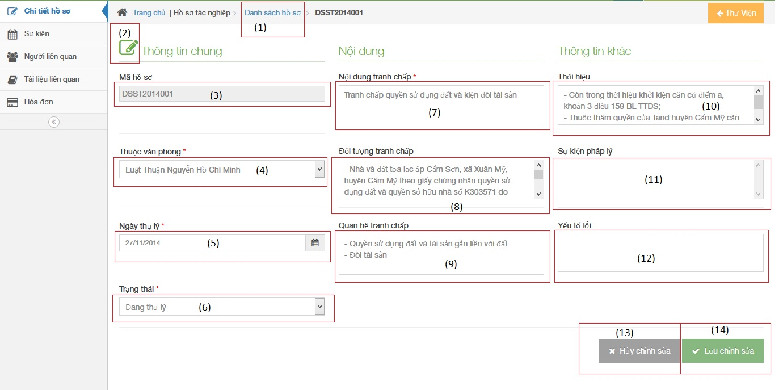

|  |  |  |  |  |
| --- | --- | --- | --- | --- |
| No | Object/ControlName | Type | Required | Description |
| 1 | “Danh sách hồ sơ” | Link | Yes | Redirect to view all cases |
| 2 | Edit | Button | Yes | Must be click to edit infor |
| 3 | “Mã hồ sơ” | Textbox | Yes | Case code |
| 4 | “Ngày thụ lý” | Textbox | Yes | Receipt date |
| 5 | “Thuộc văn phòng” | Textbox | Yes | Choose one office |
| 6 | “Trạng thái” | Textbox | Yes | Case status |
| 7 | “Nội dung tranh chấp” | Textbox | Yes | The contents of dispute |
| 8 | “Đối tượng tranh chấp” | Textbox | Yes | The subject of dispute |
| 9 | “Quan hệ tranh chấp” | Textbox | Yes | The relation of dispute |
| 10 | “Thời hiệu” | Textbox | Yes | The statute of limitations |
| 11 | “Sự kiện pháp lý” | Textbox | Yes | Legal event |
| 12 | “Yếu tố lỗi” | Textbox | Yes | Error factor |
| 13 | “Hủy chỉnh sửa” | Button | Yes | Cancel edit infor |
| 14 | “Lưu chỉnh sửa” | Button | Yes | Save new infor |

###### Sequence diagram

##### Manage Operation Event

###### List operation events

Screen design

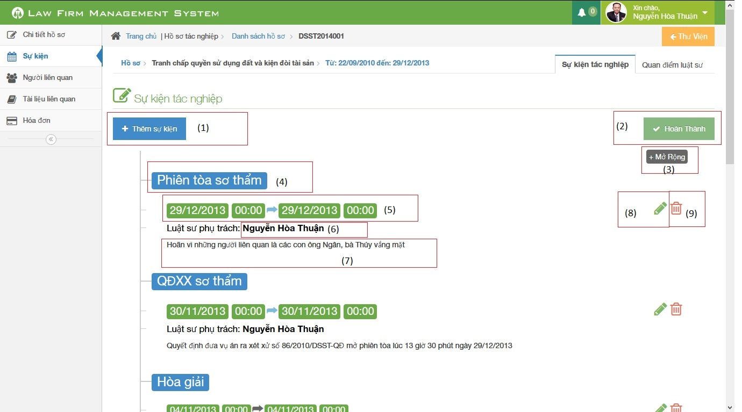

|  |  |  |  |  |
| --- | --- | --- | --- | --- |
| No | Object/ControlName | Type | Required | Description |
| 1 | Thêm sự kiện | Button | Yes | Click to add new operation event |
| 2 | Hoàn thành | Button | Yes | Click to finish edit operation event |
| 3 | Thu nhỏ / Mở rộng | Button | Yes | Reduce / Expand |
| 4 | Title | Label | Yes | Title of Operation Event |
| 5 | Time range | Label | Yes | Click to choose begin time and end time of event |
| 6 | Staff username | Label | Yes | The lawyer who create a case |
| 7 | Content | Information | Yes | Content of Operation Event |
| 8 | Pencil | Button | Yes | Edit operation event |
| 9 | Trash | Button | Yes | Delete operation event |

Sequence diagram

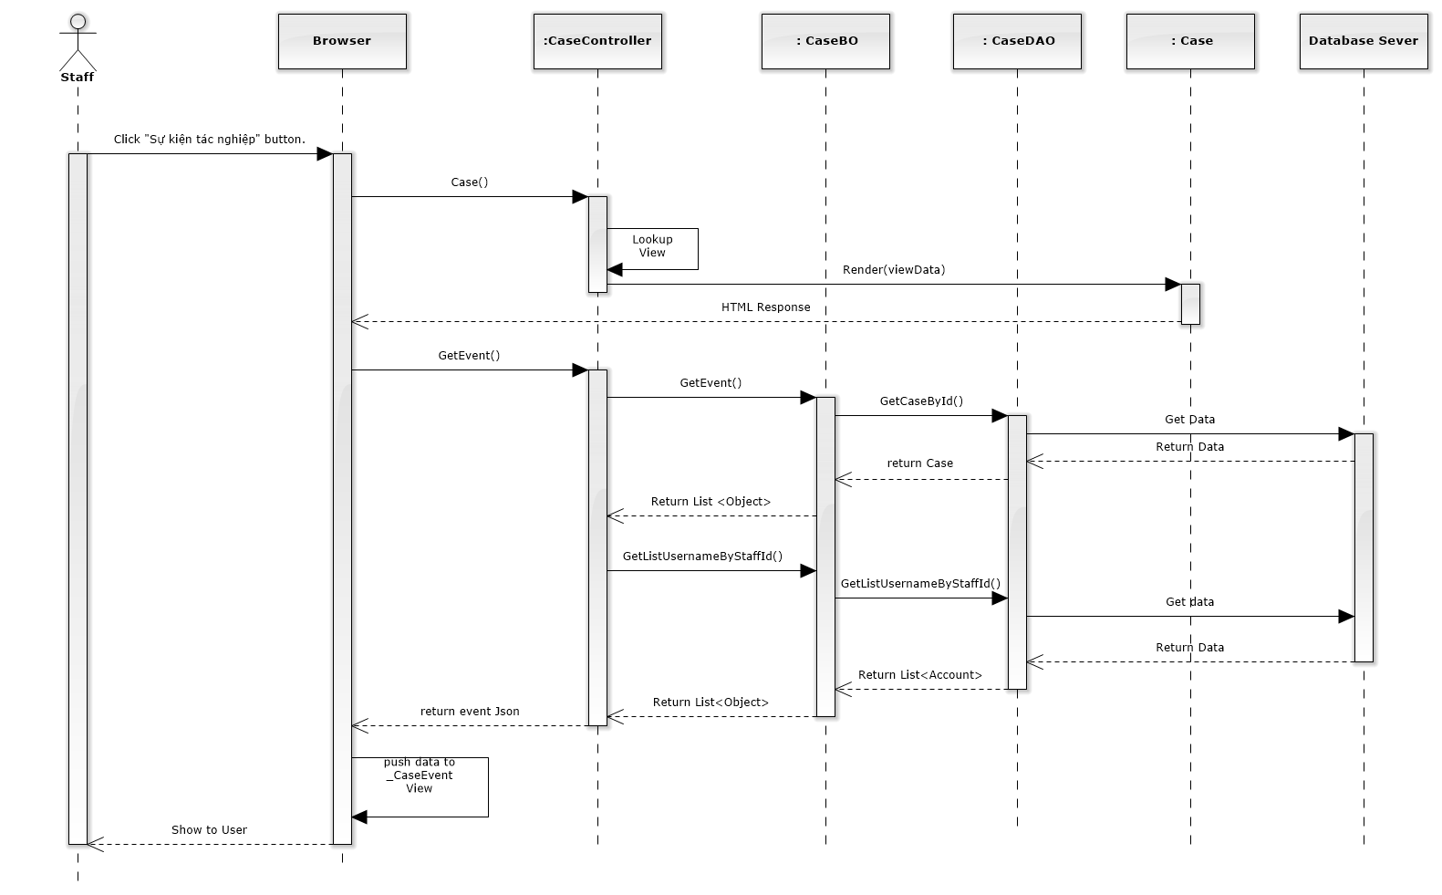

Figure 158: List Operation Events Sequence Diagram

###### Add new operation event

Screen design

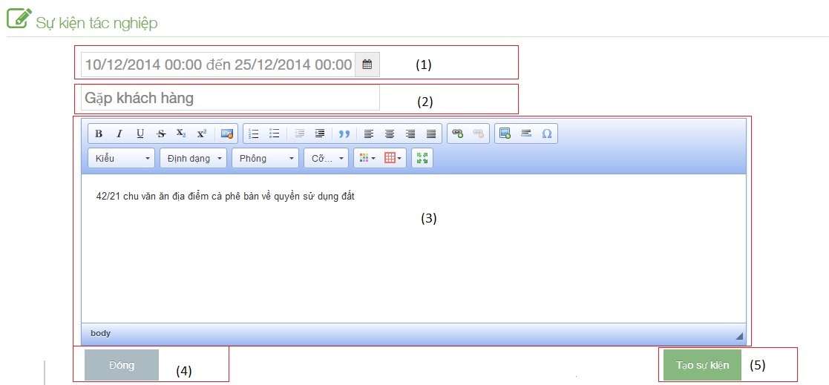

|  |  |  |  |  |
| --- | --- | --- | --- | --- |
| No | Object/ControlName | Type | Required | Description |
| 1 | Time range | Button | Yes | Click to choose begin time and end time of event |
| 2 | Title | Table | Yes | Title of Operation Event |
| 3 | Content | Label | Yes | Content of Operation Event |
| 4 | “Đóng” | Button | Yes | Click to close add new operation event |
| 5 | “Tạo sự kiện” | Button | Yes | Click to add new operation event |

Sequence diagram

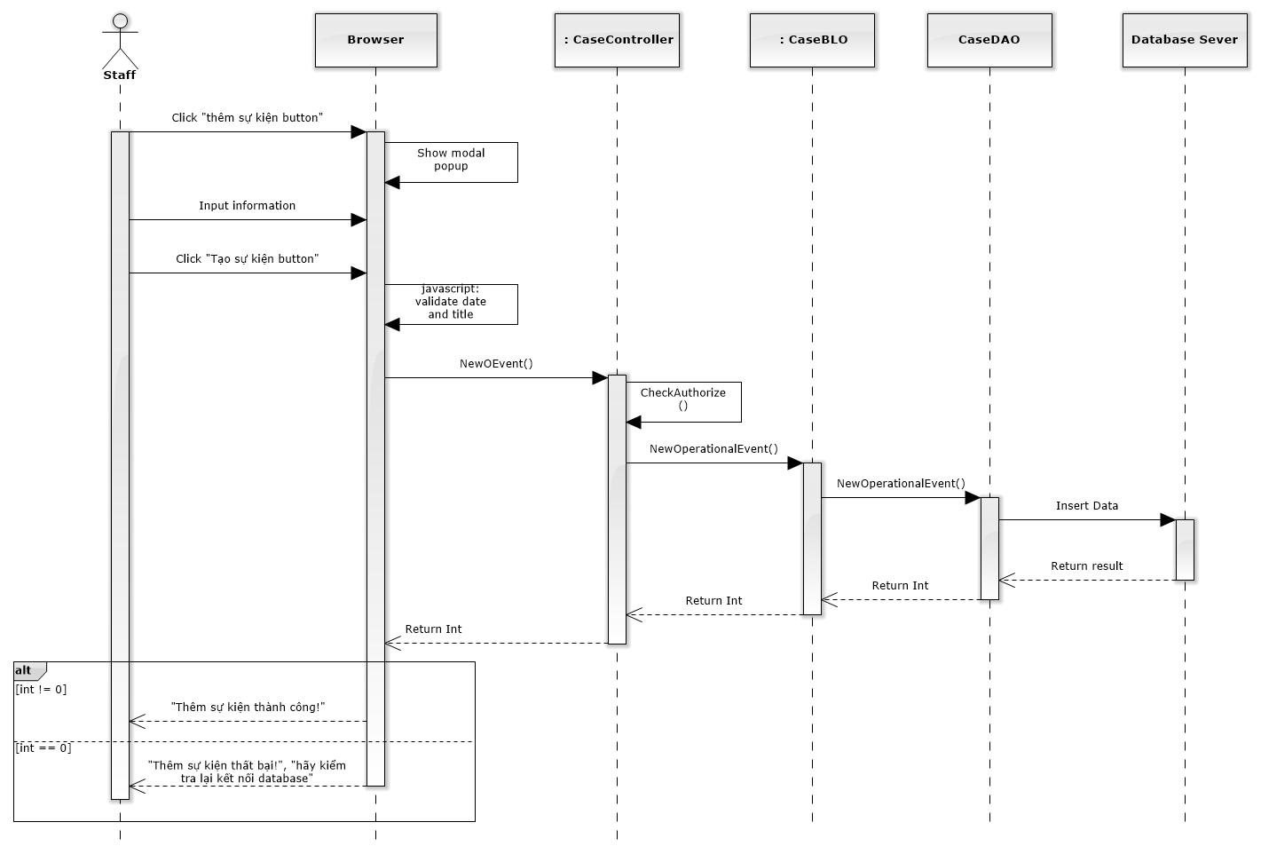

Figure 159: Add New Operation Event Sequence Diagram

###### Edit operation event

Screen design

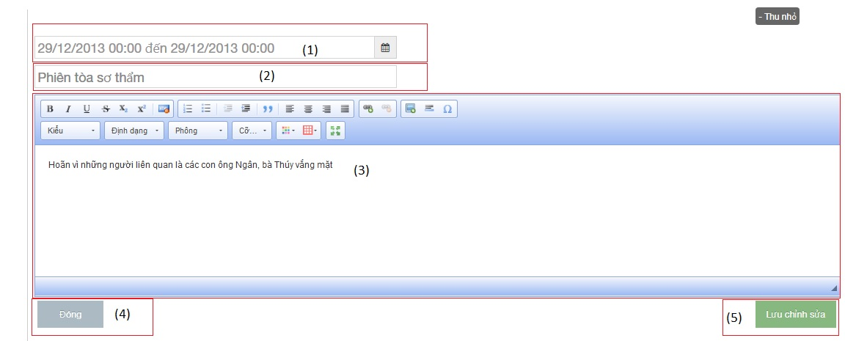

|  |  |  |  |  |
| --- | --- | --- | --- | --- |
| No | Object/ControlName | Type | Required | Description |
| 1 | Time range | Button | Yes | Click to choose begin time and end time of event |
| 2 | Title | Table | Yes | Title of Operation Event |
| 3 | Content | Label | Yes | Content of Operation Event |
| 4 | “Đóng” | Button | Yes | Click to close edit operation event |
| 5 | “Lưu chỉnh sửa” | Button | Yes | Click to edit operation event |

Sequence diagram

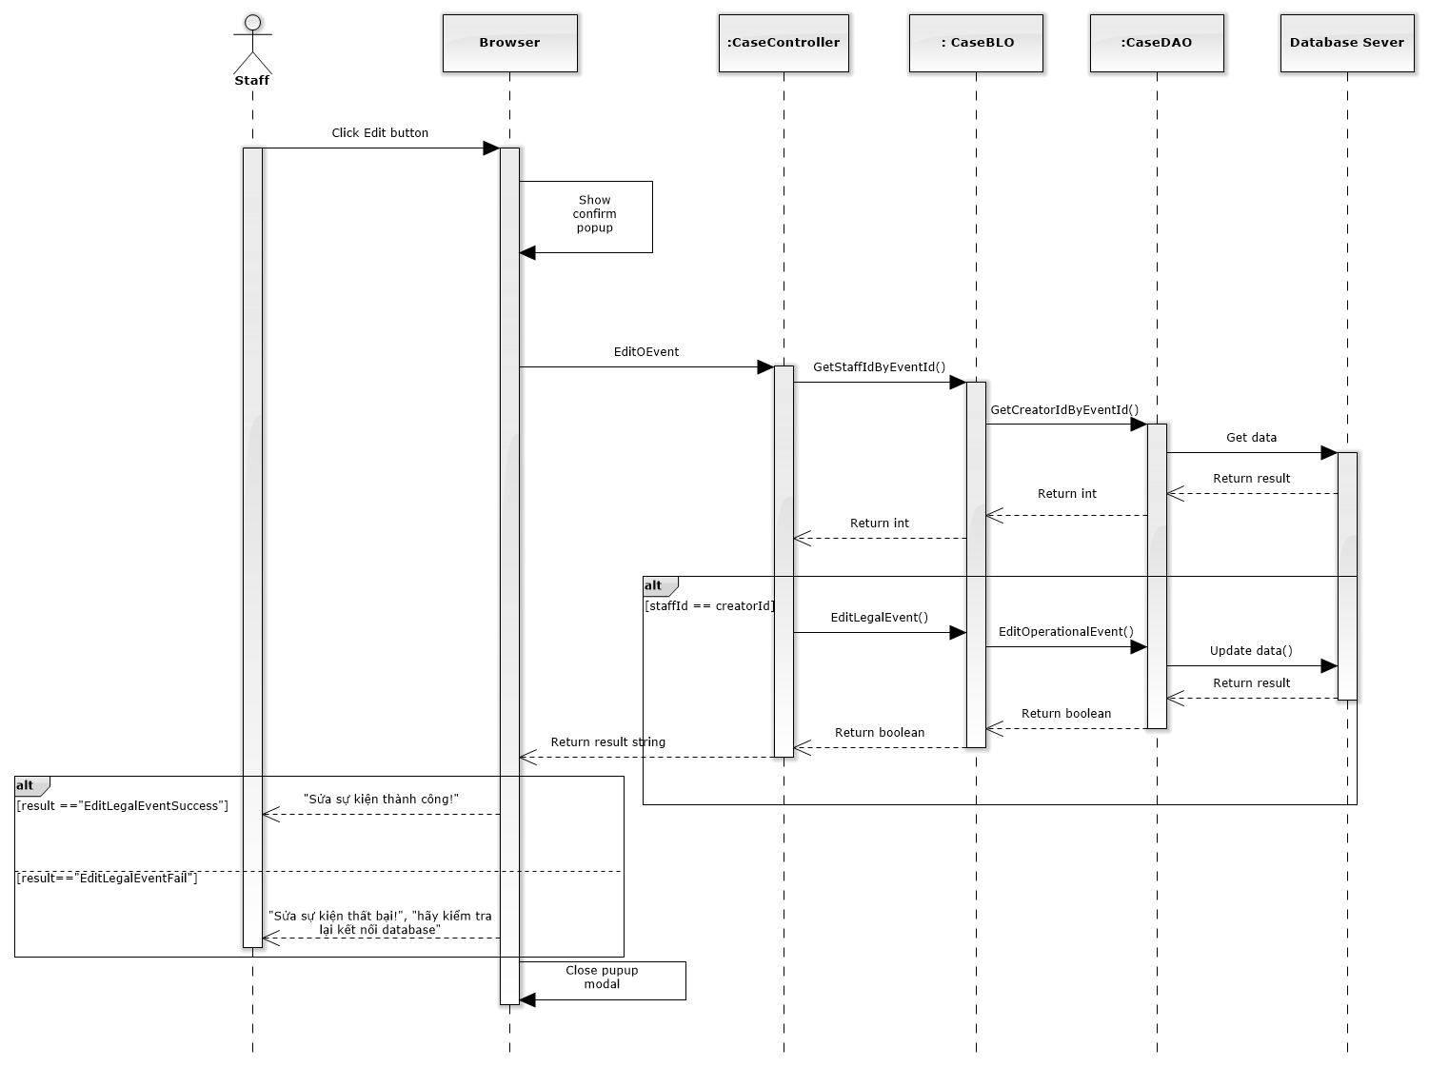

Figure 160: Edit Operation Event Sequence Diagram

###### Delete operation event

Screen design

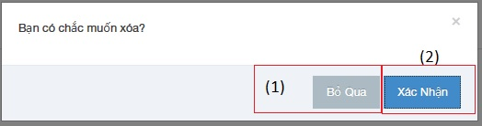

|  |  |  |  |  |
| --- | --- | --- | --- | --- |
| No | Object/ControlName | Type | Required | Description |
| 1 | “Bỏ qua” | Button | Yes | Click to close delete operation event |
| 2 | “Xác nhận” | Button | Yes | Click to delete operation event |

Sequence diagram

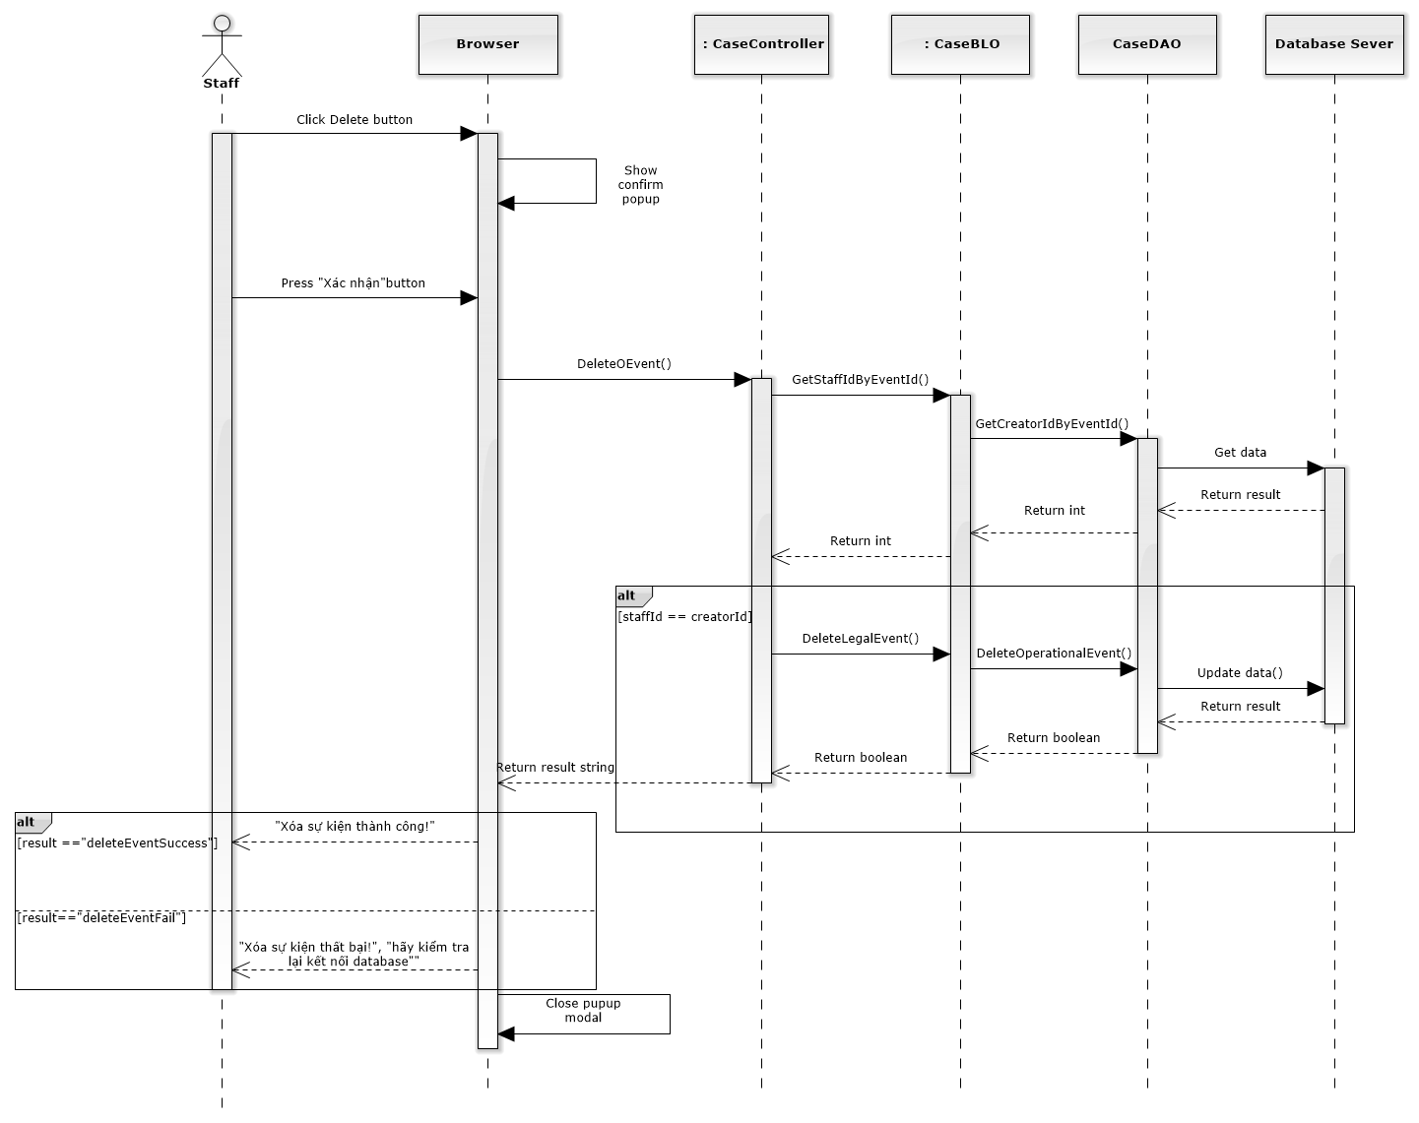

Figure 161: Delete Operation Event Sequence Diagram

##### Manage Lawyer Related

##### Manage Customer Related

##### Manage Subject Related

##### Manage Document Related

##### Manage Used Service

##### Manage Payment

### Manage Customer Group

##### Class diagram

### Manage Customer

#### List customers

##### Class diagram

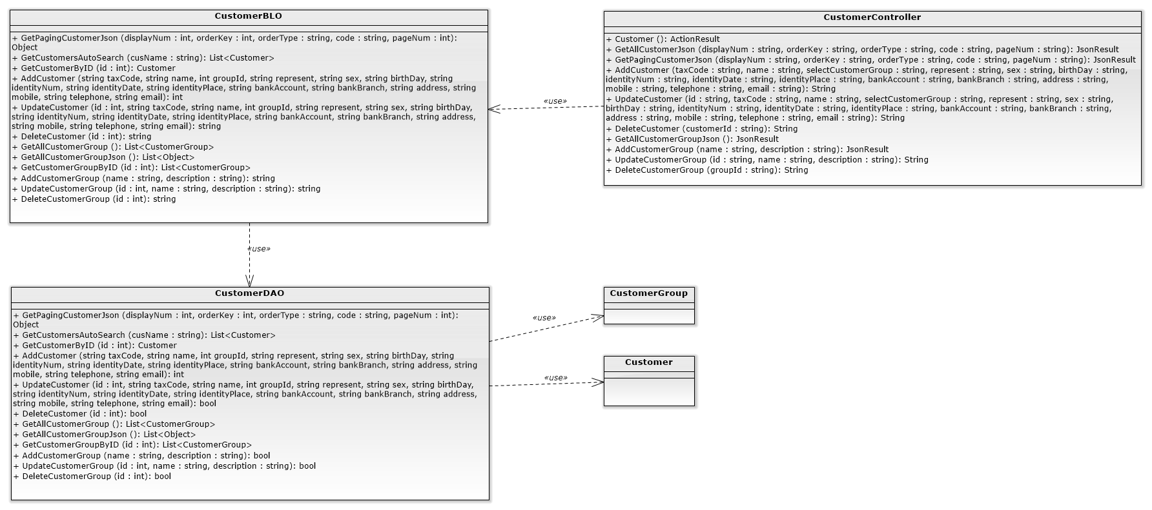

##### Screen design

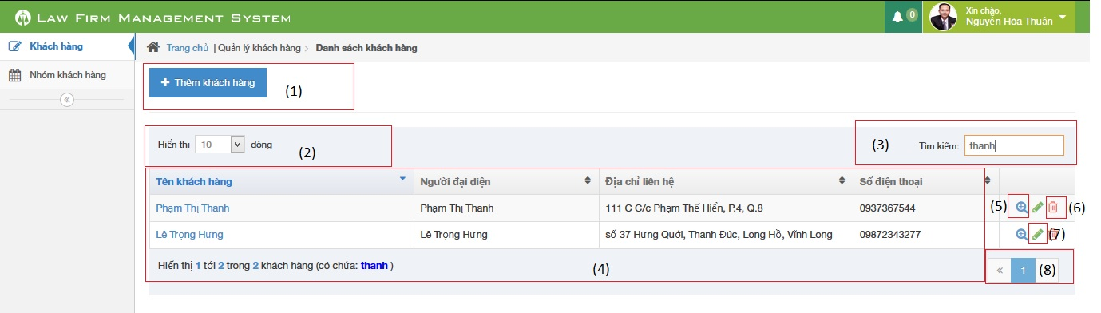

|  |  |  |  |  |
| --- | --- | --- | --- | --- |
| No | Object/ControlName | Type | Required | Description |
| 1 | Thêm khách hàng | Button | Yes | Show Add new customer pop-up |
| 2 | Number of rows | Combo-box | Yes | Choose number of rows in table |
| 3 | Search | Textbox | Yes | Search customer |
| 4 | Customer table | Table | Yes | List Customer |
| 5 | View customer detail | Icon | Yes | Show Customer detail pop-up |
| 6 | Delete customer | Icon | Yes | Delete customer |
| 7 | Edit customer | Icon | Yes | Show edit customer pop-up |
| 8 | Paging | Button | Yes | Paging the customer list |

##### Sequence diagram

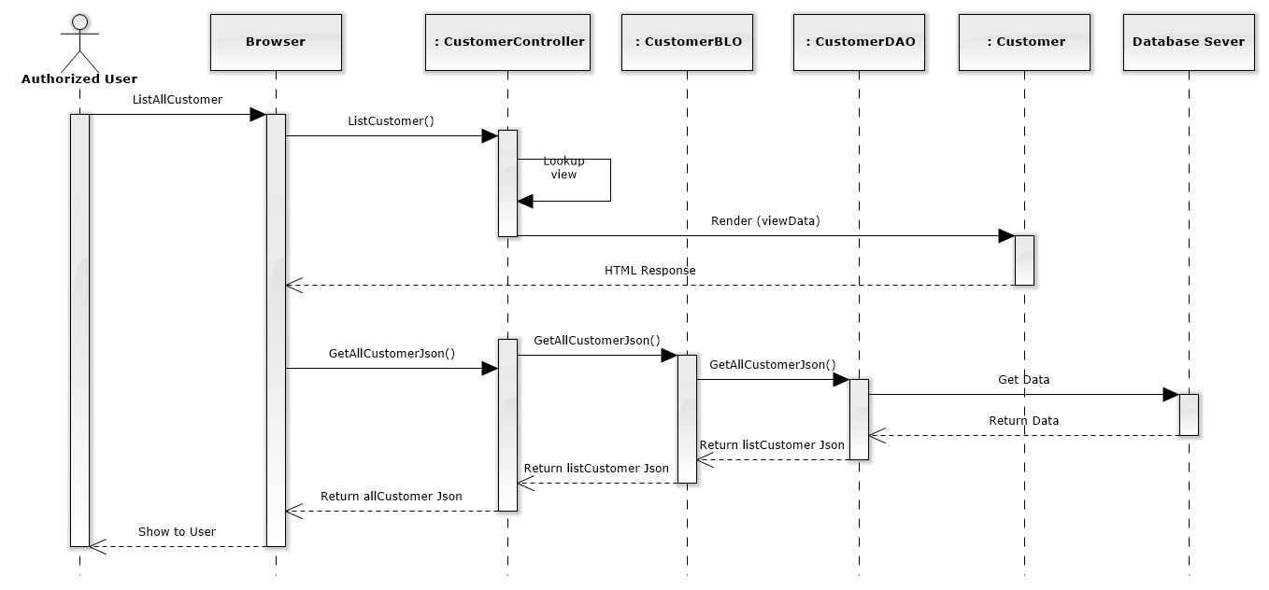

Figure 163: List Customers Sequence Diagram

#### Add new customer

##### Screen design

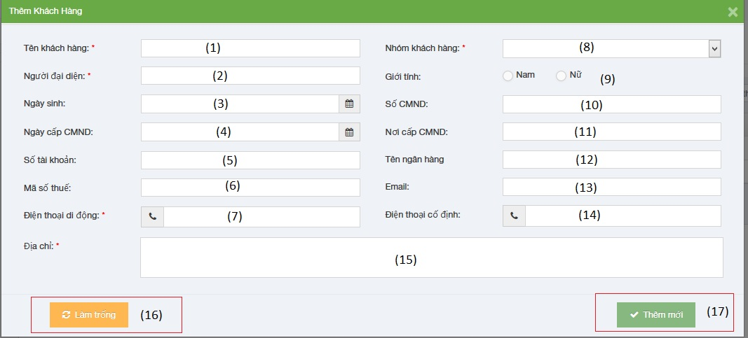

|  |  |  |  |  |
| --- | --- | --- | --- | --- |
| No | Object/ControlName | Type | Required | Description |
| 1 | Tên Khách hàng | Textbox | Yes | Customer name |
| 2 | Người đại diện | Textbox | Yes | Presentative |
| 3 | Ngày sinh | Date picker | Yes | Date of Birth |
| 4 | Ngày cấp CMND | Date picker | Yes | Identity Date |
| 5 | Số tài khoản | Textbox | Yes | Bank account |
| 6 | Mã số thuế | Textbox | Yes | Tax code |
| 7 | Điện thoại di động | Textbox | Yes | Mobile |
| 8 | Nhóm khách hàng | Combo-box | Yes | Customer group |
| 9 | Giới tính | Radio-button | Yes | Gender |
| 10 | Số CMND | Textbox | Yes | Identity Number |
| 11 | Nơi cấp CMND | Textbox | Yes | Identity Place |
| 12 | Tên ngân hàng | Textbox | Yes | Bank Branch |
| 13 | Email | Textbox | Yes | Email |
| 14 | Điện thoại cố định | Textbox | Yes | Phone |
| 15 | Địa chỉ | Text area | Yes | Address |
| 16 | Làm trống | Button | Yes | Clear all field |
| 17 | Thêm mới | Button | Yes | Add new customer |

##### Sequence diagram

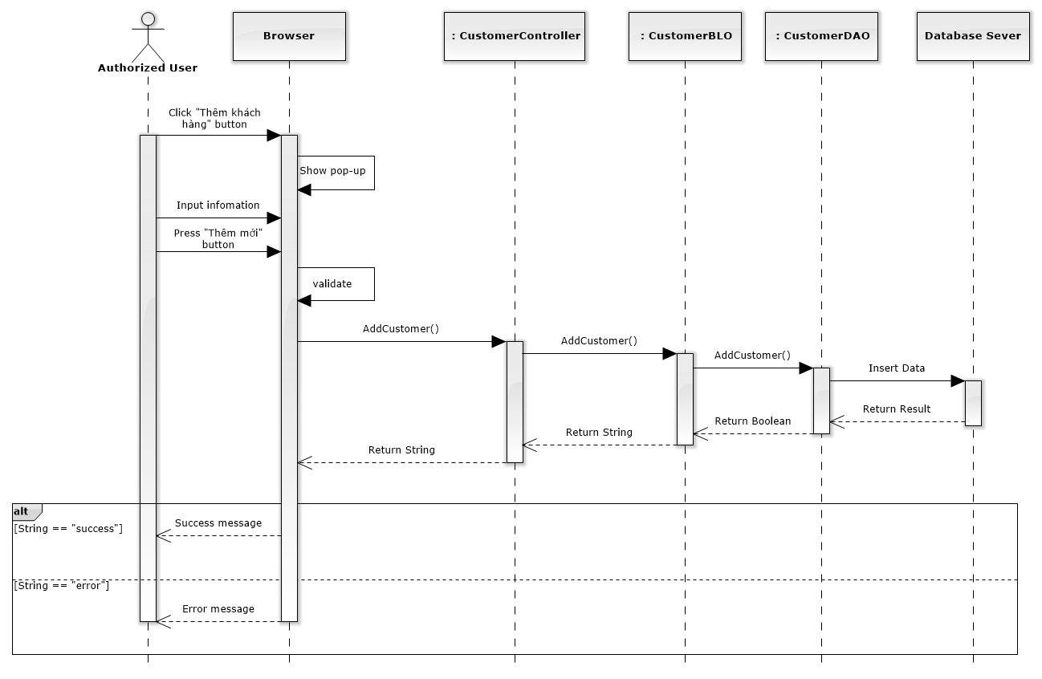

Figure 164: Add New Customer Sequence Diagram

#### Edit customer

##### Screen design

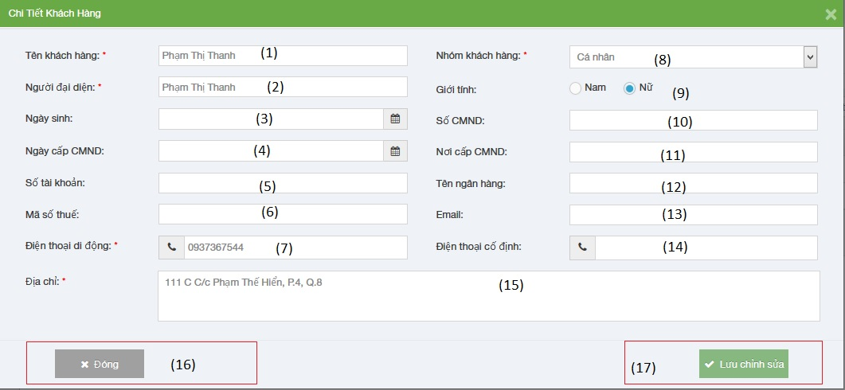

|  |  |  |  |  |
| --- | --- | --- | --- | --- |
| No | Object/ControlName | Type | Required | Description |
| 1 | Tên Khách hàng | Textbox | Yes | Customer name |
| 2 | Người đại diện | Textbox | Yes | Presentative |
| 3 | Ngày sinh | Date picker | Yes | Date of Birth |
| 4 | Ngày cấp CMND | Date picker | Yes | Identity Date |
| 5 | Số tài khoản | Textbox | Yes | Bank account |
| 6 | Mã số thuế | Textbox | Yes | Tax code |
| 7 | Điện thoại di động | Textbox | Yes | Mobile |
| 8 | Nhóm khách hàng | Combo-box | Yes | Customer group |
| 9 | Giới tính | Radio-button | Yes | Gender |
| 10 | Số CMND | Textbox | Yes | Identity Number |
| 11 | Nơi cấp CMND | Textbox | Yes | Identity Place |
| 12 | Tên ngân hàng | Textbox | Yes | Bank Branch |
| 13 | Email | Textbox | Yes | Email |
| 14 | Điện thoại cố định | Textbox | Yes | Phone |
| 15 | Địa chỉ | Text area | Yes | Address |
| 16 | Đóng | Button | Yes | Close edit customer |
| 17 | Lưu chỉnh sửa | Button | Yes | Edit customer |

##### Sequence diagram

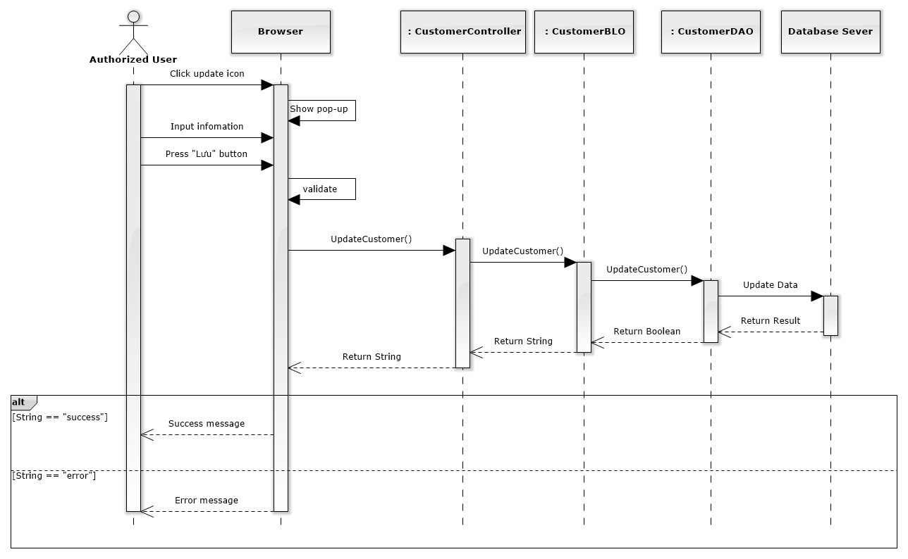

Figure 165: Edit Customer Sequence Diagram

#### Delete customer

##### Screen design

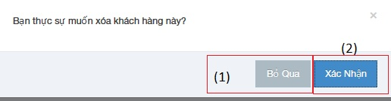

|  |  |  |  |  |
| --- | --- | --- | --- | --- |
| No | Object/ControlName | Type | Required | Description |
| 1 | “Bỏ qua” | Button | Yes | Click to close delete customer |
| 2 | “Xác nhận” | Button | Yes | Click to delete customer |

##### Sequence diagram

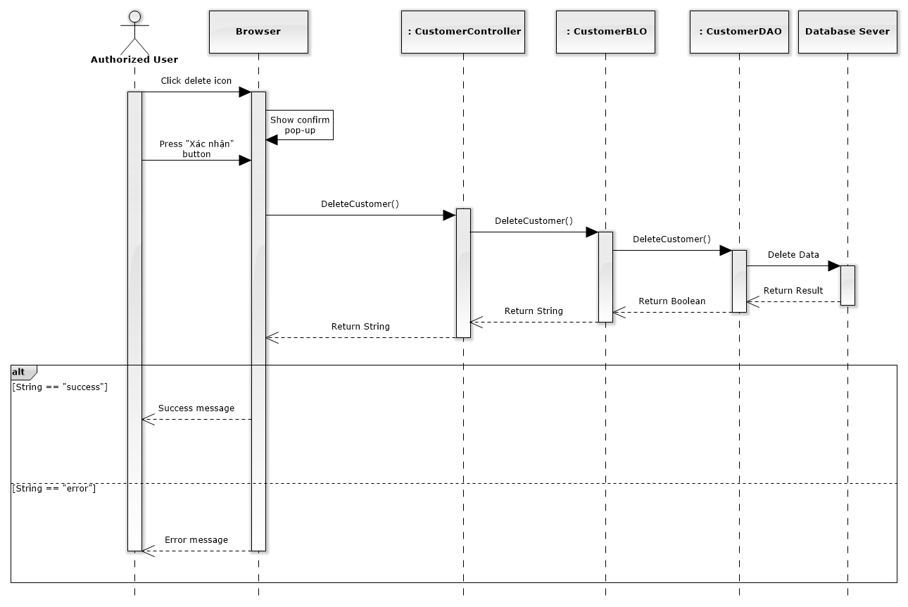

Figure 166: Delete Customer Sequence Diagram

### Manage Staff Group

##### Class diagram

### Manage Staff

#### List staffs

##### Class diagram

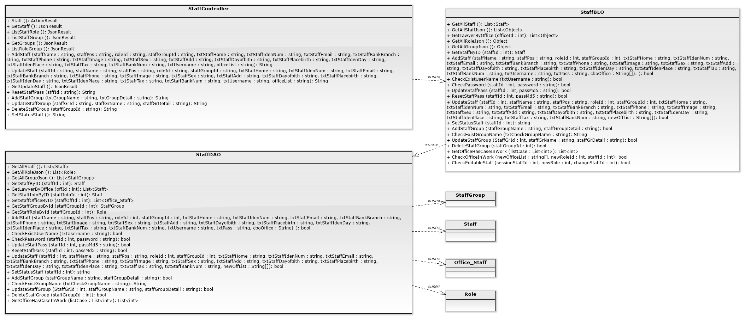

##### Screen design

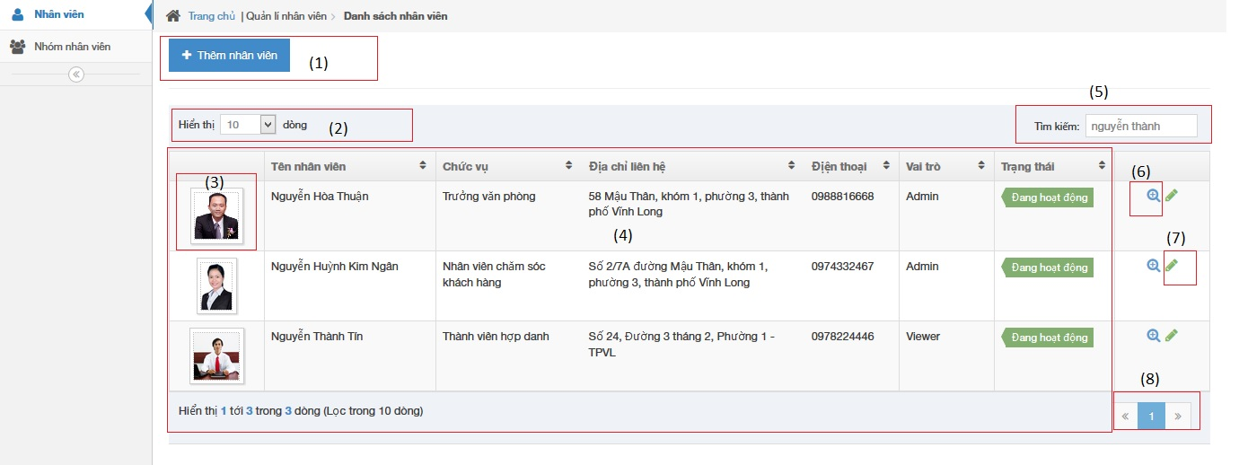

|  |  |  |  |  |
| --- | --- | --- | --- | --- |
| No | Object/ControlName | Type | Required | Description |
| 1 | Thêm nhân viên | Button | Yes | Click to show popup for add new staff |
| 2 | Number of rows | Combo-box | Yes | Choose number of rows in table |
| 3 | Image of staff | Image | Yes | Click to show popup detail of staff |
| 4 | List all staff | Table | Yes | List all staff |
| 5 | Tìm kiếm | Textbox | Yes | Search staff |
| 6 | View | Button | Yes | Click to show popup detail of staff |
| 7 | Edit | Button | Yes | Click to show popup edit detail of staff information. |
| 8 | Paging | Button | Yes | Paging page |

##### Sequence diagram

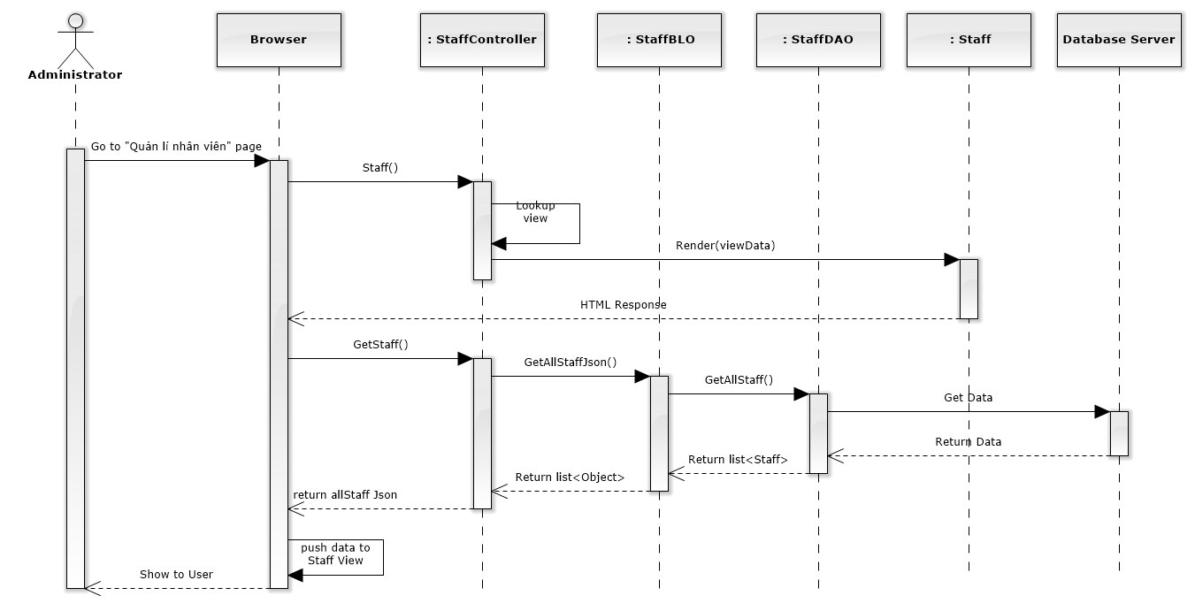

Figure 167: List Staffs Sequence Diagram

#### Add new staff

##### Screen design

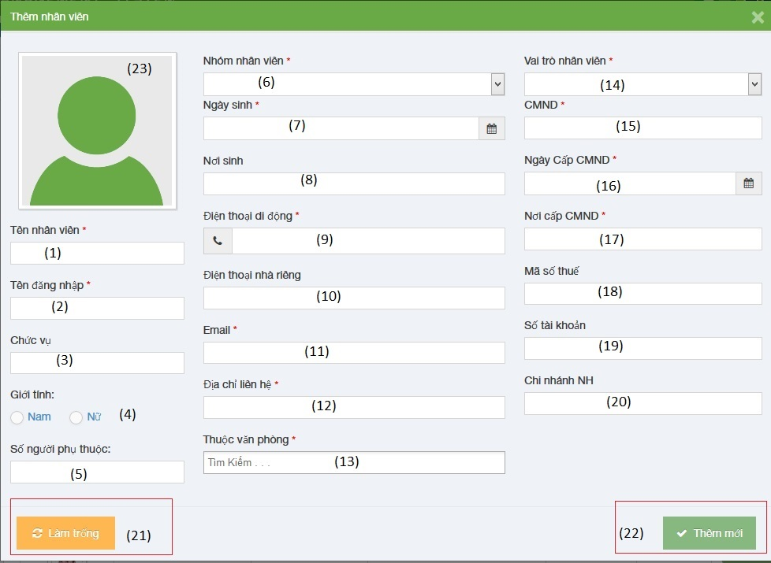

|  |  |  |  |  |
| --- | --- | --- | --- | --- |
| No | Object/ControlName | Type | Required | Description |
| 1 | Tên nhân viên | Textbox | Yes | Name of staff |
| 2 | Tên đăng nhập | Textbox | Yes | Username of staff |
| 3 | Chức vụ | Textbox | Yes | Position of staff |
| 4 | Giới tính | Radio button | Yes | Choose sex of staff |
| 5 | Số người phụ thuộc | Textbox | Yes | Number of dependents |
| 6 | Nhóm nhân viên | Textbox | Yes | Select group of staff |
| 7 | Ngày sinh | Datetime picker | Yes | Date of birth of staff |
| 8 | Nơi sinh | Textbox | Yes | Place of birth of staff |
| 9 | Điện thoại di động | Textbox | Yes | Phone number of staff |
| 10 | Điện thoại nhà riêng | Textbox | Yes | Telephone of staff |
| 11 | Email | Textbox | Yes | Email of staff |
| 12 | Địa chỉ liên hệ | Textbox | Yes | Address of staff |
| 13 | Thuộc văn phòng | Multiple select box | Yes | Select office of staff |
| 14 | Vai trò nhân viên | Select box | Yes | Select role of staff |
| 15 | CMND | Textbox | Yes | Indentity number of staff |
| 16 | Ngày cấp CMND | Datetime picker | Yes | Date of Identity of staff |
| 17 | Nơi cấp CMND | Textbox | Yes | Place of Identity of staff |
| 18 | Mã số thuế | Textbox | Yes | Tax number of staff |
| 19 | Số tài khoản | Textbox | Yes | Bank account number of staff |
| 20 | Chi nhánh ngân hàng | Textbox | Yes | Name of bank of staff |
| 21 | “Làm trống” | Button | Yes | Clear all field |
| 22 | “Thêm mới” | Button | Yes | Add new staff |
| 23 | Image of staff | Image | Yes | Image of staff |

##### Sequence diagram

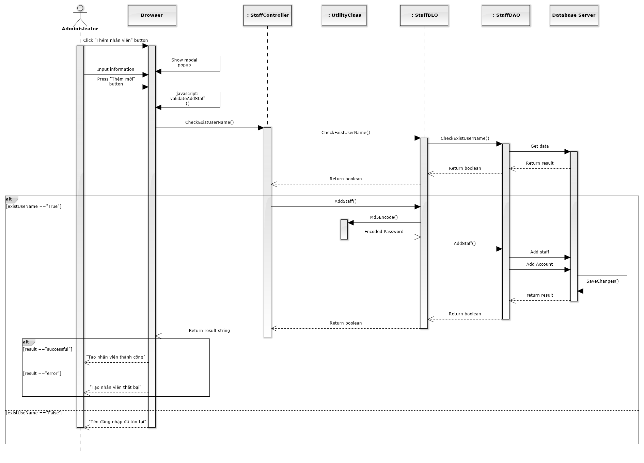

Figure 168: Add New Staff Sequence Diagram

#### Edit staff

##### Screen design

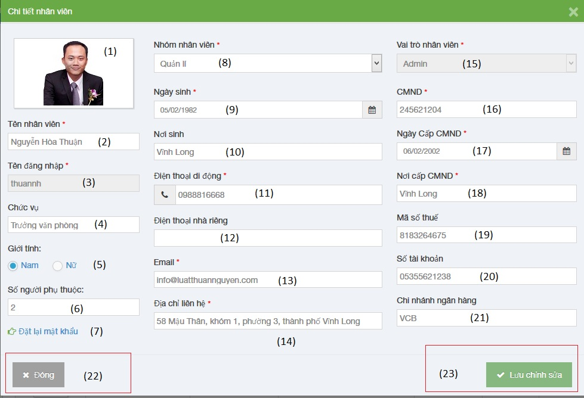

|  |  |  |  |  |
| --- | --- | --- | --- | --- |
| No | Object/ControlName | Type | Required | Description |
| 1 | Image of staff | Image | Yes | Image of staff |
| 2 | Tên nhân viên | Textbox | Yes | Name of staff |
| 3 | Tên đăng nhập | Textbox | Yes | Username of staff |
| 4 | Chức vụ | Textbox | Yes | Position of staff |
| 5 | Giới tính | Radio button | Yes | Choose sex of staff |
| 6 | Số người phụ thuộc | Textbox | Yes | Number of dependents |
| 7 | Đặt lại mật khẩu | Link | Yes | Change staff password |
| 8 | Nhóm nhân viên | Textbox | Yes | Select group of staff |
| 9 | Ngày sinh | Datetime picker | Yes | Date of birth of staff |
| 10 | Nơi sinh | Textbox | Yes | Place of birth of staff |
| 11 | Điện thoại di động | Textbox | Yes | Phone number of staff |
| 12 | Điện thoại nhà riêng | Textbox | Yes | Telephone of staff |
| 13 | Email | Textbox | Yes | Email of staff |
| 14 | Địa chỉ liên hệ | Textbox | Yes | Address of staff |
| 15 | Vai trò nhân viên | Select box | Yes | Select role of staff |
| 16 | CMND | Textbox | Yes | Indentity number of staff |
| 17 | Ngày cấp CMND | Datetime picker | Yes | Date of Identity of staff |
| 18 | Nơi cấp CMND | Textbox | Yes | Place of Identity of staff |
| 19 | Mã số thuế | Textbox | Yes | Tax number of staff |
| 20 | Số tài khoản | Textbox | Yes | Bank account number of staff |
| 21 | Chi nhánh ngân hàng | Textbox | Yes | Name of bank of staff |
| 22 | “Đóng” | Button | Yes | Close edit staff |
| 23 | “Lưu chỉnh sửa” | Button | Yes | Save edit staff |

##### Sequence diagram

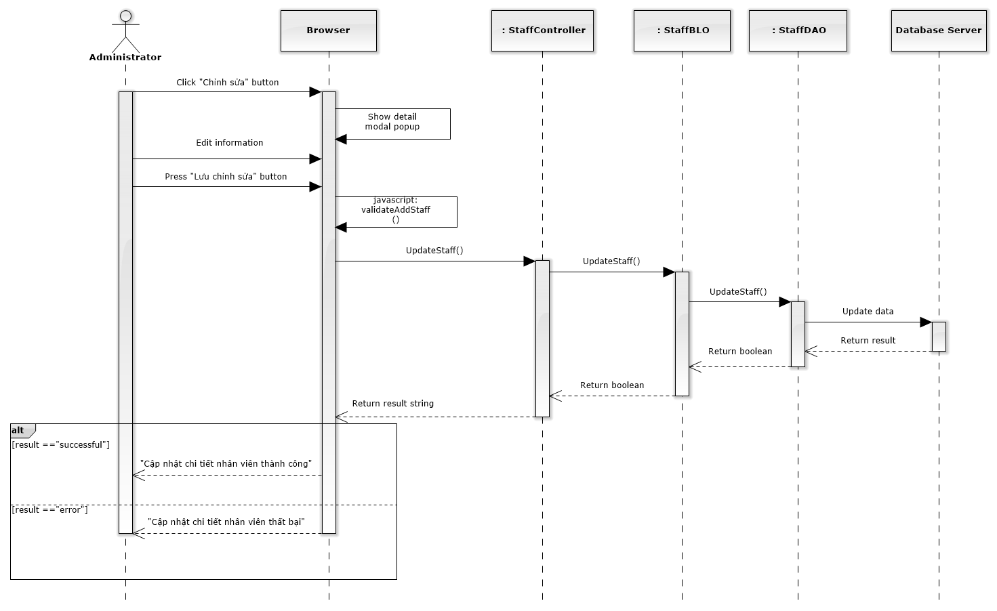

Figure 169: Edit Staff Sequence Diagram

#### Deactivate/ Activate staff

##### Screen design

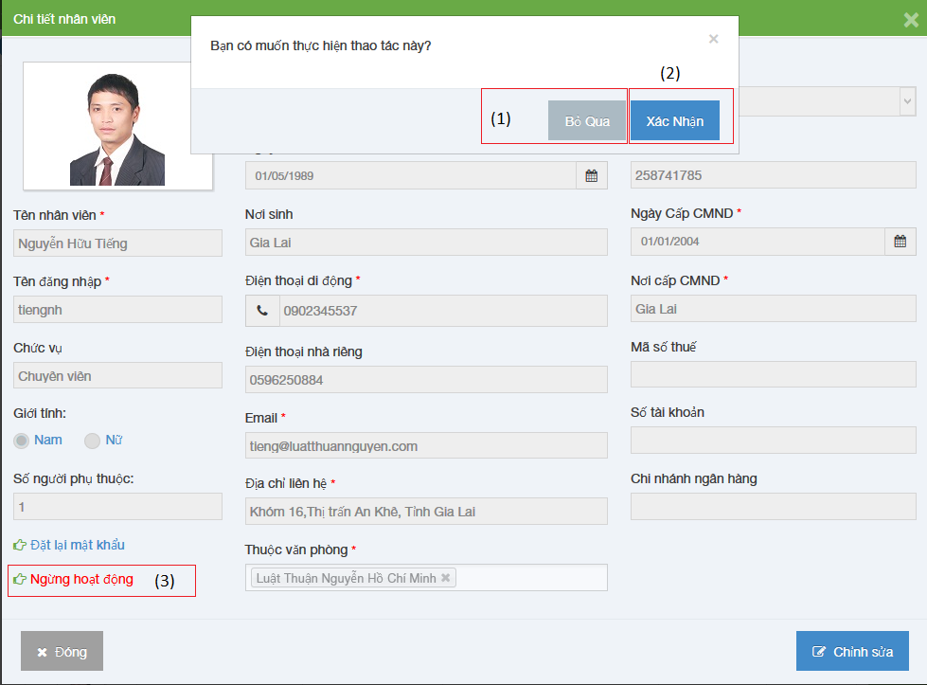

|  |  |  |  |  |
| --- | --- | --- | --- | --- |
| No | Object/ControlName | Type | Required | Description |
| 1 | “Bỏ qua” | Button | Yes | Click to close Deactive staff |
| 2 | “Xác nhận” | Button | Yes | Click to Deactive staff |
| 3 | Ngừng hoạt động | Link | Yes | Click to open confirm Deactive staff |

##### Sequence diagram

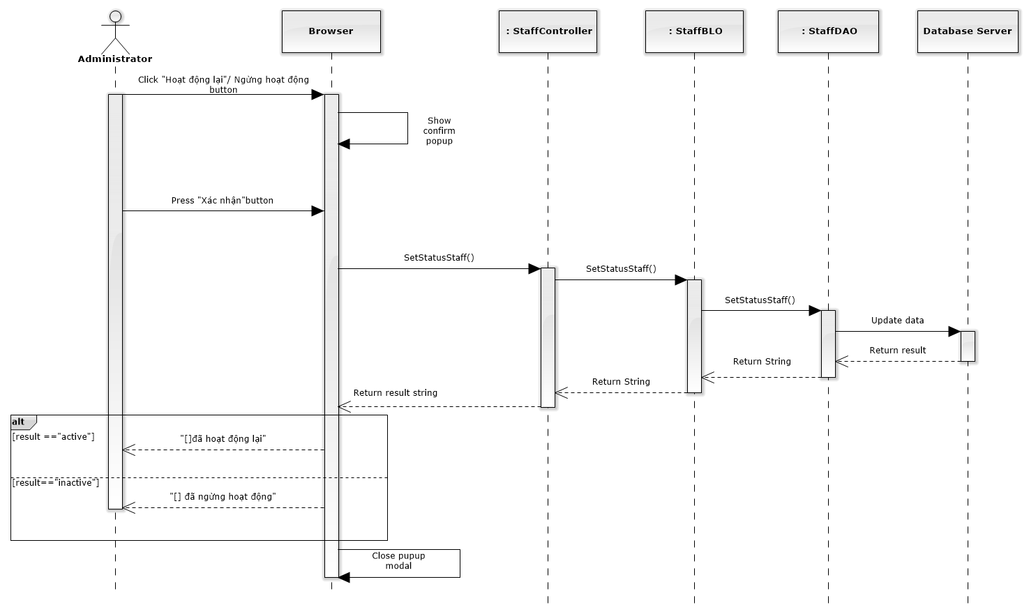

Figure 170: Deactivate / Activate Staff Sequence Diagram

#### Reset password

##### Screen design

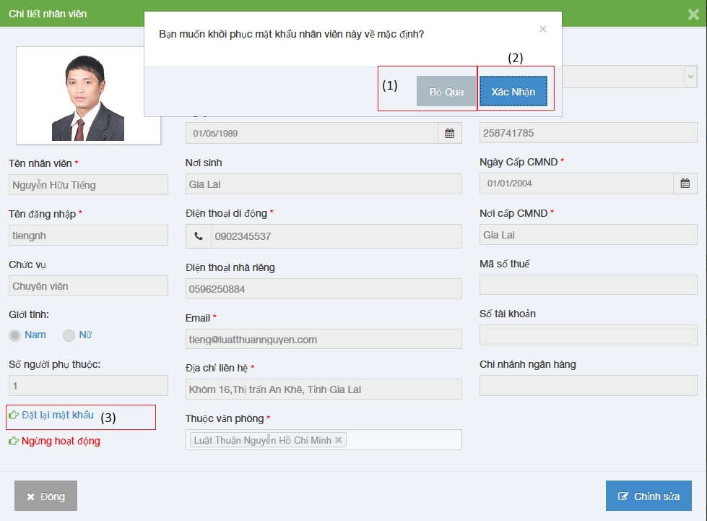

|  |  |  |  |  |
| --- | --- | --- | --- | --- |
| No | Object/ControlName | Type | Required | Description |
| 1 | “Bỏ qua” | Button | Yes | Click to close reset password staff |
| 2 | “Xác nhận” | Button | Yes | Click to reset password staff |
| 3 | Đặt lại mật khẩu | Link | Yes | Click to open reset password staff |

##### Sequence diagram

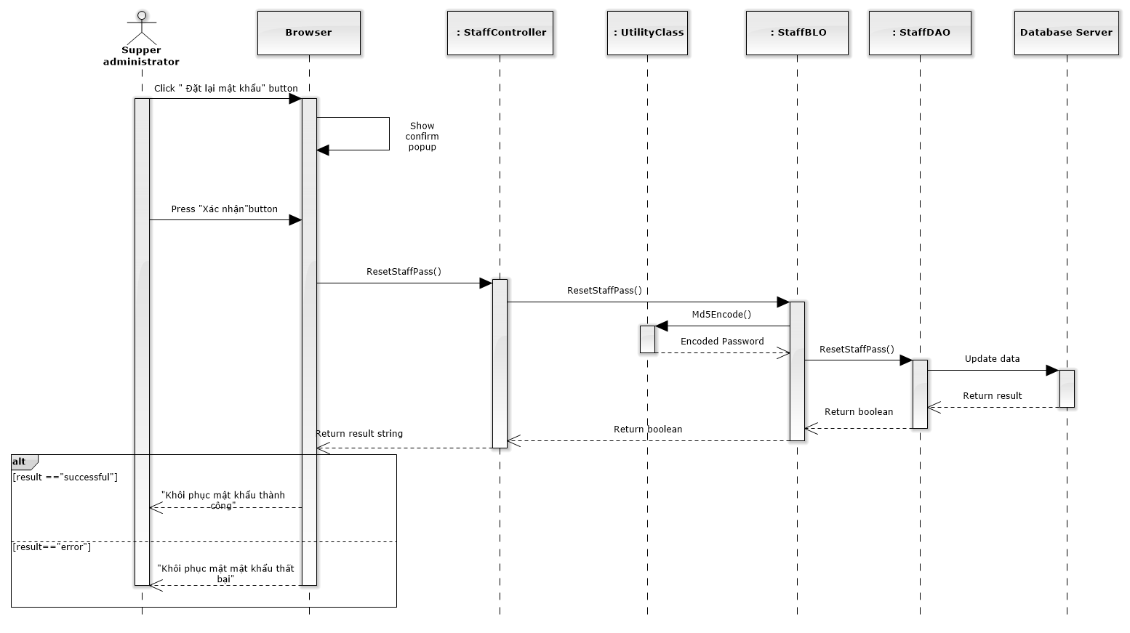

Figure 171: Reset Password Sequence Diagram

### Manage Service Type

#### Class diagram

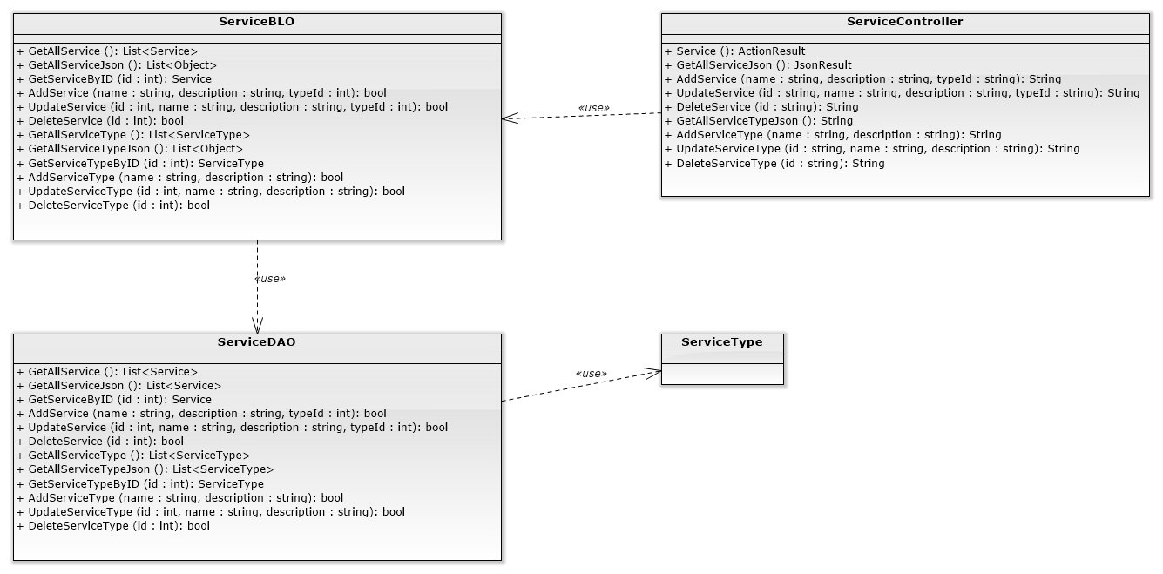

### Manage Service

#### List Services

##### Class diagram

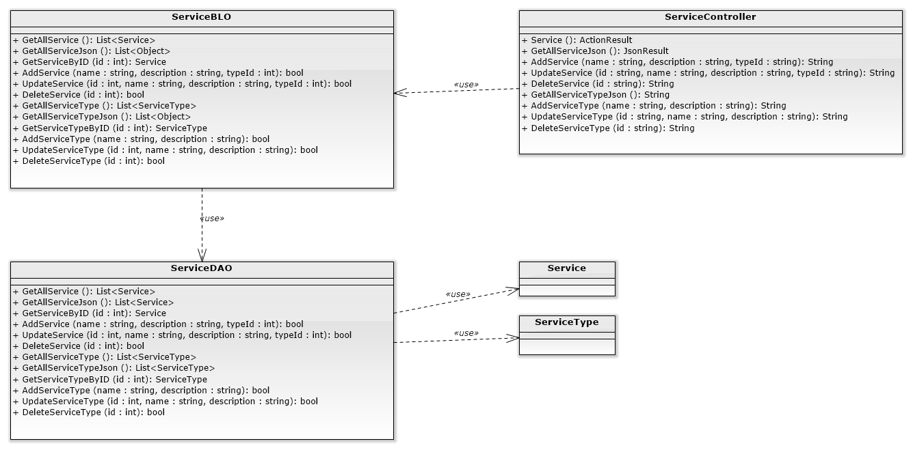

##### Screen design

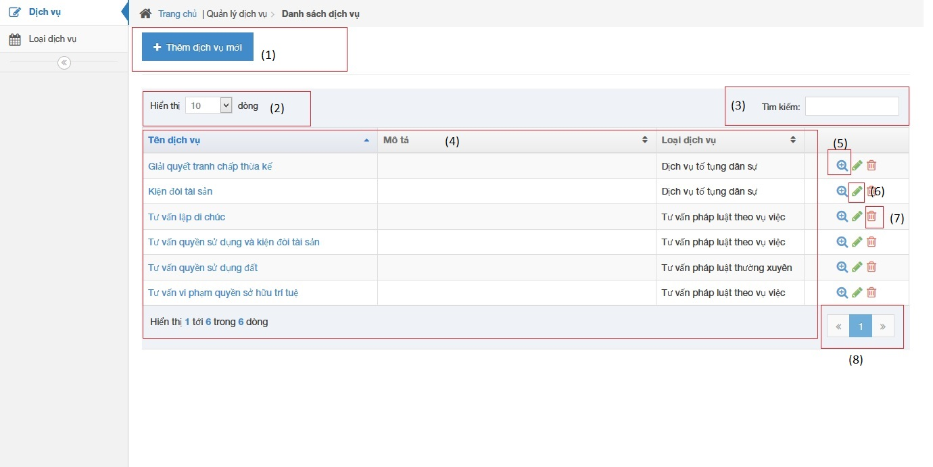

|  |  |  |  |  |
| --- | --- | --- | --- | --- |
| No | Object/ControlName | Type | Required | Description |
| 1 | Thêm dịch vụ mới | Button | Yes | Show Add new service pop-up |
| 2 | Number of rows | Combo-box | Yes | Choose number of rows in table |
| 3 | Search | Textbox | Yes | Search service |
| 4 | Services table | Table | Yes | List service |
| 5 | View service detail | Icon | Yes | Show service detail pop-up |
| 6 | Edit service | Icon | Yes | Delete service |
| 7 | Delete service | Icon | Yes | Show edit service pop-up |
| 8 | Paging | Button | Yes | Paging the service list |

##### Sequence diagram

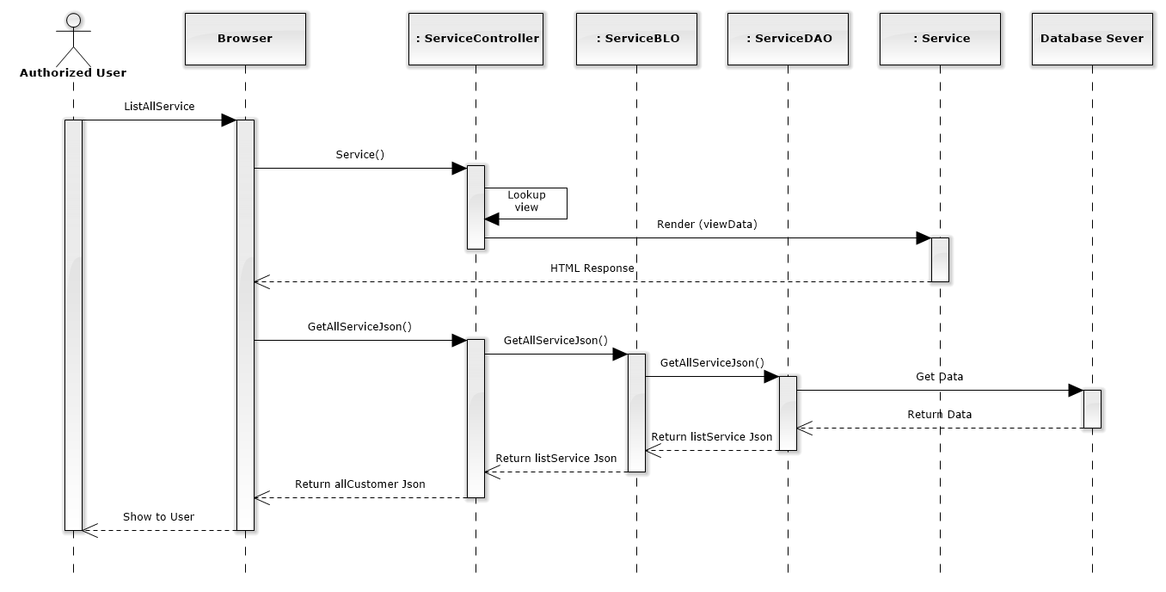

Figure 172: List Services Sequence Diagram

#### Add new service

##### Screen design

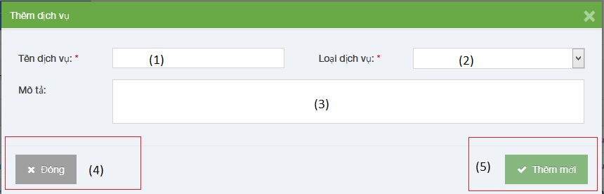

|  |  |  |  |  |
| --- | --- | --- | --- | --- |
| No | Object/ControlName | Type | Required | Description |
| 1 | Tên dịch vụ | Textbox | Yes | Name Service |
| 2 | Loại dịch vụ | Combo-box | Yes | Service type |
| 3 | Mô tả | Textbox | Yes | Description |
| 4 | “Đóng” | Button | Yes | Click to close add new service pop-up |
| 5 | “Thêm mới” | Button | Yes | Click to add new service |

##### Sequence diagram

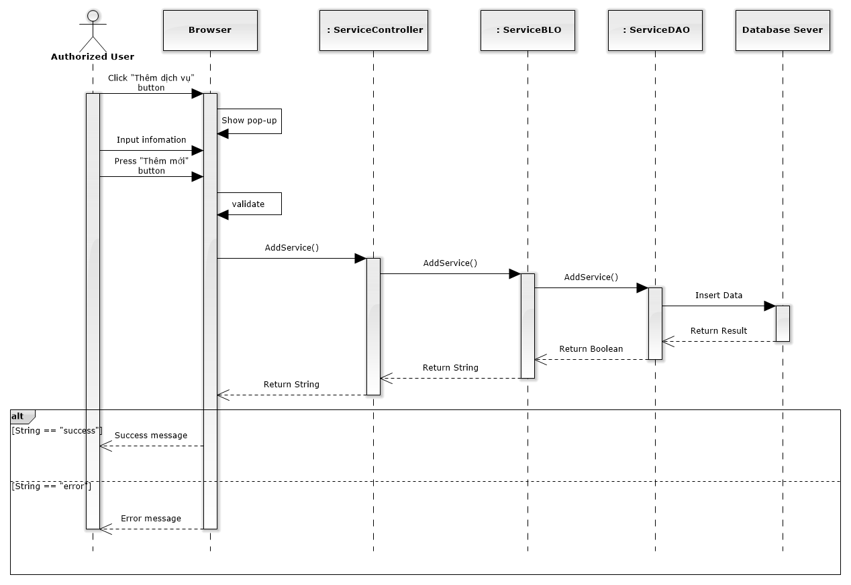

Figure 173: Add New Service Sequence Diagram

#### Edit service

##### Screen design

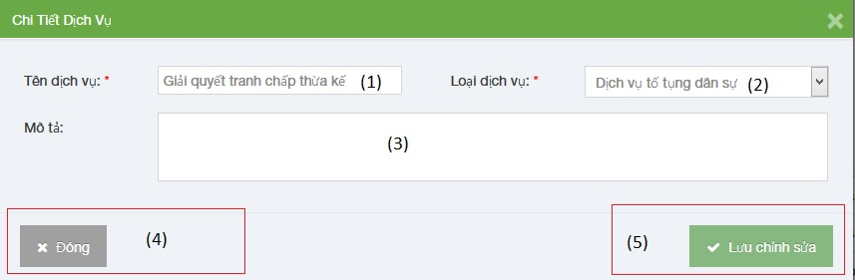

|  |  |  |  |  |
| --- | --- | --- | --- | --- |
| No | Object/ControlName | Type | Required | Description |
| 1 | Tên dịch vụ | Textbox | Yes | Name Service |
| 2 | Loại dịch vụ | Combo-box | Yes | Service type |
| 3 | Mô tả | Textbox | Yes | Description |
| 4 | “Đóng” | Button | Yes | Click to close edit service pop-up |
| 5 | “Lưu chỉnh sửa” | Button | Yes | Click to save edit service |

##### Sequence diagram

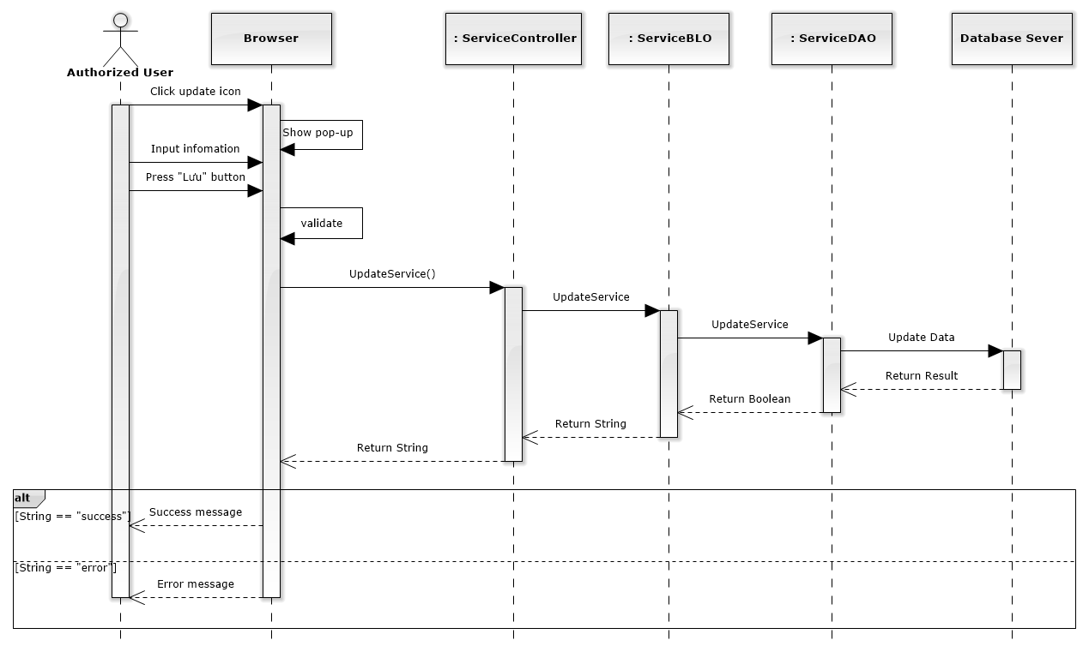

Figure 174: Edit Service Sequence Diagram

#### Delete service

##### Screen design

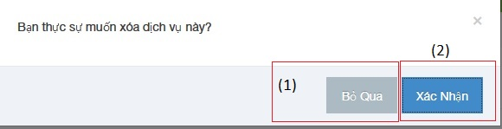

|  |  |  |  |  |
| --- | --- | --- | --- | --- |
| No | Object/ControlName | Type | Required | Description |
| 1 | Bỏ qua | Button | Yes | Click to close delete service pop-up |
| 2 | Xác nhận | Button | Yes | Click to delete service pop-up |

##### Sequence diagram

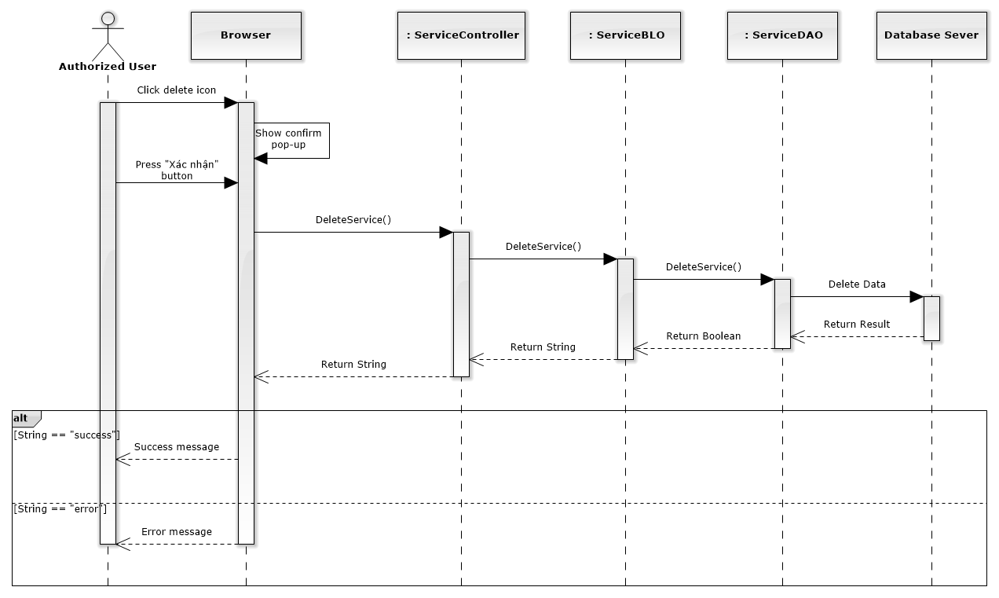

Figure 175: Delete Service Sequence Diagram

### Manage Office

#### List offices

##### Class diagram

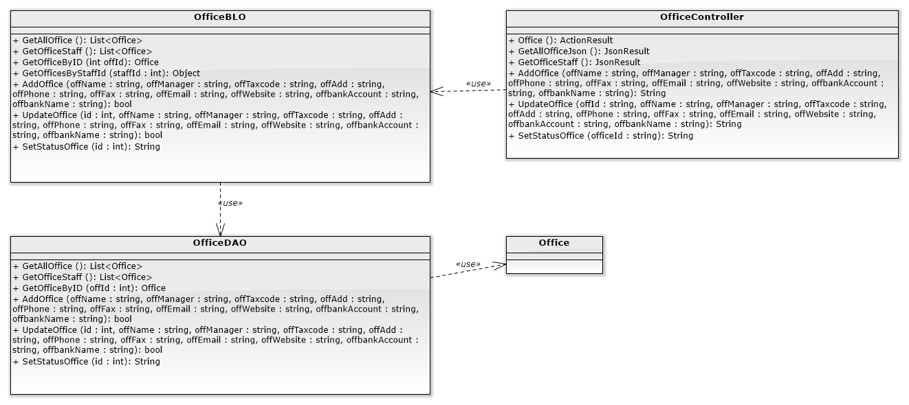

##### Screen design

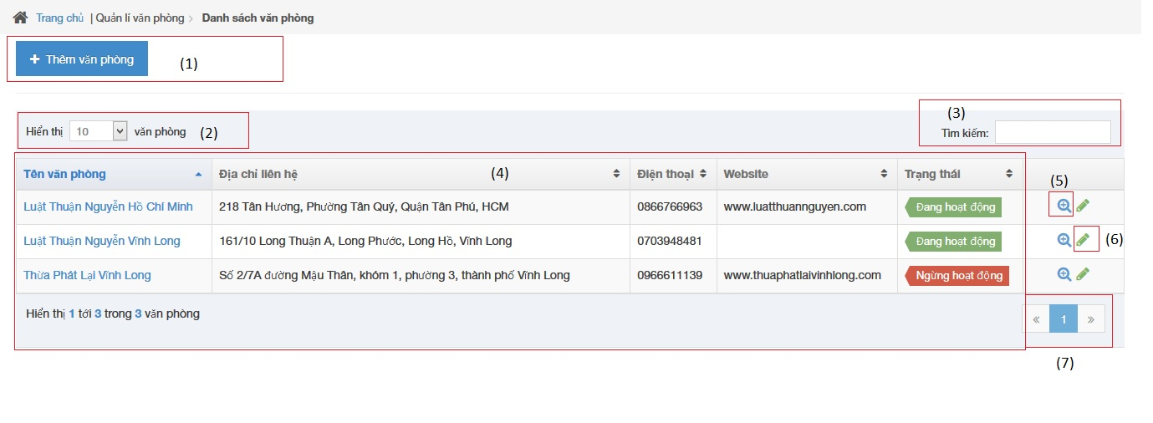

|  |  |  |  |  |
| --- | --- | --- | --- | --- |
| No | Object/ControlName | Type | Required | Description |
| 1 | Thêm văn phòng | Button | Yes | Click to show popup for add new office |
| 2 | Number of rows | Combo-box | Yes | Choose number of rows in table |
| 3 | Tìm kiếm | Textbox | Yes | Search office |
| 4 | List all office | Table | Yes | List all office |
| 5 | View | Button | Yes | Click to show popup detail of office |
| 6 | Edit | Button | Yes | Click to show popup edit detail of office information. |
| 7 | Paging | Button | Yes | Paging page |

##### Sequence diagram

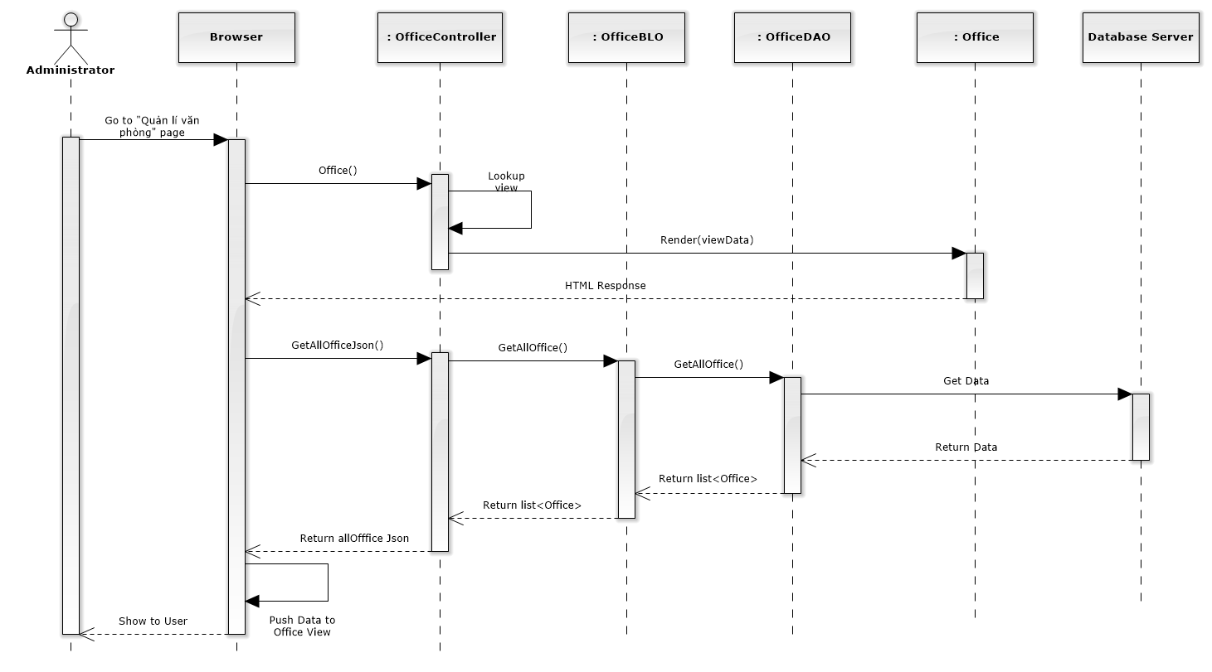

Figure 176: List Offices Sequence Diagram

#### Add new office

##### Screen design

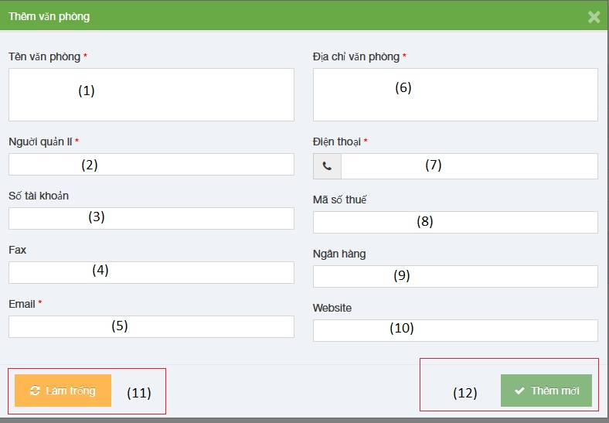

|  |  |  |  |  |
| --- | --- | --- | --- | --- |
| No | Object/ControlName | Type | Required | Description |
| 1 | Tên văn phòng | Textbox | Yes | Name of office |
| 2 | Người quản lí | Textbox | Yes | Nam’s manager of office |
| 3 | Số tài khoản | Textbox | Yes | Bank account number of office |
| 4 | Fax | Textbox | Yes | Fax of office |
| 5 | Email | Textbox | Yes | Email of office |
| 6 | Địa chỉ văn phòng | Textbox | Yes | Address of office |
| 7 | Điện thoại | Textbox | Yes | Phone number of office |
| 8 | Mã số thuế | Textbox | Yes | Tax number of office |
| 9 | Ngân hàng | Textbox | Yes | Name of bank of office |
| 10 | Website | Textbox | Yes | Website of office |
| 11 | “Làm trống” | Button | Yes | Clear field |
| 12 | “Thêm mới” | Button | Yes | Click to add new office |

##### Sequence diagram

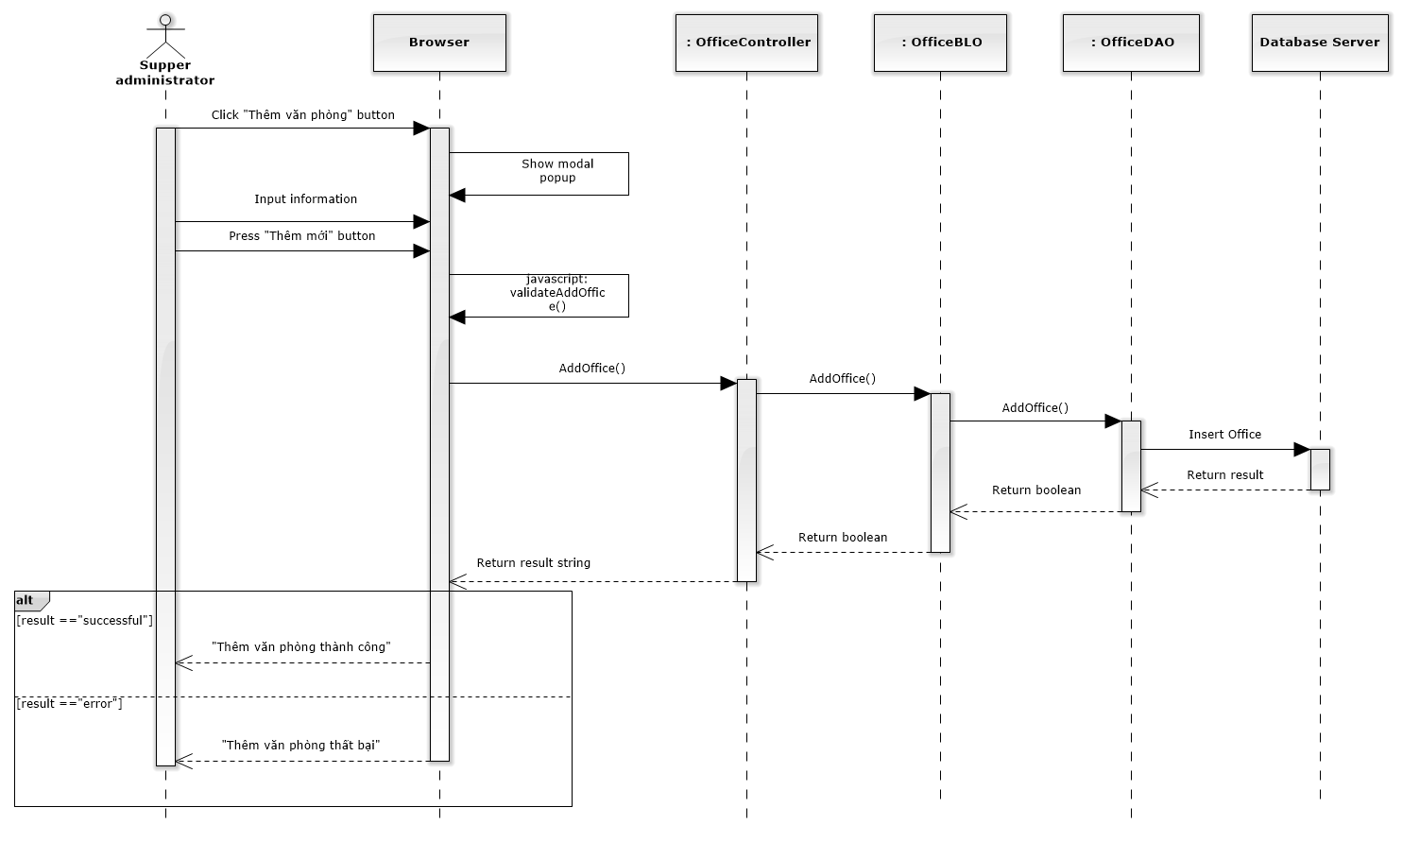

Figure 177: Add New Office Sequence Diagram

#### Edit office

##### Screen design

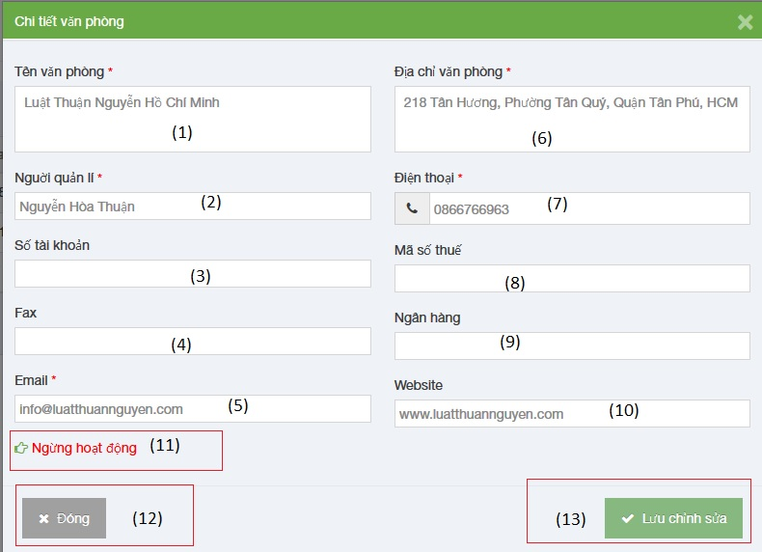

|  |  |  |  |  |
| --- | --- | --- | --- | --- |
| No | Object/ControlName | Type | Required | Description |
| 1 | Tên văn phòng | Textbox | Yes | Name of office |
| 2 | Người quản lí | Textbox | Yes | Nam’s manager of office |
| 3 | Số tài khoản | Textbox | Yes | Bank account number of office |
| 4 | Fax | Textbox | Yes | Fax of office |
| 5 | Email | Textbox | Yes | Email of office |
| 6 | Địa chỉ văn phòng | Textbox | Yes | Address of office |
| 7 | Điện thoại | Textbox | Yes | Phone number of office |
| 8 | Mã số thuế | Textbox | Yes | Tax number of office |
| 9 | Ngân hàng | Textbox | Yes | Name of bank of office |
| 10 | Website | Textbox | Yes | Website of office |
| 11 | Ngừng hoạt động | Link | Yes | Status of office |
| 12 | “Đóng” | Button | Yes | Click to close edit office |
| 13 | “Lưu chỉnh sửa” | Button | Yes | Click to save edit office |

##### Sequence diagram

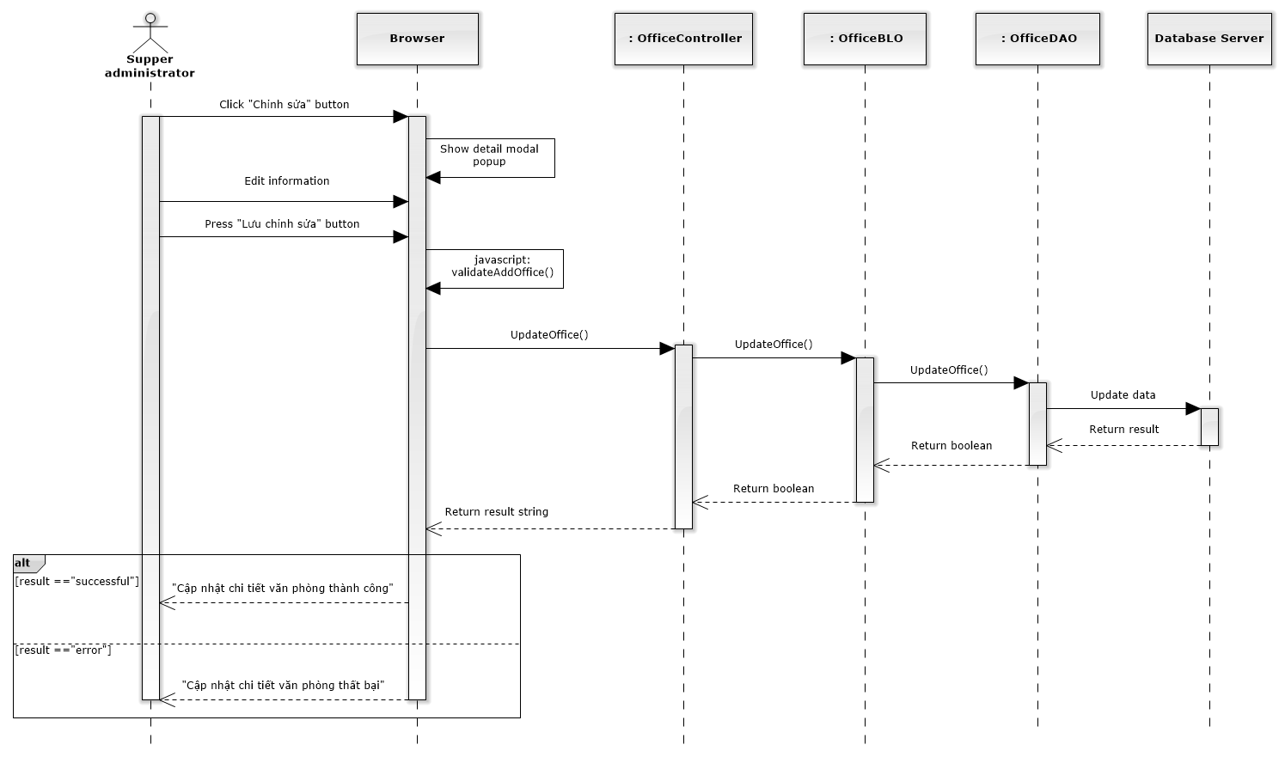

Figure 178: Edit Office Sequence Diagram

#### Deactivate/ Activate office

##### Screen design

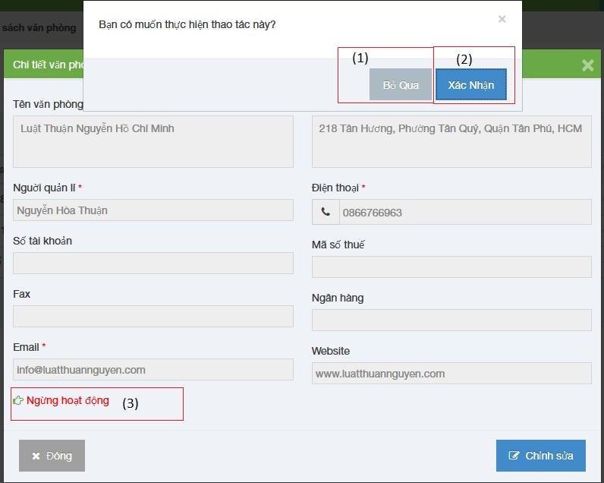

|  |  |  |  |  |
| --- | --- | --- | --- | --- |
| No | Object/ControlName | Type | Required | Description |
| 1 | “Bỏ qua” | Button | Yes | Click to close Deactive office |
| 2 | “Xác nhận” | Button | Yes | Click to Deactive office |
| 3 | Ngừng hoạt động | Link | Yes | Click to open confirm Deactive office |

##### Sequence diagram

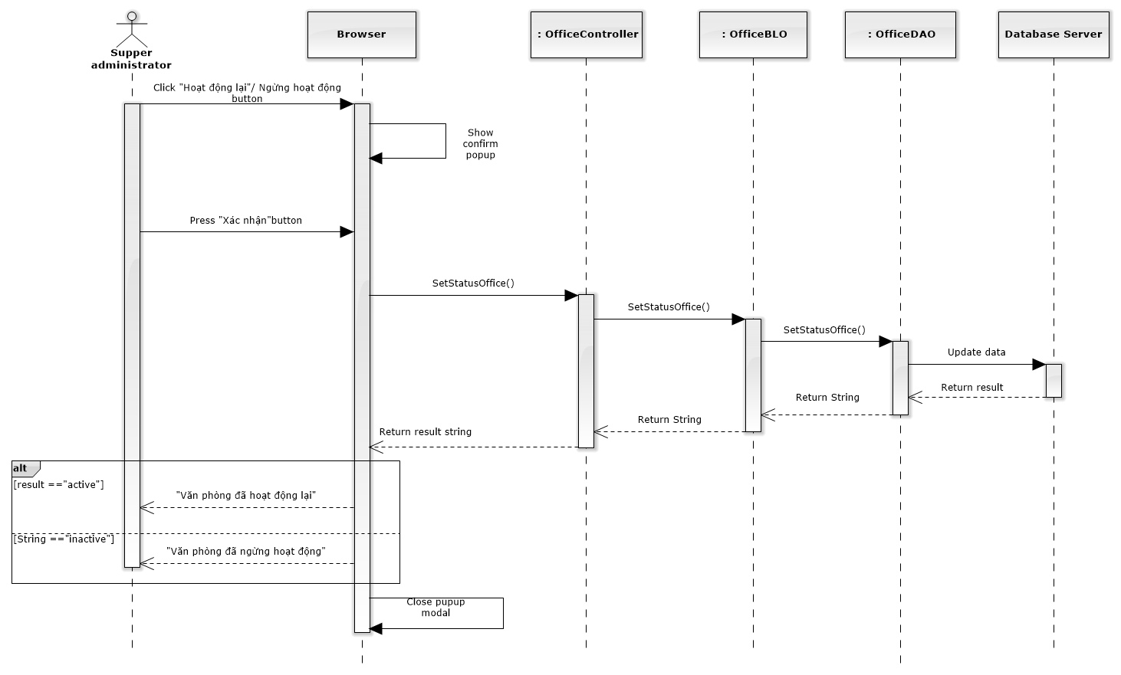

Figure 179: Deactivate / Activate Office Sequence Diagram

### Statistic

#### Office statistic

##### Class diagram

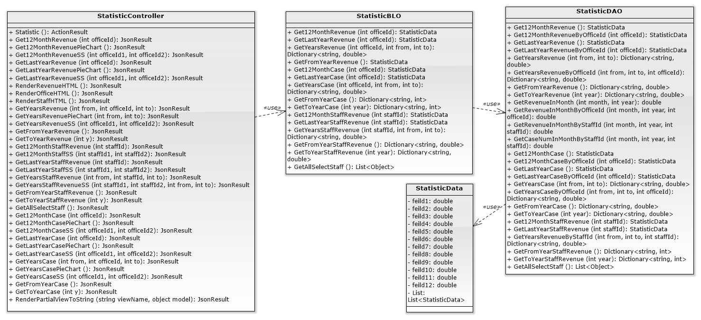

##### Screen design

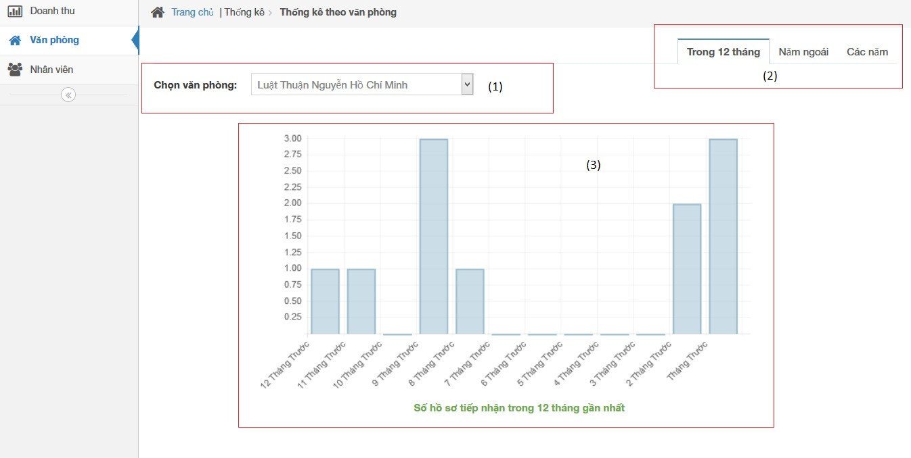

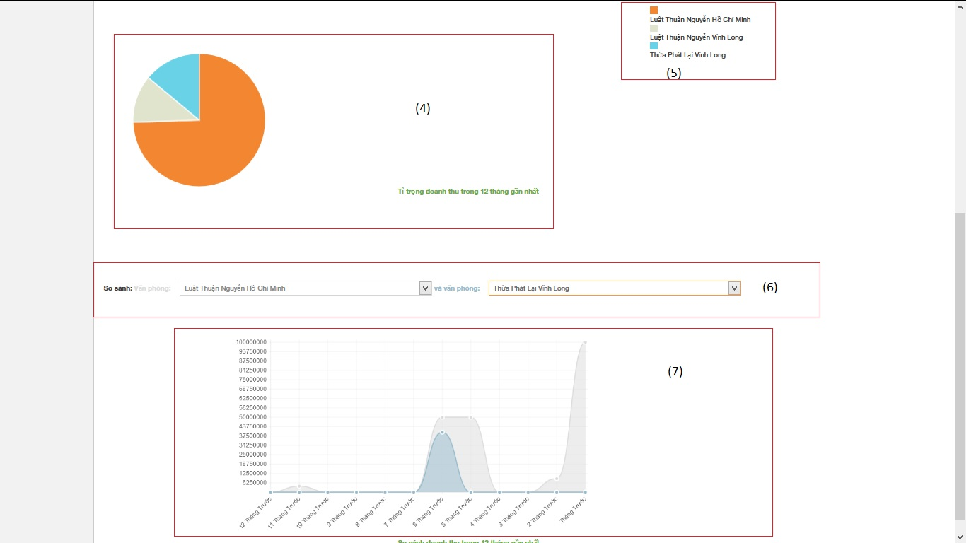

|  |  |  |  |  |
| --- | --- | --- | --- | --- |
| No | Object/ControlName | Type | Required | Description |
| 1 | Chọn văn phòng | Combo box | Yes | Click to choose name of office |
| 2 | Tab statistic | Link | Yes | Click to choose tab of statistic |
| 3 | Bar chart | Image | Yes | Image display of Bar chart |
| 4 | Pie chart | Image | Yes | Image display of Bar chart |
| 5 | Name office | Text | Yes | Name of office |
| 6 | Select name office | Combo box | Yes | Select name for comparison office |
| 7 | Comparison chart | Image | Yes | Image display of Bar chart |

##### Sequence diagram

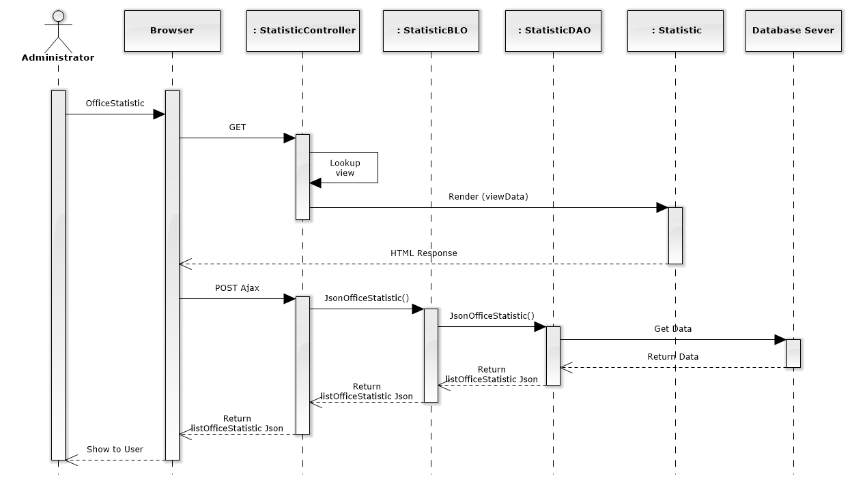

Figure 209: Office Statistic Sequence Diagram

#### Staff statistic

##### Screen design

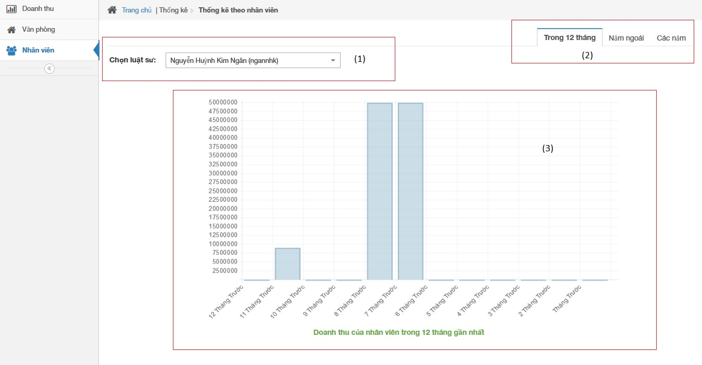

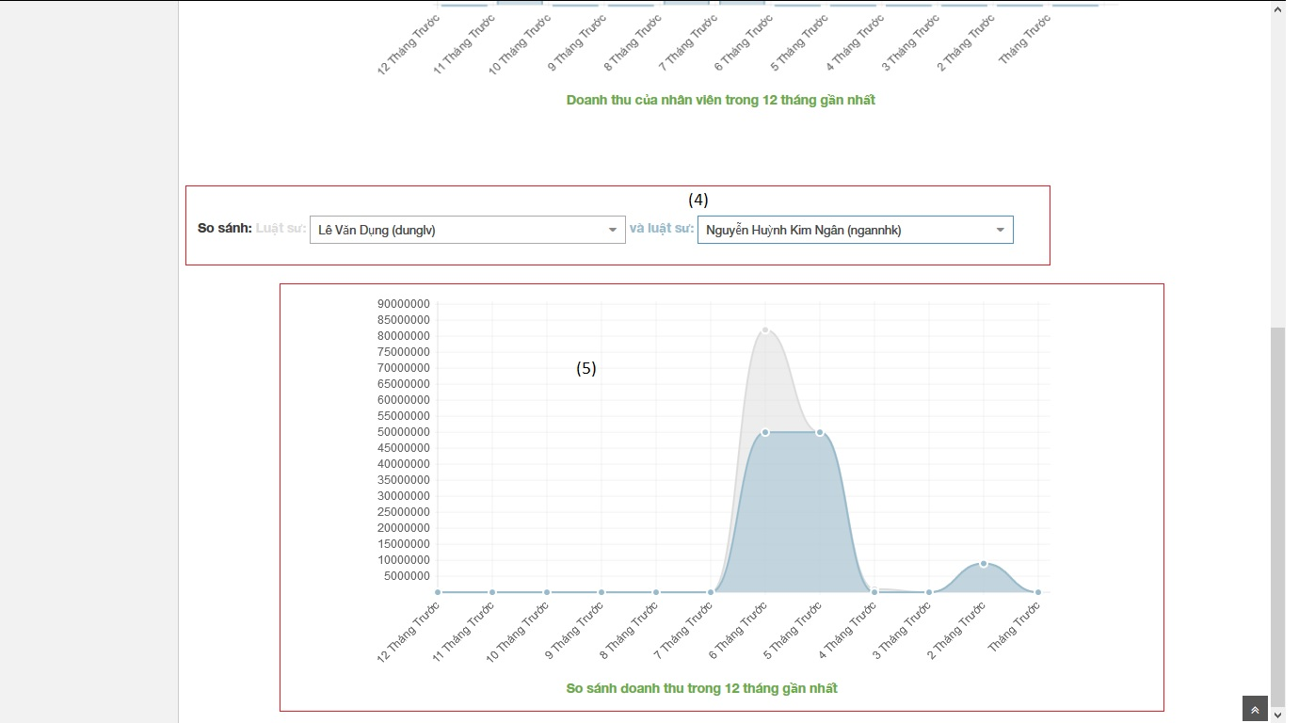

|  |  |  |  |  |
| --- | --- | --- | --- | --- |
| No | Object/ControlName | Type | Required | Description |
| 1 | Chọn luật sư | Combo box | Yes | Click to choose name of staff |
| 2 | Tab statistic | Link | Yes | Click to choose tab of statistic |
| 3 | Bar chart | Image | Yes | Image display of Bar chart |
| 4 | Select name staff | Combo box | Yes | Select name for comparison staff |
| 5 | Comparison chart | Image | Yes | Image display of Bar chart |

##### Sequence diagram

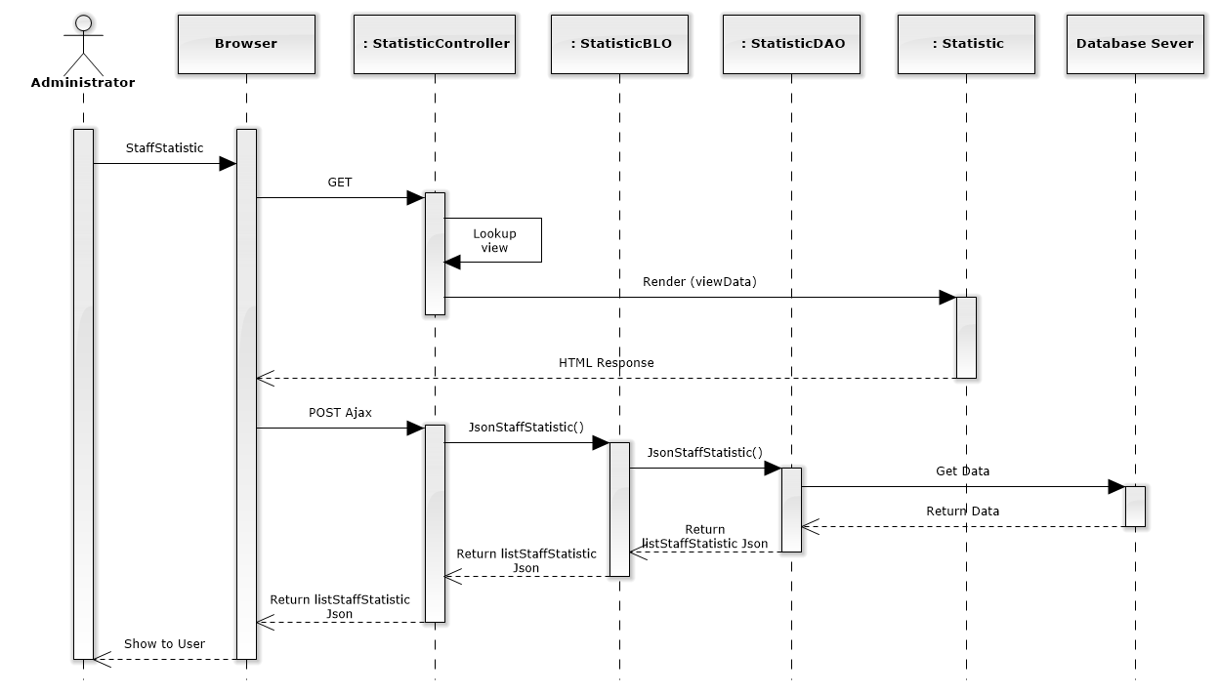

Figure 210: Staff Statistic Sequence Diagram

#### Revenue statistic

##### Screen design

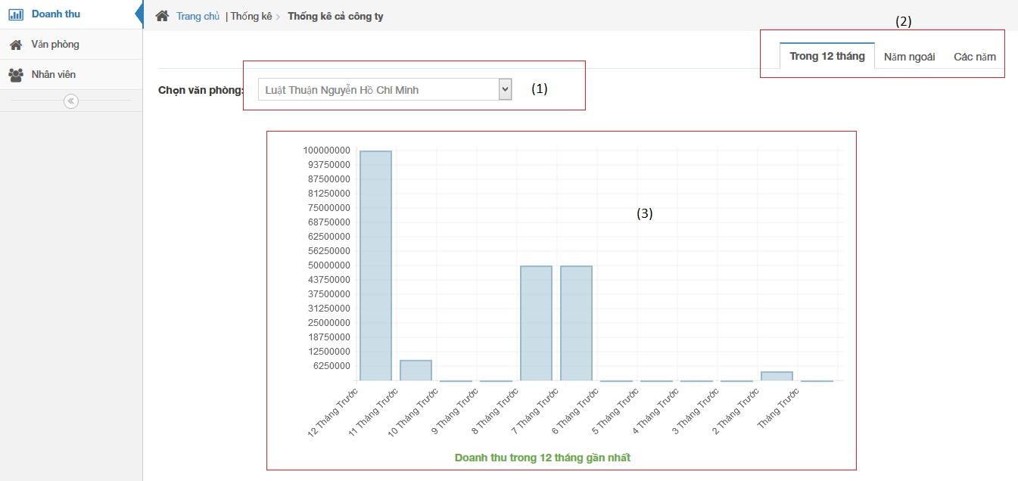

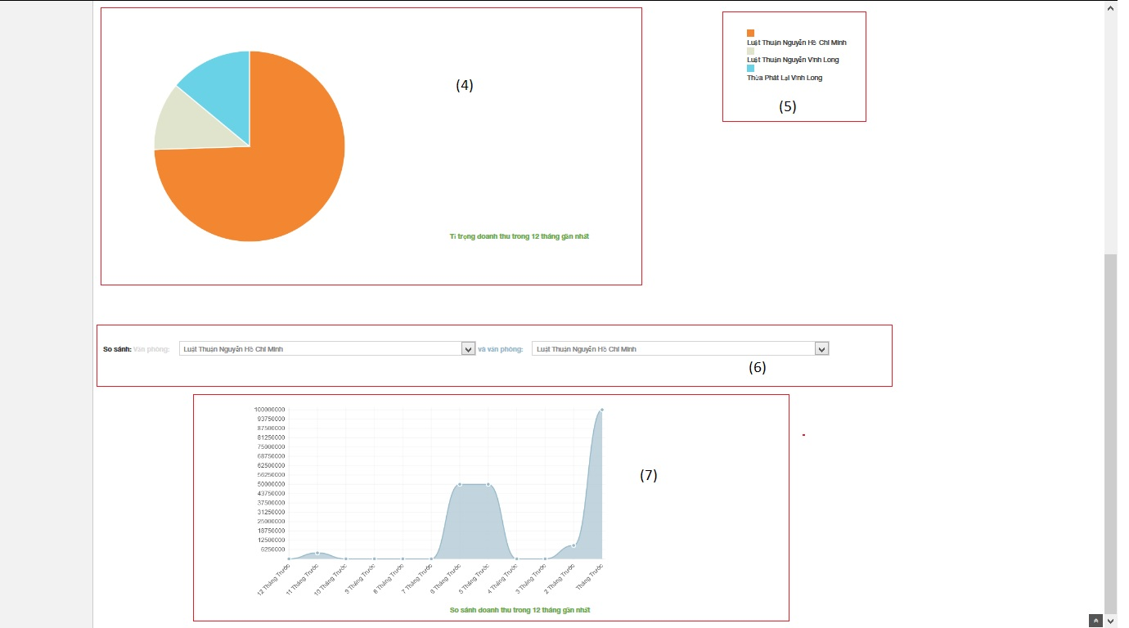

|  |  |  |  |  |
| --- | --- | --- | --- | --- |
| No | Object/ControlName | Type | Required | Description |
| 1 | Chọn văn phòng | Combo box | Yes | Click to choose name of office |
| 2 | Tab statistic | Link | Yes | Click to choose tab of statistic |
| 3 | Bar chart | Image | Yes | Image display of Bar chart |
| 4 | Pie chart | Image | Yes | Image display of Bar chart |
| 5 | Name office | Text | Yes | Name of office |
| 6 | Select name office | Combo box | Yes | Select name for comparison office |
| 7 | Comparison chart | Image | Yes | Image display of Bar chart |

##### Sequence diagram

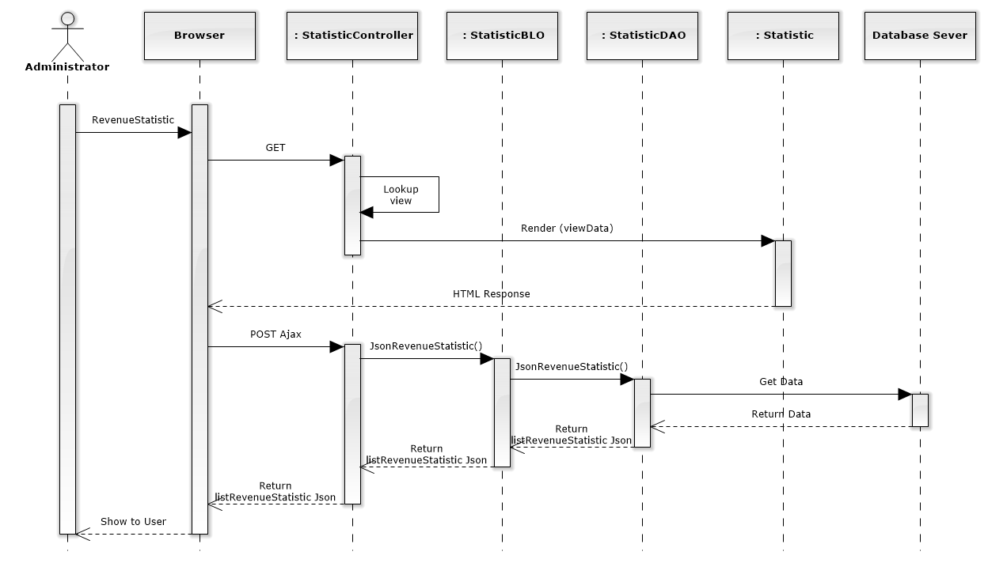

Figure 211: Revenue Statistic Sequence Diagram

## Database Design

### Relational Database Diagram

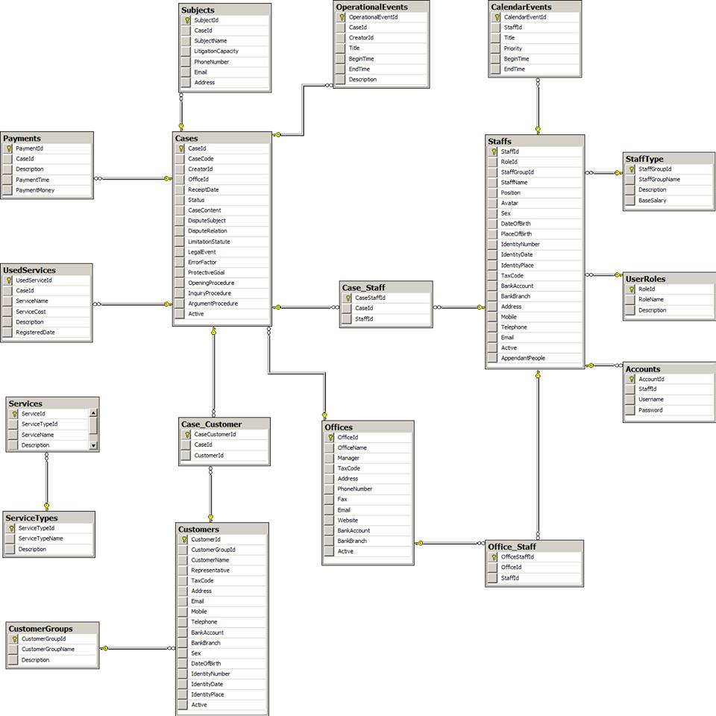

Figure 235: Relational Database Diagram

### Table Dictionary

#### Cases Table

|  |  |  |  |  |
| --- | --- | --- | --- | --- |
| Field Name | Type | Null | P/F Key | Thuật ngữ tiếng Việt |
| CaseId | int |  | PK |  |
| CaseCode | nvarchar(50) |  |  | Mã hồ sơ |
| CreatorId | int |  | FK |  |
| OfficeId | int |  | FK |  |
| ReceiptDate | date |  |  | Ngày thụ lý |
| Status | nvarchar(50) |  |  | Trạng thái hồ sơ |
| CaseContent | nvarchar(MAX) |  |  | Nội dung |
| DisputeSubject | nvarchar(MAX) | x |  | Đối tượng tranh chấp |
| DisputeRelation | nvarchar(MAX) | x |  | Quan hệ tranh chấp |
| LimitationStatute | nvarchar(MAX) | x |  | Thời hiệu |
| LegalEvent | nvarchar(MAX) | x |  | Sự kiện pháp lý |
| ErrorFactor | nvarchar(MAX) | x |  | Yếu tố lỗi |
| ProtectiveGoal | nvarchar(MAX) | x |  | Mục tiêu bảo vệ |
| OpeningProcedure | nvarchar(MAX) | x |  | Phần thủ tục bắt đầu |
| InquiryProcedure | nvarchar(MAX) | x |  | Phần thủ tục xét hỏi |
| ArgumentProcedure | nvarchar(MAX) | x |  | Phần tranh luận |
| Active | bit |  |  |  |

#### OperationEvents Table

|  |  |  |  |  |
| --- | --- | --- | --- | --- |
| Field Name | Type | Null | P/F Key | Thuật ngữ tiếng Việt |
| OperationalEventId | int |  | PK |  |
| CaseId | int |  | FK |  |
| CreatorId | int |  | FK |  |
| Title | nvarchar(100) |  |  | Tiêu đề |
| BeginTime | datetime |  |  | Thời gian bắt đầu |
| EndTime | datetime |  |  | Thời gian kết thúc |
| Description | nvarchar(MAX) | x |  | Mô tả nội dung |

#### Subjects Table

|  |  |  |  |  |
| --- | --- | --- | --- | --- |
| Field Name | Type | Null | P/F Key | Thuật ngữ tiếng Việt |
| SubjectId | int |  | PK |  |
| CaseId | int |  | FK |  |
| SubjectName | nvarchar(50) |  |  | Tên chủ thể |
| LitigationCapacity | nvarchar(50) |  |  | Tư cách tố tụng |
| PhoneNumber | nvarchar(20) | x |  | Số điện thoại |
| Email | nvarchar(50) | x |  | Hòm thư |
| Address | nvarchar(100) | x |  | Địa chỉ |

#### UsedServices Table

|  |  |  |  |  |
| --- | --- | --- | --- | --- |
| Field Name | Type | Null | P/F Key | Thuật ngữ tiếng Việt |
| UsedServiceId | int |  | PK |  |
| CaseId | int |  | FK |  |
| ServiceName | nvarchar(50) |  |  | Tên dịch vụ sử dụng |
| ServiceCost | int |  |  | Chi phí của dịch vụ |
| RegisteredDate | date |  |  | Ngày đăng ký dịch vụ |
| Description | nvarchar(MAX) |  |  | Mô tả chi tiết |

#### Payments Table

|  |  |  |  |  |
| --- | --- | --- | --- | --- |
| Field Name | Type | Null | P/F Key | Thuật ngữ tiếng Việt |
| PaymentId | int |  | PK |  |
| CaseId | int |  | FK |  |
| Description | nvarchar(MAX) |  |  | Mô tả chi tiết |
| PaymentTime | datetime |  |  | Thời gian thanh toán |
| PaymentMoney | int |  |  | Số tiền thanh toán |

#### Staffs Table

|  |  |  |  |  |
| --- | --- | --- | --- | --- |
| Field Name | Type | Null | P/F Key | Thuật ngữ tiếng Việt |
| StaffId | int |  | PK |  |
| StaffGroupId | int |  | FK |  |
| StaffName | nvarchar(50) |  |  | Tên nhân viên |
| Position | nvarchar(50) | x |  | Chức vụ |
| Avatar | nvarchar(100) | x |  | Đường dẫn ảnh đại diện |
| Sex | nvarchar(30) | x |  | Giới tính |
| DateOfBirth | date |  |  | Ngày sinh |
| PlaceOfBirth | nvarchar(100) | x |  | Nơi sinh |
| IdentityNumber | nvarchar(12) |  |  | Số CMND |
| IdentityDate | date |  |  | Ngày cấp |
| IdentityPlace | nvarchar(50) |  |  | Nơi cấp |
| TaxCode | nvarchar(14) | x |  | Mã số thuế |
| BankAccount | nvarchar(20) | x |  | Số TK ngân hàng |
| BankBranch | nvarchar(50) | x |  | Chi nhánh ngân hàng |
| Address | nvarchar(100) |  |  | Địa chỉ |
| Mobile | nvarchar(20) |  |  | Số di động |
| Telephone | nvarchar(20) | x |  | Số máy bàn |
| Email | nvarchar(50) |  |  | Hòm thư |
| Active  AppendantPeople | bit  int | x |  | Người phụ thuộc |

#### StaffType Table

|  |  |  |  |  |
| --- | --- | --- | --- | --- |
| Field Name | Type | Null | P/F Key | Thuật ngữ tiếng Việt |
| StaffGroupId | int |  | PK |  |
| StaffGroupName | nvarchar(50) |  |  | Tên nhóm nhân viên |
| Description  BaseSalary | nvarchar(MAX)  float | x  x |  | Mô tả chi tiết  Lương cơ bản |

#### UserRoles Table

|  |  |  |  |  |
| --- | --- | --- | --- | --- |
| Field Name | Type | Null | P/F Key | Thuật ngữ tiếng Việt |
| RoleId | int |  | PK |  |
| RoleName | nvarchar(50) |  |  | Tên vai trò |
| Description | nvarchar(MAX) | x |  | Mô tả chi tiết |

#### Accounts Table

|  |  |  |  |  |
| --- | --- | --- | --- | --- |
| Field Name | Type | Null | P/F Key | Thuật ngữ tiếng Việt |
| AccountId | int |  | PK |  |
| StaffId | int |  | FK |  |
| RoleId | int |  | FK |  |
| Username | nvarchar(50) |  |  | Tên đăng nhập |
| Password | nvarchar(50) |  |  | Mật khẩu |

#### CalendarEvents Table

|  |  |  |  |  |
| --- | --- | --- | --- | --- |
| Field Name | Type | Null | P/F Key | Thuật ngữ tiếng Việt |
| CalendarEventId | int |  | PK |  |
| StaffId | int |  | FK |  |
| Title | nvarchar(100) |  |  | Tiêu đề |
| Priority | nvarchar(50) |  |  | Mức độ ưu tiên |
| BeginTime | datetime |  |  | Thời gian bắt đầu |
| EndTime | datetime |  |  | Thời gian kết thúc |

#### Customers Table

|  |  |  |  |  |
| --- | --- | --- | --- | --- |
| Field Name | Type | Null | P/F Key | Thuật ngữ tiếng Việt |
| CustomerId | int |  | PK |  |
| CustomerGroupId | int |  | FK |  |
| CustomerName | nvarchar(50) |  |  | Tên khách hàng |
| Representative | nvarchar(50) | x |  | Người đại diện |
| TaxCode | nvarchar(14) | x |  | Mã số thuế |
| Address | nvarchar(100) |  |  | Địa chỉ |
| Email | nvarchar(50) |  |  | Hòm thư |
| Mobile | nvarchar(20) |  |  | Số di động |
| Telephone | nvarchar(20) | x |  | Số máy bàn |
| BankAccount | nvarchar(20) | x |  | Số TK ngân hàng |
| BankBranch | nvarchar(50) | x |  | Chi nhánh ngân hàng |
| Sex | nvarchar(20) | x |  | Giới tính |
| DateOfBirth | date | x |  | Ngày sinh |
| IdentityNumber | nvarchar(12) | x |  | Số CMND |
| IdentityDate | date | x |  | Ngày cấp |
| IdentityPlace | nvarchar(50) | x |  | Nơi cấp |
| Active | bit |  |  |  |

#### CustomerGroups Table

|  |  |  |  |  |
| --- | --- | --- | --- | --- |
| Field Name | Type | Null | P/F Key | Thuật ngữ tiếng Việt |
| CustomerGroupId | int |  | PK |  |
| CustomerGroupName | nvarchar(50) |  |  | Tên nhóm khách hàng |
| Description | nvarchar(MAX) | x |  | Mô tả chi tiết |

#### Offices Table

|  |  |  |  |  |
| --- | --- | --- | --- | --- |
| Field Name | Type | Null | P/F Key | Thuật ngữ tiếng Việt |
| OfficeId | int |  | PK |  |
| OfficeName | nvarchar(100) |  |  | Tên văn phòng |
| Manager | nvarchar(50) |  |  | Quản lý |
| TaxCode | nvarchar(14) | x |  | Mã số thuế |
| Address | nvarchar(100) |  |  | Địa chỉ |
| PhoneNumber | nvarchar(20) |  |  | Số điện thoại |
| Fax | nvarchar(20) | x |  | Số Fax |
| Email | nvarchar(50) |  |  | Hòm thư |
| Website | nvarchar(50) | x |  | Địa chỉ web |
| BankAccount | nvarchar(20) | x |  | Số TK ngân hàng |
| BankBranch | nvarchar(50) | x |  | Chi nhánh ngân hàng |
| Active | bit |  |  |  |

#### Services Table

|  |  |  |  |  |
| --- | --- | --- | --- | --- |
| Field Name | Type | Null | P/F Key | Thuật ngữ tiếng Việt |
| ServiceId | int |  | PK |  |
| ServiceTypeId | int |  | FK |  |
| ServiceName | nvarchar(50) |  |  | Tên dịch vụ |
| Description | nvarchar(MAX) | x |  | Mô tả chi tiết |

#### ServiceTypes Table

|  |  |  |  |  |
| --- | --- | --- | --- | --- |
| Field Name | Type | Null | P/F Key | Thuật ngữ tiếng Việt |
| ServiceTypeId | int |  | PK |  |
| ServiceTypeName | nvarchar(50) |  |  | Tên loại dịch vụ |
| Description | nvarchar(MAX) | x |  | Mô tả chi tiết |

# Software Testing

## Introduction

### System Overview

* This document describes plan and methods used in testing stage, an important step for grading the quality of product before packaging it.
* Testing group would plan, manage and execute the process of testing. Testers must execute and pass all test cases and technical details of system features.
* The testing group is also the coding group of Law Firm Management System.

### Test Approach

The testing of project include unit test system test and acceptance test levels. It is hoped that there will be as less problem as possible in project.

* Unit testing will be done by team member and will be approved by team leader.
* System testing will be performed by all member of team. It will check all main-flow of the system to discover error or bugs that can’t be found on unit testing level.
* Acceptance testing will be performed by all members of team and staffs at the Thuan Nguyen Law Firm. The project be checked from the Customer test to find out if the project in accordance with the expectations of Customer. The acceptance test will be done for a period of 2 weeks after completion of the System test process. Programs will enter into Acceptance test after all critical and major defects have been corrected. A program may have one major defect as long as it does not obstruct testing of the program. Prior to final completion of acceptance testing all open critical and major defects must be corrected.

## Test plan

### Scope of testing

The scope of testing in the project include:

* **Stages of testing**: the team has responsibility to conduct Unite testing, Integration testing and System testing
* **Types of testing**: The test team use functional test, white-box test and user interface testing
* **Range of testing**: Team performs testing all functions defined in the SRS based on the approved version. Test cases of each function are defined in the Test cases document that will be tested to determine if they meet the requirements and intermediate result will also be checked according to the SRS

### Requirement for testing

#### Test items

|  |  |  |
| --- | --- | --- |
| **No** | **Group of functions** | **Functions** |
| Web module | | |
|  | Account control | Login |
|  | Logout |
|  | Change password |
|  | Manage Calendar Event | List calendar events |
|  | Add new calendar event |
|  | Edit calendar event |
|  | Delete calendar event |
|  | Search calendar event |
|  | Manage Case | List all cases |
|  | Add new case |
|  | Search case |
|  | Manage case info | View Case Info |
|  | Edit case info |
|  | Manage operation event | List operation events |
|  | View operation event detail |
|  | Add new operation event |
|  | Edit operation event |
|  | Delete operation event |
|  | Manage Lawyer Related | List lawyer related |
|  | View lawyer related detail |
|  | Assign lawyer related |
|  | Remove lawyer related |
|  | Search lawyer related |
|  | Manage customer related | List customers related |
|  | View customer related detail |
|  | Add customer related |
|  | Remove customer related |
|  | Search customer related |
|  | Manage Subject Related | List subjects related |
|  | Add new subject related |
|  | Edit subject related |
|  | Delete subject related |
|  | Manage Customer | List customers |
|  | View customer detail |
|  | Add new customer |
|  | Edit customer |
|  | Delete customer |
|  | Search customer |
|  | Manage Staff | List staffs |
|  | View staff detail |
|  | Add new staff |
|  | Edit staff |
|  | Deactive/Active staff |
|  | Search staff |
|  | Reset password |
|  | Manage Service | List services |
|  | View service detail |
|  | Add new service |
|  | Edit service |
|  | Delete service |
|  | Search service |
|  | Manage Office | List offices |
|  | View office detail |
|  | Add new office |
|  | Edit office |
|  | Deactive/Active office |
|  | Search office |

#### Acceptance Test Criteria

* Test coverage on system test: >= 97%
* Test successful coverage: >= 97%

Number of test cases failed: less than 3% of total test cases

#### Constraints

* Duration of system testing is from 4 December to 10 December
* Testing team require 3 members

#### Risk list

The project could face with some risks:

* Lack of human resource
* Not enough test case cover for business project

### Test strategy

#### Test policy

* “Test without good faith”
* “Find bugs as soon as possible and always make sure they have been fixed”
* “No outstanding high severity faults”
* “Ensuring the product covers key features and attributes requirements”
* “Each primary function has at least one test case”
* “Focus on main function”
* “If any test fails we need to test again”
* “Using valid and invalid data”

#### Type of testing

##### Functional Testing

Function testing of the target-of-test should focus on any requirements for test that can be traced directly to use cases or business functions and business rules.  The goals of these tests are to verify proper data acceptance, processing, and retrieval, and the appropriate implementation of the business rules.  Identified below is an outline of the testing recommended for each application.

|  |  |
| --- | --- |
| Test Objective: | The type of this test is to ensure proper target-of-test functionality, including user interaction, all function defined in specification document implemented correctly. |
| Technique: | The test team will use use-case testing or checklist-base testing to verify the following:  Checking performance of software interface function.  The appropriate error or warning messages are displayed when invalid data is used.  Each business rule is properly applied. |
| Completion Criteria: | All test case and checklist have been executed and successful coverage > =97%. |
| Special Considerations: | Testing may be stopped when   * Time runs out * A certain number of defects found * Test coverage > 97% * Stop when testing becomes unproductive |

Table 5-1: Functional testing

##### User Interface Testing

User Interface (UI) testing verifies a user’s interaction with the software. The goal of UI testing is to ensure that the User Interface provides the user with the appropriate access and navigation through the functions of the target-of-test.  In addition, UI testing ensures that the objects within the UI function as expected and conform to corporate or industry standards.

|  |  |
| --- | --- |
| Test Objective: | Verify the following: Navigation through the target-of-test properly reflects business functions and requirements, including window-to-window, field-to-field, and use of access methods (tab keys, mouse movements, accelerator keys |
| Technique: | Use checklist and finite-state machine to create test case. |
| Completion Criteria: | All test case and checklist have been executed and successful coverage > =97%. |

Table 5-2: User Interface testing

#### Test stage

Clearly state the stage in which the test will be executed. Identified below are the stages in which common test are executed

|  |  |  |  |
| --- | --- | --- | --- |
| Type of Tests | Stage of Test | | |
| Unit | Integration | System |
| Function Test |  | x | x |
| User Interface test | x |  | x |
| Whitebox test | x |  |  |

Table 5-3: Test stages

#### Tools

|  |  |  |  |
| --- | --- | --- | --- |
| Purpose | Tool | Vendor/In-house | Version |
| Access to website | Firefox |  |  |
| Keep tracking defects | MS Word |  | Office 2010 & 2013 |
| Test Plan | MS Word |  | Office 2010 & 2013 |
| Test Case, Test Report | MS Excel |  | Office 2010 & 2013 |

Table 5-4: Tools

#### Resources

This table shows the staffing assumptions for the project.

|  |  |
| --- | --- |
| Worker/Doer | Specific Responsibilities/Comments |
| Đặng Nguyễn Khiêm  Trần Anh Tuấn  Phạm Văn Duy  Lê Duy Hoàng | Manage Test resource and assign test tasks  Create Test Plan  Review Test Cases  Create Test Report  Execute Test |

Table 5-5: Human resource

#### Schedule

Duration of all testing is from 22 October to 10 December

Duration of create test plan, test case and checklist are from 22 October to 29 October

## Test Cases

### Login

|  |  |  |  |  |  |  |  |
| --- | --- | --- | --- | --- | --- | --- | --- |
| ID | Test Case Description | Pre-conditions | Test Case Procedure | Expected Output | Result | Test Date | Note |
| Login | | | | | | | |
| Steps  1. Go to Index page  2. Click on “Login” button | | | | | | | |
| AU_01 | Test Login  Blank Field |  | 1. Type url “http://localhost:19442/Login/Login” into location of web browser  Go to website Login page  2. Click [Đăng nhập] button | 1. Login page will be shown  2. Login fail and error message is displayed:  “Tên đăng nhập hoặc mật khẩu không đúng! ” | Pass | 23/10/2014 |  |
| AU_02 | Test Login Successfully |  | 1. Type url “http://localhost:19442/Login/Login” into location of web browser  Go to website Login page  2. Login account:  - Input the account into “Tên đăng nhập” example “thuannh”  - Input password into “Mật khẩu” example “123456”  - Click [Đăng nhập] button | 1. Login page will be shown  2. Login succeed and displayed:  - Login successfully.  - [User] page will be shown. | Pass | 23/10/2014 |  |
| AU_03 | Test Login with wrong username |  | 1. Type url “http://localhost:19442/Login/Login” into location of web browser  Go to website Login page  2. Login account:  - Input the account into “Tên đăng nhập” example “thuannh123”  - Input passowrd into “Mật khẩu” example “123456”  -Click [Đăng nhập] button | 1. Login page will be shown  2. Login fail and displayed message:  “Tên đăng nhập hoặc mật khẩu không đúng! ” | Pass | 23/10/2014 |  |
| AU_04 | Test Login with wrong password |  | 1. Type url “http://localhost:19442/Login/Login” into location of web browser  Go to website Login page  2. Login account:  - Input the account into “Tên đăng nhập” example “thuannh”  - Input password into “Mật khẩu” example “123456789”  - Click [Đăng nhập] button | 1. Login page will be shown  2. Login fail and displayed message:  “Tên đăng nhập hoặc mật khẩu không đúng! ” | Pass | 23/10/2014 |  |
| AU_05 | Test Login with accout is Active | User  ”thuannh” have status is Active | 1. Type url “http://localhost:19442/Login/Login” into location of web browser  Go to website Login page  2. Login account:  - Input the account into “Tên đăng nhập” example “thuannh”  - Input passowrd into “Mật khẩu” example “12345678”  -Click [Đăng nhập] button | 1. Login page will be shown  2. Login fail and displayed message:  “Nhân viên đang ngừng hoạt động!” | Pass | 23/10/2014 |  |
| AU_06 | Test Login with error server |  | 1. Type url “http://localhost:19442/Login/Login” into location of web browser  Go to website Login page  2. Login account:  - Input the account into “Tên đăng nhập” example “thuannh”  - Input passowrd into “Mật khẩu” example “123456”  -Click [Đăng nhập] button | 1. Login page will be shown  2. Login fail and displayed message:  “Lỗi kết nối đến máy chủ! | Pass | 23/10/2014 |  |

### Logout

|  |  |  |  |  |  |  |  |
| --- | --- | --- | --- | --- | --- | --- | --- |
| ID | Test Case Description | Preconditions | Test Case Procedure | Expected Output | Result | Test Date | Note |
| Logout | | | | | | | |
| Steps  1. User have login into system.  2. Click “Đăng xuất” in Control panel. | | | | | | | |
| AC_07 | Test Logout | User have login | 1. Login account succesful  2. Logout account:  -Click on user account in right of the top  -Click [Đăng xuất] button | 1. [User] page will be shown  2. Logout success and go back to website Login page | Pass | 23/10/2014 |  |

### Change Password

|  |  |  |  |  |  |  |  |
| --- | --- | --- | --- | --- | --- | --- | --- |
| ID | Test Case Description | Preconditions | Test Case Procedure | Expected Output | Result | Test Date | Note |
| Change Password | | | | | | | |
| Steps  1. User have logininto system.  2. Click “Đổi mật khẩu” in Control panel. | | | | | | | |
| AC_08 | Test change password screen | User have login | 1. Login account succesful  2. Go to change password screen:  - Click on user account in right of the top  -Click [Đổi mật khẩu] button | 1. [User] page will be shown  2.“Thay đổi mật khẩu” Popup is displayed corectly  Two button [Đổi mật khẩu], [Đóng] | Pass | 23/10/2014 |  |
| AC_09 | Test change password  Blank Field | AC_08 | 1. Login account succesful  2. Go to change password screen:  - Click on user account in right of the top  -Click [Đổi mật khẩu] button  3. Test blank field:  Click [Đổi mật khẩu] button in “Thay đổi mật khẩu” popup | 1. [User] page will be shown  2.“Thay đổi mật khẩu” popup is displayed corectly  Two button [Đổi mật khẩu], [Đóng]  3. Error message is displayed:  “Hãy nhập lại mật khẩu cũ ”  “Hãy nhập mật khẩu mới.”  “Hãy nhập lại mật khẩu mới.” | Pass | 23/10/2014 |  |
| AC_10 | Test change password  Input not enough 6 character in field “Mật khẩu mới” and “Lặp lại mật khẩu mới” | AC_08 | 1. Login account succesful  2. Go to change password screen:  - Click on user account in right of the top.  -Click [Đổi mật khẩu] button  3. Change password:  -Input “123” to “Mật khẩu mới” text box  -Input “123” to “Lặp lại mật khẩu mới” text box | 1. [User] page will be shown  2.“Thay đổi mật khẩu” popup is displayed corectly  Two button [Đổi mật khẩu], [Đóng]  3. Error message is displayed:  “Mật khẩu mới phải có ít nhất 6 kí tự.” | Pass | 23/10/2014 |  |
| AC_11 | Test change password  Input character in field “Mật khẩu mới” and “Lặp lại mật khẩu mới” diffirent | AC_08 | 1. Login account succesful  2. Go to change password screen:  - Click on user account in right of the top.  -Click [Đổi mật khẩu] button  3. Change password:  -Input “123456” to “Mật khẩu mới” text box  -Input “123567” to “Lặp lại mật khẩu mới” text box | 1. [User] page will be shown  2.“Thay đổi mật khẩu” popup is displayed corectly  Two button [Đổi mật khẩu], [Đóng]  3. Error message is displayed:  “Mật khẩu 2 không trùng khớp.” | Pass | 23/10/2014 |  |
| AC_12 | Test change password  Input error old password(example: account “thuannh”) | AC_08  Old password of user “thuannh” is 123456 | 1. Login account succesful  2. Go to change password screen:  - Click on user account in right of the top.  -Click [Đổi mật khẩu] button  3. Change password:  -Input “1234567” to “Mật khẩu cũ” text box  -Input “12356” to “Mật khẩu mới” text box  -Input “12356” to “Lặp lại mật khẩu mới” text box  - Click [Đổi mật khẩu] button | 1. [User] page will be shown  2.“Thay đổi mật khẩu” popup is displayed corectly  Two button [Đổi mật khẩu], [Đóng]  3. Error message is displayed:  “Mật khẩu cũ không đúng !” | Pass | 23/10/2014 |  |
| AC_13 | Test change password  Successfully(exampl: account “thuannh”) | AC_08  Old password of user “thuannh” is 123456 | 1. Login account succesful  2. Go to change password screen:  - Click on user account in right of the top.  -Click [Đổi mật khẩu] button  3. Change password:  -Input “123456” to “Mật khẩu cũ” text box  -Input “123567” to “Mật khẩu mới” text box  -Input “123567” to “Lặp lại mật khẩu mới” text box  - Click [Đổi mật khẩu] button | 1. [User] page will be shown  2.“Thay đổi mật khẩu” popup is displayed corectly  Two button [Đổi mật khẩu], [Đóng]  3. Success message is displayed:  “Cập nhật mật khẩu nhân viên thành công!”  New password of user “ thuannh” is 1234567 | Pass | 23/10/2014 |  |
| AC_14 | Test change password  Close button | AC_08 | 1. Login account succesful  2. Go to change password screen:  - Click on user account in right of the top.  -Click [Đổi mật khẩu] button  3. Close “Thay đổi mật khẩu” popup:  Click [Đóng] button or “X” button | 1. [User] page will be shown  2.“Thay đổi mật khẩu” Popup is displayed corectly  Two button [Đổi mật khẩu], [Đóng]  3. “Thay đổi mật khẩu” Popup is closed | Pass | 23/10/2014 |  |

### View Home

|  |  |  |  |  |  |  |  |
| --- | --- | --- | --- | --- | --- | --- | --- |
| ID | Test Case Description | Preconditions | Test Case Procedure | Expected Output | Result | Test Date | Note |
| View Home | | | | | | | |
| Steps  1. User have logininto system.  2. Click “Law Firm Management System” in page website header. | | | | | | | |
| AC_1 | Test View Home | User have login | 1. Login account successful  2. Go to view Home page:  Click [Law Firm Management System] in page website header. | 1. [User] page will be shown  2. [Home] page will be shown | Pass | 23/10/2014 |  |

### Manage Calendar Event

#### List Calendar Events

|  |  |  |  |  |  |  |  |
| --- | --- | --- | --- | --- | --- | --- | --- |
| ID | Test Case Description | Preconditions | Test Case Procedure | Expected Output | Result | Test Date | Note |
| List calendar events | | | | | | | |
| Steps  1. Go to Calendar Event page.  2. Click on [Lịch làm việc] tab. | | | | | | | |
| AC_1 | Test List calendar events | User have login | 1. Login account succesful  **2.** Go to view list calendar events page:  Click on [Lịch làm việc] tab | 1. [User] page will be shown  2. List calendar events will be shown | Pass | 23/10/2014 |  |

#### Add New Calendar Event

|  |  |  |  |  |  |  |  |  |
| --- | --- | --- | --- | --- | --- | --- | --- | --- |
| ID | Test Case Description | | Preconditions | Test Case Procedure | Expected Output | Result | Test Date | Note |
| Add New Calendar Event | | | | | | | | |
| Steps  1. Go to Calendar Event page  2. Click on [Lịch làm việc] tab | | | | | | | | |
| CE _01 | | Test Add new calendar event | User have login | 1. Login account succesful  **2.** Go to list calendar events page:  Click on [Lịch làm việc] tab  3. Add new calendar event:  Click and drag at calendar, input event name and press “Xác nhận” button | 1. [User] page will be shown  2. List calendar events will be shown  3. Event is created | Pass | 23/10/2014 |  |
| CE_02 | | Test Add new calendar event | User have login | 1. Login account succesful  **2.** Go to list calendar events page:  Click on [Lịch làm việc] tab  3. Add new calendar event:  Drag and drop an event tag to calendar, input event name and press “Xác nhận” button | 1. [User] page will be shown  2. List calendar events will be shown  3. Event is created | Pass | 23/10/2014 |  |
| CE_03 | | Test Cancel add new calendar event | User have login | 1. Login account succesful  **2.** Go to list calendar events page:  Click on [Lịch làm việc] tab  3. Cancel add new calendar event:  Click and drag at calendar, input event name and press “Bỏ qua” button or “X” button | 1. [User] page will be shown  2. List calendar events will be shown  3. Confirm pop-up is closed | Pass | 23/10/2014 |  |
| CE_04 | | Test Cancel add new calendar event | User have login | 1. Login account succesful  **2.** Go to list calendar events page:  Click on [Lịch làm việc] tab  3. Cancel add new calender event:  Drag and drop an event tag to calendar, input event name and press “Bỏ qua” button or “X” button | 1. [User] page will be shown  2. List calendar events will be shown  3. Confirm pop-up is closed | Pass | 23/10/2014 |  |

#### Edit Calendar Event

|  |  |  |  |  |  |  |  |  |
| --- | --- | --- | --- | --- | --- | --- | --- | --- |
| ID | Test Case Description | | Preconditions | Test Case Procedure | Expected Output | Result | Test Date | Note |
| Edit Calendar Event | | | | | | | | |
| Steps  1. Go to Calendar Event page  2. Click on [Lịch làm việc] tab | | | | | | | | |
| CE _01 | | Test Edit calendar event | User have login | 1. Login account succesful  **2.** Go to list calendar events page:  Click on [Lịch làm việc] tab  3. Edit calendar event:  Click at event name, input edit name and press “Lưu” button | 1. [User] page will be shown  2. List calendar events will be shown  3. Event is edited | Pass | 23/10/2014 |  |
| CE_03 | | Test Cancel Edit calendar event | User have login | 1. Login account succesful  **2.** Go to list calendar events page:  Click on [Lịch làm việc] tab  3. Cancel edit calendar event:  Click at event name, input edit name and press “Đóng” button or “X” button | 1. [User] page will be shown  2. List calendar events will be shown  3. Edit pop-up is closed | Pass | 23/10/2014 |  |

#### Delete Calendar Event

|  |  |  |  |  |  |  |  |  |
| --- | --- | --- | --- | --- | --- | --- | --- | --- |
| ID | Test Case Description | | Preconditions | Test Case Procedure | Expected Output | Result | Test Date | Note |
| Delete Calendar Event | | | | | | | | |
| Steps  1. Go to Calendar Event page  2. Click on [Lịch làm việc] tab | | | | | | | | |
| CE _01 | | Test Delete calendar event | User have login | 1. Login account succesful  **2.** Go to list calendar events page:  Click on [Lịch làm việc] tab  3. Delete calendar event:  Click at event name, press “Xóa Sự Kiện” button | 1. [User] page will be shown  2. List calendar events will be shown  3. Event is deleted | Pass | 23/10/2014 |  |
| CE_03 | | Test Cancel Delete calendar event | User have login | 1. Login account succesful  **2.** Go to list calendar events page:  Click on [Lịch làm việc] tab  3. Cancel delete calendar event  Click at event name, press “Đóng” button or “X” button | 1. [User] page will be shown  2. List calendar events will be shown  3. Delete pop-up is closed | Pass | 23/10/2014 |  |

#### Search Calendar Event

|  |  |  |  |  |  |  |  |  |
| --- | --- | --- | --- | --- | --- | --- | --- | --- |
| ID | Test Case Description | | Preconditions | Test Case Procedure | Expected Output | Result | Test Date | Note |
| Search Calendar Event | | | | | | | | |
| Steps  1. Go to Calendar Event page  2. Click on [Lịch làm việc] tab | | | | | | | | |
| CE _01 | | Test Search calendar event | User have login | 1. Login account succesful  **2.** Go to list calendar events page:  Click on [Lịch làm việc] tab  3. Search calendar event:  Click at “Lịch làm việc các luật sư” button, select another account at dropdown menu | 1. [User] page will be shown  2. List calendar events will be shown  3. Search results are displayed | Pass | 23/10/2014 |  |
| CE_03 | | Test Cancel Search calendar event | User have login | 1. Login account succesful  **2.** Go to list calendar events page:  Click on [Lịch làm việc] tab  3. Cancel search calendar event:  Click at “Lịch làm việc các luật sư” button, select another account at dropdown menu, press “Đóng” button or “X” button | 1. [User] page will be shown  2. List calendar events will be shown  3. Search tab is closed | Pass | 23/10/2014 |  |

### Manage Case

#### List All Cases

|  |  |  |  |  |  |  |  |
| --- | --- | --- | --- | --- | --- | --- | --- |
| ID | Test Case Description | Preconditions | Test Case Procedure | Expected Output | Result | Test Date | Note |
| List All Cases | | | | | | | |
| Steps  1. Login the system with “Creator” role  2. Click on Plus button in home or go to “Danh sách hồ sơ” page | | | | | | | |
| AC_1 | Test List all cases | User have login | 1. Login account with “Creator” role succesful  2. Go to view list all cases:  Click on Plus button in home or click on user account in right of the top, then click on “Danh sách hồ sơ” button | 1. [User] page will be shown  2. List all cases will be shown | Pass | 23/10/2014 |  |

#### Add New Case

|  |  |  |  |  |  |  |  |
| --- | --- | --- | --- | --- | --- | --- | --- |
| ID | Test Case Description | Pre-conditions | Test Case Procedure | Expected Output | Result | Test Date | Note |
| Add New Case | | | | | | | |
| Steps  1. Login the system with “Creator” role  2. Click on Plus button in home or go to “Danh sách hồ sơ” page and then click on “Thêm hồ sơ tác nghiệp” button  3. Input information  4. Click on “Thêm mới” button | | | | | | | |
| CA01 | Test add new case popup sreen | Login with “Creator” role | 1. Login account with “Creator” role successful  2. Go to add new case popup screen:  Click on “Thêm hồ sơ tác nghiệp” button | 1. [User] page will be shown  2. The modal popup will be show with:  - Mã hồ sơ (textbox)  - Ngày thụ lý (datetime picker)  - Thuộc văn phòng (dropdown list)  - Nội dung (textarea) | Pass | 24/10/2014 |  |
| CA02 | Test add new case successfully | CA01 | 1. Login account with “Creator” role successful  2. Go to add new case popup screen:  Click on “Thêm hồ sơ tác nghiệp” button  3. Add new case:  - Input case information  - Click on “Thêm mới” button | 1. [User] page will be shown  2. The modal popup will be show with:  - Mã hồ sơ (textbox)  - Ngày thụ lý (datetime picker)  - Thuộc văn phòng (dropdown list)  - Nội dung (textarea)  3. Add new case successful:  - System will be create new case  - Redirect to case detail page | Pass | 24/10/2014 |  |
| CA03 | Test add new case validation | CA01 | 1. Login account with “Creator” role successful  2. Go to add new case popup screen:  Click on “Thêm hồ sơ tác nghiệp” button  3. Test add new case validation:  - Do not input “Mã hồ sơ”  - Click on “Thêm mới” button | 1. [User] page will be shown  2. The modal popup will be show with:  - Mã hồ sơ (textbox)  - Ngày thụ lý (datetime picker)  - Thuộc văn phòng (dropdown list)  - Nội dung (textarea)  3. Error message will be displayed: “Nhập mã hồ sơ!” | Pass | 24/10/2014 |  |
| CA04 | Test add new case validation | CA01 | 1. Login account with “Creator” role successful  2. Go to add new case popup screen:  Click on “Thêm hồ sơ tác nghiệp” button  3. Test add new case validation:  - Input case information, but do not input “Thuộc văn phòng”  - Click on “Thêm mới” button | 1. [User] page will be shown  2. The modal popup will be show with:  - Mã hồ sơ (textbox)  - Ngày thụ lý (datetime picker)  - Thuộc văn phòng (dropdown list)  - Nội dung (textarea)  3. Error message will be displayed: “Chọn văn phòng!” | Pass | 24/10/2014 |  |
| CA05 | Test add new case validation | CA01 | 1. Login account with “Creator” role successful  2. Go to add new case popup screen:  Click on “Thêm hồ sơ tác nghiệp” button  3. Test add new case validation:  - Input case information, but do not input “Nội dung”  - Click on “Thêm mới” button | 1. [User] page will be shown  2. The modal popup will be show with:  - Mã hồ sơ (textbox)  - Ngày thụ lý (datetime picker)  - Thuộc văn phòng (dropdown list)  - Nội dung (textarea)  3. Error message will be displayed: “Nhập nội dung!” | Pass | 24/10/2014 |  |
| CA06 | Test add new case validation | CA01 | 1. Login account with “Creator” role successful  2. Go to add new case popup screen:  Click on “Thêm hồ sơ tác nghiệp” button  3. Test add new case validation:  - Input case information, but input “Mã hồ sơ” already exist  - Click on “Thêm mới” button | 1. [User] page will be shown  2. The modal popup will be show with:  - Mã hồ sơ (textbox)  - Ngày thụ lý (datetime picker)  - Thuộc văn phòng (dropdown list)  - Nội dung (textarea)  3. Error message will be displayed: “Mã hồ sơ đã tồn tại!” | Pass | 24/10/2014 |  |
| CA07 | Test cancel add new case | CA01 | 1. Login account with “Creator” role successful  2. Go to add new case popup screen:  Click on “Thêm hồ sơ tác nghiệp” button  3. Cancel add new case:  Click on “Đóng” button or “X” button | 1. [User] page will be shown  2. The modal popup will be show with:  - Mã hồ sơ (textbox)  - Ngày thụ lý (datetime picker)  - Thuộc văn phòng (dropdown list)  - Nội dung (textarea)  3.”Thêm hồ sơ tác nghiệp” popup is closed | Pass | 24/10/2014 |  |

#### Search Case

|  |  |  |  |  |  |  |  |
| --- | --- | --- | --- | --- | --- | --- | --- |
| ID | Test Case Description | Preconditions | Test Case Procedure | Expected Output | Result | Test Date | Note |
| Search Case | | | | | | | |
| Steps  1. Login the system with “Creator” role  2. Click on Plus button in home or go to “Danh sách hồ sơ” page | | | | | | | |
| AC_1 | Test search cases | User have login | 1. Login account with “Creator” role succesful  2. Go to view list all cases:  Click on Plus button in home or click on user account in right of the top, then click on “Danh sách hồ sơ” button  3. Search cases:  Input into search textbox example “Tranh chấp” | 1. [User] page will be shown  2. List all cases will be shown  3. All result content “Tranh chấp” are displayed | Pass | 23/10/2014 |  |

#### Manage Case Detail

##### Manage Case Info

###### View Case Info

|  |  |  |  |  |  |  |  |
| --- | --- | --- | --- | --- | --- | --- | --- |
| ID | Test Case Description | Preconditions | Test Case Procedure | Expected Output | Result | Test Date | Note |
| View Case Info | | | | | | | |
| Steps  1. User logged in system  2. Go to Case Detail page | | | | | | | |
| AC_1 | Test View Case Info | - User logged in  - Admin or user is assigned in current case | 1. Login account as admin or user account is assigned in current case successful  2. Go to view list all cases:  Click on Plus button in home or click on user account in right of the top, then click on “Danh sách hồ sơ” button  3. Go to case detail page :  Click on case want to view detail in list all cases | 1. [User] page will be shown  2. List all caes will be shown  3. The page will be show with:  - Mã hồ sơ (textbox)  - Thuộc văn phòng (dropdown list)  - Ngày thụ lý (datetime picker)  - Trạng thái (dropdown list)  - Nội dung tranh chấp (textarea)  - Đối tượng tranh chấp (textarea)  - Quan hệ tranh chấp (textarea)  - Thời hiệu (textarea)  -Sự kiện pháp lý (textarea)  - Yếu tố lỗi (textarea) | Pass | 23/10/2014 |  |

###### Edit Case Info

|  |  |  |  |  |  |  |  |
| --- | --- | --- | --- | --- | --- | --- | --- |
| ID | Test Case Description | Pre-conditions | Test Case Procedure | Expected Output | Result | Test Date | Note |
| Edit Case Info | | | | | | | |
| Steps  1. User logged in system  2. Go to Case Detail page  3. Click on edit icon button  4. Edit information  5. Click on “Lưu chỉnh sửa” button | | | | | | | |
| CI02 | Test update case info successfully | CI01 | 1. Login account as admin or user account is assigned in current case successful  2. Go to view list all cases:  Click on Plus button in home or click on user account in right of the top, then click on “Danh sách hồ sơ” button  3. Go to case detail page :  Click on case want to view detail in list all cases  4. Update case info:  - Click on icon edit button  - Edit case info  - Click on “Lưu chỉnh sửa” button | 1. [User] page will be shown  2. List all caes will be shown  3. The page will be show with:  - Mã hồ sơ (textbox)  - Thuộc văn phòng (dropdown list)  - Ngày thụ lý (datetime picker)  - Trạng thái (dropdown list)  - Nội dung tranh chấp (textarea)  - Đối tượng tranh chấp (textarea)  - Quan hệ tranh chấp (textarea)  - Thời hiệu (textarea)  -Sự kiện pháp lý (textarea)  - Yếu tố lỗi (textarea)  4. System will be update case info  - A notification will be displayed “Cập nhật thông tin hồ sơ thành công!” | Pass | 24/10/2014 |  |
| CI03 | Test update case info validation | CI01 | 1. Login account as admin or user account is assigned in current case successful  2. Go to view list all cases:  Click on Plus button in home or click on user account in right of the top, then click on “Danh sách hồ sơ” button  3. Go to case detail page :  Click on case want to view detail in list all cases  4. Validate update case info:  - Click on icon edit button  - Edit case info, but “Nội dung tranh chấp” textbox is empty  - Click on “Lưu chỉnh sửa” button | 1. [User] page will be shown  2. List all caes will be shown  3. The page will be show with:  - Mã hồ sơ (textbox)  - Thuộc văn phòng (dropdown list)  - Ngày thụ lý (datetime picker)  - Trạng thái (dropdown list)  - Nội dung tranh chấp (textarea)  - Đối tượng tranh chấp (textarea)  - Quan hệ tranh chấp (textarea)  - Thời hiệu (textarea)  -Sự kiện pháp lý (textarea)  - Yếu tố lỗi (textarea)  4. Error message will be displayed: “Nhập nội dung!” | Pass | 24/10/2014 |  |
| CI04 | Test cancel update case info | CI01 | 1. Login account as admin or user account is assigned in current case successful  2. Go to view list all cases:  Click on Plus button in home or click on user account in right of the top, then click on “Danh sách hồ sơ” button  3. Go to case detail page :  Click on case want to view detail in list all cases  4. Cancel update case info:  - Click on icon edit button  - Click on “Hủy chỉnh sửa” button | 1. [User] page will be shown  2. List all caes will be shown  3. The page will be show with:  - Mã hồ sơ (textbox)  - Thuộc văn phòng (dropdown list)  - Ngày thụ lý (datetime picker)  - Trạng thái (dropdown list)  - Nội dung tranh chấp (textarea)  - Đối tượng tranh chấp (textarea)  - Quan hệ tranh chấp (textarea)  - Thời hiệu (textarea)  -Sự kiện pháp lý (textarea)  - Yếu tố lỗi (textarea)  4. Two button is hidden  - All field is read only | Pass | 24/10/2014 |  |

##### Manage Operation Event

###### List Operation Events

|  |  |  |  |  |  |  |  |
| --- | --- | --- | --- | --- | --- | --- | --- |
| ID | Test Case Description | Preconditions | Test Case Procedure | Expected Output | Result | Test Date | Note |
| List Operation Events | | | | | | | |
| Steps  1. User logged in system  2. Go to Case detail and click [Sự kiện] button | | | | | | | |
| AC_1 | Test List Operation Events | - User logged in  - Admin or user is assigned in current case | 1. Login account as admin or user is assigned in current case successful  2. Go to view list all cases:  Click on Plus button in home or click on user account in right of the top, then click on “Danh sách hồ sơ” button  3. Go to case detail page :  Click on case want to view detail in list all cases  4. Go to List Operation Events:  Click [Sự kiện] button | 1. [User] page will be shown  2. List all caes will be shown  3. The page will be show with:  - Mã hồ sơ (textbox)  - Thuộc văn phòng (dropdown list)  - Ngày thụ lý (datetime picker)  - Trạng thái (dropdown list)  - Nội dung tranh chấp (textarea)  - Đối tượng tranh chấp (textarea)  - Quan hệ tranh chấp (textarea)  - Thời hiệu (textarea)  -Sự kiện pháp lý (textarea)  - Yếu tố lỗi (textarea)  4. The page will be show with:  - Thời gian sự kiện (button)  - Tiêu đề sự kiện (button) | Pass | 23/10/2014 |  |

###### View Operation Event Detail

|  |  |  |  |  |  |  |  |
| --- | --- | --- | --- | --- | --- | --- | --- |
| ID | Test Case Description | Preconditions | Test Case Procedure | Expected Output | Result | Test Date | Note |
| View Operation Events Detail | | | | | | | |
| Steps  1. User logged in system  2. Go to Case detail and click [Sự kiện] button | | | | | | | |
| AC_1 | Test View Operation Events Detail | - User logged in  - Admin or user is assigned in current case | 1. Login account as admin or user is assigned in current case successful  2. Go to view list all cases:  Click on Plus button in home or click on user account in right of the top, then click on “Danh sách hồ sơ” button  3. Go to case detail page :  Click on case want to view detail in list all cases  4. Go to list operation events:  Click [Sự kiện] button  5. Go to view operation events detail:  Click on “Tiêu đề sự kiện” and “Thời gian sự kiện” button. | 1. [User] page will be shown  2. List all caes will be shown  3. The page will be show with:  - Mã hồ sơ (textbox)  - Thuộc văn phòng (dropdown list)  - Ngày thụ lý (datetime picker)  - Trạng thái (dropdown list)  - Nội dung tranh chấp (textarea)  - Đối tượng tranh chấp (textarea)  - Quan hệ tranh chấp (textarea)  - Thời hiệu (textarea)  -Sự kiện pháp lý (textarea)  - Yếu tố lỗi (textarea)  4. The page will be show with:  - Thời gian sự kiện (button)  - Tiêu đề sự kiện (button)  5. The page will be show all detail information of “Sự kiện”. | Pass | 23/10/2014 |  |

###### Add New Operation Event

|  |  |  |  |  |  |  |  |  |
| --- | --- | --- | --- | --- | --- | --- | --- | --- |
| ID | Test Case Description | | Preconditions | Test Case Procedure | Expected Output | Result | Test Date | Note |
| Add New Operation Event | | | | | | | | |
| Steps  1. User logged in system  2. Go to Case detail and click [Sự kiện] button  3. Click on edit icon button  4. Click on [Thêm sự kiện] button  5. Input information and click [Tạo sự kiện] button | | | | | | | | |
| OE _01 | | Test Add new operation event screen | User have login  User assign current case | 1. Login account as admin or user is assigned in current case successful  2. Go to view list all cases:  Click on Plus button in home or click on user account in right of the top, then click on “Danh sách hồ sơ” button  3. Go to case detail page :  Click on case want to view detail in list all cases  4. Go to list operation events:  Click [Sự kiện] button  5. Go to add new operation event screen:  -Click icon [Sửa sự kiện tác nghiệp] button  -Click [Thêm sự kiện] button | 1. [User] page will be shown  2. List all caes will be shown  3. The page will be show with:  - Mã hồ sơ (textbox)  - Thuộc văn phòng (dropdown list)  - Ngày thụ lý (datetime picker)  - Trạng thái (dropdown list)  - Nội dung tranh chấp (textarea)  - Đối tượng tranh chấp (textarea)  - Quan hệ tranh chấp (textarea)  - Thời hiệu (textarea)  -Sự kiện pháp lý (textarea)  - Yếu tố lỗi (textarea)  4. The page will be show with:  - Thời gian sự kiện (button)  - Tiêu đề sự kiện (button)  5. Popup is displayed corectly  Two button [Đóng], [Tạo sự kiện] | Pass | 23/10/2014 |  |
| OE _02 | | Test Add new operation event  Blank Field | User have login  User assign current case | 1. Login account as admin or user is assigned in current case successful  2. Go to view list all cases:  Click on Plus button in home or click on user account in right of the top, then click on “Danh sách hồ sơ” button  3. Go to case detail page :  Click on case want to view detail in list all cases  4. Go to list operation events:  Click [Sự kiện] button  5. Go to add new operation event screen:  -Click icon [Sửa sự kiện tác nghiệp] button  -Click [Thêm sự kiện] button  6. Add new operation event with blank field:  Click [Tạo sự kiện] button | 1. [User] page will be shown  2. List all caes will be shown  3. The page will be show with:  - Mã hồ sơ (textbox)  - Thuộc văn phòng (dropdown list)  - Ngày thụ lý (datetime picker)  - Trạng thái (dropdown list)  - Nội dung tranh chấp (textarea)  - Đối tượng tranh chấp (textarea)  - Quan hệ tranh chấp (textarea)  - Thời hiệu (textarea)  -Sự kiện pháp lý (textarea)  - Yếu tố lỗi (textarea)  4. The page will be show with:  - Thời gian sự kiện (button)  - Tiêu đề sự kiện (button)  5. Popup is displayed corectly  Two button [Đóng], [Tạo sự kiện]  6. Error message is displayed  “Hãy chọn thời gian và nhập tiêu đề!” | Pass | 23/10/2014 |  |
| OE _03 | | Test Add new operation event  Add Successfully | User have login  User assign current case | 1. Login account as admin or user is assigned in current case successful  2. Go to view list all cases:  Click on Plus button in home or click on user account in right of the top, then click on “Danh sách hồ sơ” button  3. Go to case detail page :  Click on case want to view detail in list all cases  4. Go to list operation events:  Click [Sự kiện] button  5. Go to add new operation event screen:  -Click icon [Sửa sự kiện tác nghiệp] button  -Click [Thêm sự kiện] button  6. Add new operation event  - Input all information in all field.  -Click [Tạo sự kiện] button | 1. [User] page will be shown  2. List all caes will be shown  3. The page will be show with:  - Mã hồ sơ (textbox)  - Thuộc văn phòng (dropdown list)  - Ngày thụ lý (datetime picker)  - Trạng thái (dropdown list)  - Nội dung tranh chấp (textarea)  - Đối tượng tranh chấp (textarea)  - Quan hệ tranh chấp (textarea)  - Thời hiệu (textarea)  -Sự kiện pháp lý (textarea)  - Yếu tố lỗi (textarea)  4. The page will be show with:  - Thời gian sự kiện (button)  - Tiêu đề sự kiện (button)  5. Popup is displayed corectly  Two button [Đóng], [Tạo sự kiện]  6. Successful message is displayed.  “Thêm sự kiện thành công!”  New Event is inserted and display on timeline | Pass | 23/10/2014 |  |
| OE _04 | | Test Add new operation event  Close button | User have login  User assign current case | 1. Login account as admin or user is assigned in current case successful  2. Go to view list all cases:  Click on Plus button in home or click on user account in right of the top, then click on “Danh sách hồ sơ” button  3. Go to case detail page :  Click on case want to view detail in list all cases  4. Go to list operation events:  Click [Sự kiện] button  5. Go to add new operation event screen:  -Click icon [Sửa sự kiện tác nghiệp] button  -Click [Thêm sự kiện] button  6. Close popup add new operation event:  Click [Đóng] button | 1. [User] page will be shown  2. List all caes will be shown  3. The page will be show with:  - Mã hồ sơ (textbox)  - Thuộc văn phòng (dropdown list)  - Ngày thụ lý (datetime picker)  - Trạng thái (dropdown list)  - Nội dung tranh chấp (textarea)  - Đối tượng tranh chấp (textarea)  - Quan hệ tranh chấp (textarea)  - Thời hiệu (textarea)  -Sự kiện pháp lý (textarea)  - Yếu tố lỗi (textarea)  4. The page will be show with:  - Thời gian sự kiện (button)  - Tiêu đề sự kiện (button)  5. Popup is displayed corectly  Two button [Đóng], [Tạo sự kiện]  6. Popup add new operation event is closed  - Back to timeline screen. | Pass | 23/10/2014 |  |
| OE _05 | | Test Add new operation event  Input date to start > date to finish | User have login  User assign current case | 1. Login account as admin or user is assigned in current case successful  2. Go to view list all cases:  Click on Plus button in home or click on user account in right of the top, then click on “Danh sách hồ sơ” button  3. Go to case detail page :  Click on case want to view detail in list all cases  4. Go to list operation events:  Click [Sự kiện] button  5. Go to add new operation event screen:  -Click icon [Sửa sự kiện tác nghiệp] button  -Click [Thêm sự kiện] button  6. Add new operation event with input date to start > date to finish :  - Choose date start “24/10/2014 0:0” and date finish “3/4/2014 0:0”  -Click [Áp dụng] button  - Click [Thêm mới] textbox | 1. [User] page will be shown  2. List all caes will be shown  3. The page will be show with:  - Mã hồ sơ (textbox)  - Thuộc văn phòng (dropdown list)  - Ngày thụ lý (datetime picker)  - Trạng thái (dropdown list)  - Nội dung tranh chấp (textarea)  - Đối tượng tranh chấp (textarea)  - Quan hệ tranh chấp (textarea)  - Thời hiệu (textarea)  -Sự kiện pháp lý (textarea)  - Yếu tố lỗi (textarea)  4. The page will be show with:  - Thời gian sự kiện (button)  - Tiêu đề sự kiện (button)  5. Popup is displayed corectly  Two button [Đóng], [Tạo sự kiện]  6. System can not insert this date becase date start > date finish. | Pass | 23/10/2014 |  |
| OE _06 | | Test Add new operation event  Input time to start > time to finish | User have login  User assign current case | 1. Login account as admin or user is assigned in current case successful  2. Go to view list all cases:  Click on Plus button in home or click on user account in right of the top, then click on “Danh sách hồ sơ” button  3. Go to case detail page :  Click on case want to view detail in list all cases  4. Go to list operation events:  Click [Sự kiện] button  5. Go to add new operation event screen:  -Click icon [Sửa sự kiện tác nghiệp] button  -Click [Thêm sự kiện] button  6. Add new operation event with input time to start > time to finish :  - Choose date start “24/10/2014 10:00” and date finish “24/10/2014 09:00”  -Click [Áp dụng] button  - Click [Thêm mới] textbox | 1. [User] page will be shown  2. List all caes will be shown  3. The page will be show with:  - Mã hồ sơ (textbox)  - Thuộc văn phòng (dropdown list)  - Ngày thụ lý (datetime picker)  - Trạng thái (dropdown list)  - Nội dung tranh chấp (textarea)  - Đối tượng tranh chấp (textarea)  - Quan hệ tranh chấp (textarea)  - Thời hiệu (textarea)  -Sự kiện pháp lý (textarea)  - Yếu tố lỗi (textarea)  4. The page will be show with:  - Thời gian sự kiện (button)  - Tiêu đề sự kiện (button)  5. Popup is displayed corectly  Two button [Đóng], [Tạo sự kiện]  6. System can not insert this date becase time start > time finish. | Pass | 23/10/2014 |  |
| OE _07 | | Test Add new operation event  Click [Hủy bỏ] button | User have login  User assign current case | 1. Login account as admin or user is assigned in current case successful  2. Go to view list all cases:  Click on Plus button in home or click on user account in right of the top, then click on “Danh sách hồ sơ” button  3. Go to case detail page :  Click on case want to view detail in list all cases  4. Go to list operation events:  Click [Sự kiện] button  5. Go to add new operation event screen:  -Click icon [Sửa sự kiện tác nghiệp] button  -Click [Thêm sự kiện] button  6. Add new operation event with click [Hủy bỏ] button:  - Choose date start “24/10/2014 0:0” and date finish “3/4/2014 0:0”  -Click [Hủy bỏ] button | 1. [User] page will be shown  2. List all caes will be shown  3. The page will be show with:  - Mã hồ sơ (textbox)  - Thuộc văn phòng (dropdown list)  - Ngày thụ lý (datetime picker)  - Trạng thái (dropdown list)  - Nội dung tranh chấp (textarea)  - Đối tượng tranh chấp (textarea)  - Quan hệ tranh chấp (textarea)  - Thời hiệu (textarea)  -Sự kiện pháp lý (textarea)  - Yếu tố lỗi (textarea)  4. The page will be show with:  - Thời gian sự kiện (button)  - Tiêu đề sự kiện (button)  5. Popup is displayed corectly  Two button [Đóng], [Tạo sự kiện]  6. Popup date time picker is closed and back to input screen. | Pass | 23/10/2014 |  |

###### Edit Operation Event

|  |  |  |  |  |  |  |  |
| --- | --- | --- | --- | --- | --- | --- | --- |
| ID | Test Case Description | Pre-conditions | Test Case Procedure | Expected Output | Result | Test Date | Note |
| Edit Case Info | | | | | | | |
| Steps  1. User logged in system  2. Go to Case detail and click [Sự kiện] button  3. Click on edit icon button  4. Click on [Edit] button  5. Input eidt information and click [Lưu chỉnh sửa] button | | | | | | | |
| CI02 | Test update operation event successfully | CI01 | 1. Login account as admin or user is assigned in current case successful  2. Go to view list all cases:  Click on Plus button in home or click on user account in right of the top, then click on “Danh sách hồ sơ” button  3. Go to case detail page :  Click on case want to view detail in list all cases  4. Go to list operation events:  Click [Sự kiện] button  5. Go to edit operation event screen:  -Click icon [Sửa sự kiện tác nghiệp] button  6. Update operation event:  - Click icon [edit] button of operation event want to update  - Edit operation event information  - Click on “Lưu chỉnh sửa” button | 1. [User] page will be shown  2. List all caes will be shown  3. The page will be show with:  - Mã hồ sơ (textbox)  - Thuộc văn phòng (dropdown list)  - Ngày thụ lý (datetime picker)  - Trạng thái (dropdown list)  - Nội dung tranh chấp (textarea)  - Đối tượng tranh chấp (textarea)  - Quan hệ tranh chấp (textarea)  - Thời hiệu (textarea)  -Sự kiện pháp lý (textarea)  - Yếu tố lỗi (textarea)  4. The page will be show with:  - Thời gian sự kiện (button)  - Tiêu đề sự kiện (button)  5. Edit operation event screen will be shown  6. System will be update operation event  - A notification will be displayed “Sửa sự kiện thành công!” | Pass | 24/10/2014 |  |
| CI03 | Test update operation event validation | CI01 | 1. Login account as admin or user is assigned in current case successful  2. Go to view list all cases:  Click on Plus button in home or click on user account in right of the top, then click on “Danh sách hồ sơ” button  3. Go to case detail page :  Click on case want to view detail in list all cases  4. Go to list operation events:  Click [Sự kiện] button  5. Go to edit operation event screen:  -Click icon [Sửa sự kiện tác nghiệp] button  6. Update operation event with validation:  - Click icon [edit] button of operation event want to update  - Edit operation event information  - “Tiêu đề sự kiện” is empty  -“Thời gian sự kiện” is empty  - Click on “Lưu chỉnh sửa” button | 1. [User] page will be shown  2. List all caes will be shown  3. The page will be show with:  - Mã hồ sơ (textbox)  - Thuộc văn phòng (dropdown list)  - Ngày thụ lý (datetime picker)  - Trạng thái (dropdown list)  - Nội dung tranh chấp (textarea)  - Đối tượng tranh chấp (textarea)  - Quan hệ tranh chấp (textarea)  - Thời hiệu (textarea)  -Sự kiện pháp lý (textarea)  - Yếu tố lỗi (textarea)  4. The page will be show with:  - Thời gian sự kiện (button)  - Tiêu đề sự kiện (button)  5. Edit operation event screen will be shown  6. Error message will be displayed: “Hãy nhập tiêu đề và chọn thời gian cho sự kiện” | Pass | 24/10/2014 |  |
| CI04 | Test cancel update operation event | CI01 | 1. Login account as admin or user is assigned in current case successful  2. Go to view list all cases:  Click on Plus button in home or click on user account in right of the top, then click on “Danh sách hồ sơ” button  3. Go to case detail page :  Click on case want to view detail in list all cases  4. Go to list operation events:  Click [Sự kiện] button  5. Go to edit operation event screen:  -Click icon [Sửa sự kiện tác nghiệp] button  6. Close popup update operation event:  - Click icon [edit] button of operation event want to update  - Click on “Đóng” button | 1. [User] page will be shown  2. List all caes will be shown  3. The page will be show with:  - Mã hồ sơ (textbox)  - Thuộc văn phòng (dropdown list)  - Ngày thụ lý (datetime picker)  - Trạng thái (dropdown list)  - Nội dung tranh chấp (textarea)  - Đối tượng tranh chấp (textarea)  - Quan hệ tranh chấp (textarea)  - Thời hiệu (textarea)  -Sự kiện pháp lý (textarea)  - Yếu tố lỗi (textarea)  4. The page will be show with:  - Thời gian sự kiện (button)  - Tiêu đề sự kiện (button)  5. Edit operation event screen will be shown  6. Two button is hidden  - All field is read only | Pass | 24/10/2014 |  |
| CI04 | Test cancel update operation event with change information | CI01 | 1. Login account as admin or user is assigned in current case successful  2. Go to view list all cases:  Click on Plus button in home or click on user account in right of the top, then click on “Danh sách hồ sơ” button  3. Go to case detail page :  Click on case want to view detail in list all cases  4. Go to list operation events:  Click [Sự kiện] button  5. Go to edit operation event screen:  -Click icon [Sửa sự kiện tác nghiệp] button  6. Close popup update operation event with change information:  - Click icon [edit] button of operation event want to update  - Edit operation event information or delete operation event information  - Click on “Đóng” button | 1. [User] page will be shown  2. List all caes will be shown  3. The page will be show with:  - Mã hồ sơ (textbox)  - Thuộc văn phòng (dropdown list)  - Ngày thụ lý (datetime picker)  - Trạng thái (dropdown list)  - Nội dung tranh chấp (textarea)  - Đối tượng tranh chấp (textarea)  - Quan hệ tranh chấp (textarea)  - Thời hiệu (textarea)  -Sự kiện pháp lý (textarea)  - Yếu tố lỗi (textarea)  4. The page will be show with:  - Thời gian sự kiện (button)  - Tiêu đề sự kiện (button)  5. Edit operation event screen will be shown  6. Error message will be displayed: “Nội dung đã thay đổi, bạn có đồng ý không lưu?” | Pass | 24/10/2014 |  |

###### Delete Operation Event

Reference to DVD: <root>/Documents/LFMS Project Document - Full Report.docx

##### Manage Lawyer Related

###### List Lawyers Related

Reference to DVD: <root>/Documents/LFMS Project Document - Full Report.docx

###### View Lawyer Related Detail

Reference to DVD: <root>/Documents/LFMS Project Document - Full Report.docx

###### Assign Lawyer Related

|  |  |  |  |  |  |  |  |
| --- | --- | --- | --- | --- | --- | --- | --- |
| ID | Test Case Description | Pre-conditions | Test Case Procedure | Expected Output | Result | Test Date | Note |
| Assign Lawyer Related | | | | | | | |
| Steps  1. User logged in system  2. Go to Case Detail and then “Người liên quan” page  3. Click on edit icon button  4. Search lawyer to assign  5. Click “Thêm vào danh sách” button | | | | | | | |
| LR01 | Test assign lawyer related component screen | - User logged in  - User is admin or creator of current case | 1. Login account as admin or user is assigned in current case successful  2. Go to view list all cases:  Click on Plus button in home or click on user account in right of the top, then click on “Danh sách hồ sơ” button  3. Go to case detail page :  Click on case want to view detail in list all cases  4. Go “Người liên quan” page:  Click on “Người liên quan” button  5. Go to assign lawyer related component screen:  - Click on “Luật sư” tab  - Click on edit icon button | 1. [User] page will be shown  2. List all caes will be shown  3. The page will be show with:  - Mã hồ sơ (textbox)  - Thuộc văn phòng (dropdown list)  - Ngày thụ lý (datetime picker)  - Trạng thái (dropdown list)  - Nội dung tranh chấp (textarea)  - Đối tượng tranh chấp (textarea)  - Quan hệ tranh chấp (textarea)  - Thời hiệu (textarea)  -Sự kiện pháp lý (textarea)  - Yếu tố lỗi (textarea)  4. “Người liên quan” page will be shown  5. The page will be show with:  - List of lawyer related (table)  - Tìm kiếm (dropdown list)  - Thêm vào danh sách (button)  - Hoàn thành (button) | Pass | 24/10/2014 |  |
| LR02 | Test assign lawyer related successfully | LR01 | 1. Login account as admin or user is assigned in current case successful  2. Go to view list all cases:  Click on Plus button in home or click on user account in right of the top, then click on “Danh sách hồ sơ” button  3. Go to case detail page :  Click on case want to view detail in list all cases  4. Go “Người liên quan” page:  Click on “Người liên quan” button  5. Go to assign lawyer related component screen:  - Click on “Luật sư” tab  - Click on edit icon button  6. Assign lawyer related component successful:  - Search and then choose one lawyer  - Click on “Thêm vào danh sách” button | 1. [User] page will be shown  2. List all caes will be shown  3. The page will be show with:  - Mã hồ sơ (textbox)  - Thuộc văn phòng (dropdown list)  - Ngày thụ lý (datetime picker)  - Trạng thái (dropdown list)  - Nội dung tranh chấp (textarea)  - Đối tượng tranh chấp (textarea)  - Quan hệ tranh chấp (textarea)  - Thời hiệu (textarea)  -Sự kiện pháp lý (textarea)  - Yếu tố lỗi (textarea)  4. “Người liên quan” page will be shown  5. The page will be show with:  - List of lawyer related (table)  - Tìm kiếm (dropdown list)  - Thêm vào danh sách (button)  - Hoàn thành (button)  6. System will be assign the lawyer into case  - A notification will be displayed “Đã phân công luật sư!” | Pass | 24/10/2014 |  |
| LR03 | Test assign lawyer related validation | LR01 | 1. Login account as admin or user is assigned in current case successful  2. Go to view list all cases:  Click on Plus button in home or click on user account in right of the top, then click on “Danh sách hồ sơ” button  3. Go to case detail page :  Click on case want to view detail in list all cases  4. Go “Người liên quan” page:  Click on “Người liên quan” button  5. Go to assign lawyer related component screen:  - Click on “Luật sư” tab  - Click on edit icon button  6. Assign lawyer related with validation:  - No choose lawyer  - Click on “Thêm vào danh sách” button | 1. [User] page will be shown  2. List all caes will be shown  3. The page will be show with:  - Mã hồ sơ (textbox)  - Thuộc văn phòng (dropdown list)  - Ngày thụ lý (datetime picker)  - Trạng thái (dropdown list)  - Nội dung tranh chấp (textarea)  - Đối tượng tranh chấp (textarea)  - Quan hệ tranh chấp (textarea)  - Thời hiệu (textarea)  -Sự kiện pháp lý (textarea)  - Yếu tố lỗi (textarea)  4. “Người liên quan” page will be shown  5. The page will be show with:  - List of lawyer related (table)  - Tìm kiếm (dropdown list)  - Thêm vào danh sách (button)  - Hoàn thành (button)  6. Error message will be displayed: “Hãy chọn 1 luật sư!” | Pass | 24/10/2014 |  |
| LR04 | Test assign lawyer related validation | LR01 | 1. Login account as admin or user is assigned in current case successful  2. Go to view list all cases:  Click on Plus button in home or click on user account in right of the top, then click on “Danh sách hồ sơ” button  3. Go to case detail page :  Click on case want to view detail in list all cases  4. Go “Người liên quan” page:  Click on “Người liên quan” button  5. Go to assign lawyer related component screen:  - Click on “Luật sư” tab  - Click on edit icon button  6. Assign lawyer related with validation:  - Choose the lawyer already exist in list  - Click on “Thêm vào danh sách” button | 1. [User] page will be shown  2. List all caes will be shown  3. The page will be show with:  - Mã hồ sơ (textbox)  - Thuộc văn phòng (dropdown list)  - Ngày thụ lý (datetime picker)  - Trạng thái (dropdown list)  - Nội dung tranh chấp (textarea)  - Đối tượng tranh chấp (textarea)  - Quan hệ tranh chấp (textarea)  - Thời hiệu (textarea)  -Sự kiện pháp lý (textarea)  - Yếu tố lỗi (textarea)  4. “Người liên quan” page will be shown  5. The page will be show with:  - List of lawyer related (table)  - Tìm kiếm (dropdown list)  - Thêm vào danh sách (button)  - Hoàn thành (button)  6. Error message will be displayed: “Đã tồn tại luật sư!” | Pass | 24/10/2014 |  |
| LR05 | Test complete assign lawyer related | LR01 | 1. Login account as admin or user is assigned in current case successful  2. Go to view list all cases:  Click on Plus button in home or click on user account in right of the top, then click on “Danh sách hồ sơ” button  3. Go to case detail page :  Click on case want to view detail in list all cases  4. Go “Người liên quan” page:  Click on “Người liên quan” button  5. Go to assign lawyer related component screen:  - Click on “Luật sư” tab  - Click on edit icon button  6. Complete assign lawyer related:  Click on “Hoàn thành” button | 1. [User] page will be shown  2. List all caes will be shown  3. The page will be show with:  - Mã hồ sơ (textbox)  - Thuộc văn phòng (dropdown list)  - Ngày thụ lý (datetime picker)  - Trạng thái (dropdown list)  - Nội dung tranh chấp (textarea)  - Đối tượng tranh chấp (textarea)  - Quan hệ tranh chấp (textarea)  - Thời hiệu (textarea)  -Sự kiện pháp lý (textarea)  - Yếu tố lỗi (textarea)  4. “Người liên quan” page will be shown  5. The page will be show with:  - List of lawyer related (table)  - Tìm kiếm (dropdown list)  - Thêm vào danh sách (button)  - Hoàn thành (button)  6.Two button and search textbox is hidden | Pass | 24/10/2014 |  |

###### Remove Lawyer Related

Reference to DVD: <root>/Documents/LFMS Project Document - Full Report.docx

###### Search Lawyer Related

Reference to DVD: <root>/Documents/LFMS Project Document - Full Report.docx

##### Manage Customer Related

###### List Customers Related

Reference to DVD: <root>/Documents/LFMS Project Document - Full Report.docx

###### View Customer Related Detail

Reference to DVD: <root>/Documents/LFMS Project Document - Full Report.docx

###### Add Customer Related

|  |  |  |  |  |  |  |  |
| --- | --- | --- | --- | --- | --- | --- | --- |
| ID | Test Case Description | Pre-conditions | Test Case Procedure | Expected Output | Result | Test Date | Note |
| Add Customer Related | | | | | | | |
| Steps  1. User logged in system  2. Go to Case Detail and then “Người liên quan”, “Khách hàng” tab  3. Click on edit icon button  4. Search customer to assign (if not exist, user can be add new customer)  5. Click “Thêm vào danh sách” button | | | | | | | |
| CR01 | Test add customer related component screen | - User logged in  - Admin or user is assigned in current case | 1. Login account as admin or user is assigned in current case successful  2. Go to view list all cases:  Click on Plus button in home or click on user account in right of the top, then click on “Danh sách hồ sơ” button  3. Go to case detail page :  Click on case want to view detail in list all cases  4. Go “Người liên quan” page:  Click on “Người liên quan” button  5. Go to add customer related component screen:  - Click on “Khách hàng” tab  - Click on edit icon button | 1. [User] page will be shown  2. List all caes will be shown  3. The page will be show with:  - Mã hồ sơ (textbox)  - Thuộc văn phòng (dropdown list)  - Ngày thụ lý (datetime picker)  - Trạng thái (dropdown list)  - Nội dung tranh chấp (textarea)  - Đối tượng tranh chấp (textarea)  - Quan hệ tranh chấp (textarea)  - Thời hiệu (textarea)  -Sự kiện pháp lý (textarea)  - Yếu tố lỗi (textarea)  4. “Người liên quan” page will be shown  5. The page will be show with:  - List of customer related (table)  - Tạo khách hàng (button)  - Tìm kiếm (dropdown list)  - Thêm vào danh sách (button)  - Hoàn thành (button) | Pass | 24/10/2014 |  |
| CR02 | Test add customer related successfully | CR01 | 1. Login account as admin or user is assigned in current case successful  2. Go to view list all cases:  Click on Plus button in home or click on user account in right of the top, then click on “Danh sách hồ sơ” button  3. Go to case detail page :  Click on case want to view detail in list all cases  4. Go “Người liên quan” page:  Click on “Người liên quan” button  5. Go to add customer related component screen:  - Click on “Khách hàng” tab  - Click on edit icon button  6. Add customer related:  - Search and then choose one customer  - Click on “Thêm vào danh sách” button | 1. [User] page will be shown  2. List all caes will be shown  3. The page will be show with:  - Mã hồ sơ (textbox)  - Thuộc văn phòng (dropdown list)  - Ngày thụ lý (datetime picker)  - Trạng thái (dropdown list)  - Nội dung tranh chấp (textarea)  - Đối tượng tranh chấp (textarea)  - Quan hệ tranh chấp (textarea)  - Thời hiệu (textarea)  -Sự kiện pháp lý (textarea)  - Yếu tố lỗi (textarea)  4. “Người liên quan” page will be shown  5. The page will be show with:  - List of customer related (table)  - Tạo khách hàng (button)  - Tìm kiếm (dropdown list)  - Thêm vào danh sách (button)  - Hoàn thành (button)  6. System will be add customer related into case  - A notification will be displayed “Thêm khách hàng thành công!” | Pass | 24/10/2014 |  |
| CR03 | Test add customer related validation | CR01 | 1. Login account as admin or user is assigned in current case successful  2. Go to view list all cases:  Click on Plus button in home or click on user account in right of the top, then click on “Danh sách hồ sơ” button  3. Go to case detail page :  Click on case want to view detail in list all cases  4. Go “Người liên quan” page:  Click on “Người liên quan” button  5. Go to add customer related component screen:  - Click on “Khách hàng” tab  - Click on edit icon button  6. Add customer related with validation:  - No choose customer  - Click on “Thêm vào danh sách” button | 1. [User] page will be shown  2. List all caes will be shown  3. The page will be show with:  - Mã hồ sơ (textbox)  - Thuộc văn phòng (dropdown list)  - Ngày thụ lý (datetime picker)  - Trạng thái (dropdown list)  - Nội dung tranh chấp (textarea)  - Đối tượng tranh chấp (textarea)  - Quan hệ tranh chấp (textarea)  - Thời hiệu (textarea)  -Sự kiện pháp lý (textarea)  - Yếu tố lỗi (textarea)  4. “Người liên quan” page will be shown  5. The page will be show with:  - List of customer related (table)  - Tạo khách hàng (button)  - Tìm kiếm (dropdown list)  - Thêm vào danh sách (button)  - Hoàn thành (button)  6. Error message will be displayed: “Hãy chọn 1 khách hàng!” | Pass | 24/10/2014 |  |
| CR04 | Test add customer related validation | CR01 | 1. Login account as admin or user is assigned in current case successful  2. Go to view list all cases:  Click on Plus button in home or click on user account in right of the top, then click on “Danh sách hồ sơ” button  3. Go to case detail page :  Click on case want to view detail in list all cases  4. Go “Người liên quan” page:  Click on “Người liên quan” button  5. Go to add customer related component screen:  - Click on “Khách hàng” tab  - Click on edit icon button  6. Add customer related with validation:  - Choose the customer already exist in list  - Click on “Thêm vào danh sách” button | 1. [User] page will be shown  2. List all caes will be shown  3. The page will be show with:  - Mã hồ sơ (textbox)  - Thuộc văn phòng (dropdown list)  - Ngày thụ lý (datetime picker)  - Trạng thái (dropdown list)  - Nội dung tranh chấp (textarea)  - Đối tượng tranh chấp (textarea)  - Quan hệ tranh chấp (textarea)  - Thời hiệu (textarea)  -Sự kiện pháp lý (textarea)  - Yếu tố lỗi (textarea)  4. “Người liên quan” page will be shown  5. The page will be show with:  - List of customer related (table)  - Tạo khách hàng (button)  - Tìm kiếm (dropdown list)  - Thêm vào danh sách (button)  - Hoàn thành (button)  6. Error message will be displayed: “Đã tồn tại khách hàng!” | Pass | 24/10/2014 |  |
| CR05 | Test complete add customer related | CR01 | 1. Login account as admin or user is assigned in current case successful  2. Go to view list all cases:  Click on Plus button in home or click on user account in right of the top, then click on “Danh sách hồ sơ” button  3. Go to case detail page :  Click on case want to view detail in list all cases  4. Go “Người liên quan” page:  Click on “Người liên quan” button  5. Go to add customer related component screen:  - Click on “Khách hàng” tab  - Click on edit icon button  6. Complete add customer related:  Click on “Hoàn thành” button | 1. [User] page will be shown  2. List all caes will be shown  3. The page will be show with:  - Mã hồ sơ (textbox)  - Thuộc văn phòng (dropdown list)  - Ngày thụ lý (datetime picker)  - Trạng thái (dropdown list)  - Nội dung tranh chấp (textarea)  - Đối tượng tranh chấp (textarea)  - Quan hệ tranh chấp (textarea)  - Thời hiệu (textarea)  -Sự kiện pháp lý (textarea)  - Yếu tố lỗi (textarea)  4. “Người liên quan” page will be shown  5. The page will be show with:  - List of customer related (table)  - Tạo khách hàng (button)  - Tìm kiếm (dropdown list)  - Thêm vào danh sách (button)  - Hoàn thành (button)  6. Three button and search textbox is hidden | Pass | 24/10/2014 |  |

###### Remove Customer Related

Reference to DVD: <root>/Documents/LFMS Project Document - Full Report.docx

###### Search Customer Related

Reference to DVD: <root>/Documents/LFMS Project Document - Full Report.docx

##### Manage Subject Related

###### List Subjects Related

Reference to DVD: <root>/Documents/LFMS Project Document - Full Report.docx

###### Add New Subject Related

|  |  |  |  |  |  |  |  |
| --- | --- | --- | --- | --- | --- | --- | --- |
| ID | Test Case Description | Pre-conditions | Test Case Procedure | Expected Output | Result | Test Date | Note |
| Add New Subject Related | | | | | | | |
| Steps  1. User logged in system  2. Go to Case Detail and then “Người liên quan”, “Chủ thể” tab  3. Click on edit icon button  5. Click “Tạo chủ thể” button | | | | | | | |
| SR01 | Test add new subject related component screen | - User logged in  - Admin or user is assigned in current case | 1. Login account as admin or user is assigned in current case successful  2. Go to view list all cases:  Click on Plus button in home or click on user account in right of the top, then click on “Danh sách hồ sơ” button  3. Go to case detail page :  Click on case want to view detail in list all cases  4. Go “Người liên quan” page:  Click on “Người liên quan” button  5. Go to add new subject related component screen:  - Click on “Chủ thể” tab  - Click on edit icon button  - Click on “Tạo chủ thể” button | 1. [User] page will be shown  2. List all caes will be shown  3. The page will be show with:  - Mã hồ sơ (textbox)  - Thuộc văn phòng (dropdown list)  - Ngày thụ lý (datetime picker)  - Trạng thái (dropdown list)  - Nội dung tranh chấp (textarea)  - Đối tượng tranh chấp (textarea)  - Quan hệ tranh chấp (textarea)  - Thời hiệu (textarea)  -Sự kiện pháp lý (textarea)  - Yếu tố lỗi (textarea)  4. “Người liên quan” page will be shown  5.The modal popup will be show with:  - Tên chủ thể (button)  - Tư cách tố tụng (button)  - Điện thoại (button)  - Email (button)  - Địa chỉ (button) | Pass | 24/10/2014 |  |
| SR02 | Test add new subject related successfully | SR01 | 1. Login account as admin or user is assigned in current case successful  2. Go to view list all cases:  Click on Plus button in home or click on user account in right of the top, then click on “Danh sách hồ sơ” button  3. Go to case detail page :  Click on case want to view detail in list all cases  4. Go “Người liên quan” page:  Click on “Người liên quan” button  5. Go to add new subject related component screen:  - Click on “Chủ thể” tab  - Click on edit icon button  - Click on “Tạo chủ thể” button  6. Add new subject related:  - Input information  - Click on “Thêm mới” button | 1. [User] page will be shown  2. List all caes will be shown  3. The page will be show with:  - Mã hồ sơ (textbox)  - Thuộc văn phòng (dropdown list)  - Ngày thụ lý (datetime picker)  - Trạng thái (dropdown list)  - Nội dung tranh chấp (textarea)  - Đối tượng tranh chấp (textarea)  - Quan hệ tranh chấp (textarea)  - Thời hiệu (textarea)  -Sự kiện pháp lý (textarea)  - Yếu tố lỗi (textarea)  4. “Người liên quan” page will be shown  5.The modal popup will be show with:  - Tên chủ thể (button)  - Tư cách tố tụng (button)  - Điện thoại (button)  - Email (button)  - Địa chỉ (button)  6. System will be assign the lawyer into case  - A notification will be displayed “Thêm chủ thể mới thành công!” | Pass | 24/10/2014 |  |
| SR03 | Test add new subject related validation | SR01 | 1. Login account as admin or user is assigned in current case successful  2. Go to view list all cases:  Click on Plus button in home or click on user account in right of the top, then click on “Danh sách hồ sơ” button  3. Go to case detail page :  Click on case want to view detail in list all cases  4. Go “Người liên quan” page:  Click on “Người liên quan” button  5. Go to add new subject related component screen:  - Click on “Chủ thể” tab  - Click on edit icon button  - Click on “Tạo chủ thể” button  6. Add new subject related with validation:  - Do not input “Tên chủ thể”  - Click on “Thêm mới” button | 1. [User] page will be shown  2. List all caes will be shown  3. The page will be show with:  - Mã hồ sơ (textbox)  - Thuộc văn phòng (dropdown list)  - Ngày thụ lý (datetime picker)  - Trạng thái (dropdown list)  - Nội dung tranh chấp (textarea)  - Đối tượng tranh chấp (textarea)  - Quan hệ tranh chấp (textarea)  - Thời hiệu (textarea)  -Sự kiện pháp lý (textarea)  - Yếu tố lỗi (textarea)  4. “Người liên quan” page will be shown  5.The modal popup will be show with:  - Tên chủ thể (button)  - Tư cách tố tụng (button)  - Điện thoại (button)  - Email (button)  - Địa chỉ (button)  6. Error message will be displayed: “Nhập tên chủ thể!” | Pass | 24/10/2014 |  |
| SR04 | Test add new subject related validation | SR01 | 1. Login account as admin or user is assigned in current case successful  2. Go to view list all cases:  Click on Plus button in home or click on user account in right of the top, then click on “Danh sách hồ sơ” button  3. Go to case detail page :  Click on case want to view detail in list all cases  4. Go “Người liên quan” page:  Click on “Người liên quan” button  5. Go to add new subject related component screen:  - Click on “Chủ thể” tab  - Click on edit icon button  - Click on “Tạo chủ thể” button  6. Add new subject related with validation:  - Do not input “Tư cách tố tụng”  - Click on “Thêm mới” button | 1. [User] page will be shown  2. List all caes will be shown  3. The page will be show with:  - Mã hồ sơ (textbox)  - Thuộc văn phòng (dropdown list)  - Ngày thụ lý (datetime picker)  - Trạng thái (dropdown list)  - Nội dung tranh chấp (textarea)  - Đối tượng tranh chấp (textarea)  - Quan hệ tranh chấp (textarea)  - Thời hiệu (textarea)  -Sự kiện pháp lý (textarea)  - Yếu tố lỗi (textarea)  4. “Người liên quan” page will be shown  5.The modal popup will be show with:  - Tên chủ thể (button)  - Tư cách tố tụng (button)  - Điện thoại (button)  - Email (button)  - Địa chỉ (button)  6. Error message will be displayed: “Nhập tư cách tố tụng!” | Pass | 24/10/2014 |  |
| SR05 | Test add new subject related validation | SR01 | 1. Login account as admin or user is assigned in current case successful  2. Go to view list all cases:  Click on Plus button in home or click on user account in right of the top, then click on “Danh sách hồ sơ” button  3. Go to case detail page :  Click on case want to view detail in list all cases  4. Go “Người liên quan” page:  Click on “Người liên quan” button  5. Go to add new subject related component screen:  - Click on “Chủ thể” tab  - Click on edit icon button  - Click on “Tạo chủ thể” button  6. Add new subject related with validation:  Input character is not number in “Điện thoại” textbox | 1. [User] page will be shown  2. List all caes will be shown  3. The page will be show with:  - Mã hồ sơ (textbox)  - Thuộc văn phòng (dropdown list)  - Ngày thụ lý (datetime picker)  - Trạng thái (dropdown list)  - Nội dung tranh chấp (textarea)  - Đối tượng tranh chấp (textarea)  - Quan hệ tranh chấp (textarea)  - Thời hiệu (textarea)  -Sự kiện pháp lý (textarea)  - Yếu tố lỗi (textarea)  4. “Người liên quan” page will be shown  5.The modal popup will be show with:  - Tên chủ thể (button)  - Tư cách tố tụng (button)  - Điện thoại (button)  - Email (button)  - Địa chỉ (button)  6. Do not allow to input | Pass | 24/10/2014 |  |
| SR06 | Test add new subject related validation | SR01 | 1. Login account as admin or user is assigned in current case successful  2. Go to view list all cases:  Click on Plus button in home or click on user account in right of the top, then click on “Danh sách hồ sơ” button  3. Go to case detail page :  Click on case want to view detail in list all cases  4. Go “Người liên quan” page:  Click on “Người liên quan” button  5. Go to add new subject related component screen:  - Click on “Chủ thể” tab  - Click on edit icon button  - Click on “Tạo chủ thể” button  6. Add new subject related with validation:  Input wrong format email in “Email” textnox. Example “asdfg” | 1. [User] page will be shown  2. List all caes will be shown  3. The page will be show with:  - Mã hồ sơ (textbox)  - Thuộc văn phòng (dropdown list)  - Ngày thụ lý (datetime picker)  - Trạng thái (dropdown list)  - Nội dung tranh chấp (textarea)  - Đối tượng tranh chấp (textarea)  - Quan hệ tranh chấp (textarea)  - Thời hiệu (textarea)  -Sự kiện pháp lý (textarea)  - Yếu tố lỗi (textarea)  4. “Người liên quan” page will be shown  5.The modal popup will be show with:  - Tên chủ thể (button)  - Tư cách tố tụng (button)  - Điện thoại (button)  - Email (button)  - Địa chỉ (button)  6. Error message will be displayed: “Email chưa đúng định dạng!” | Pass | 24/10/2014 |  |
| SR07 | Test cancel add new subject related | SR01 | 1. Login account as admin or user is assigned in current case successful  2. Go to view list all cases:  Click on Plus button in home or click on user account in right of the top, then click on “Danh sách hồ sơ” button  3. Go to case detail page :  Click on case want to view detail in list all cases  4. Go “Người liên quan” page:  Click on “Người liên quan” button  5. Go to add new subject related component screen:  - Click on “Chủ thể” tab  - Click on edit icon button  - Click on “Tạo chủ thể” button  6. Cancel add new subject related:  Click on “Đóng” button or “X” button | 1. [User] page will be shown  2. List all caes will be shown  3. The page will be show with:  - Mã hồ sơ (textbox)  - Thuộc văn phòng (dropdown list)  - Ngày thụ lý (datetime picker)  - Trạng thái (dropdown list)  - Nội dung tranh chấp (textarea)  - Đối tượng tranh chấp (textarea)  - Quan hệ tranh chấp (textarea)  - Thời hiệu (textarea)  -Sự kiện pháp lý (textarea)  - Yếu tố lỗi (textarea)  4. “Người liên quan” page will be shown  5.The modal popup will be show with:  - Tên chủ thể (button)  - Tư cách tố tụng (button)  - Điện thoại (button)  - Email (button)  - Địa chỉ (button)  6. Popup add new subject related will be closed | Pass | 24/10/2014 |  |

###### Edit Subject Related

Reference to DVD: <root>/Documents/LFMS Project Document - Full Report.docx

###### Delete Subject Related

Reference to DVD: <root>/Documents/LFMS Project Document - Full Report.docx

##### Manage Document Related

Reference to DVD: <root>/Documents/LFMS Project Document - Full Report.docx

##### Manage Used Service

Reference to DVD: <root>/Documents/LFMS Project Document - Full Report.docx

##### Manage Payment

Reference to DVD: <root>/Documents/LFMS Project Document - Full Report.docx

### Manage Customer Group

Reference to DVD: <root>/Documents/LFMS Project Document - Full Report.docx

### Manage Customer

#### List Customers

Reference to DVD: <root>/Documents/LFMS Project Document - Full Report.docx

#### View Customer Detail

Reference to DVD: <root>/Documents/LFMS Project Document - Full Report.docx

#### Add New Customer

|  |  |  |  |  |  |  |  |  |  |
| --- | --- | --- | --- | --- | --- | --- | --- | --- | --- |
| ID | Test Case Description | | Preconditions | | Test Case Procedure | Expected Output | Result | Test Date | Note |
| Add New Customer | | | | | | | | | |
| Steps  1. Go to Manage Customer page | | | | | | | | | |
| MA_01 | | Test Add new customer screen | Authorized User | 1. Login account as authorized user successful  2. Go to manage customer page:  - Click on user account in right of the top.  - Click [Quản lý khác hàng] button  3. Go to add new customer sreen:  Click [Thêm khách hàng] button | | 1. [User] page will be shown  2. Manage customer page will be shown  3. “Thêm khách hàng” Popup is displayed corectly  Two button [Làm trống], [Tạo mới] | Pass | 23/10/2014 |  |
| MA _02 | | Test Add new customer screen  Blank Field | Authorized User | 1. Login account as authorized user successful  2. Go to manage customer page:  - Click on user account in right of the top.  - Click [Quản lý khác hàng] button  3. Go to add new customer sreen:  Click [Thêm khách hàng] button  4. Test blank field:  Click [Thêm mới] button | | 1. [User] page will be shown  2. Manage customer page will be shown  3. “Thêm khách hàng” Popup is displayed corectly  Two button [Làm trống], [Tạo mới]  4. Error message is displayed in current filed (field with * lable with red color) require input data. | Pass | 23/10/2014 |  |
| MA _03 | | Test Add new customer screen  Add Successfully | Authorized User | 1. Login account as authorized user successful  2. Go to manage customer page:  - Click on user account in right of the top  - Click [Quản lý khác hàng] button  3. Go to add new customer sreen:  Click [Thêm khách hàng] button  4. Add new customer:  - Input all information in all field.  -Click [Thêm mới] button | | 1. [User] page will be shown  2. Manage customer page will be shown  3. “Thêm khách hàng” Popup is displayed corectly  Two button [Làm trống], [Tạo mới]  4. Successful message is displayed.  “Tạo khách hàng thành công!”  New Customer is inserted and display in Customer View | Pass | 23/10/2014 |  |
| MA _04 | | Test Add new customer screen  Clear data | Authorized User | 1. Login account as authorized user successful  2. Go to manage customer page:  - Click on user account in right of the top.  - Click [Quản lý khác hàng] button  3. Go to add new customer sreen:  Click [Thêm khách hàng] button  4. Clear data in “Thêm khách hàng” popup:  - Input all information in all field.  -Click [Làm trống] button | | 1. [User] page will be shown  2. Manage customer page will be shown  3. “Thêm khách hàng” Popup is displayed corectly  Two button [Làm trống], [Tạo mới]  4. All field is reset to blank. | Pass | 23/10/2014 |  |
| MA _07 | | Test Add new customer screen  Input regular expression in Email | Authorized User | 1. Login account as authorized user successful  2. Go to manage customer page:  - Click on user account in right of the top.  - Click [Quản lý khác hàng] button  3. Go to add new customer sreen:  Click [Thêm khách hàng] button  4. Add new customer with input regular expression in email:  - Input all information in all field.  -Input regular expression into “Email” textbox. Example “thuaninfo”  - Click [Thêm mới] textbox | | 1. [User] page will be shown  2. Manage customer page will be shown  3. “Thêm khách hàng” Popup is displayed corectly  Two button [Làm trống], [Tạo mới]  4. Error message is displayed:  “Hãy nhập địa chỉ email đúng” | Pass | 23/10/2014 |  |
| MA _08 | | Test Add new customer screen  Input Character in numeric’s fields | Authorized User | 1. Login account as authorized user successful  2. Go to manage customer page:  - Click on user account in right of the top.  - Click [Quản lý khác hàng] button  3. Go to add new customer sreen:  Click [Thêm khách hàng] button  4. Add new customer with input character in numeric’s fields:  - Input all information in all field.  -Input character into “Điện thoại di động” , “Điện thoại cố định”, “Số tài khoản”, “Mã số thuế”, “Số CMND” textbox. Example “asdfg” | | 1. [User] page will be shown  2. Manage customer page will be shown  3. “Thêm khách hàng” Popup is displayed corectly  Two button [Làm trống], [Tạo mới]  4. Error message is displayed:  Can not input character in this fields | Pass | 23/10/2014 |  |
| MA _09 | | Test Cancel add new customer | Authorized User | 1. Login account as authorized user successful  2. Go to manage customer page:  - Click on user account in right of the top.  - Click [Quản lý khác hàng] button  3. Go to add new customer sreen:  Click [Thêm khách hàng] button  4. Cancel add new cuctomer:  Click “X” button | | 1. [User] page will be shown  2. Manage customer page will be shown  3. “Thêm khách hàng” Popup is displayed corectly  Two button [Làm trống], [Tạo mới]  4. The Add customer pop-up is closed | Pass | 23/10/2014 |  |

#### Edit Customer

Reference to DVD: <root>/Documents/LFMS Project Document - Full Report.docx

#### Delete Customer

Reference to DVD: <root>/Documents/LFMS Project Document - Full Report.docx

#### Search Customer

Reference to DVD: <root>/Documents/LFMS Project Document - Full Report.docx

### Manage Staff Group

Reference to DVD: <root>/Documents/LFMS Project Document - Full Report.docx

### Manage Staff

#### List Staffs

Reference to DVD: <root>/Documents/LFMS Project Document - Full Report.docx

#### View Staff Detail

Reference to DVD: <root>/Documents/LFMS Project Document - Full Report.docx

#### Add New Staff

|  |  |  |  |  |  |  |  |  |
| --- | --- | --- | --- | --- | --- | --- | --- | --- |
| ID | Test Case Description | | Pre-  conditions | Test Case Procedure | Expected Output | Result | Test Date | Note |
| Add New Staff | | | | | | | | |
| Steps  1. User logged in system  2. Go to [Quản lí nhân viên] page  3. Click on [Thêm nhân viên] button  4. Input information and click [Tạo mới] button. | | | | | | | | |
| ST _01 | | Test Add new staff screen | User have login with “Admin” role | 1. Login account as “Admin” role successful  2. Go to manage staff page:  - Click on user account in right of the top.  - Click [Quản lý nhân viên] button  3. Go to add new staff screen:  Click [Thêm nhân viên] button | 1. [User] page will be shown  2. Manage staff page will be shown  3. “Thêm nhân viên” Popup is displayed corectly  Two button [Làm trống], [Tạo mới] | Pass | 23/10/2014 |  |
| ST _02 | | Test Add new staff  Blank Field | ST _01 | 1. Login account as “Admin” role successful  2. Go to manage staff page:  - Click on user account in right of the top.  - Click [Quản lý nhân viên] button  3. Go to add new staff screen:  Click [Thêm nhân viên] button  4. Add new staff with blank field:  Click [Thêm mới] button | 1. [User] page will be shown  2. Manage staff page will be shown  3. “Thêm nhân viên” Popup is displayed corectly  Two button [Làm trống], [Tạo mới]  4. Error message is displayed in current filed (field with * lable with red color) require input data. | Pass | 23/10/2014 |  |
| ST _03 | | Test Add new staff  Add Successfully | ST _01 | 1. Login account as “Admin” role successful  2. Go to manage staff page:  - Click on user account in right of the top.  - Click [Quản lý nhân viên] button  3. Go to add new staff screen:  Click [Thêm nhân viên] button  4. Add new staff:  - Input all information in all field.  -Click [Thêm mới] button | 1. [User] page will be shown  2. Manage staff page will be shown  3. “Thêm nhân viên” Popup is displayed corectly  Two button [Làm trống], [Tạo mới]  4. Successful message is displayed.  “Tạo nhân viên thành công!”  New Staff is inserted and display in Staff View | Pass | 23/10/2014 |  |
| ST _04 | | Test Add new staff  Clear data | ST _01 | 1. Login account as “Admin” role successful  2. Go to manage staff page:  - Click on user account in right of the top.  - Click [Quản lý nhân viên] button  3. Go to add new staff screen:  Click [Thêm nhân viên] button  4. Clear data in “Thêm nhân viên” popup:  - Input all information in all field.  -Click [Làm trống] button | 1. [User] page will be shown  2. Manage staff page will be shown  3. “Thêm nhân viên” Popup is displayed corectly  Two button [Làm trống], [Tạo mới]  4. All field is reset to blank. | Pass | 23/10/2014 |  |
| ST _05 | | Test Add new staff  Input usename is exist in database | ST _01  Have use thuannh in databasse | 1. Login account as “Admin” role successful  2. Go to manage staff page:  - Click on user account in right of the top.  - Click [Quản lý nhân viên] button  3. Go to add new staff screen:  Click [Thêm nhân viên] button  4. Add new staff with input username is exist in database:  - Input all information in all field.  -Input “thuannh” in to “Tên đăng nhập” textbox  -Click [Tạo mới] button | 1. [User] page will be shown  2. Manage staff page will be shown  3. “Thêm nhân viên” Popup is displayed corectly  Two button [Làm trống], [Tạo mới]  4. Error message is displayed.  “Tên đăng nhập nhân viên đã tồn tại!” | Pass | 23/10/2014 |  |
| ST _06 | | Test Add new staff  Input regular expression in username | ST _01 | 1. Login account as “Admin” role successful  2. Go to manage staff page:  - Click on user account in right of the top.  - Click [Quản lý nhân viên] button  3. Go to add new staff screen:  Click [Thêm nhân viên] button  4. Add new staff with input regular expression in username:  - Input all information in all field.  -Input regular expression into “Tên đăng nhập” textbox. Example “thuan!@#” | 1. [User] page will be shown  2. Manage staff page will be shown  3. “Thêm nhân viên” Popup is displayed corectly  Two button [Làm trống], [Tạo mới]  4. Error message is displayed.  “Tên đăng nhập không được chứa ký tự đặc biệt” | Pass | 23/10/2014 |  |
| ST _07 | | Test Add new staff  Input regular expression in Email | ST _01 | 1. Login account as “Admin” role successful  2. Go to manage staff page:  - Click on user account in right of the top.  - Click [Quản lý nhân viên] button  3. Go to add new staff screen:  Click [Thêm nhân viên] button  4. Add new staff with input regular expression in email:  - Input all information in all field.  -Input regular expression in to “Email” textbox. Example “thuaninfo”  - Click [Thêm mới] textbox | 1. [User] page will be shown  2. Manage staff page will be shown  3. “Thêm nhân viên” Popup is displayed corectly  Two button [Làm trống], [Tạo mới]  4. Error message is displayed.  “Hãy nhập địa chỉ email đúng” | Pass | 23/10/2014 |  |
| ST _08 | | Test Add new staff  Input Character in numeric’s fields | ST _01 | 1. Login account as “Admin” role successful  2. Go to manage staff page:  - Click on user account in right of the top.  - Click [Quản lý nhân viên] button  3. Go to add new staff screen:  Click [Thêm nhân viên] button  4. Add new staff with input character in numeric’s field:  - Input all information in all field.  -Input character into “Điện thoại di động” , “Điện thoại nhà riêng”, “Số tài khoản”, “Mã số thuế” textbox. Example “asdfg” | 1. [User] page will be shown  2. Manage staff page will be shown  3. “Thêm nhân viên” Popup is displayed corectly  Two button [Làm trống], [Tạo mới]  4. Error message is displayed:  Can not input character in this fields | Pass | 23/10/2014 |  |
| ST_09 | | Test Cancel add new staff | ST_01 | 1. Login account as “Admin” role successful  2. Go to manage staff page:  - Click on user account in right of the top.  - Click [Quản lý nhân viên] button  3. Go to add new staff screen:  Click [Thêm nhân viên] button  4. Cancel add new staff:  Click “X” button | 1. [User] page will be shown  2. Manage staff page will be shown  3. “Thêm nhân viên” Popup is displayed corectly  Two button [Làm trống], [Tạo mới]  4. The Add new staff pop-up is closed | Pass | 23/10/2014 |  |

#### Edit Staff

Reference to DVD: <root>/Documents/LFMS Project Document - Full Report.docx

#### Deactivate/Activate Staff

Reference to DVD: <root>/Documents/LFMS Project Document - Full Report.docx

#### Search Staff

Reference to DVD: <root>/Documents/LFMS Project Document - Full Report.docx

#### Reset Password

|  |  |  |  |  |  |  |  |  |
| --- | --- | --- | --- | --- | --- | --- | --- | --- |
| ID | Test Case Description | | Preconditions | Test Case Procedure | Expected Output | Result | Test Date | Note |
| Reset Password | | | | | | | | |
| Steps  1. Go to Manage Staff page  2. Choose one staff and lick [Edit] button.  3. Click “Đặt lại mật khẩu” link | | | | | | | | |
| ST _16 | | Test Reset Password screen | User have login with role supper administrator | 1. Login account with role supper administrator successful  2. Go to manage staff page:  - Click on user account in right of the top.  - Click [Quản lý nhân viên] button  3. Go to edit staff sreen:  Click on icon [Edit] button  4. Go to reset password sreen:  Click [Đặt lại mật khẩu] link | 1. [User] page will be shown  2. Manage staff page will be shown  3. “Chi tiết nhân viên” popup will be shown  4. Conrfirm Popup is displayed  Two button [Bỏ qua], [Xác nhận] | Pass | 23/10/2014 |  |
| ST _17 | | Test Reset Password  Click [Bỏ qua] button | User have login with role supper administrator | 1. Login account with role supper administrator successful  2. Go to manage staff page:  - Click on user account in right of the top.  - Click [Quản lý nhân viên] button  3. Go to edit staff sreen:  Click on icon [Edit] button  4. Go to reset password sreen:  Click [Đặt lại mật khẩu] link  5. Cancel reset password:  Click [Bỏ qua] button | 1. [User] page will be shown  2. Manage staff page will be shown  3. “Chi tiết nhân viên” popup will be shown  4. Conrfirm Popup is displayed  Two button [Bỏ qua], [Xác nhận]  5. Back to “ Chi tiết nhân viên” Popup and password of staff is not reset to default. | Pass | 23/10/2014 |  |
| ST _18 | | Test Reset Password  Successfully | User have login with role supper administrator | 1. Login account with role supper administrator successful  2. Go to manage staff page:  - Click on user account in right of the top.  - Click [Quản lý nhân viên] button  3. Go to edit staff sreen:  Click on icon [Edit] button  4. Go to reset password sreen:  Click [Đặt lại mật khẩu] link  5. Reset password successful:  - Click [Xác nhận] button | 1. [User] page will be shown  2. Manage staff page will be shown  3. “Chi tiết nhân viên” popup will be shown  4. Conrfirm Popup is displayed  Two button [Bỏ qua], [Xác nhận]  5. Successful message is displayed.  “Khôi phục mật khẩu thành công!”  Password of staff is reset to default “123456” | Pass | 23/10/2014 |  |

### Manage Service Type

Reference to DVD: <root>/Documents/LFMS Project Document - Full Report.docx

### Manage Service

#### List Services

Reference to DVD: <root>/Documents/LFMS Project Document - Full Report.docx

#### View Service Detail

Reference to DVD: <root>/Documents/LFMS Project Document - Full Report.docx

#### Add New Service

|  |  |  |  |  |  |  |  |  |  |
| --- | --- | --- | --- | --- | --- | --- | --- | --- | --- |
| ID | Test Case Description | | Preconditions | | Test Case Procedure | Expected Output | Result | Test Date | Note |
| Add New Service | | | | | | | | | |
| Steps  1. Go to Manage Service page | | | | | | | | | |
| MA_01 | | Test Add new Service screen | Login with “admin” role | 1. Login account as “Admin” role successful  2. Go to manage service page:  - Click on user account in right of the top.  - Click [Quản lý dịch vụ] button  3. Go to add new service screen:  Click [Thêm dịch vụ] button | | 1. [User] page will be shown  2. Mange service page will be shown  3. “Thêm dịch vụ” Popup is displayed corectly  Two button [Đóng], [Tạo mới] | Pass | 23/10/2014 |  |
| MA _02 | | Test Add new Service screen  Blank Field | Login with “admin” role | 1. Login account as “Admin” role successful  2. Go to manage service page:  - Click on user account in right of the top.  - Click [Quản lý dịch vụ] button  3. Go to add new service screen:  Click [Thêm dịch vụ] button  4. Go to add new service with blank field:  Click [Thêm mới] button | | 1. [User] page will be shown  2. Mange service page will be shown  3. “Thêm dịch vụ” Popup is displayed corectly  Two button [Đóng], [Tạo mới]  4. Error message is displayed in current filed (field with * lable with red color) require input data. | Pass | 23/10/2014 |  |
| MA _03 | | Test Add new Service screen Add Successfully | Login with “admin” role | 1. Login account as “Admin” role successful  2. Go to manage service page:  - Click on user account in right of the top.  - Click [Quản lý dịch vụ] button  3. Go to add new service screen:  Click [Thêm dịch vụ] button  4. Add new service successful:  - Input all information in all field.  -Click [Thêm mới] button | | 1. [User] page will be shown  2. Mange service page will be shown  3. “Thêm dịch vụ” Popup is displayed corectly  Two button [Đóng], [Tạo mới]  4. Successful message is displayed.  “Tạo dịch vụ thành công!”  New Service is inserted and display in Service View | Pass | 23/10/2014 |  |
| MA_04 | | Test Cancel add new Service | Login with “admin” role | 1. Login account as “Admin” role successful  2. Go to manage service page:  - Click on user account in right of the top.  - Click [Quản lý dịch vụ] button  3. Go to add new service screen:  Click “Thêm dịch vụ” button  4. Cancel add new service:  Click “Đóng” button | | 1. [User] page will be shown  2. Mange service page will be shown  3. “Thêm dịch vụ” Popup is displayed corectly  Two button [Đóng], [Tạo mới]  4. The Add service pop-up is closed | Pass | 23/10/2014 |  |

#### Edit Service

Reference to DVD: <root>/Documents/LFMS Project Document - Full Report.docx

#### Delete Service

Reference to DVD: <root>/Documents/LFMS Project Document - Full Report.docx

#### Search Service

Reference to DVD: <root>/Documents/LFMS Project Document - Full Report.docx

### Manage Office

#### List Offices

Reference to DVD: <root>/Documents/LFMS Project Document - Full Report.docx

#### View Office Detail

Reference to DVD: <root>/Documents/LFMS Project Document - Full Report.docx

#### Add New Office

|  |  |  |  |  |  |  |  |  |
| --- | --- | --- | --- | --- | --- | --- | --- | --- |
| ID | Test Case Description | | Pre-conditions | Test Case Procedure | Expected Output | Result | Test Date | Note |
| Add New Office | | | | | | | | |
| Steps  1. User logged in system  2. Go to [Quản lí văn phòng] page  3. Click on [Thêm văn phòng] button  4. Input information and click [Tạo mới] button. | | | | | | | | |
| OF _01 | | Test Add new office screen | User have login with role supper administrator | 1. Login account as supper administrator role successful  2. Go to manage office page:  - Click on user account in right of the top.  - Click [Quản lý văn phòng] button  3. Go to add new office screen:  Click [Thêm văn phòng] button | 1. [User] page will be shown  2. Mange office page will be shown  3.“Thêm văn phòng” Popup is displayed corectly  Two button [Làm trống], [Tạo mới] | Pass | 23/10/2014 |  |
| OF _02 | | Test Add new office  Blank Field | OF _01 | 1. Login account as supper administrator role successful  2. Go to manage office page:  - Click on user account in right of the top.  - Click [Quản lý văn phòng] button  3. Go to add new office screen:  Click [Thêm văn phòng] button  4. Add new office with blank field:  Click [Thêm mới] button | 1. [User] page will be shown  2. Mange office page will be shown  3.“Thêm văn phòng” Popup is displayed corectly  Two button [Làm trống], [Tạo mới]  4. Error message is displayed in current filed (field with * lable with red color) require input data. | Pass | 23/10/2014 |  |
| OF _03 | | Test Add new office  Add Successfully | OF _01 | 1. Login account as supper administrator role successful  2. Go to manage office page:  - Click on user account in right of the top.  - Click [Quản lý văn phòng] button  3. Go to add new office screen:  Click [Thêm văn phòng] button  4. Add new office successful:  - Input all information in all field.  -Click [Thêm mới] button | 1. [User] page will be shown  2. Mange office page will be shown  3.“Thêm văn phòng” Popup is displayed corectly  Two button [Làm trống], [Tạo mới]  4. Successful message is displayed.  “Thêm văn phòng thành công!”  New office is inserted and display in Office View | Pass | 23/10/2014 |  |
| OF _04 | | Test Add new office  Clear data | OF _01 | 1. Login account as supper administrator role successful  2. Go to manage office page:  - Click on user account in right of the top.  - Click [Quản lý văn phòng] button  3. Go to add new office screen:  Click [Thêm văn phòng] button  4. Clear data in add new office:  - Input all information in all field.  -Click [Làm trống] button | 1. [User] page will be shown  2. Mange office page will be shown  3.“Thêm văn phòng” Popup is displayed corectly  Two button [Làm trống], [Tạo mới]  4. All field is reset to blank. | Pass | 23/10/2014 |  |
| OF _05 | | Test Add new staff  Input regular expression in Email | OF _01 | 1. Login account as supper administrator role successful  2. Go to manage office page:  - Click on user account in right of the top.  - Click [Quản lý văn phòng] button  3. Go to add new office screen:  Click [Thêm văn phòng] button  4. Add new staff with input regular expression in email:  - Input all information in all field.  -Input regular expression into “Email” textbox. Example “thuaphaltlai”  - Click [Thêm mới] textbox | 1. [User] page will be shown  2. Mange office page will be shown  3.“Thêm văn phòng” Popup is displayed corectly  Two button [Làm trống], [Tạo mới]  4. Error message is displayed.  “Hãy nhập địa chỉ email đúng” | Pass | 23/10/2014 |  |
| OF _06 | | Test Add new staff  Input Character in numeric’s fields | OF _01 | 1. Login account as supper administrator role successful  2. Go to manage office page:  - Click on user account in right of the top.  - Click [Quản lý văn phòng] button  3. Go to add new office screen:  Click [Thêm văn phòng] button  4. Add new staff with input character in numeric’s field:  - Input all information in all field.  -Input character into “Điện thoại di động” , “Mã số thuế” textbox. Example “asdfg” | 1. [User] page will be shown  2. Mange office page will be shown  3.“Thêm văn phòng” Popup is displayed corectly  Two button [Làm trống], [Tạo mới]  4. Can not input character in this fields | Pass | 23/10/2014 |  |

#### Edit Office

Reference to DVD: <root>/Documents/LFMS Project Document - Full Report.docx

#### Deactivate/Activate Office

Reference to DVD: <root>/Documents/LFMS Project Document - Full Report.docx

#### Search Office

Reference to DVD: <root>/Documents/LFMS Project Document - Full Report.docx

# Software User’s Manuals

## Installation Guide

### Introduction

This document contains guide-lines step by step to use LFMS application, and set up its own database.

### Environment

Following are the software required to start the LFMS System:

- Operating System: Windows 7, Windows 8.

- Application server: LFMS application system requires an application server running on Windows 7

- Browsers: Firefox 20 or higher.

- .NET 4.0 Framework

- Database: SQL Server 2008

- Tool: Microsoft visual studio 2010

### Application Installation

#### Database creation

Please follow these steps to create a new database for system:

* **Step 1**: Preparing database

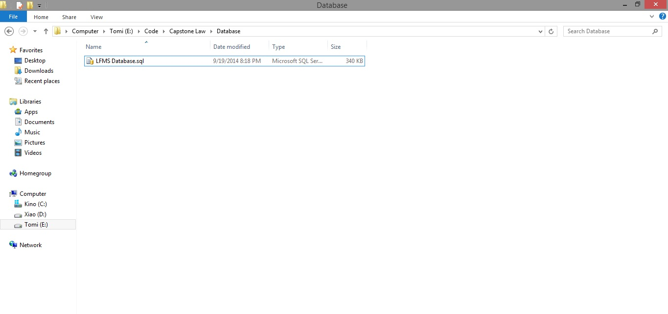

They include a .sql file. The .sql file is database SQL scrip file.

**Step 2**: Import database to SQL Server

Open Script file database using SQL Server

Copy user’s directory that has install SQL Server and replace this location in script file.

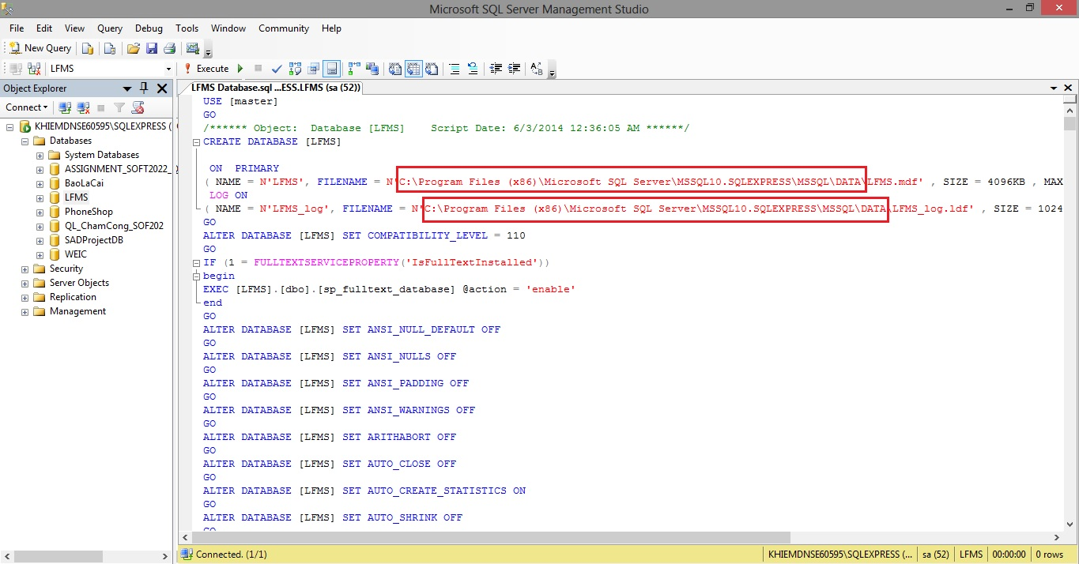

Excute script file to add new database into SQL Server

#### Setup Internet Information Services(IIS)

**Step 1**: Go Start 🡪 Control panel 🡪 Click on Programs and Features 🡪 Click on Turn Windows features on or off.

**Step 2**: Select this features in the picture below to install IIS Service.

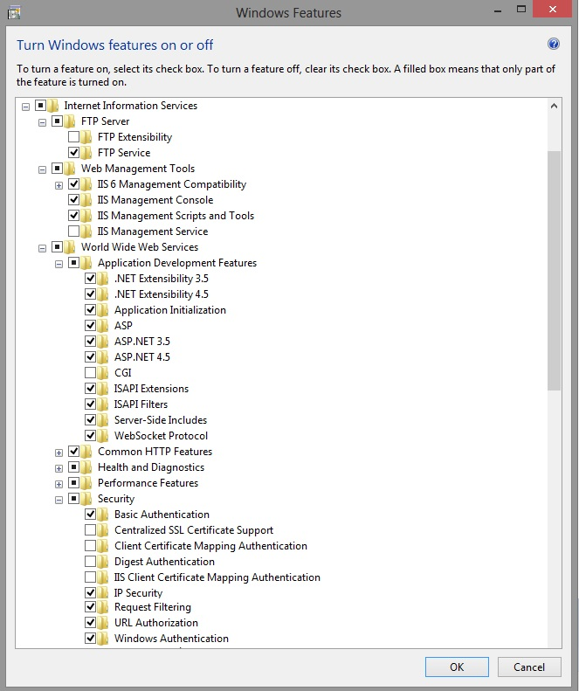

**Step 3**: Go Start 🡪 type Run 🡪 input inetmgr

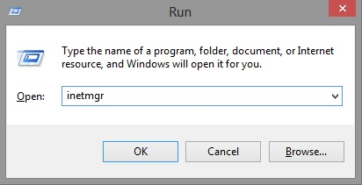

**Step 4:** Go Application Pools 🡪 Right click to select Add Application Pool 🡪 Setup this like the picture below.

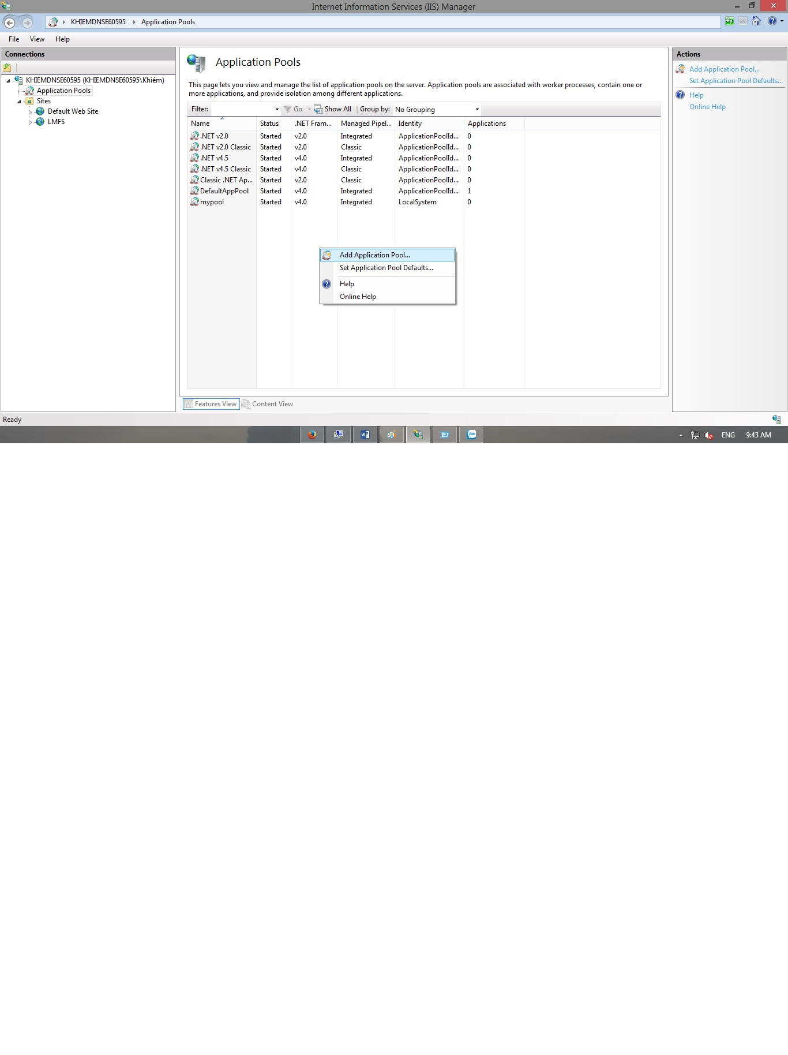

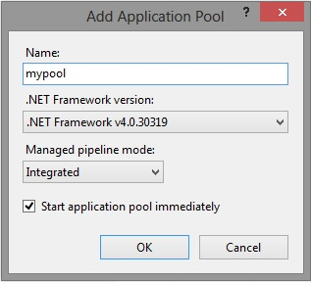

**Step 5:** Open Microsoft SQL Server Management Studio 🡪 Go Security 🡪 Right click to select New Login 🡪 Setup this like the picture below

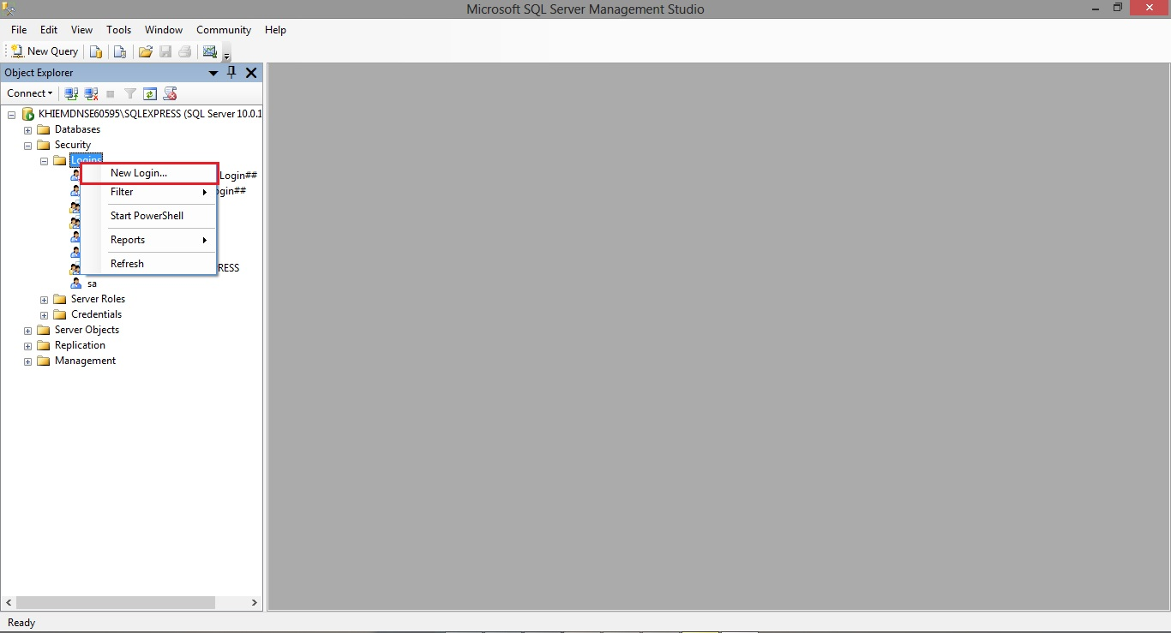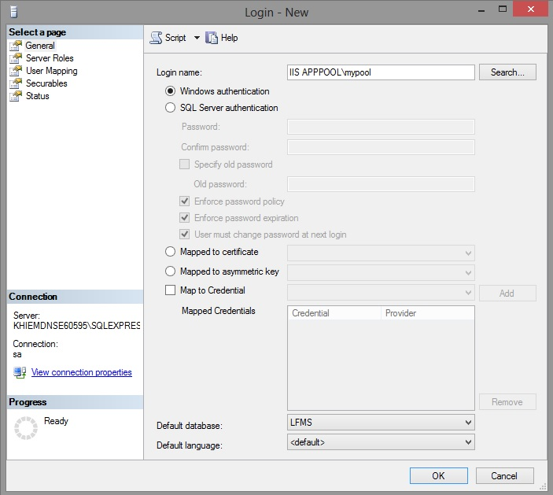

**Step 6:** Go to login user has been created 🡪 Right click then select Properties 🡪 Click on User Mapping 🡪 Setup this like the picture below

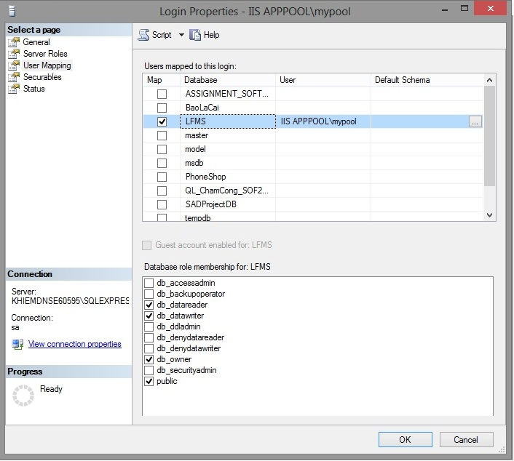

#### Setup and Deloy website into IIS

**Step 1:** Go Sites 🡪 Right click to select Add Website 🡪 Setup this like the picture below.

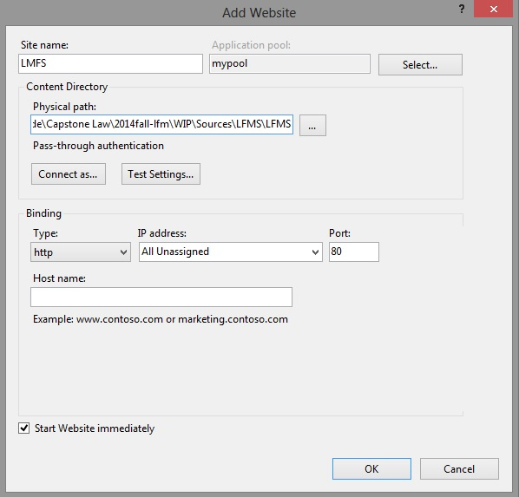

**Step 2:** Goto website user has been created 🡪 Double click on Directory Browsing 🡪 Make this select Enable like the picture below.

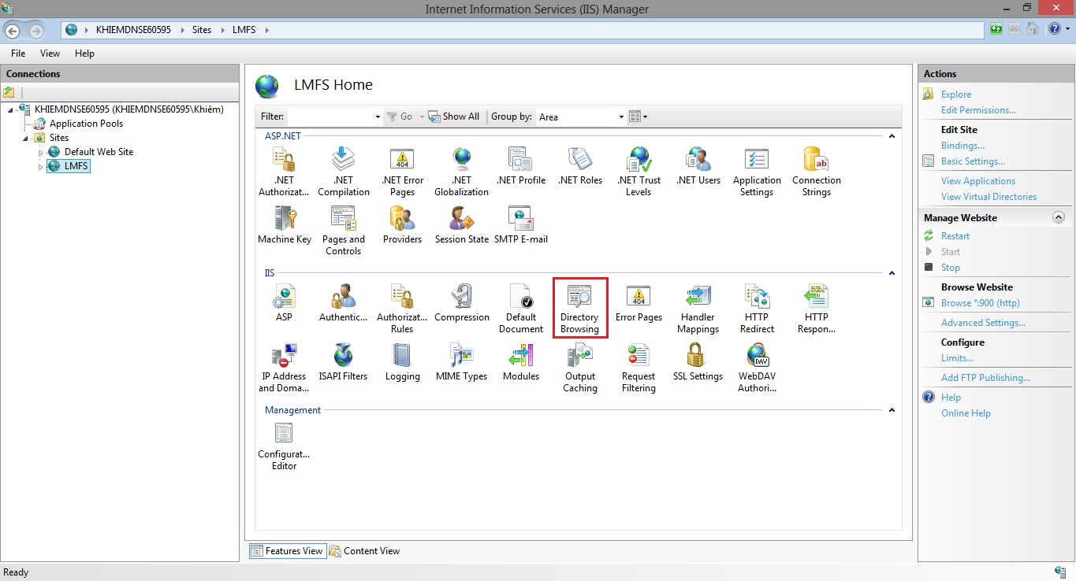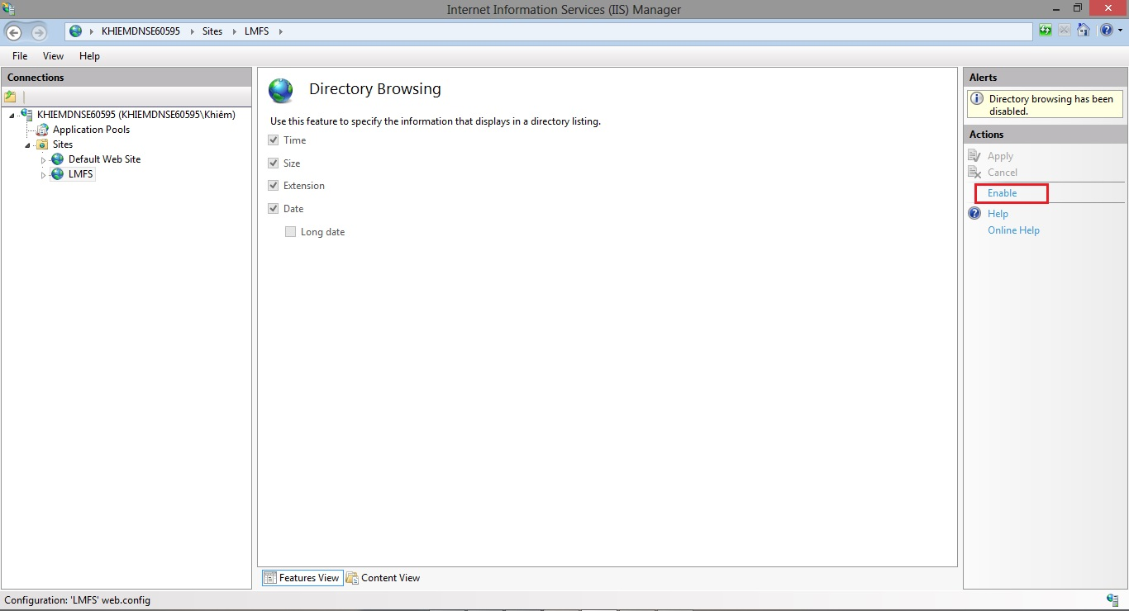

**Step 3:** Goto website user has been created 🡪 Right click to select Manage website 🡪 Choose Browse like the picture below.

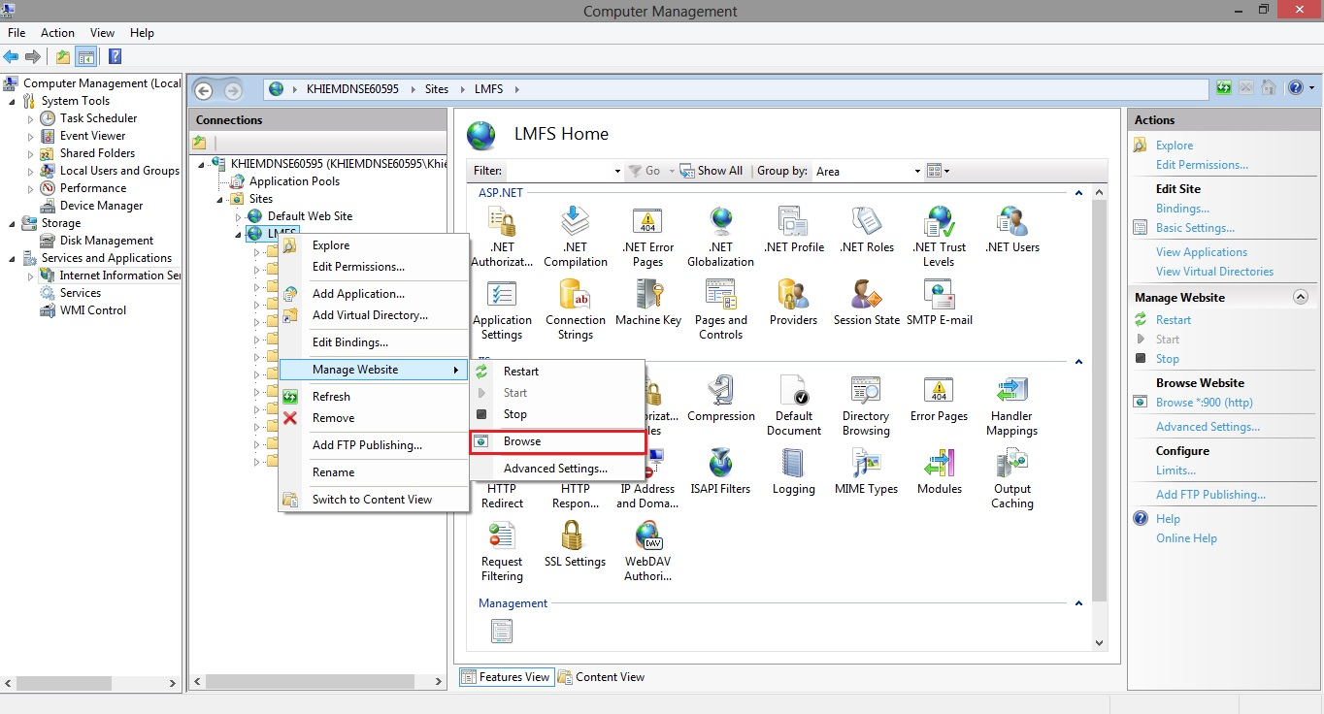

## User’s Guide

### How to create a Calendar Event

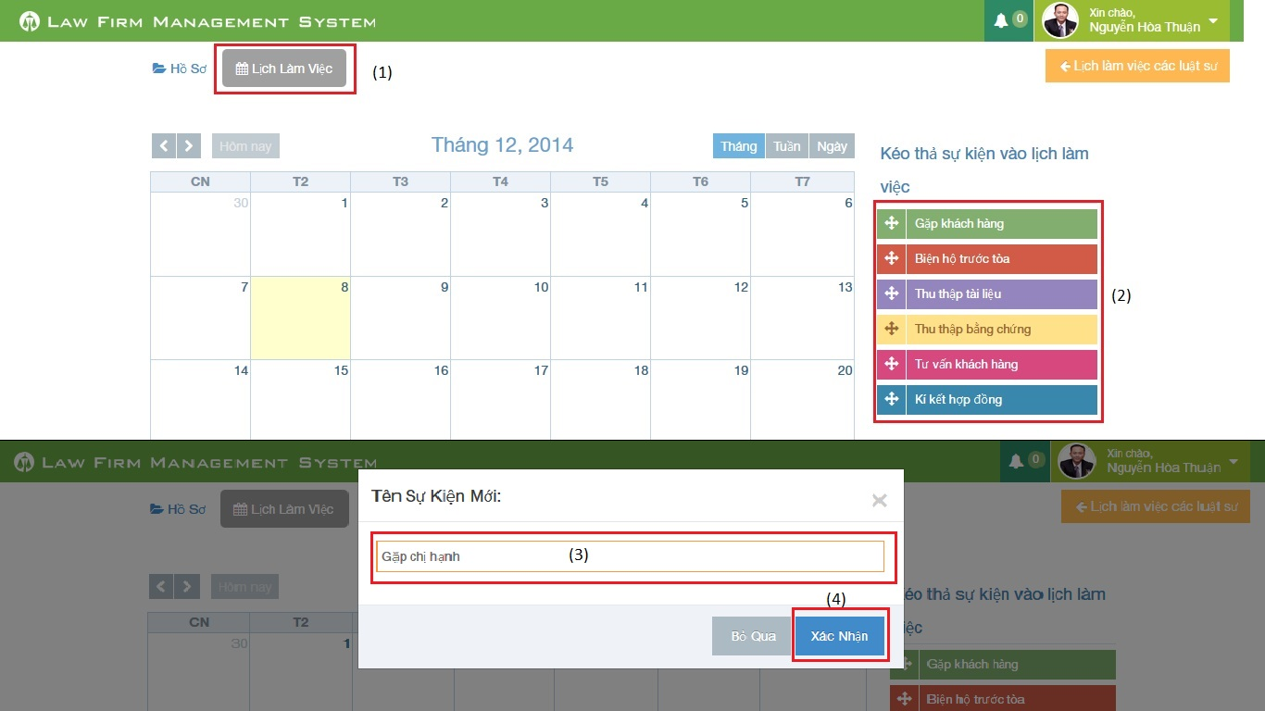

Figure 1: How to create a Calendar Event

|  |  |
| --- | --- |
| Step | Description |
| 1 | At Index page, click at “Lịch làm việc” tab |
| 2 | Drag any event and drop it into calendar.  (User can also click or click and drag anywhere in calendar to create a new event) |
| 3 | Input New calendar event name. |
| 4 | Press “Xác nhận” button to create new calendar event. |

### How to view calendar event of other lawyer

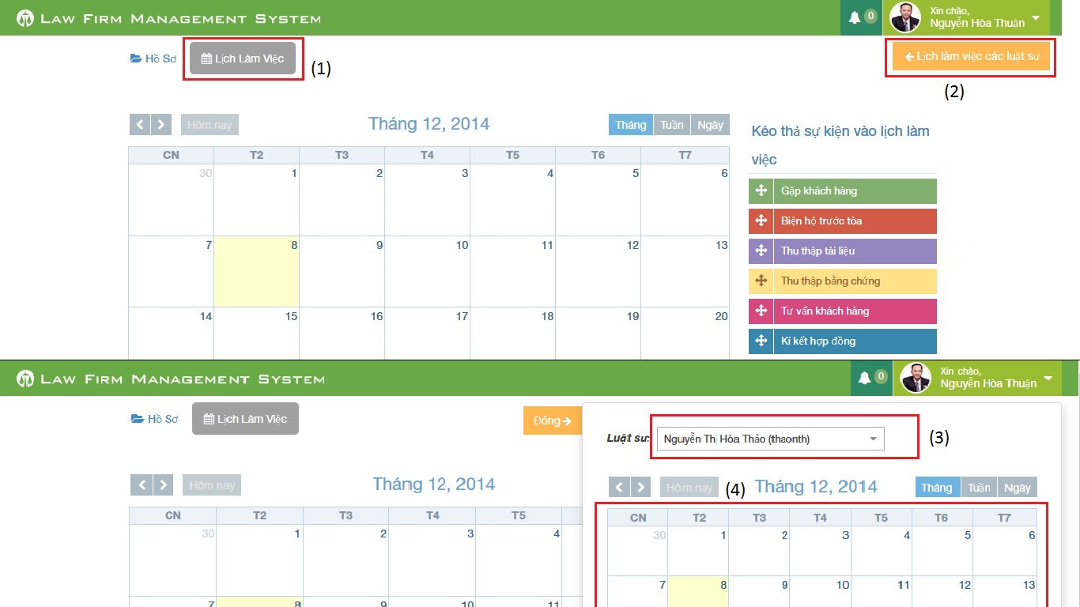

Figure 2: How to view calendar event of other lawyer

|  |  |
| --- | --- |
| Step | Description |
| 1 | At Index page, click at “Lịch làm việc” tab |
| 2 | At “Lịch làm việc” tab click at “Lịch làm việc các luật sư” |
| 3 | Choose a name of lawyer user want to view at combo-box |
| 4 | Calendar event will show below combo-box |

### How to create an Operation Event

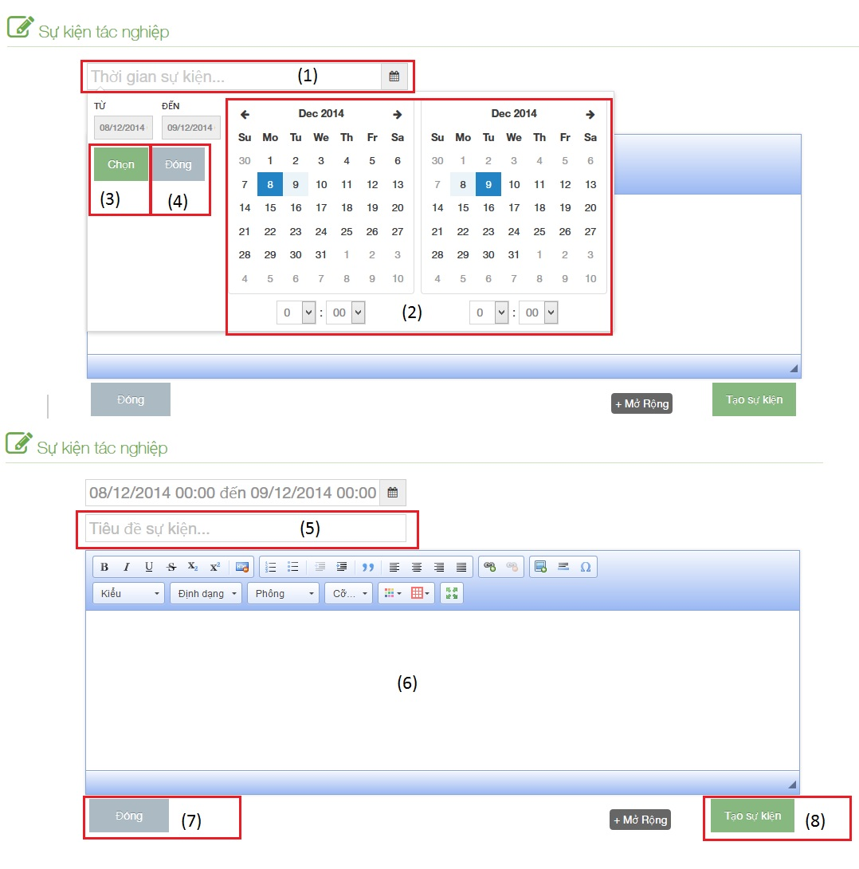

Figure 3: How to create an Operation Event

|  |  |
| --- | --- |
| Step | Description |
| 1 | Click to text box to add time start and finish of event |
| 2 | Choose date and time of event |
| 3 | Click [Chọn] button to input data on “Thời gian sự kiện” |
| 4 | Click [Đóng] button to cancel input |
| 5 | Input title of event |
| 6 | Input content of event include: text, image…. |
| 7 | Click [Đóng] button to close Popup and back to [List event] screen |
| 8 | Click [Tạo sự kiện] to insert new operation event |

### How to upload photos to Documents Related

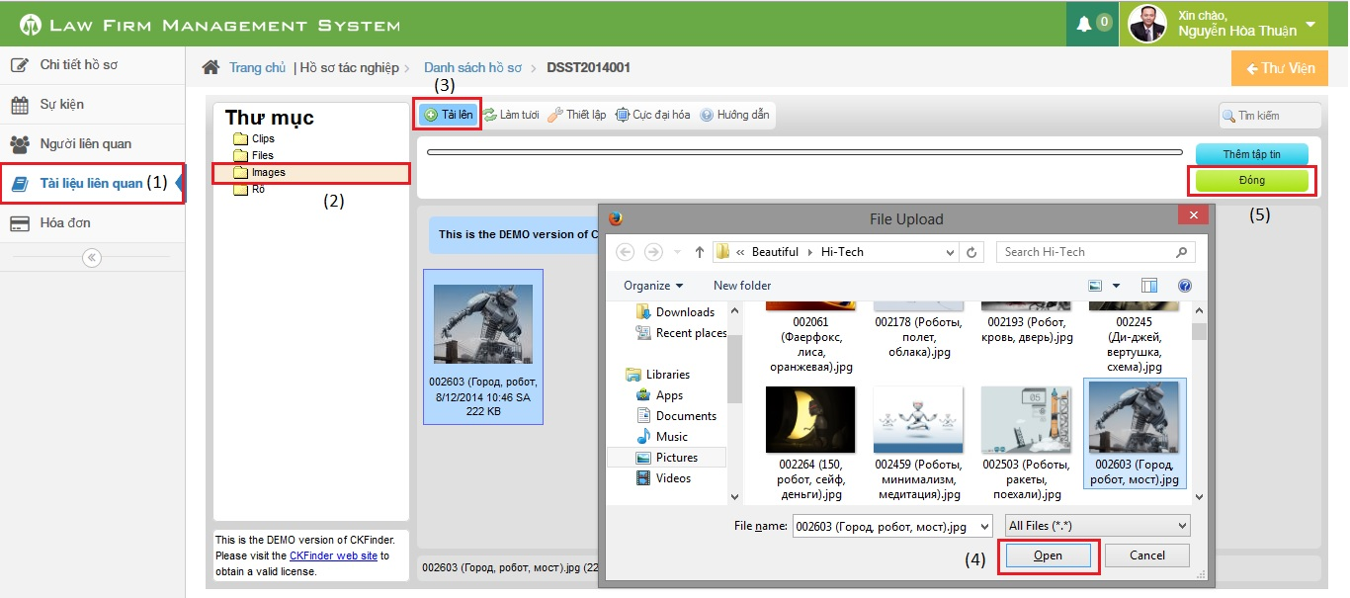

Figure 4: How to upload photos to Documents Related

|  |  |
| --- | --- |
| Step | Description |
| 1 | Go to case detail page and then click on “Tài liệu liên quan” link |
| 2 | Click on “Images” button (can upload only image file format) |
| 3 | Click on “Tải lên” button to show a popup |
| 4 | Choose one or many photos and then click “Open” button |
| 5 | Click on “Đóng” button to complete upload |

### How to create a case

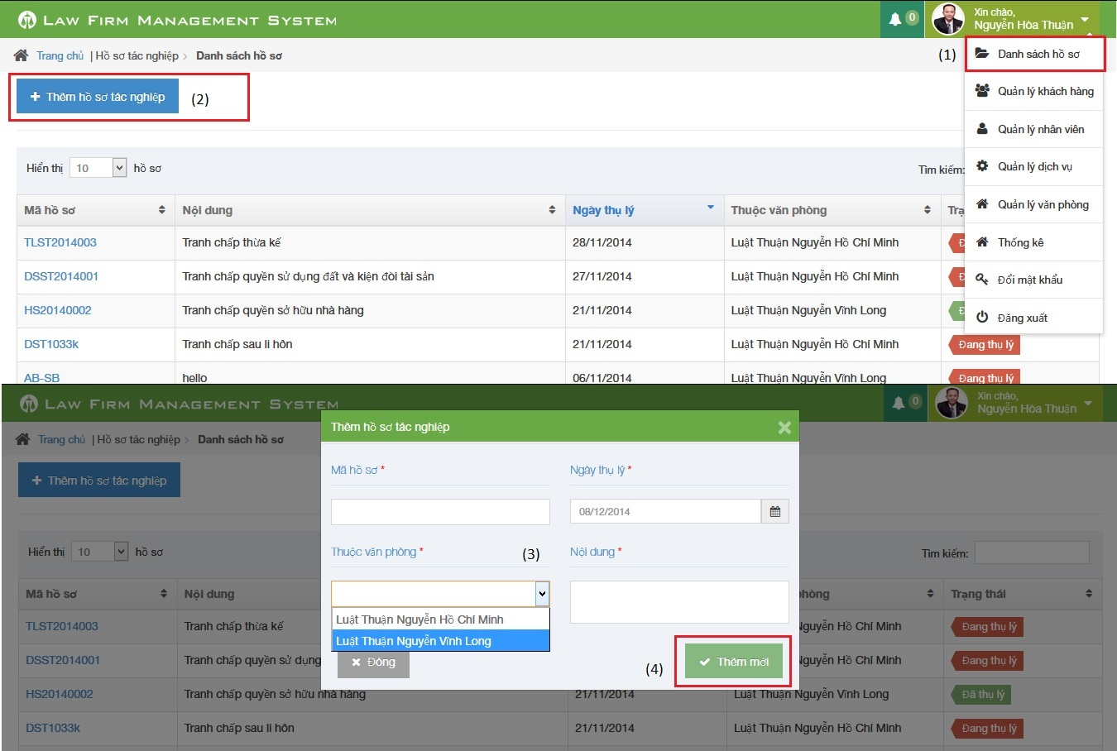

Figure 5: How to create a Case

|  |  |
| --- | --- |
| Step | Description |
| 1 | Click on list menu and then choose “Danh sách hồ sơ” to go to view list case page |
| 2 | Click on “Thêm hồ sơ tác nghiệp” to show a popup |
| 3 | Fill information of case:  - Mã hồ sơ, Ngày thụ lý, Thuộc văn phòng, Nội dung is required |
| 4 | Click [Thêm mới] button to insert new case |

### How to create a customer

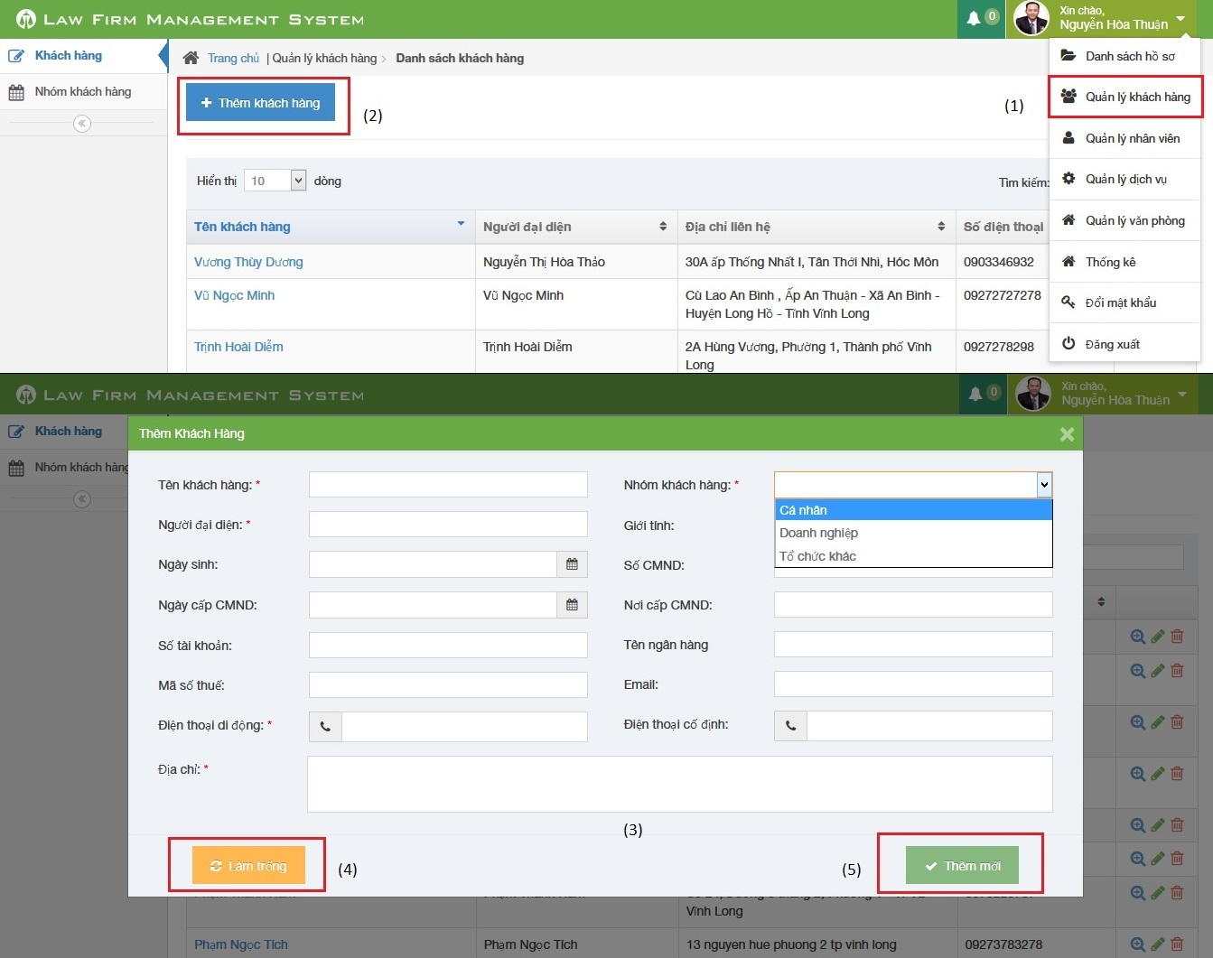

Figure 6: How to create a Customer

|  |  |
| --- | --- |
| Step | Description |
| 1 | Click on list menu and then choose “Quản lý khách hàng” to go to view list customer page |
| 2 | Click on “Thêm khách hàng” to show a popup |
| 3 | Fill information of case:  - Tên khách hàng, Người đại diện, Nhóm khách hàng, Điện thoại di động, Địa chỉ is required  - Điện thoại di động, Điện thoại cố định, số CMND, Mã số thuế, Số tài khoản must be number  - Email to compliance with format |
| 4 | Click [Làm trống] button to clear all fill to blank. |
| 5 | Click [Thêm mới] button to insert new customer |

### How to create a Staff

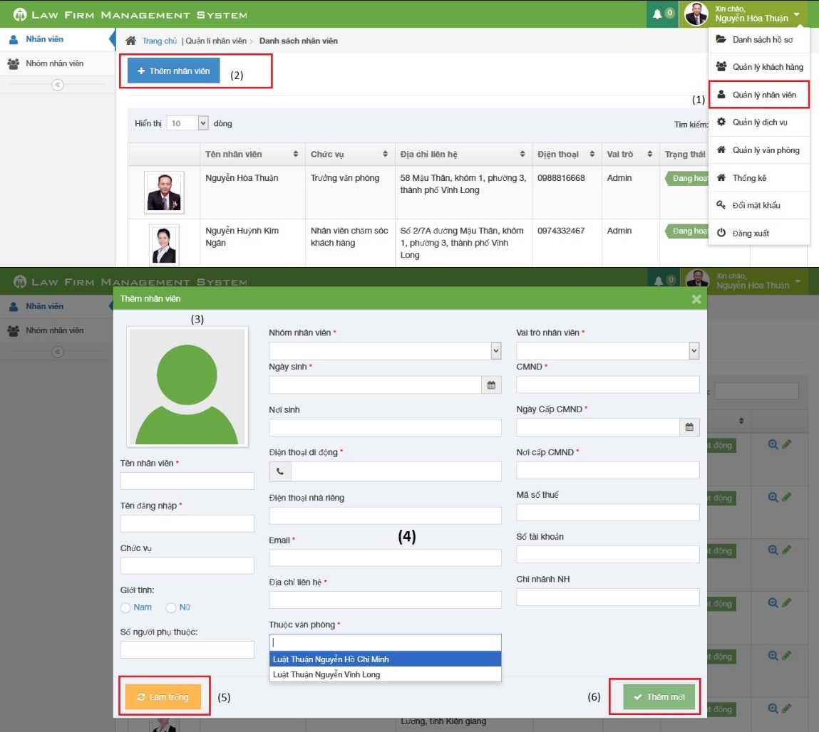

Figure 7: How to create a Staff

|  |  |
| --- | --- |
| Step | Description |
| 1 | Click on list menu and then choose “Quản lý nhân viên” to go to view list staff page |
| 2 | Click on “Thêm nhân viên” to show a popup |
| 3 | Click to input avatar of staff |
| 4 | Fill information of staff:  - Tên nhân viên, Tên đăng nhập, Nhóm nhân viên, Ngày sinh, Điện thoại di động, Email, Địa chỉ liên hệ, Thuộc văn phòng, Vai trò nhân viên, CMND, Ngày cấp CMND, Nơi cấp CMND is required  - Điện thoại di động, Điện thoại nhà riêng, CMND, Mã số thuế, Số tài khoản must be number  - Email to compliance with format |
| 5 | Click [Làm trống] button to clear all fill to blank. |
| 6 | Click [Thêm mới] button to insert new staff |

### How to create a service

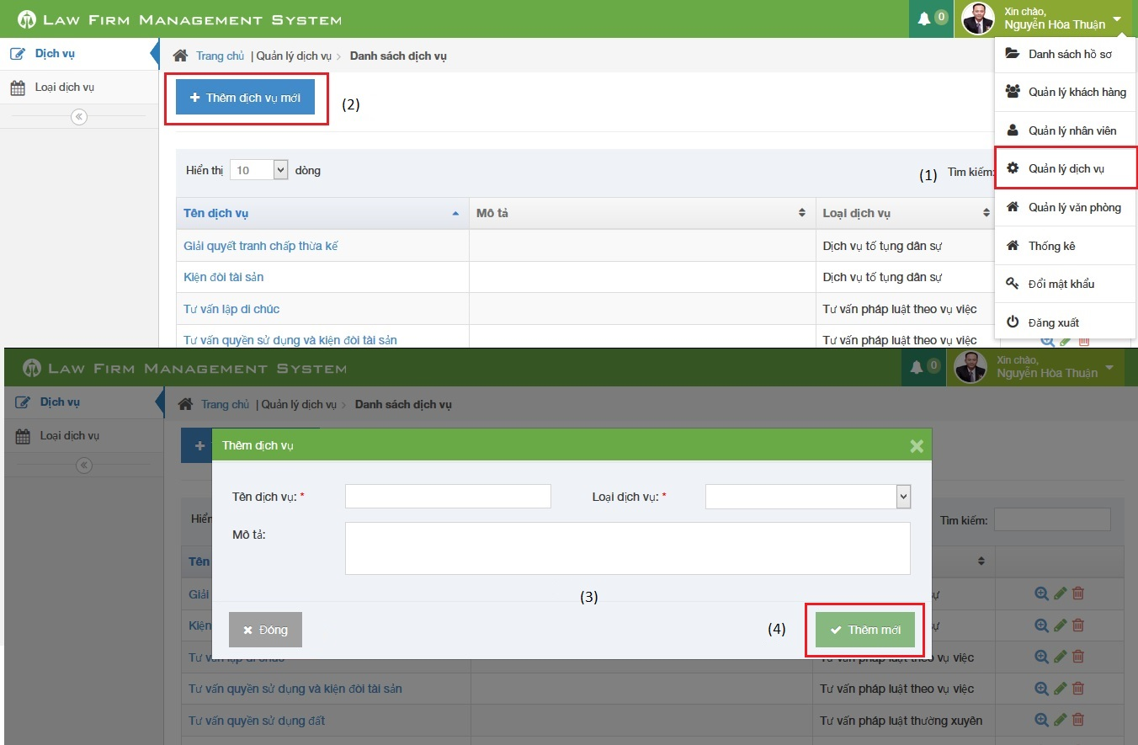

Figure 8: How to create a service

|  |  |
| --- | --- |
| Step | Description |
| 1 | Click on list menu and then choose “Quản lý dịch vụ” to go to view list service page |
| 2 | Click on “Thêm dịch vụ mới” to show a popup |
| 3 | Fill information of case:  - Tên dịch vụ, Loại dịch vụ is required |
| 4 | Click [Thêm mới] button to insert new service |

### How to create an office

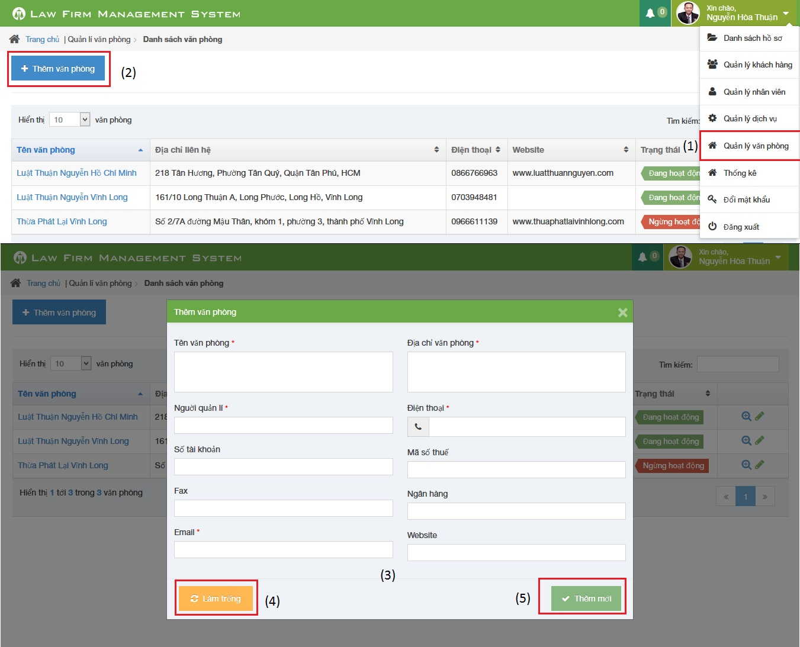

Figure 7: How to create a Staff

|  |  |
| --- | --- |
| Step | Description |
| 1 | Click on list menu and then choose “Quản lý văn phòng” to go to view list office page |
| 2 | Click on “Thêm văn phòng” to show a popup |
| 3 | Fill information of case:  - Tên văn phòng, Địa chỉ văn phòng, Người quản lí, Điện thoại, Email is required  - Điện thoại, Mã số thuế, Số tài khoản must be number  - Email to compliance with format |
| 4 | Click [Làm trống] button to clear all fill to blank. |
| 5 | Click [Thêm mới] button to insert new service |

### How to view statistic

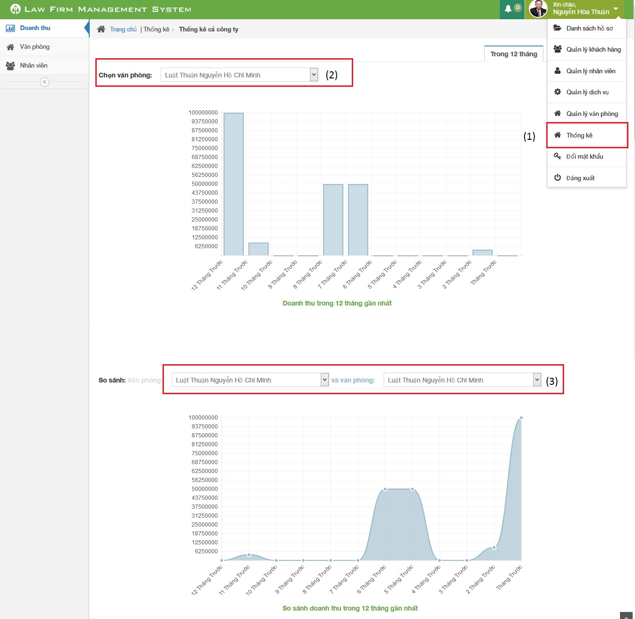

Figure 8: How to view statistic

|  |  |
| --- | --- |
| Step | Description |
| 1 | Click on list menu and then choose “Thống kê” to go to view list statistic page |
| 2 | Choose office user want to show statistic |
| 3 | Choose two office user want to compare in statistic |

**End.**